How to Clean a Meat Slicer: Facility Sanitation SOP
This standard operating procedure explains how to clean a meat slicer, including disassembly, washing, sanitizing, and reassembly of all components. Follow these steps every time the slicer is cleaned to protect food safety and keep the equipment in safe working condition.

Purpose
The objective of this procedure is to ensure the slicer is cleaned and sanitized at least once every four hours of use and at the end of each workday. This routine cleaning ensures food safety and proper equipment maintenance. It also controls the risk of injury from the slicer's exposed blade during disassembly, cleaning, and reassembly.

Scope
This procedure applies to commercial meat slicers, including semi-automatic models (which must be switched to manual mode before cleaning) and models with either removable or non-removable carriage assemblies. It covers the slicer body, blade, fence, carriage, feed grip, knife guard, knife scraper, thickness control dial, and sharpener (on models where it is stored on top of the machine).
The scope includes the stainless steel food preparation table, the sink station used for washing disassembled parts, and the area beneath the slicer on models equipped with a lift lever. Running any portion of the slicer or its components through a dishwasher is explicitly excluded from this procedure.

Supplies
- [ ] Cut-resistant gloves
- [ ] Disposable or nitrile gloves (blue), worn in addition to cut-resistant gloves for added safety
- [ ] Mild detergent
- [ ] Warm water
- [ ] Nylon brush
- [ ] Clean cloths and moist wipes
- [ ] Sanitizer solution or spray bottle sanitizer
- [ ] Color-coded cleaning buckets (red and green)
- [ ] Access to a stainless steel sink for washing components
Store detergent, sanitizer, and cleaning buckets according to your facility's chemical storage requirements. The source procedure does not specify dilution ratios; confirm the correct sanitizer dilution with your facility's chemical supplier before use.

Safety Precautions
Personal protective equipment
- [ ] Put on cut-resistant gloves before cleaning the slicer to protect your hands from sharp blades.
- [ ] Use both cut-resistant gloves and disposable gloves together for added safety.


Operator preparing to put on cut-resistant gloves, with blue disposable gloves visible on the table.
Lockout before cleaning
- [ ] Turn off the slicer machine before beginning any cleaning steps.
- [ ] Always unplug the slicer before starting any cleaning procedure to prevent accidental startup and electrical hazards.


Red warning overlay reading "DANGER" with an exclamation mark, showing a wall power outlet.
Exposed blade caution
- [ ] After removing the carriage and other components, treat the blade edge as exposed and hazardous.
- [ ] Use extreme caution at all times to avoid injury when working near the blade.

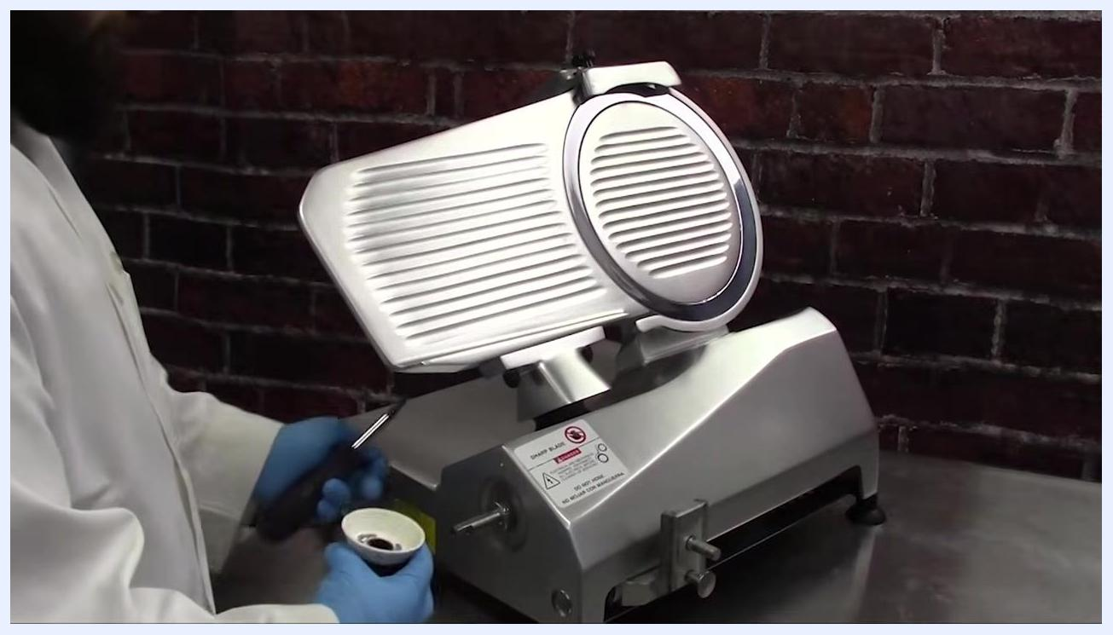
Red warning overlay reading "USE EXTREME CAUTION AROUND THE EXPOSED BLADE," with the exposed slicer blade visible in the background.
Chemical and equipment handling
- [ ] Never run any portion of the slicer or its components through a dishwasher, as this may damage the equipment.

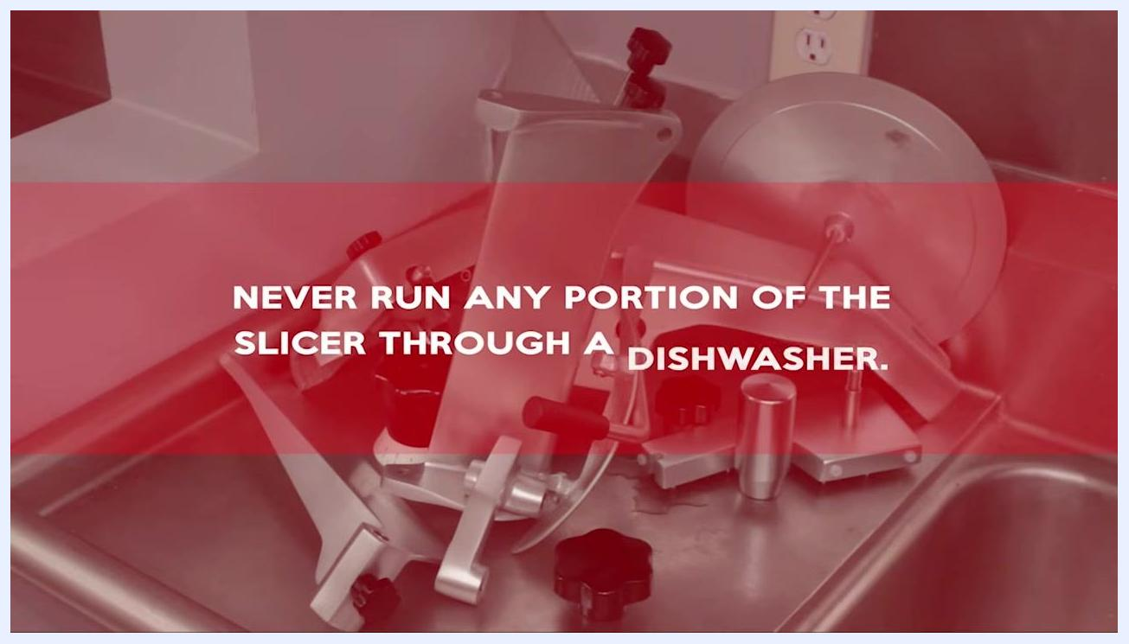
Red warning overlay reading "NEVER RUN ANY PORTION OF THE SLICER THROUGH A DISHWASHER," with slicer parts visible in a sink.
- [ ] After sanitizing, do not wipe parts dry. Let all parts air dry completely to ensure effective sanitation.


Operator standing near the slicer with a large "IMPORTANT" warning on screen, emphasizing the need to air dry after sanitizing.
- [ ] Do not overtighten the adjustment spacer shaft or the weight on the gravity feed assembly. Hand-tighten only, so future adjustments remain easy and components are not damaged.

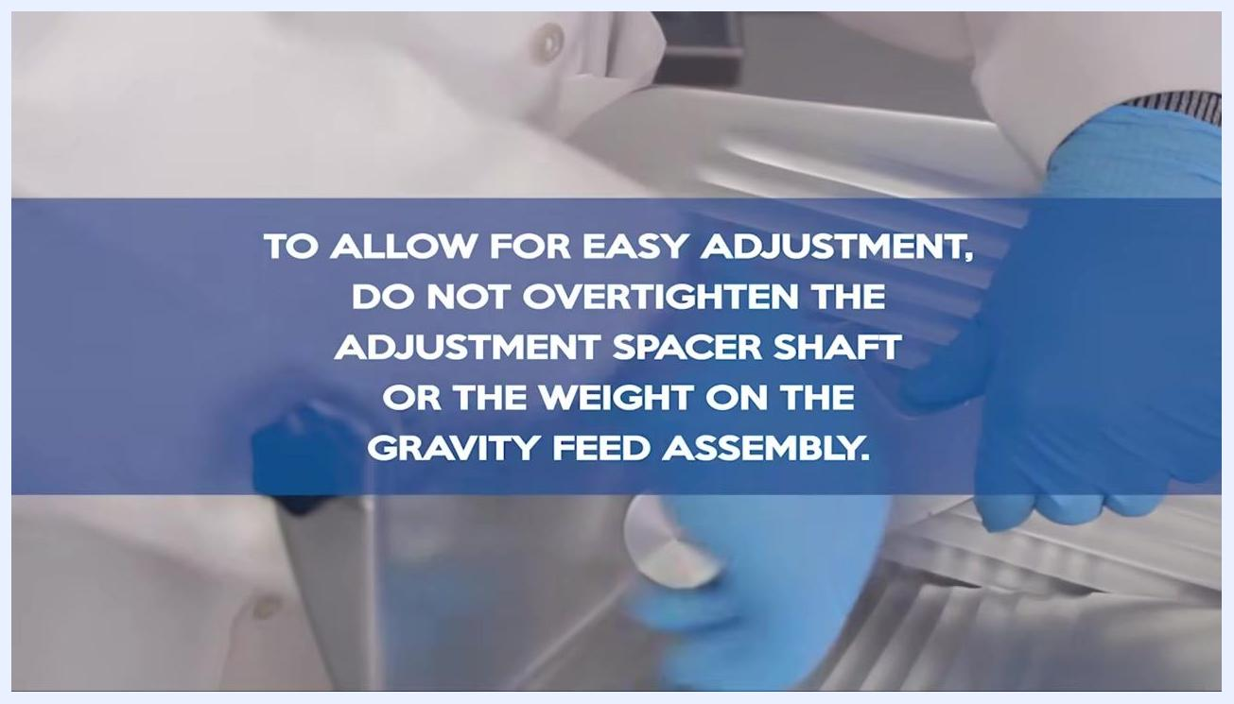
Instructional overlay reading "TO ALLOW FOR EASY ADJUSTMENT, DO NOT OVERTIGHTEN THE ADJUSTMENT SPACER SHAFT OR THE WEIGHT ON THE GRAVITY FEED ASSEMBLY," with blue gloves and slicer components visible in the background.
Wet-floor and ventilation controls
The source material does not describe wet-floor signage or ventilation requirements for this task; your facility should post wet-floor warnings around the sink and cleaning area and ensure adequate ventilation when using detergents and sanitizers.
Allergen controls
The source material does not address allergen cross-contact controls; your facility should define separate cleaning tools or sequencing if the slicer is used for multiple allergen categories.

Cleaning steps

Prepare the slicer

- Rotate the thickness control dial all the way to the minimum setting to close the fence.
- Pull the carriage all the way toward you.
- If your slicer is a semi-automatic model, switch it to manual mode before cleaning.

Slicer on a stainless steel table with the thickness control dial visible and the carriage pulled forward; operator wearing a white coat and blue gloves.

- Unplug the slicer before continuing (see Safety Precautions above).

Disassemble the carriage and feed components

- After unplugging, remove the carriage components from the slicer.
- If your model has a non-removable carriage assembly, loosen the carriage arm knob and tilt the carriage assembly away from the slicer body. Note that on some models the thickness control dial also functions as a release lever for the carriage.

Slicer with the carriage assembly tilted away from the body; operator loosening the carriage arm knob while wearing blue gloves.

- Loosen the adjustment spacer knob, unscrew the adjustment spacer rod, and remove the rod and spacer. Set them aside for cleaning.

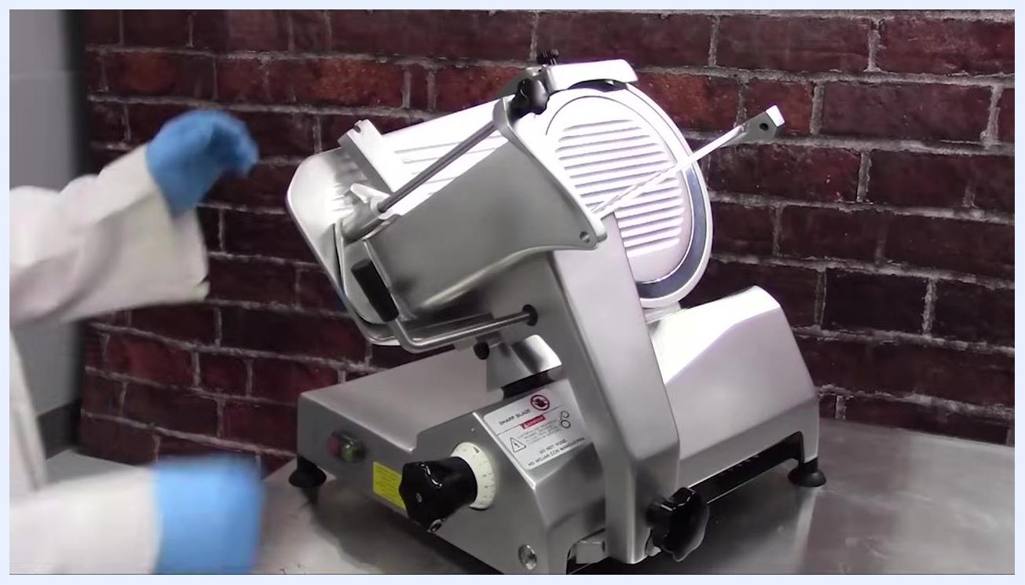
Operator loosening the adjustment spacer knob on the slicer.

- Detach the feed grip from the slicer and set it aside for cleaning.

Slicer with the feed grip being removed; operator's gloved hands visible.

- If your slicer model has a multi-piece grip: remove the feed weight by turning it counterclockwise, remove the first spacing washer, detach the feed grip from the support arm, and remove the second plastic spacing washer and the small metal grip washer. Set all pieces aside for cleaning.

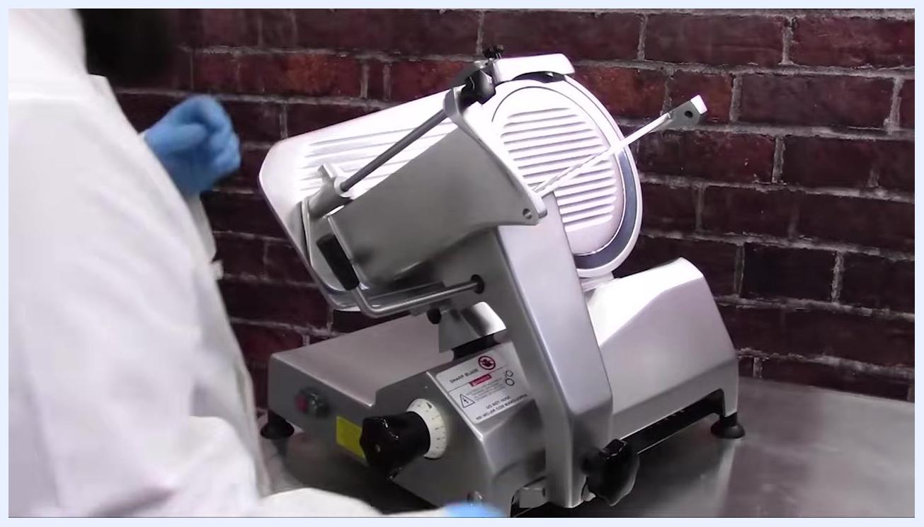
Operator turning the feed weight counterclockwise to remove it from the slicer, with the feed grip and support arm visible.

- Loosen the knob on the product feed rod by turning it counterclockwise, then remove the rod, the feed grip, and the two impact-absorbing washers. Set these aside for cleaning.

Close-up of the slicer with the feed grip and rod removed, showing the support arm and mounting post.

Remove the carriage, dial, and sharpener

- On models with removable carriages, unscrew the carriage arm knob and pull upward to remove the carriage. Set the knob and carriage aside for cleaning.

Operator unscrewing the carriage arm knob and preparing to remove the carriage assembly.

- Carefully lift the carriage assembly away from the slicer and place it in a safe area for cleaning.

Operator holding the removed carriage assembly and moving it away from the slicer.

- On models with a removable thickness control dial, loosen the screw on the front of the dial and remove the knob. Set it aside for cleaning.

Close-up of a gloved hand loosening and removing the black thickness control dial, marked with numbers 0–9.

- On models where the sharpener is stored on top of the machine, unscrew the sharpener locking pin and carefully pull the sharpener upward to remove it. Set it aside for cleaning.

Operator holding the removed sharpener and locking pin, standing next to the slicer with the sharpener storage area visible.

Remove the knife guard assembly

- If your slicer model has a removable knife scraper, carefully remove it from behind the blade and set it aside for cleaning. If your model has a non-detachable knife scraper, tilt it down to allow access for cleaning.
- Locate the knife guard knob on the back of the slicer and loosen it by turning counterclockwise. If your model has a removable knife guard knob, remove it completely and set it aside for cleaning.
- Push upward on the knife guard rod to lift the guard away from the blade, then set the knife guard aside for cleaning.

Wash all disassembled components

- Gather all removed slicer components (knife scraper, knife guard, feed grip, carriage, etc.) and take them to the sink for cleaning and sanitizing.

Operator wearing blue gloves washing slicer components in a stainless steel sink, with a tub of additional parts nearby.

- Wash each component in mild detergent and warm water. Use a brush or cloth to thoroughly clean all surfaces, rinse each part with clean water, sanitize according to your facility's procedures, and allow all parts to air dry completely before reassembly.

Clean the slicer body and blade

- Working from top to bottom, use a clean cloth to wipe away excess food debris from the slicer base and blade area.

Operator wiping down the slicer base and blade area with a cloth, working from top to bottom.

- Use a nylon brush soaked in mild detergent and warm water to clean around the ring guard, and use the same brush to clean the back side of the knife, being careful not to touch the blade edge.

Operator using a brush to clean the back side of the slicer knife, focusing on the ring guard area.

- Using a moist wipe or clean cloth soaked in mild detergent and warm water, clean the knife blade with a circular motion, starting from the center and working outward. Always avoid direct contact with the blade edge.

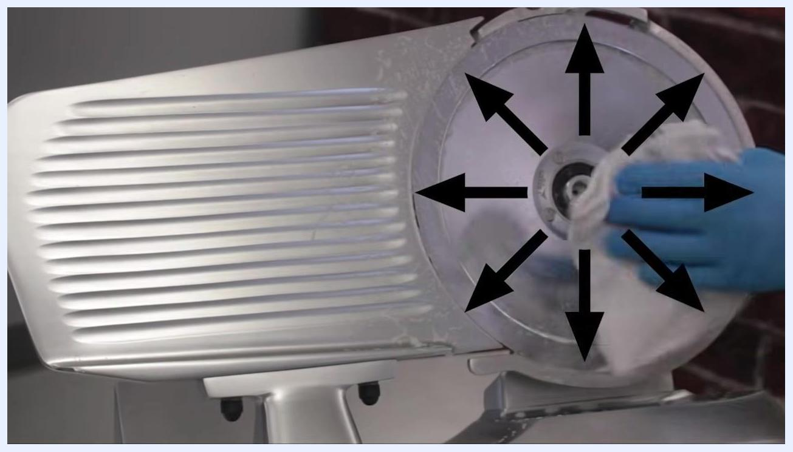
Operator cleaning the slicer blade with a cloth, following outward arrows indicating a circular motion from the center.

- Clean the fence by starting at the knife and working outward, ensuring all surfaces are free of food debris and residue.
- Using a clean cloth or wipe soaked in mild detergent and warm water, thoroughly wipe the entire slicer body, focusing on the grooved surfaces and the area surrounding the knife blade. Ensure all visible food residue and moisture are removed.

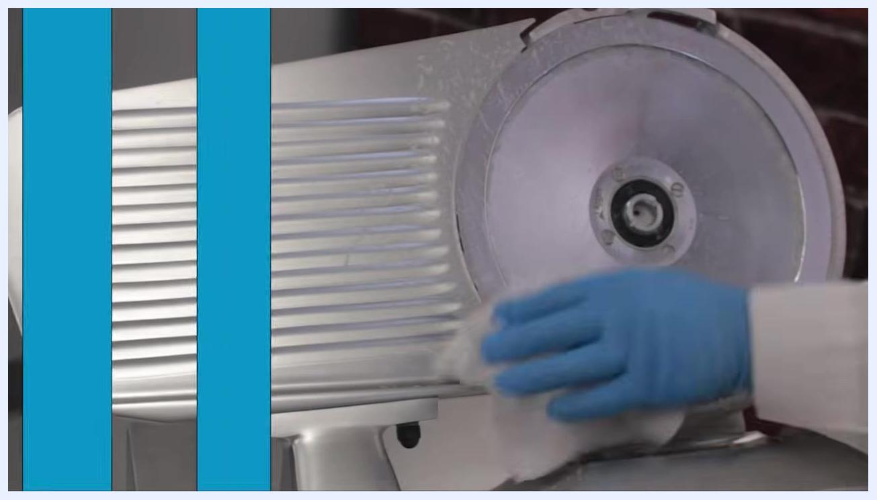
Operator wiping the grooved body and blade area of the slicer with a cloth in the food preparation area.

Final wipe-down before sanitizing

- Wipe the knife from the center outward, using protective gloves and a clean cloth. Never wipe toward the blade edge.

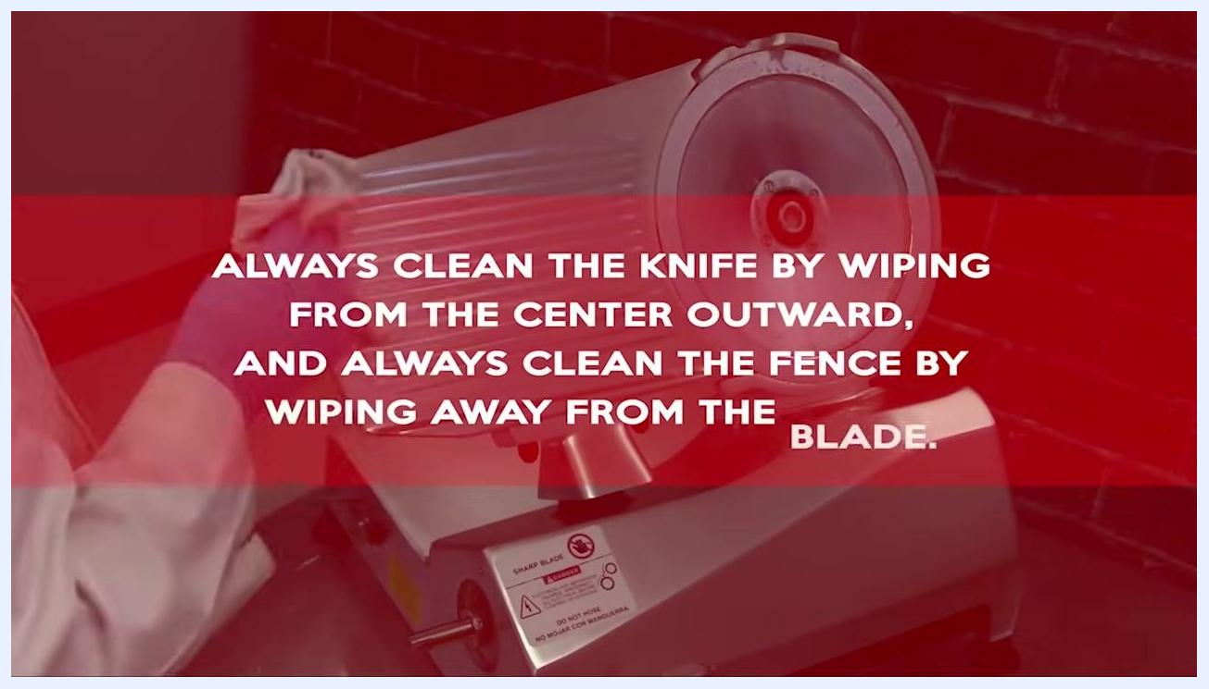
Operator cleaning the meat slicer blade with a cloth; on-screen text reads "ALWAYS CLEAN THE KNIFE BY WIPING FROM THE CENTER OUTWARD, AND ALWAYS CLEAN."

- Wipe the fence away from the blade with a clean cloth to prevent accidental cuts.

Operator cleaning the slicer fence; on-screen text reads "ALWAYS CLEAN THE KNIFE BY WIPING FROM THE CENTER OUTWARD, AND ALWAYS CLEAN THE FENCE BY WIPING AWAY FROM THE BLADE."

- Insert a moist wipe or damp cloth between the blade edge and the protective ring guard, and carefully work the cloth around the blade edge. Take extra caution to avoid direct contact with the blade.

Operator cleaning around the blade edge of the slicer, using a cloth to reach between the blade and the guard.

- Wipe down the entire slicer, including the body and any accessible surfaces, ensuring all food contact surfaces are thoroughly cleaned.

Operator wiping the main body of the slicer with a cloth.

Dry and sanitize the slicer

- Using a clean, dry cloth, dry the knife by wiping from the center outward, and dry the fence by starting at the knife and wiping away from the blade.

Operator drying the slicer blade and fence with a cloth; surfaces are visibly wet.

- Using a clean cloth soaked in sanitizer solution or a spray bottle sanitizer, wipe down all surfaces of the slicer to ensure proper sanitation.

Operator sanitizing the slicer, wiping the fence area with a cloth; the slicer is visibly wet with sanitizer.

- Allow the slicer and all parts to air dry completely. Do not wipe dry after sanitizing.

Reassemble the slicer

- Carefully align the knife guard cover over the blade, allow the knife guard to drop into place, and secure it by tightening the knob on the knife guard.

Operator preparing to reassemble the slicer, holding parts and aligning the knife guard cover.

Operator securing the knife guard onto the slicer blade.

- Place the knife scraper back into its position. For models equipped with a top-mounted scraper, follow the manufacturer's instructions for correct placement.

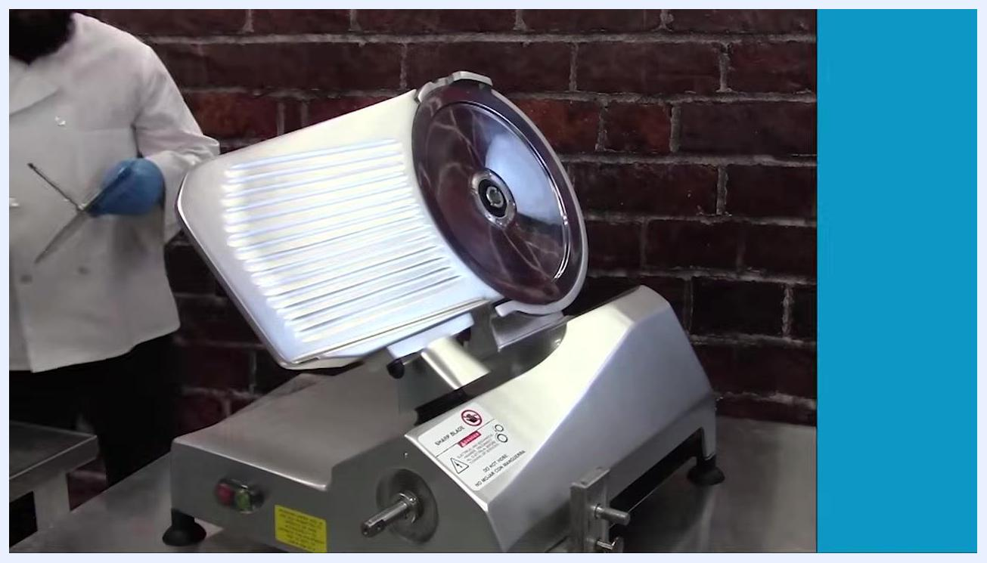
Close-up of the operator reinstalling the knife scraper on the slicer, showing the adjustment knobs and scraper mechanism.

- Hold the sharpener unit with both hands, align it with its designated storage slot, and carefully insert it into place.

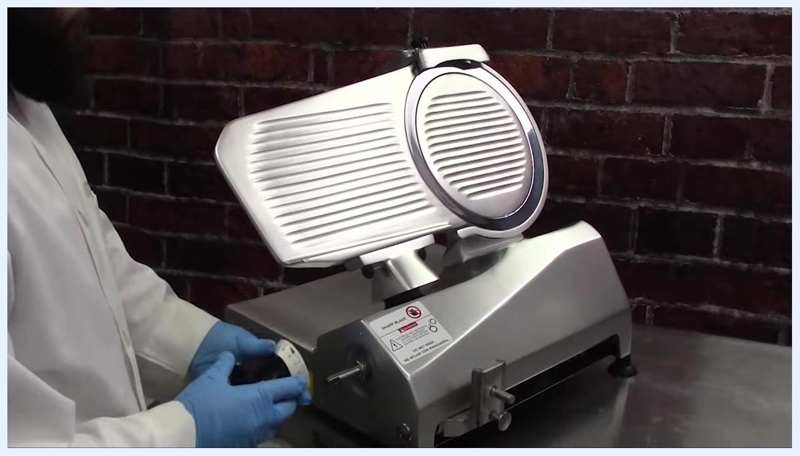
Operator holding the slicer sharpener above the slicer, preparing to reinstall it into its storage position; the slicer is fully assembled except for the sharpener.

- Locate the thickness control dial's mounting position, align the dial with the shaft, gently push it into place, and secure it by tightening the screw or knob.

Operator reattaching the thickness control dial to the front of the slicer.

- If your model has a removable carriage, position it onto the slicer, aligning it with the guide rails, slide it into place, and tighten the carriage arm knob to secure it.

Operator reattaching the carriage to the slicer, holding the carriage arm and aligning it with the slicer body.

Reassemble the grip mechanism

- If your grip is comprised of multiple pieces, thread the product feed rod through the first hole on the carriage, slide the first thick impact-absorbing washer onto the rod, and slide the support onto the shaft.

Close-up of the operator threading the product feed rod through the first hole on the carriage and preparing to slide a thick washer onto the rod.

- Insert the rod and washer assembly through the carriage, ensuring the washer is seated properly against the carriage wall.

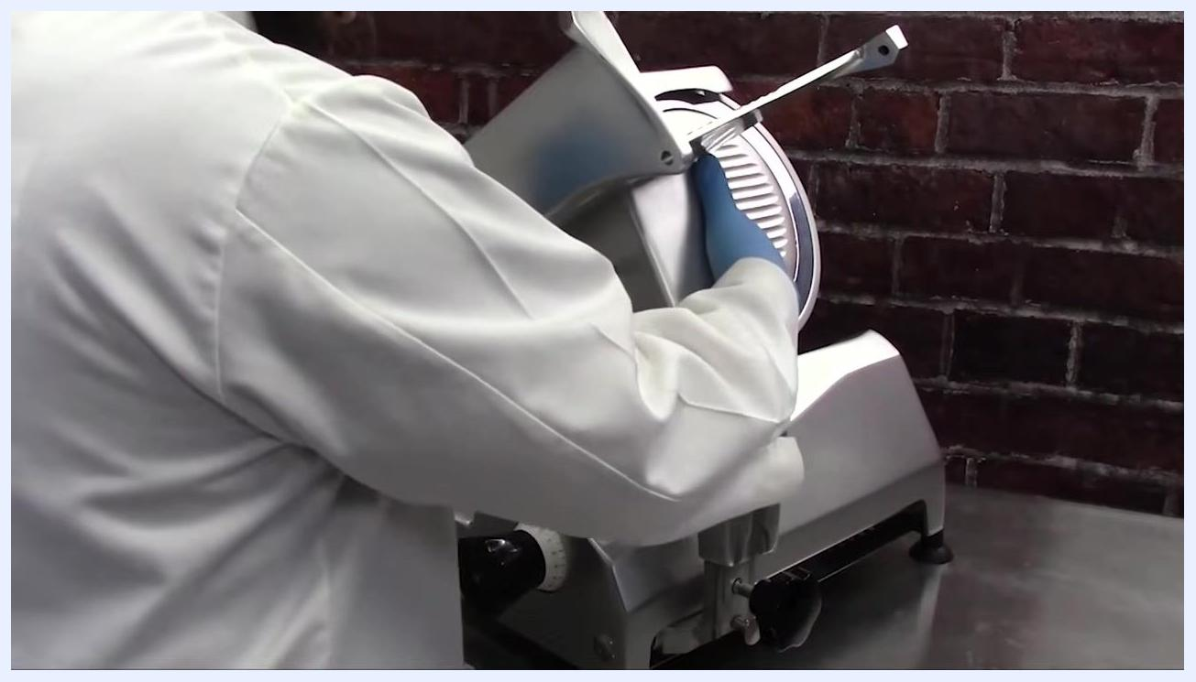
Close-up of the product feed rod and washer assembly being inserted through the carriage, with the washer positioned against the carriage wall.

- Guide the rod through the second hole on the carriage and rotate it clockwise to tighten and secure it in place.

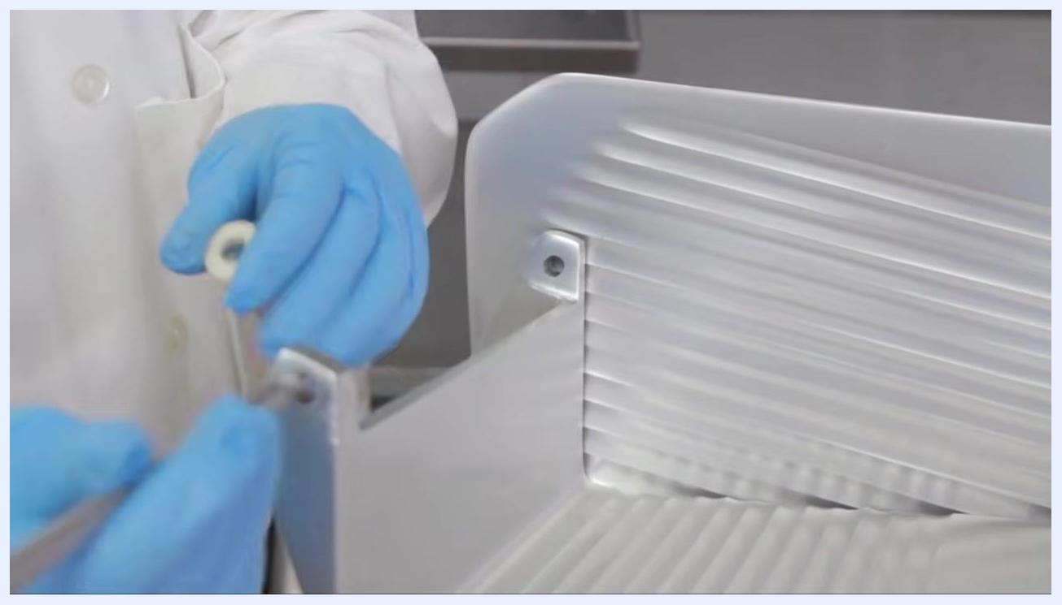
Close-up of the rod and washer assembly being inserted through the second hole on the carriage, with the operator's gloved hand turning the rod to tighten.

- Locate the thin plastic spacing washer and slide it onto the feed grip rod, ensuring it sits flush against the support.

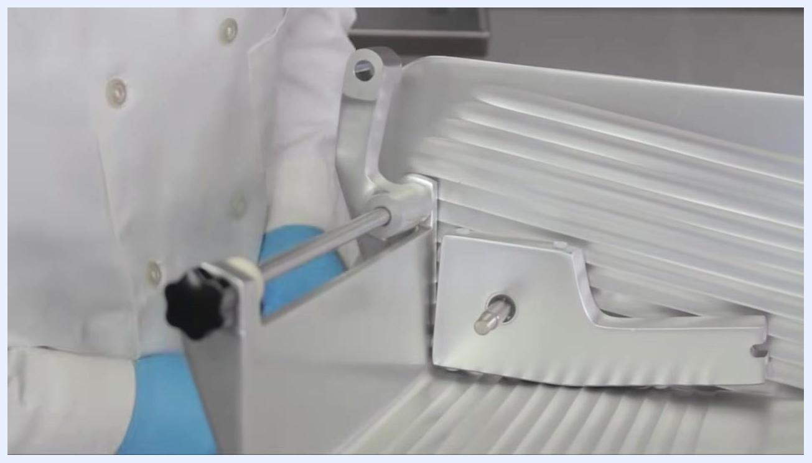
Operator placing a thin plastic spacing washer onto the feed grip rod inside the slicer carriage.

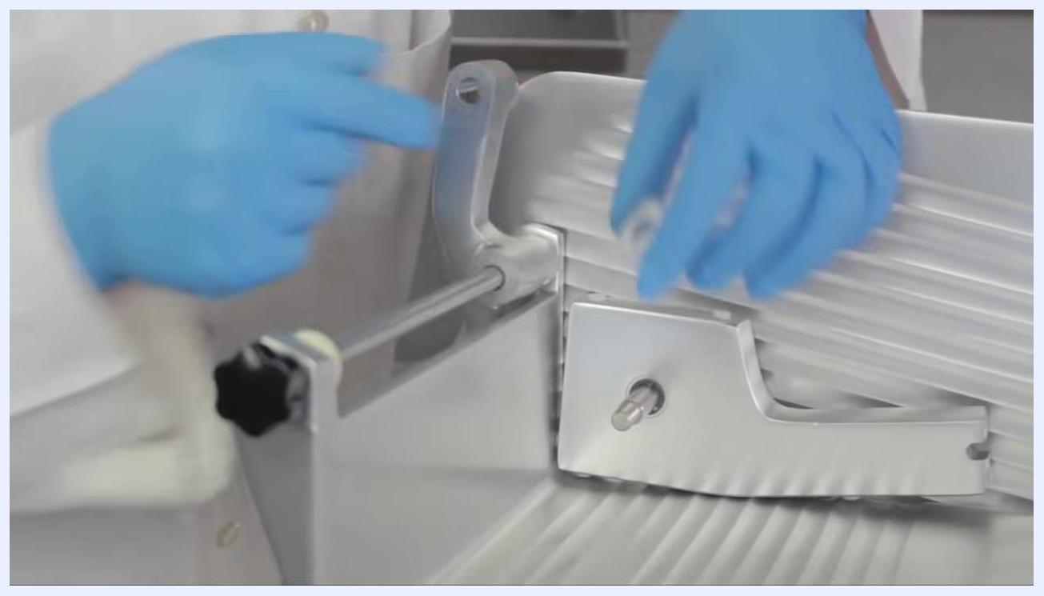
Operator positioning the thin plastic spacing washer onto the feed grip rod, ensuring proper placement.

- Position the adjustment spacer onto the rod, insert the rod into its designated slot or hole, and tighten the knob to secure the assembly.

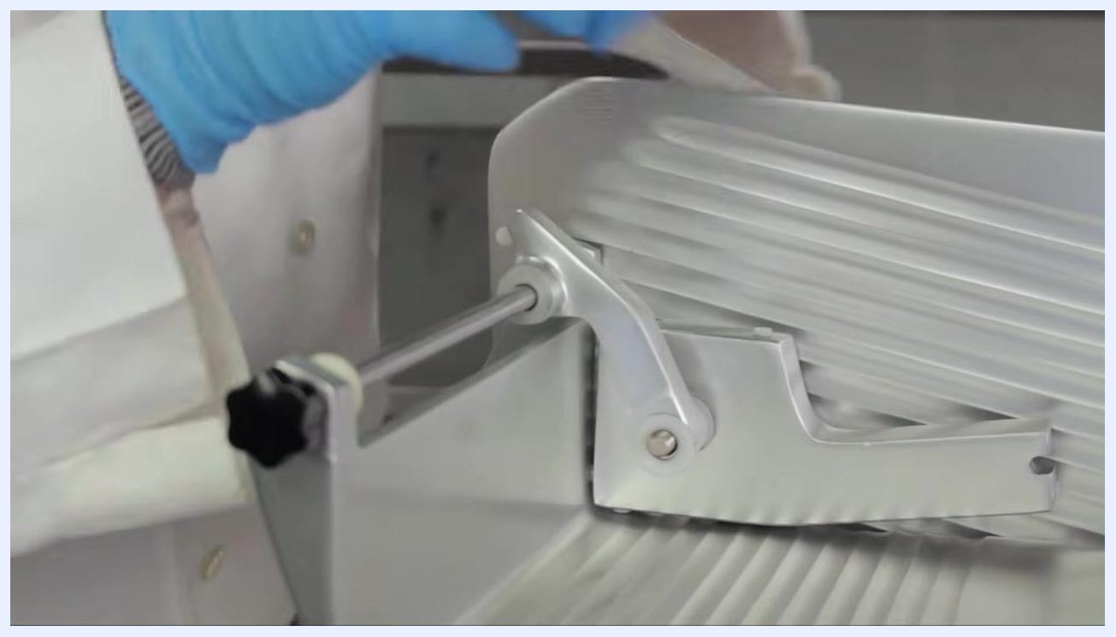
Operator reinstalling the adjustment spacer and rod, tightening the knob to secure the assembly inside the slicer carriage.

- Double-check that all knobs, washers, and rods are tightened, and confirm the grip mechanism moves smoothly and is correctly assembled.

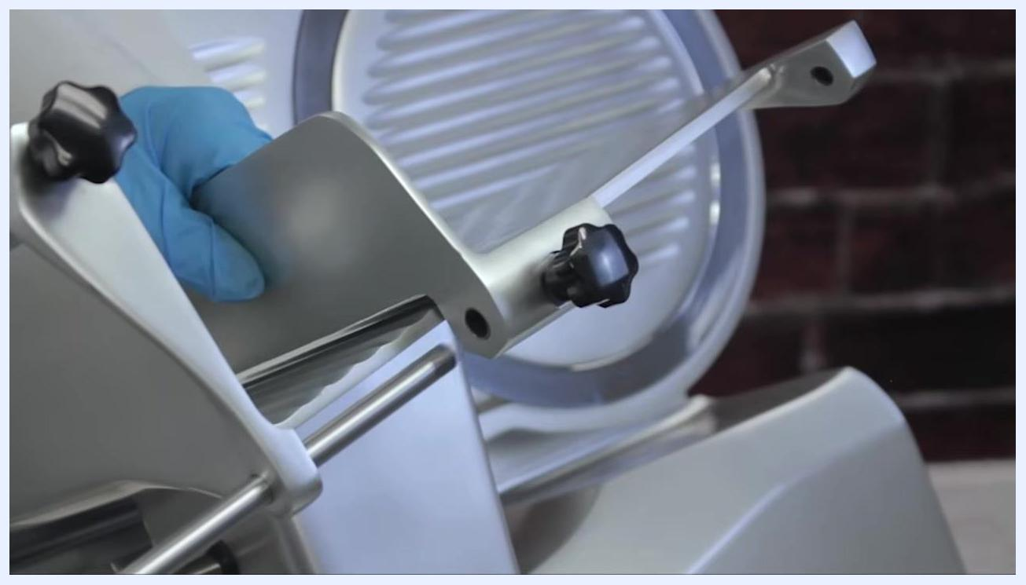
Operator holding the assembled grip mechanism, showing the adjustment knobs and rods securely in place on the slicer.

- Hold the slicer carriage firmly with both hands, use one hand to slide the adjustment spacer to its correct position, and with your other hand turn the adjustment knob clockwise to secure the spacer. Ensure the knob is tight enough to hold the spacer, but do not overtighten.

Operator holding the slicer carriage, sliding the adjustment spacer into position and tightening the knob to secure it.

Clean and reset the area beneath the slicer

- If your model has a non-removable carriage, carefully tilt the carriage back as instructed to access the area beneath the slicer. Always use caution when lifting heavier models to avoid injury.
- Use a clean, sanitized cloth to wipe down the stainless steel table surface beneath the slicer, ensuring all food debris and cleaning solution residues are removed.

Operator wiping the stainless steel table underneath the slicer, with red and green cleaning buckets visible nearby.

- On models equipped with a lift lever, locate the lever beneath the slicer, push it away from your body, and while holding the lever, gently lift the front of the slicer to raise it off the table. This allows for thorough cleaning and sanitizing underneath the machine.


Operator using the lift lever to raise the front of the slicer, as indicated by a large white arrow pointing upward; the slicer is tilted, exposing the area underneath for cleaning.

- After cleaning and sanitizing, carefully release the lift lever and gently lower the slicer back into its normal position, avoiding pinched fingers or damage to the equipment.

Inspection
- [ ] Carefully examine all cleaned surfaces, including the blade, body, and grooves, for any remaining food particles or residue.
- [ ] If any debris is found, repeat the cleaning process on those areas before proceeding.
- [ ] Ensure all cleaned parts and the slicer base are completely dry before proceeding to sanitizing and reassembly.
- [ ] Gather all cleaned and dried components in a sanitary area prior to reassembly.
- [ ] Verify that all fasteners and moving parts are correctly installed and tightened before operating the slicer.
- [ ] Confirm that the grip mechanism moves smoothly and is correctly assembled.
The source material does not describe a formal supervisor sign-off step; your facility should define who performs the final inspection and how a failed inspection is documented and escalated before the slicer returns to service.

Frequency
- [ ] Clean and sanitize the slicer at least once every four hours of use.
- [ ] Clean and sanitize the slicer at the end of each workday.
The source material does not specify weekly, monthly, or deep-clean intervals beyond this cadence; your facility should establish additional intervals as needed based on usage volume and local food-safety requirements.

Manufacturer support
For further assistance, contact Univex support:
- Phone: (800) 258-6358
- Email: sales@univexcorp.com
- Website: www.univexcorp.com


Univex logo displaying contact phone number (800) 258-6358, email sales@univexcorp.com, and website www.univexcorp.com on a blue background.
Always wear protective gloves when handling or cleaning the slicer, double-check all fasteners and moving parts for security before operating the slicer, and refer to the manufacturer's manual for model-specific instructions and safety guidelines.
Title screen showing "Slicer Cleaning" with images of three different slicer models on a blue background.

