SOP: Calibrating a Dial Probe Thermometer

Purpose
This standard operating procedure describes how to calibrate a dial probe thermometer using the ice water method. Proper calibration ensures the thermometer provides accurate temperature readings, which is essential for food safety and quality control in a commercial kitchen setting.

Scope
This procedure applies to any staff member responsible for verifying and adjusting the accuracy of dial probe thermometers before use in food handling, storage, or preparation activities.

Required Equipment
- Dial probe thermometer with protective sheath
- A glass or container
- Ice cubes
- Cold water

Procedure

Step 1: Prepare the ice water bath
Fill a glass with ice cubes. Pour cold water into the glass, allowing the water to fill the gaps between the ice cubes. Ensure the ice is not floating — the glass should be packed with ice with just enough water to fill the cracks.
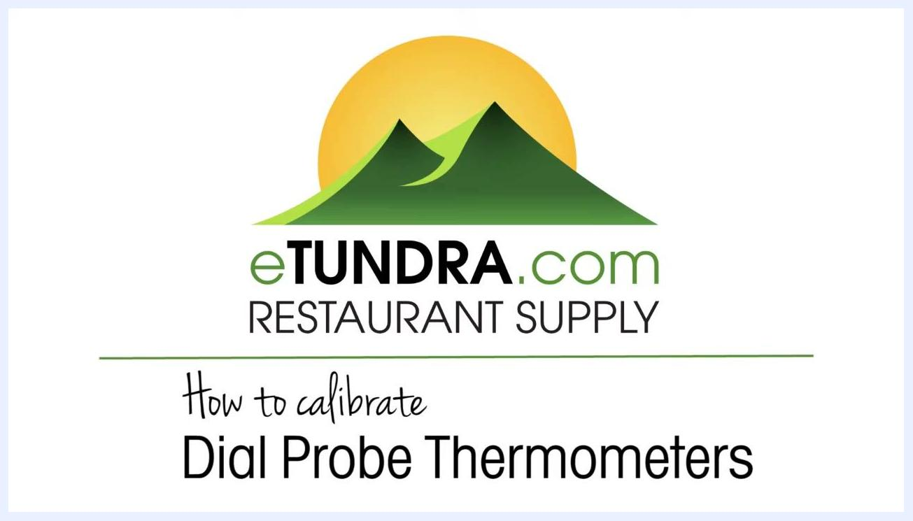
A chef in a white coat holding a dial probe thermometer and its black sheath, standing in a commercial kitchen

Step 2: Remove the thermometer from its sheath
Take the dial probe thermometer out of its protective sheath.
Note: The sheath may include a holding hole for convenience during later steps.

Step 3: Insert the thermometer into the ice water
Place the thermometer probe into the center of the glass, making sure it does not touch the sides or bottom of the container. Lower the probe near the bottom, then raise it slightly so it is suspended in the middle of the ice water. If available, use the sheath's holding hole to hang the thermometer on the rim of the glass.
Hands holding a dial probe thermometer and its sheath above a glass filled with ice water, preparing to insert the thermometer

Step 4: Read the initial temperature
Wait for the thermometer needle to stabilize, then observe the temperature reading. In the example shown, the thermometer reads 40°F.
Reference point: Properly prepared ice water should read 32°F.
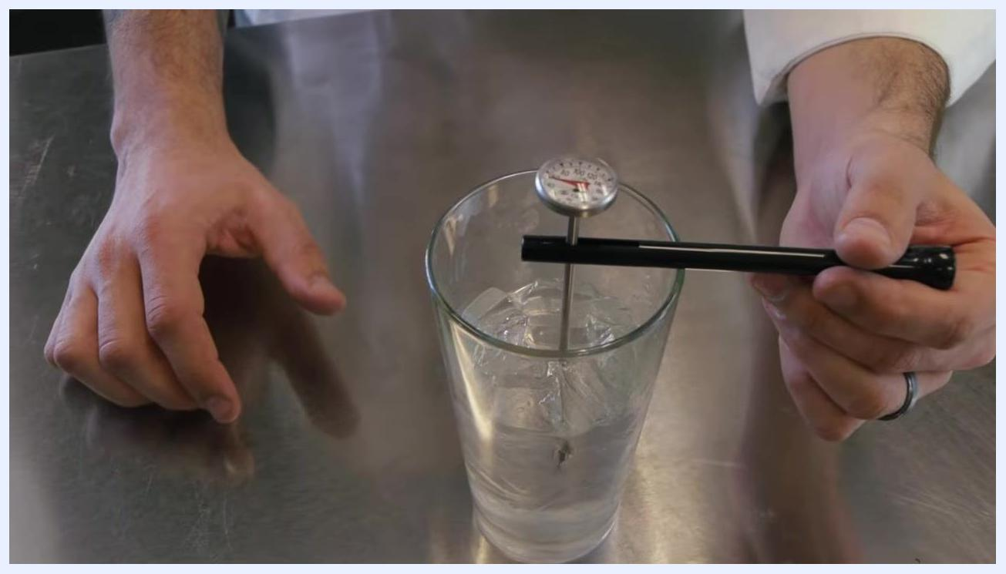
Dial probe thermometer suspended in a glass of ice water, needle visible, reading above 30°F

Step 5: Identify the calibration nut
Remove the thermometer from the ice water and locate the small hex nut at the bottom of the thermometer dial.
Note: The top of the thermometer sheath is designed to fit this nut and acts as a wrench for adjustment.
Close-up of a hand pointing to the calibration nut on the back of the thermometer dial, thermometer above a glass of ice water

Step 6: Adjust the thermometer
Insert the thermometer into the sheath so the sheath can be used as a wrench. Hold the thermometer securely and use the sheath to turn the calibration nut. Adjust the needle downward by approximately 8 degrees (for example, from 40°F to 32°F).
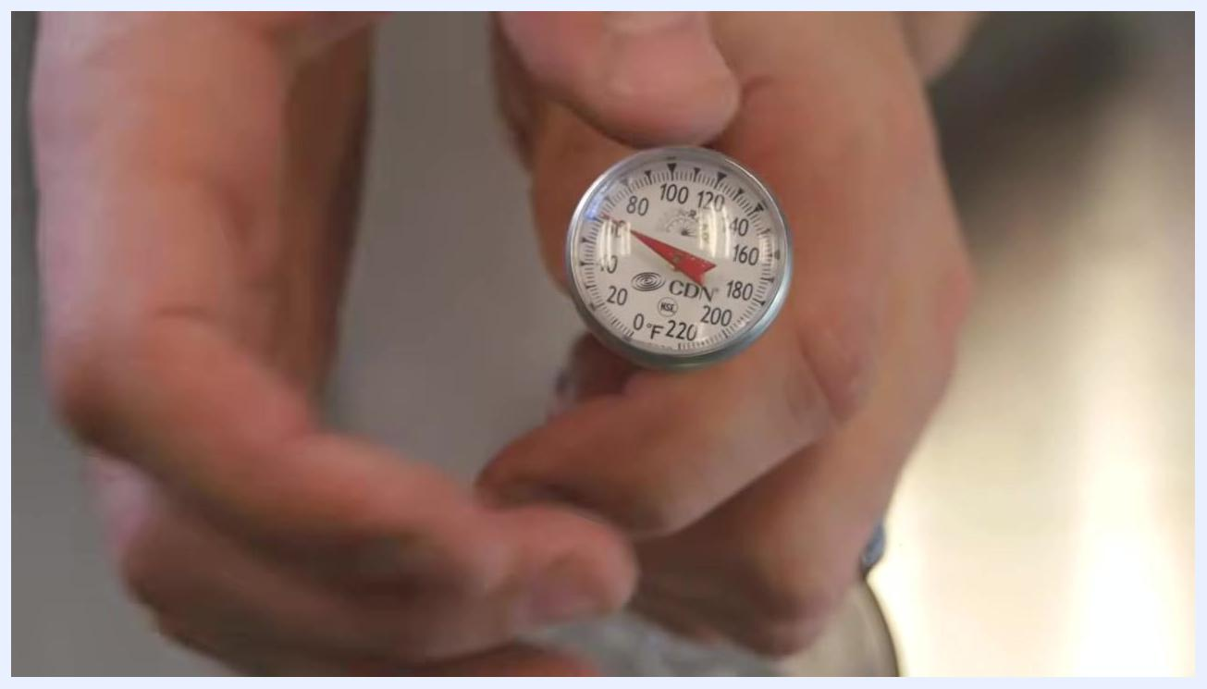
Hands using the sheath as a wrench to adjust the calibration nut on the thermometer, above a glass of ice water

Step 7: Check the calibration
Remove the thermometer from the sheath and reinsert it into the ice water. Wait for the needle to stabilize. The needle should now point to approximately 32°F (one tick above the 30°F mark).
Close-up of hands holding the dial probe thermometer, needle now closer to 32°F after adjustment

Step 8: Ensure the adjustment is secure
Confirm that the calibration nut is tight after adjustment. The thermometer should now be properly calibrated for accurate readings.
Hands holding the dial probe thermometer, showing the needle at the correct calibration point

Verification
Once the calibration nut is secure and the needle reads approximately 32°F in the ice water bath, the dial probe thermometer is properly calibrated and ready for accurate use in food safety and quality control tasks.

Additional Resources
For more information on the products shown in this procedure, visit www.etundra.com. This site provides further details, purchasing options, and support for restaurant supply products.
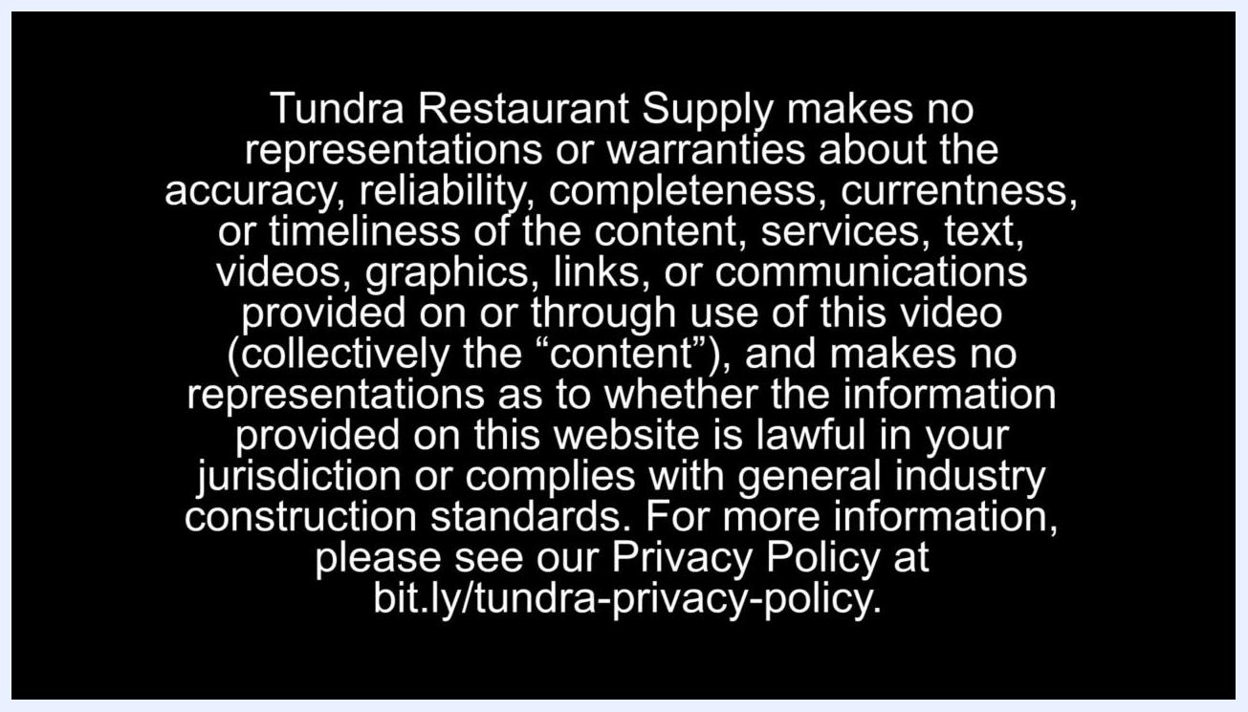
A chef in a white coat stands in a commercial kitchen. Overlaid text reads: "For all products shown in this video (and more) visit us at www.etundra.com." The eTundra.com Restaurant Supply logo is visible in the lower right corner.

Legal Notice
Tundra Restaurant Supply makes no representations or warranties about the accuracy, reliability, completeness, currentness, or timeliness of the content, services, text, videos, graphics, links, or communications provided in or through the use of this material. No representations are made as to whether the information is lawful in your jurisdiction or complies with general industry construction standards. For more information, review the privacy policy at bit.ly/tundra-privacy-policy.
White legal disclaimer text on a black background, stating that Tundra Restaurant Supply makes no representations or warranties about the content, with a link to their privacy policy at bit.ly/tundra-privacy-policy

