How to Install a Water Heater: A Step-by-Step Replacement Guide
This SOP walks you through how to install a water heater, covering the full replacement of an electric water heater from initial diagnosis through final startup. Follow each step in order, and always confirm your work against local building codes and the manufacturer's instructions before moving to the next stage.

Purpose
This procedure provides a repeatable, safe method for removing a failed or aging electric water heater and installing a new unit in its place, including pressure management, plumbing connections, electrical reconnection, and post-installation verification.

Scope
This procedure applies to standard residential electric water heater replacements. It covers diagnosis, safety preparation, removal of the old tank, installation of the new tank, and system startup checks. It does not cover gas water heaters or commercial installations.

Required equipment and materials
- Pressure gauge (for outdoor spigot and post-installation checks)
- Pressure-reducing valve (if house pressure exceeds 80 PSI)
- Thermal expansion tank and inline pressure gauge
- Push-fit fittings, or soldering supplies (soldering paste, solder, heat source) if sweating joints
- Hand air pump (for setting expansion tank pressure)
- Voltage detector
- Garden hose and buckets (or access to a floor drain)
- Hand truck (for safely moving the tank)
- Drain pan
- New T&P relief valve and discharge pipe
- Flexible hose kit (two flexible hoses, heat trap nipples, brass connectors, plumber's tape)
- Dielectric fittings (if required by local code)
- Compression nuts and pipe-cutting tools
- Seismic straps and wall-mounting hardware
- Wire connectors (wire nuts) and a screwdriver
- New electric water heater matching your current unit's specifications

Step 1: Diagnose the issue
Before you begin, confirm that a replacement is actually needed.
- If you are not getting hot water, check for a damaged heating element.
- If you see water pooling on the floor near the water heater, the tank itself has likely failed and needs replacement.
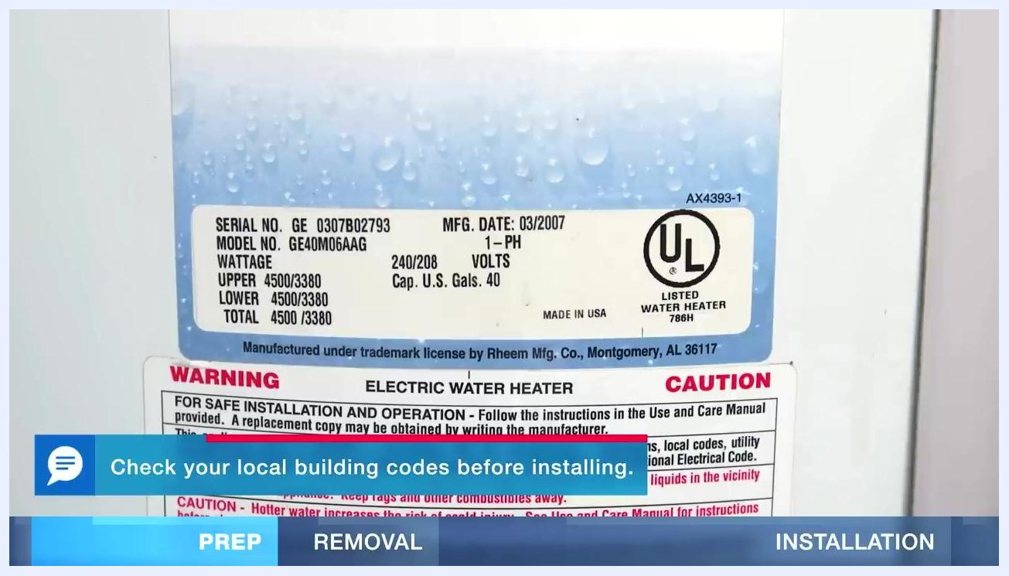
A water heater with a visible puddle of water on the floor, a warning label, and a tool bag nearby.

Step 2: Record your water heater's specifications
Locate the data label on your current unit and record the details you'll need to purchase a matching replacement.
- Model No., Serial No., and Manufacture Date
- Capacity (in U.S. gallons)
- Voltage and wattage ratings (upper element, lower element, and total)
Check your local building codes before installing a new water heater.
Close-up of a water heater data label showing model, serial number, wattage, voltage, and capacity, with warning and caution labels also visible.

Step 3: Check your home's water pressure
Attach a pressure gauge to an outdoor spigot to measure your home's water pressure. Ideal pressure is between 50 and 60 PSI. If the reading is higher than 80 PSI, you will need to install a pressure-reducing valve after the main water shut-off.
Close-up of a pressure gauge showing PSI readings, with the needle pointing above 80.

Step 4: Install an inline pressure gauge and thermal expansion tank (recommended)
An inline pressure gauge and thermal expansion tank help manage excess pressure in the system. Turn off the water supply before installing the pressure-reducing valve and expansion tank. The expansion tank should be installed on the cold supply line.
Diagram of a cold supply line with an inline pressure gauge and a blue thermal expansion tank, with an instructional note to turn off the water before installing the pressure-reducing valve and expansion tank.

Step 5: Select and prepare the expansion tank
Choose an expansion tank sized to match your system's requirements. Check the manufacturer's instructions for size recommendations before installing.
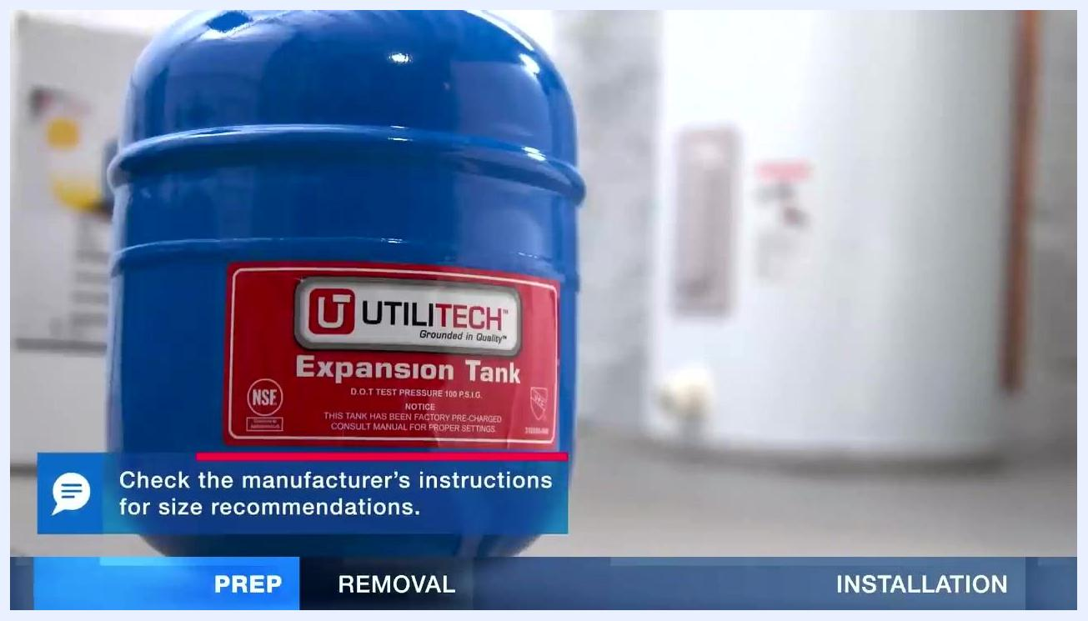
A blue expansion tank with a clear label, placed in a utility room, with a note to check the manufacturer's instructions for size recommendations.

Step 6: Install the expansion tank with push-fit fittings
Push-fit fittings allow you to connect the expansion tank to the pipe without soldering. Simply slide the fitting onto the pipe until it is fully seated.
A gloved hand installing a push-fit fitting onto a blue expansion tank.

Step 7: Solder the expansion tank fittings (optional alternative)
If you choose to solder instead of using push-fit fittings, deburr and clean the pipes and fittings first. Apply soldering paste and assemble the joint, then heat the fitting and apply solder to seal the connection.
A gloved hand holding a copper pipe with soldering paste applied, preparing for soldering.

Step 8: Set the expansion tank pressure
The expansion tank pressure must match your home's main water pressure. Use a hand air pump to increase the pressure, or depress the valve to lower it as needed.
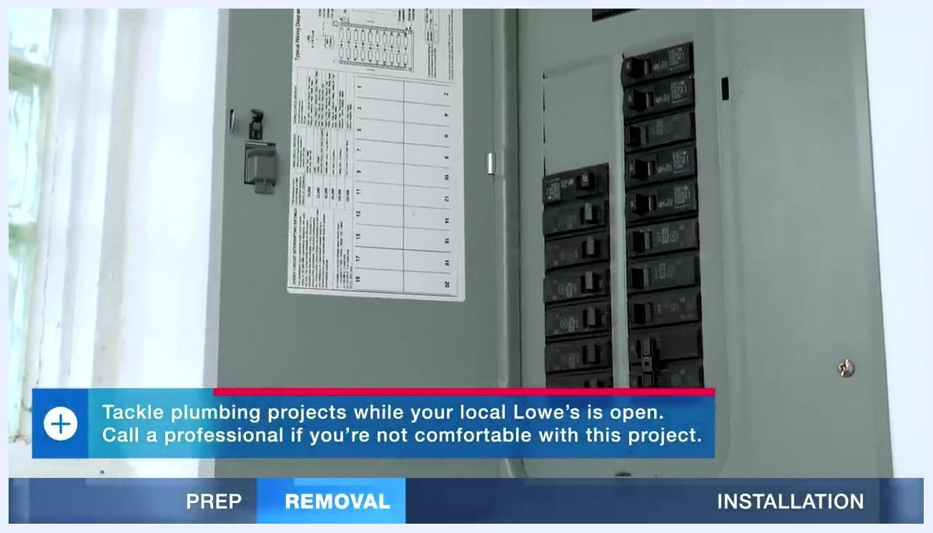
A person using a hand air pump to adjust the pressure of a blue expansion tank installed above.

Step 9: Turn off power to the water heater
Go to your electrical panel and turn off the circuit breaker for the water heater before doing any further work.
Safety note: If you are not comfortable working with electrical panels or plumbing, call a licensed professional.
An open electrical panel with circuit breakers and a label chart.

Step 10: Verify power is off
Use a voltage detector to confirm that power to the water heater is fully off before you touch any wiring.
A person using a voltage detector to check wires at the top of a water heater, with multiple wires and wire nuts visible.

Step 11: Shut off the cold water supply and drain the tank
Turn off the cold water supply to the water heater. Connect a garden hose to the drain valve at the bottom of the tank and route the other end into buckets or toward a floor drain. Open the drain valve and open a hot water faucet in your home to help the tank drain faster.
Note: Drain water may contain sediment from the tank.
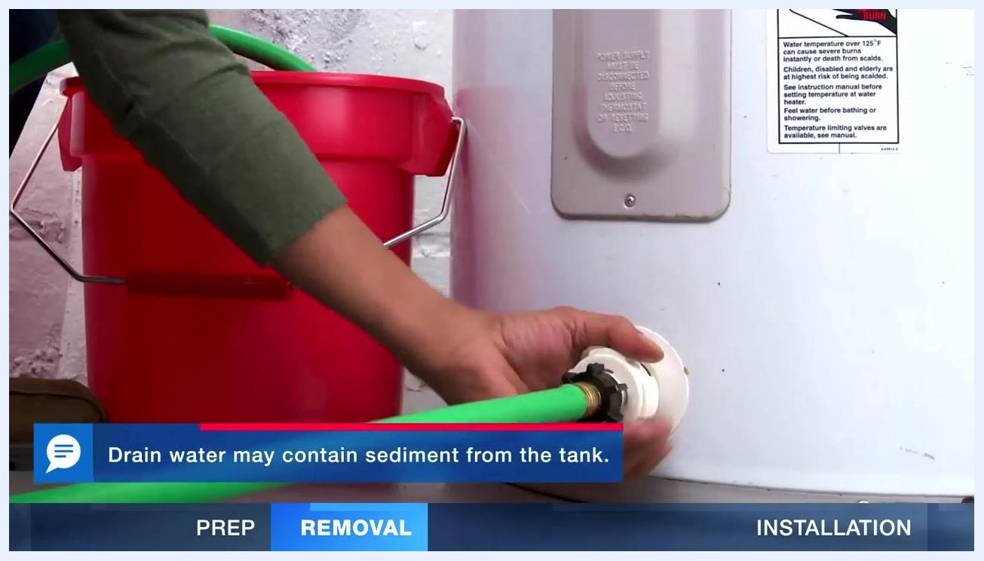
A person kneeling next to a water heater, attaching a green garden hose to the drain valve, with a red bucket nearby and a warning label visible on the heater.

Step 12: Remove the discharge pipe from the T&P relief valve
Once the tank is fully empty, remove the discharge pipe from the temperature and pressure (T&P) relief valve. You can reuse the discharge pipe, but do not reuse the old T&P relief valve.
A person unscrewing the discharge pipe from the T&P relief valve at the top of the water heater, with several flexible water supply lines visible.

Step 13: Disconnect the water supply pipes
Disconnect the water supply pipes from the old water heater. If you need to cut the pipes, leave them as long as possible to make reconnection easier later.

Step 14: Remove the old water heater tank
Carefully remove the old tank from its location. Water tanks can be heavy, so get help or use a hand truck for safe removal.
A water heater tank being moved with a red hand truck, tilted and being transported out of the utility area.

Step 15: Set the new tank in place
Place the new water heater in a drain pan to catch any leaks or drips. Route the drain pan to a floor drain if possible to avoid flooding.

Step 16: Install the T&P relief valve and discharge pipe
Install the new T&P relief valve on the water heater and attach the discharge pipe to direct water toward a drain. If no drain is available, place a bucket under the pipe and cut the pipe so it sits no more than six inches above the bucket.
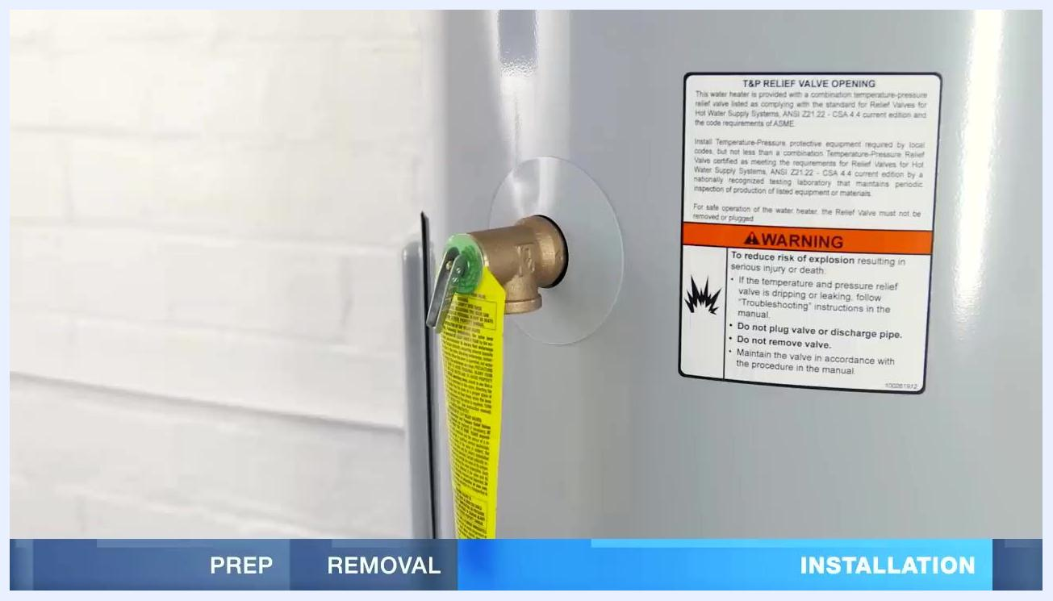
Close-up of a new water heater with a T&P relief valve installed and a warning label about explosion risk.
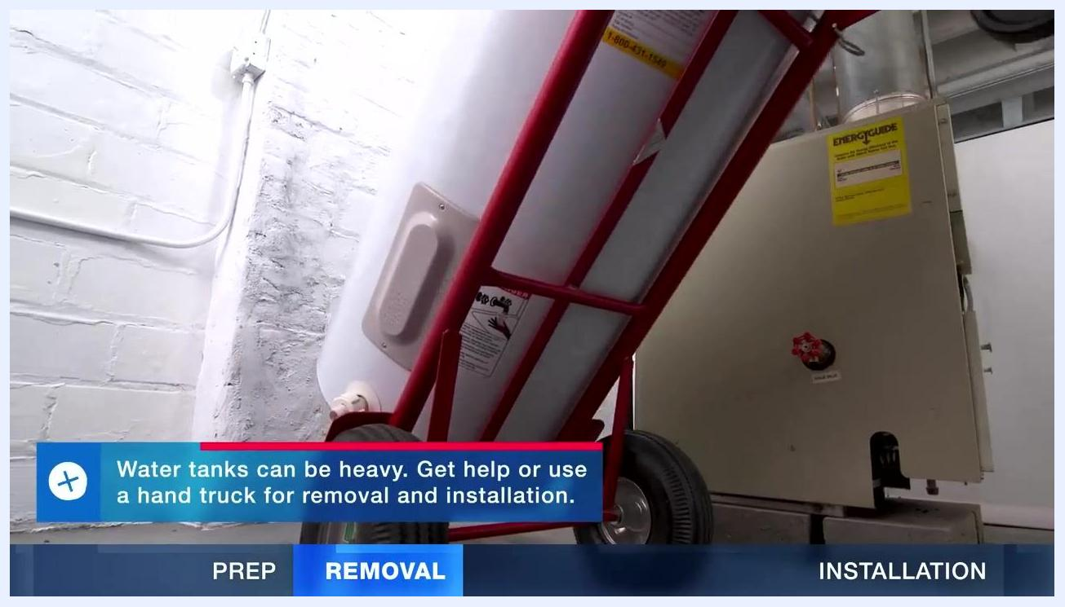
A person positioning a copper discharge pipe into a bucket under the T&P relief valve of a new water heater.

Step 17: Prepare the flexible hose kit for water connections
Use a flexible hose kit to connect the water supply lines; this is recommended for earthquake safety. A typical kit includes two flexible hoses, heat trap nipples, brass connectors, and plumber's tape.
A flexible hose kit for water heaters, including two corrugated hoses, two heat trap nipples, two brass connectors, and a roll of plumber's tape.

Step 18: Apply plumber's tape and attach hoses
Apply plumber's tape to the threads of the heat trap nipples, then attach the flexible hoses to the nipples on the water heater.
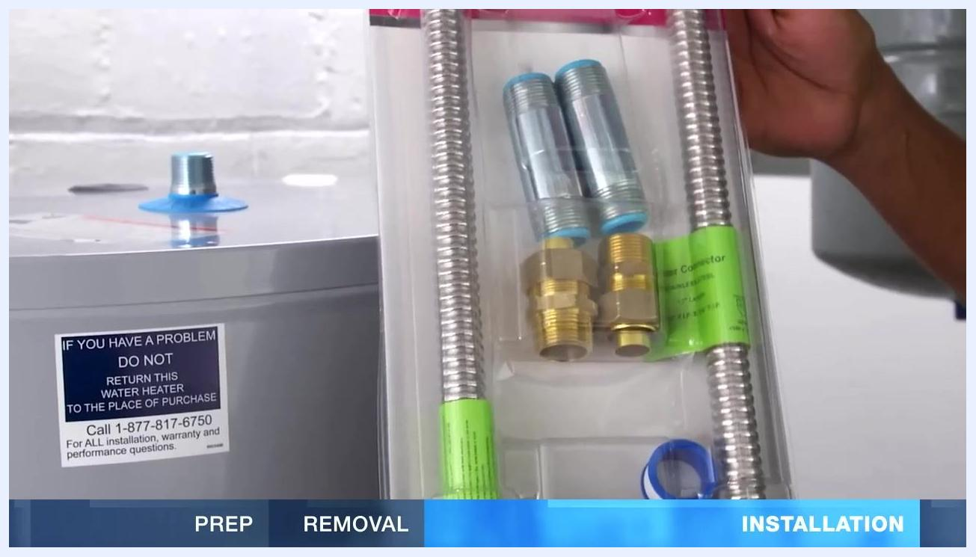
Close-up of the flexible hose kit showing the plumber's tape and connectors, with the top of the new water heater visible.

Step 19: Install dielectric fittings (if required)
In some areas, dielectric fittings are required to reduce corrosion between different metals. Add plumber's tape to the connector body threads and secure the dielectric fitting to the hose.

Step 20: Connect hoses to the water supply pipes
Hold the flexible hose up to the water supply pipe, leaving a little slack, and mark the pipe at the correct length.
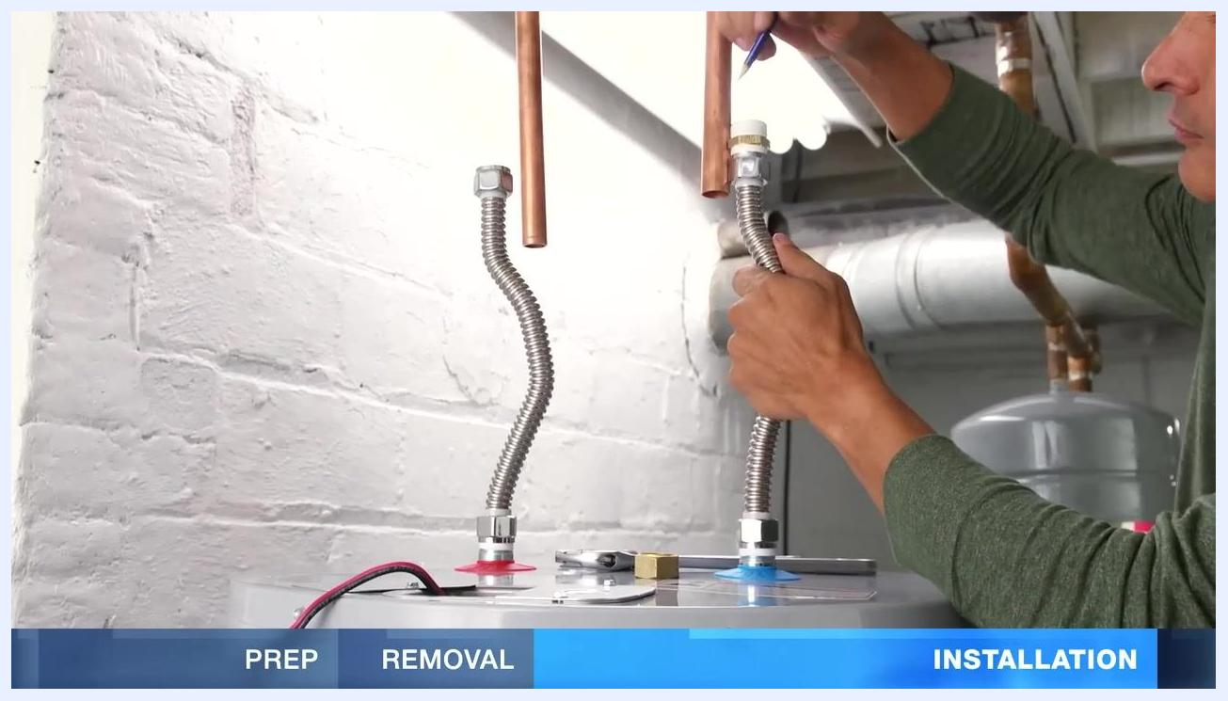
A person holding a flexible hose up to a copper water supply pipe above the new water heater, marking the pipe for cutting, with both hot and cold lines visible.
Cut the pipe at the mark, remove any burrs, and slide the compression nut onto the pipe.
A person marking a copper pipe above a new water heater in preparation for cutting, with flexible hoses already attached to the heater.

Step 21: Install seismic straps
Install seismic straps around the water heater to brace it securely against the wall. Position one strap in the upper third and one in the lower third of the tank, and attach the straps to wall studs or a solid backing to prevent the tank from toppling during an earthquake. Refer to local codes for specific installation requirements.
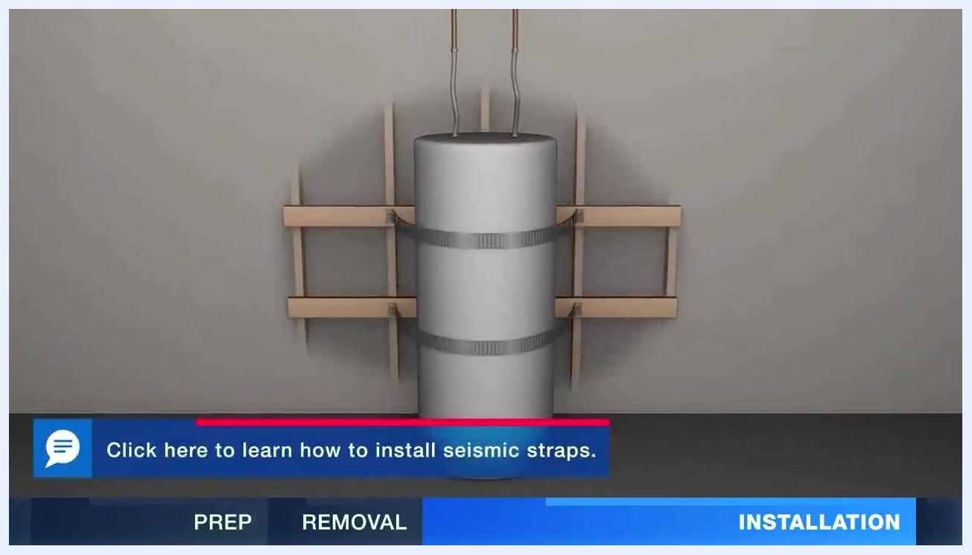
A water heater tank secured to a wall with two seismic straps and wooden backing for support.

Step 22: Remove the aerator from the nearest faucet
Go to the faucet closest to the water heater and unscrew the aerator from the faucet spout. This prevents debris from clogging the aerator during startup.

Step 23: Purge air and fill the tank
Open the hot side of the nearest faucet, then turn on the cold water supply to the water heater. Check all water connections for leaks as the tank fills; if none are found, allow the tank to continue filling. When water flows steadily from the open faucet, the tank is full. Let the water run for about three minutes to purge air and flush out any debris.
Safety note: The heating element can be damaged if the tank is not completely full.
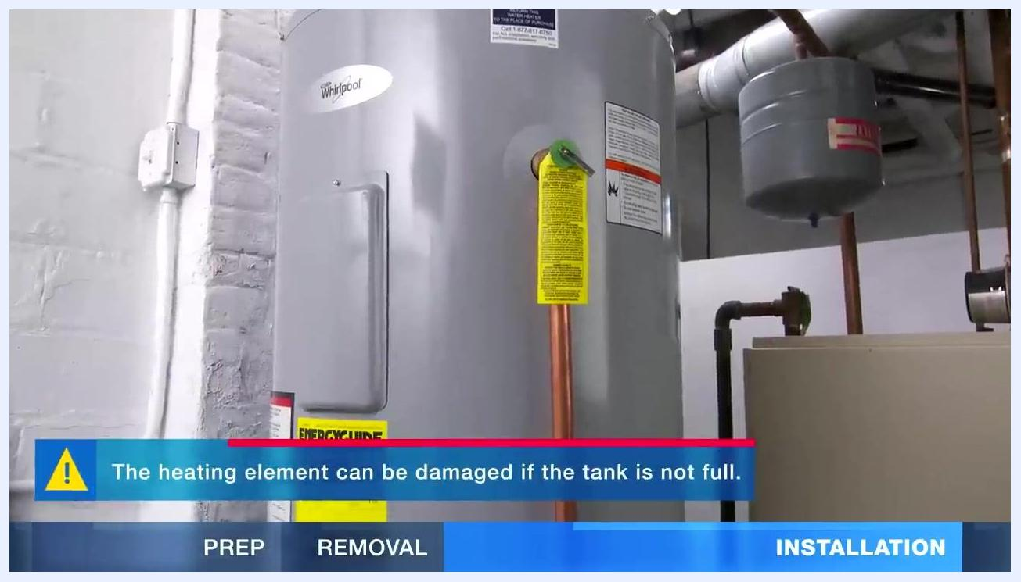
A water heater installed in a utility room with copper pipes connected, a yellow warning tag, and an EnergyGuide label visible.
Warning message about heating element damage if the tank is not full, shown next to the installed water heater with copper piping and EnergyGuide label.

Step 24: Connect the electrical wiring
Ensure the tank is completely full before proceeding. Remove the junction box cover on the water heater and attach the ground wire to the green ground screw inside the box. Using the previous wiring connections as a guide, twist the corresponding wires together using wire connectors, then replace the junction box cover securely.
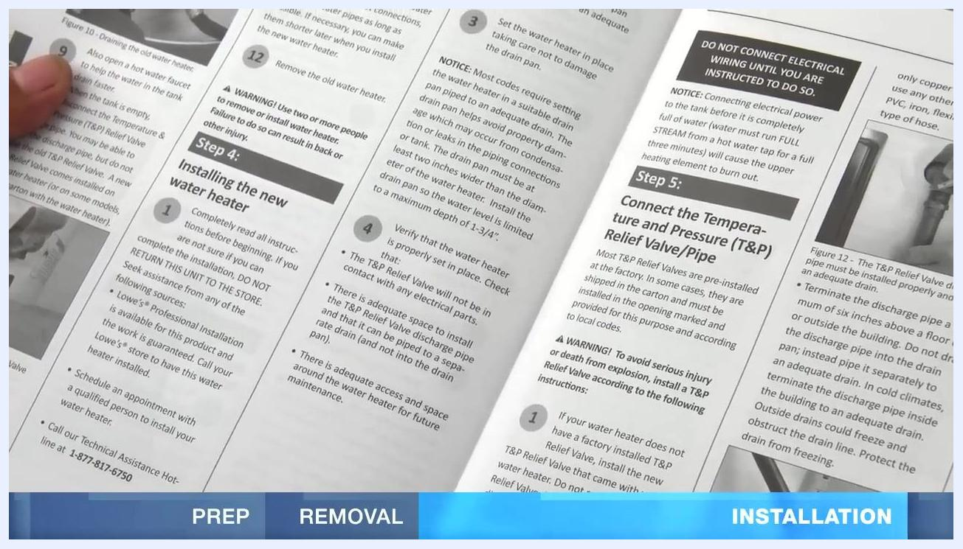
A person connecting electrical wires at the top of a water heater using wire connectors, with the junction box cover open and a screwdriver nearby.

Step 25: Restore power and test operation
Turn on the circuit breaker to restore power to the water heater. If the unit does not power on, turn off the breaker and double-check all wiring connections. Follow the manufacturer's operation instructions for initial startup and settings.
Close-up of a water heater installation manual, open to the steps for installing the new water heater and connecting the T&P relief valve and discharge pipe.

Step 26: Wait for the water to heat
Allow several hours for the water heater to reach the desired temperature. Set the thermostat to 120°F (49°C) for optimal safety and efficiency.

Step 27: Check the discharge pipe and water pressure
After a few hours, inspect the discharge pipe from the T&P relief valve. If the pipe is dripping, water pressure may be too high. Use a pressure gauge to check the system pressure and adjust the pressure regulator to keep it below 80 PSI.
Close-up of a pressure gauge attached to plumbing, reading just below 80 PSI.

Step 28: Clean faucet aerators if needed
If any faucet stops working after installation, remove the aerator and clean out any debris or sediment. Reinstall the aerator and run hot water to flush out any remaining loose sediment.
A chrome bathroom faucet on a granite countertop, with a flower vase and candle nearby.

Verification and summary
Once installation is complete, confirm the following before considering the job finished:
- The tank was completely full before power was restored, protecting the heating elements from damage.
- All water connections show no signs of leaking.
- The discharge pipe from the T&P relief valve is dry, and system pressure reads below 80 PSI.
- The thermostat is set to 120°F (49°C).
- All faucets run smoothly with no clogged aerators.
Important reminders:
- Always follow local codes and manufacturer instructions for installation and operation.
- Never power on the water heater before the tank is completely full, to avoid damaging the heating elements.
- Regularly check for leaks and proper operation after installation.
- This procedure is intended as a general guideline. Always check and comply with local building codes and regulations, and consult a licensed professional if you have any doubts about your project.

What's next
With your new water heater installed and verified, monitor its performance over the following days for any delayed leaks or pressure issues. Keep your recorded model and serial number information on file for future maintenance or warranty needs.

A blue screen with a "SUBSCRIBE NOW" button, a preview image of a person installing a pedestal sink, and the text "NEXT: HOW TO INSTALL A PEDESTAL SINK." Informational disclaimer and copyright notice at the bottom.

A blue screen with a "SUBSCRIBE NOW" button, a preview image of a completed pedestal sink in a bathroom, and the text "NEXT: HOW TO INSTALL A PEDESTAL SINK." Informational disclaimer and copyright notice at the bottom.

