How to Test a Capacitor With a Multimeter
This procedure explains how to test a capacitor with a multimeter (or a dedicated capacitor tester) to determine whether it is functioning correctly. A capacitor is a component that stores an electrical charge and then releases it, and it is commonly used to help start and run motors and compressors. Following these steps allows you to identify a defective capacitor, safely discharge it, and verify both its resistance behavior and its capacitance rating before deciding whether it needs to be replaced.
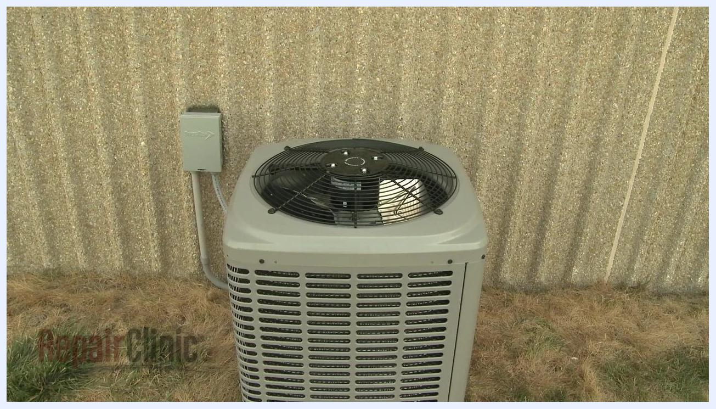
Outdoor central air conditioning unit next to a wall, a typical location for a capacitor

Purpose
The purpose of this procedure is to guide you through inspecting, discharging, and electrically testing a capacitor so you can determine whether it is operating within its specified range or needs to be replaced.

Scope
This procedure applies to capacitors found in common household and HVAC equipment, including:

RepairClinic logo and slogan "We make fixing things easy"
- Central air conditioners
- Furnaces
- Other heating and cooling equipment
- Appliances such as refrigerators and washing machines
Outdoor air conditioner and indoor furnace, both common examples of equipment that use capacitors
It covers both single capacitors and dual (run) capacitors.

Required equipment
- Analog-style ohm meter or a dedicated capacitor tester
- Multimeter with a capacitance testing function (or a standalone capacitance tester)
- Insulated-handle screwdriver (for safely discharging the capacitor)
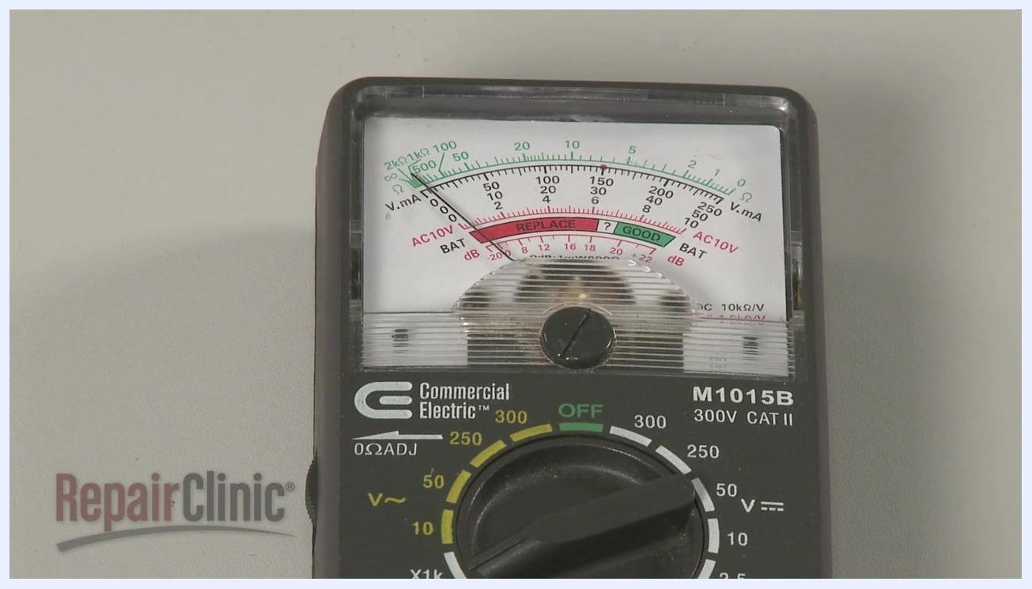
Analog ohm meter showing needle movement during a dual capacitor test

Procedure

1. Recognize typical capacitor applications
Capacitors are commonly used to help start and run motors and compressors in equipment such as central air conditioners and furnaces.

Title screen with "RepairClinic", slogan "We make fixing things easy", and "Capacitor Testing"

2. Identify signs of capacitor failure
If a motor or compressor does not start or starts slowly, suspect a defective capacitor.
Top view of an outdoor air conditioning unit, showing where the capacitor is located
Hand holding a visibly bulging and damaged capacitor, with label and terminals visible
Inspect the capacitor body for bulging or leaking. If either sign is present, replace the capacitor immediately without testing it further.

3. Prepare to test the capacitor
If there are no visible signs of damage, proceed to test the capacitor to confirm whether it is functioning properly. The first test checks whether the capacitor can store and release an electrical charge, and it can be performed using an analog-style ohm meter or a dedicated capacitor tester.
Split image: an analog ohm meter connected to a capacitor on top, and a digital capacitor tester displaying "0046" on the bottom
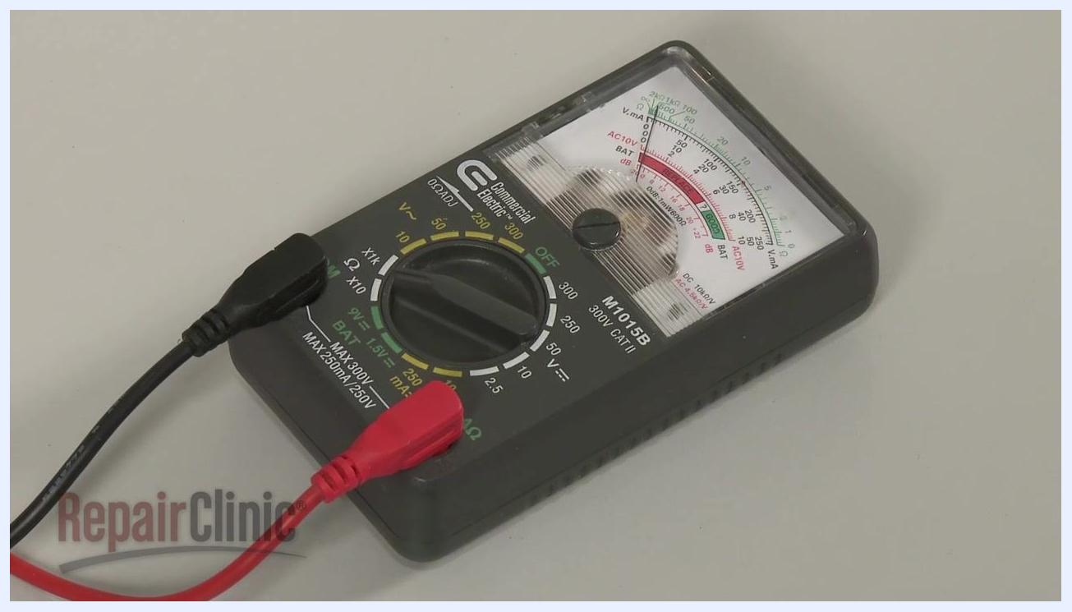
Analog ohm meter with dial set, red and black probes attached

4. Discharge the capacitor safely
Before handling or testing the capacitor, release any stored electrical charge to avoid injury. Use a screwdriver with an insulated handle, and place it across each set of terminals on the capacitor.
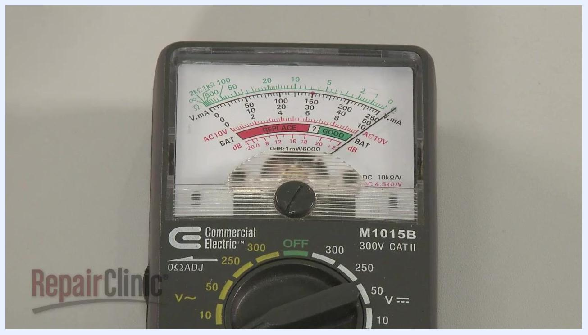
Hand using an insulated screwdriver to discharge a capacitor, with a "SHOCK" warning icon visible
Warning: Do not touch the metal blade of the screwdriver while discharging the capacitor. Doing so can cause electric shock.

5. Set the range on the ohm meter
Rotate the range selection dial on the analog ohm meter to a setting of 1000 ohms or higher.
Close-up of an analog ohm meter, showing the needle and adjustment dial

6. Calibrate the ohm meter
If necessary, pinch the probes together and adjust the needle to read zero on the scale before testing.

7. Test a single capacitor for resistance behavior
Touch one probe to one terminal of the capacitor and the second probe to the other terminal. Watch the meter needle: it should deflect toward zero ohms and then return toward infinite resistance.
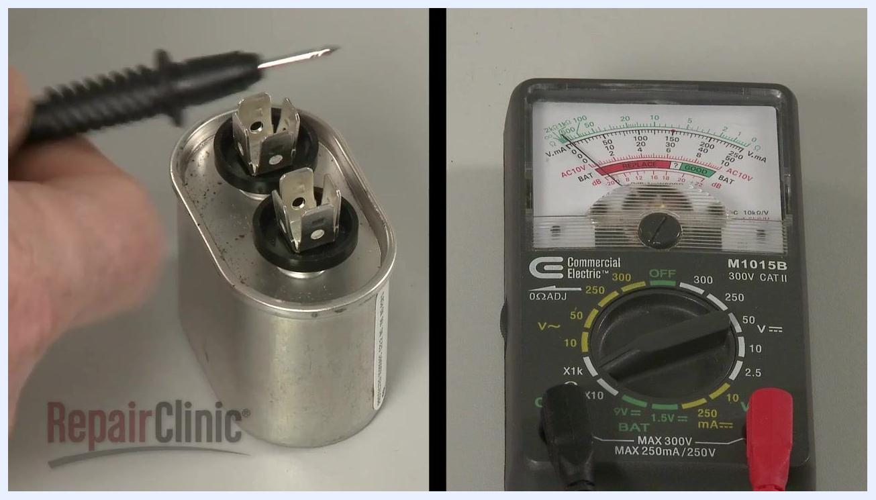
Split image: a hand holding a probe near the capacitor terminals on the left, and the ohm meter showing needle deflection on the right
Reverse the probes and repeat the test. The needle should behave the same way in both directions.
Result interpretation: If the needle does not move, or stays near zero ohms, the capacitor has failed and must be replaced.
Analog ohm meter with the needle at zero, indicating a failed capacitor

8. Test a dual (run) capacitor for resistance behavior
Identify the terminals on the dual capacitor. The common terminal is often marked "C", with the other terminals labeled "FAN" and "HERM" (or "COMP").
Close-up of dual capacitor terminals, clearly labeled "C" and "FAN"
To test the fan circuit, touch one probe to the common terminal ("C") and the second probe to the fan terminal ("FAN"). The needle should deflect toward zero ohms and return to infinite resistance.
Dual capacitor with visible terminal labels and manufacturer sticker, ready for probe placement
Repeat the same process for the HERM or COMP circuit by touching one probe to the common terminal ("C") and the second probe to the HERM or COMP terminal. The needle should again deflect toward zero ohms and return to infinite resistance.

9. Check the capacitor for a short to ground
Using a standard ohm meter, place one probe on each terminal, one at a time, while touching the second probe to the metal casing of the capacitor. No terminal should show continuity.
Dual capacitor connected to an ohm meter with test leads, hand holding a probe near the terminals, ready to check for a short to ground
If the meter shows continuity (the needle moves), the capacitor is shorted to ground and must be replaced.

Close-up of an analog ohm meter, needle at zero indicating continuity and a short to ground

10. Prepare to test the capacitance rating
Obtain a capacitor tester or a multimeter with a capacitance testing function. The capacitance rating is measured in microfarads (µF).
Illustration labeled "Capacitance Rating Microfarads" with a capacitor graphic, blue fill indicating stored charge
Important: Confirm that the capacitor is fully discharged before performing this test.

11. Measure the microfarad rating of a single capacitor
Locate the microfarad (MFD) rating printed on the capacitor. For example, the capacitor shown is labeled "7.5 MFD 370 VAC".
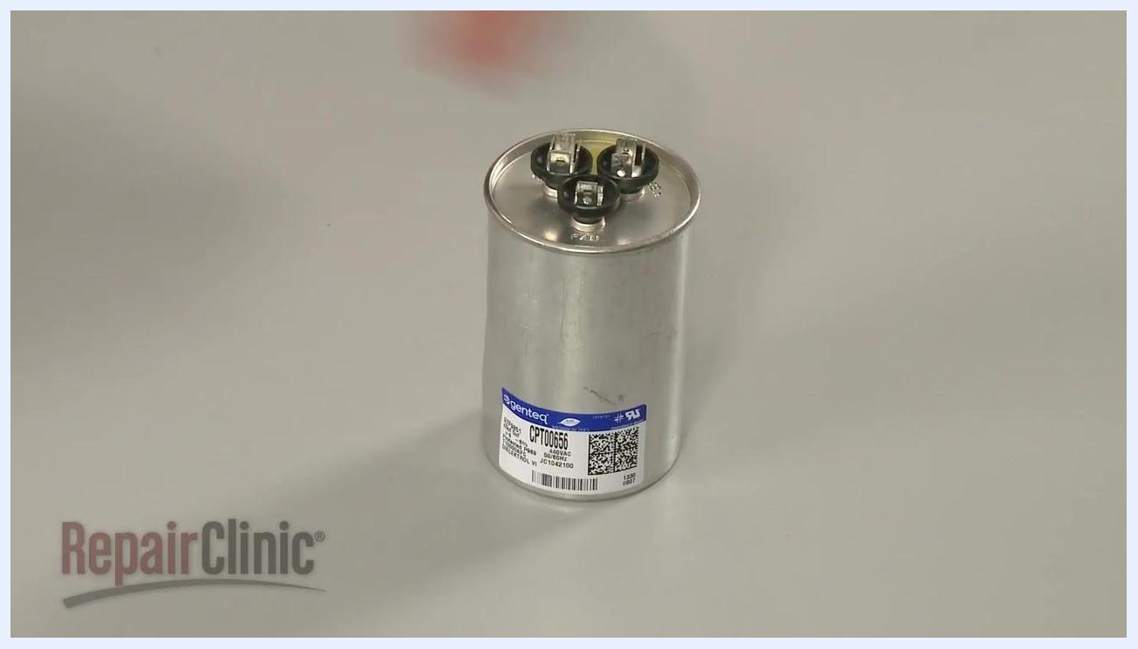
Hand holding a single capacitor labeled "7.5 MFD 370 VAC", showing the microfarad rating clearly
Set your capacitance tester or multimeter to the appropriate microfarad range that matches the capacitor's rating, connect the tester probes to the capacitor terminals, and press the button on the tester to display the reading.
Illustration labeled "Capacitance Rating Microfarads" with a capacitor graphic, emphasizing the unit of measurement
Compare the reading to the rating printed on the capacitor. The measured value should be close to the specified rating. If the reading is significantly lower than the rated value, replace the capacitor.

12. Measure the microfarad rating of a dual (run) capacitor
Identify the two microfarad ratings printed on the capacitor label. For example, "45uf 5uf" indicates 45 microfarads and 5 microfarads. The higher rating is typically for the HERM or COMP (compressor) circuit, and the lower rating is for the FAN circuit.
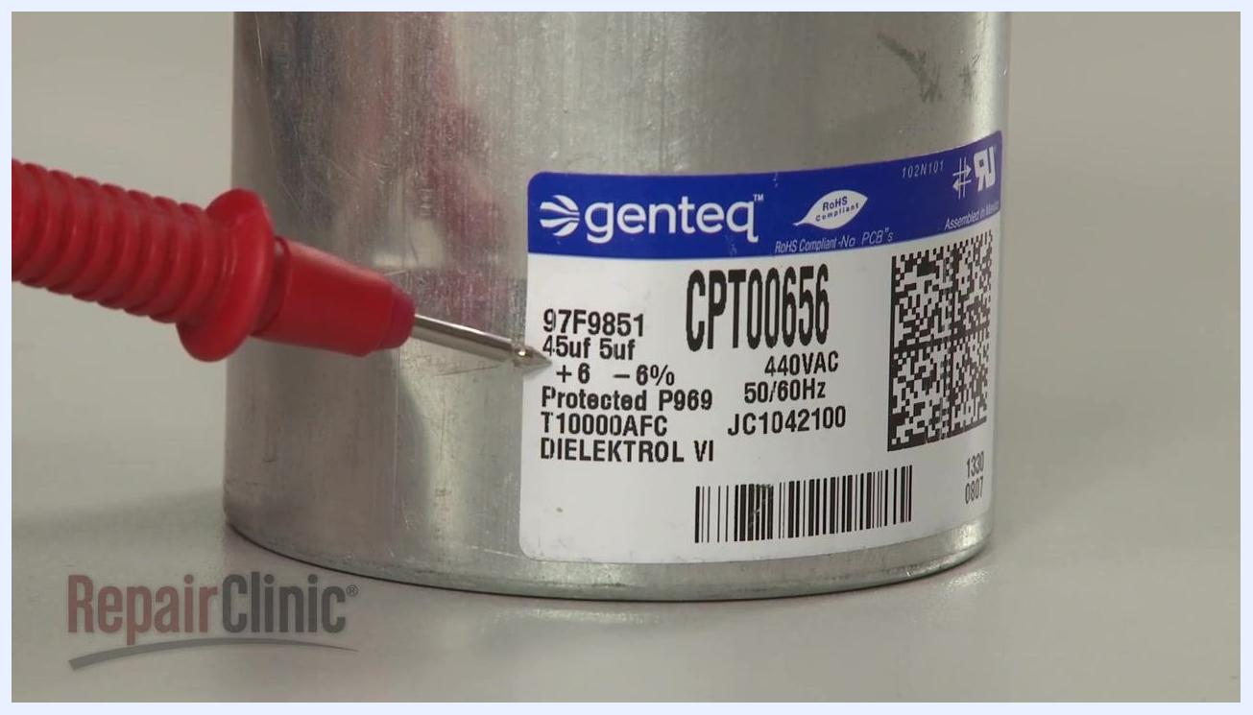
Close-up of a dual capacitor label showing "45uf 5uf" ratings, with a probe pointing at the values
Test each circuit separately: connect the tester probes to the "C" (common) and "HERM" or "COMP" terminals to measure the higher rating, then connect the probes to the "C" (common) and "FAN" terminals to measure the lower rating. Press the button on the tester to display each reading and compare it to the corresponding rating on the label.
Capacitor connected to a Supco MFD10 capacitor tester, probes attached to terminals, ready to measure capacitance

13. Interpret the capacitance test results
If the measured microfarad value for any section is significantly lower than the rating printed on the component, the capacitor is faulty and must be replaced.

Verification
A capacitor is functioning correctly when:
- The ohm meter needle deflects toward zero ohms and returns to infinite resistance during resistance testing (in both probe directions, and for each circuit on a dual capacitor).
- No terminal shows continuity when checked against the metal casing for a short to ground.
- The measured microfarad reading is close to the rating printed on the capacitor for each circuit tested.
Analog ohm meter (Commercial Electric M1015B) showing needle movement during a capacitor test, with "GOOD" and "REPLACE" zones marked on the scale
If any of these checks fail—no needle movement, continuity to ground, or a significantly low microfarad reading—the capacitor should be replaced.

What's next
After confirming that a capacitor has failed any of these tests (visible bulging or leaking, no resistance deflection, continuity to ground, or a low microfarad reading), replace the capacitor with one matching the correct rating before returning the equipment to service.
Dual capacitor connected to a Supco MFD10 tester, display showing "0046" (46 microfarads), hand pressing the test button
Close-up of a Supco MFD10 tester display showing a low reading of "0.753", indicating a failed capacitor section

