HVAC Preventive Maintenance Checklist: Complete Rooftop Unit Procedure
This HVAC preventive maintenance checklist walks you through a full inspection and service routine for a rooftop HVAC unit, from initial power verification through final performance testing. Following this checklist ensures the unit is safely de-energized, thoroughly cleaned, electrically sound, and restored to service with verified operating parameters. Use it as a standard reference each time you perform scheduled maintenance on a rooftop unit.
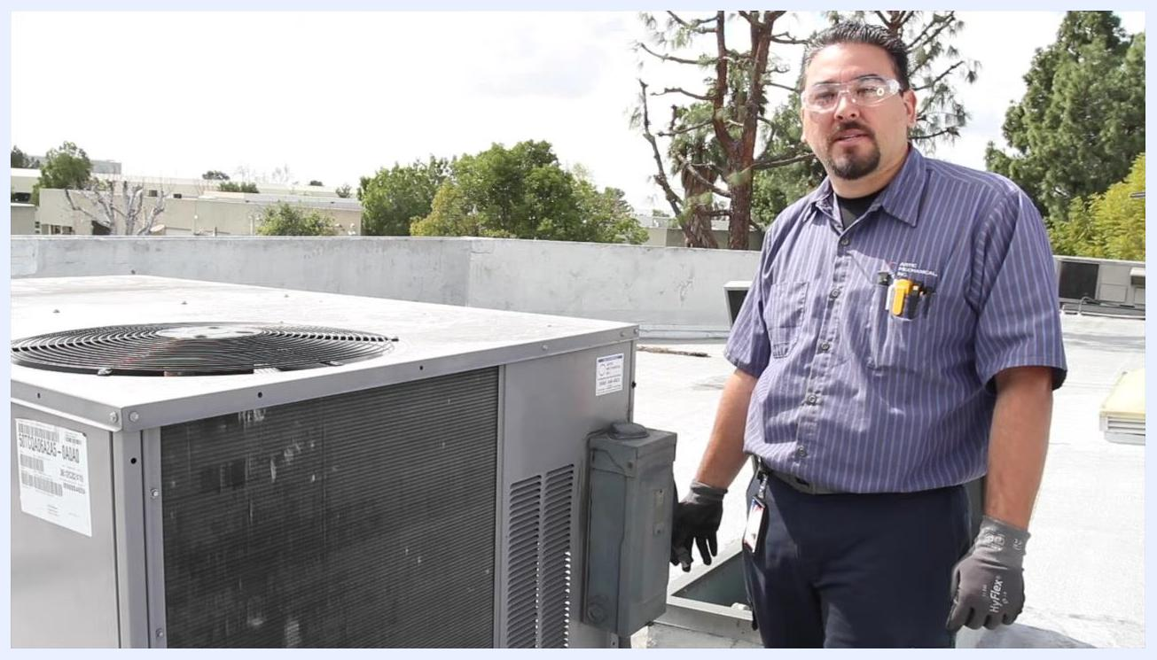
Technician standing beside the HVAC unit, addressing the camera, wearing safety glasses and gloves, with company branding visible on the shirt.

Purpose
This procedure standardizes the steps required to inspect, clean, test, and service a rooftop HVAC unit. It covers electrical safety checks, coil cleaning, component inspection, filter and drain servicing, refrigerant system checks, and performance verification.
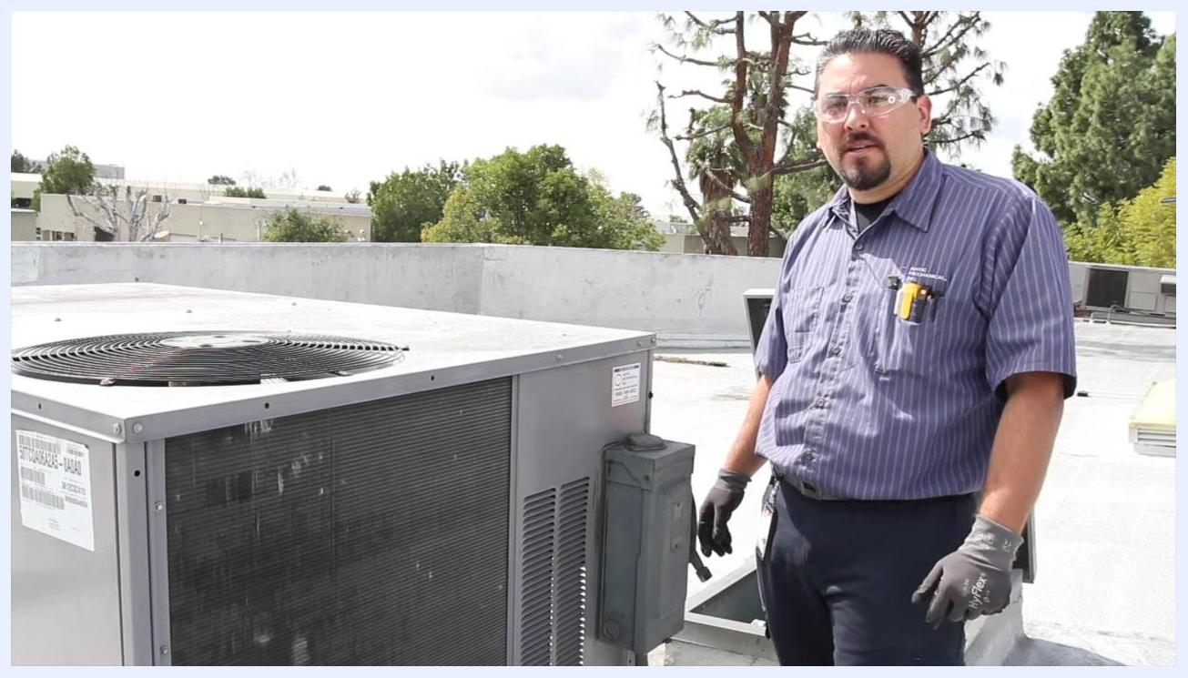
Black screen with white text reading "THE END".

Scope
This checklist applies to technicians performing routine preventive maintenance on rooftop HVAC units, including units with condenser fan motors, blower assemblies, capacitors, contactors, and optional economizers.

Required equipment and PPE
- Safety glasses
- Gloves
- Multimeter (capable of voltage and microfarad readings)
- Insulated screwdriver
- Water hose or coil cleaning tool
- Clamp meter
- Digital thermometer or temperature probe
- Replacement air filters
- Panel drain pan tablets (pan taps)
- CO2 or compressed air source
- Pressure gauges
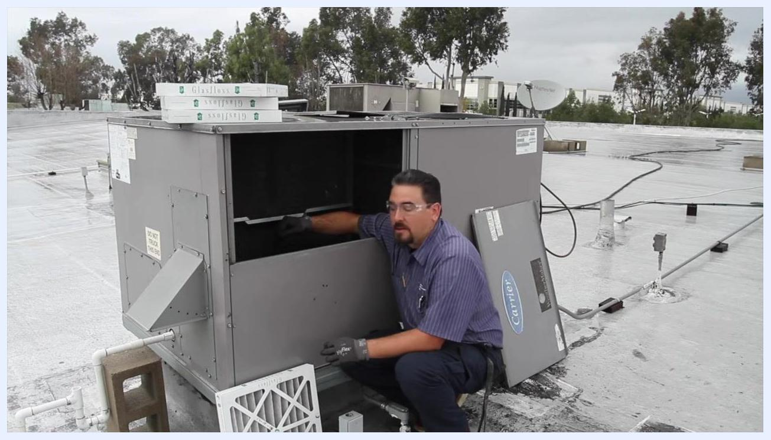
Technician removing an old air filter from the HVAC unit, with new filters ready for installation.

Step 1: Prepare for maintenance
Before approaching the unit, put on appropriate personal protective equipment, including safety glasses and gloves.

Step 2: Verify power to the unit
Check the voltage at the HVAC unit using a multimeter and confirm the unit is receiving the correct voltage. Inspect the fuses to ensure they are intact and functioning, and verify that power is present before proceeding.
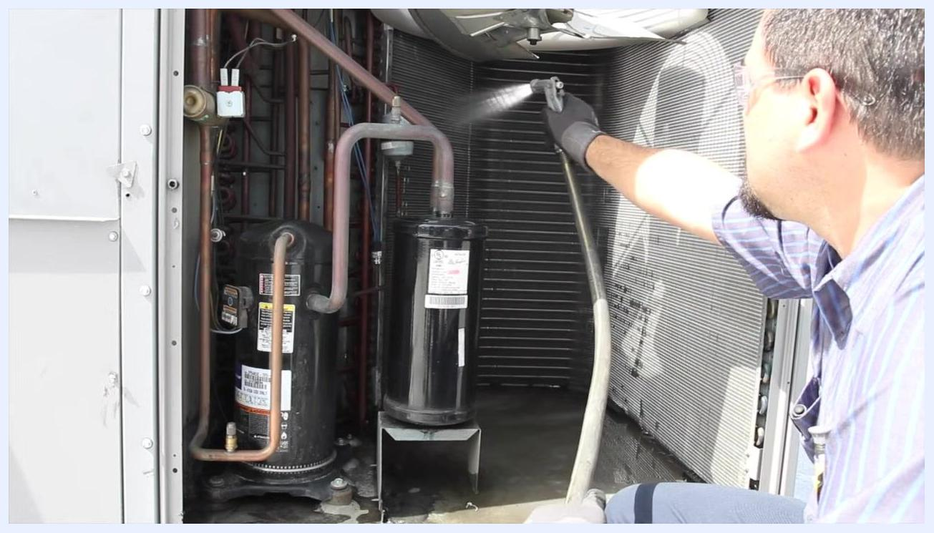
Technician spraying water directly onto the coil inside the HVAC unit, with internal copper piping and the compressor visible.

Step 3: De-energize the unit for safety
Turn off the power supply to the HVAC unit to de-energize it. Use a multimeter to confirm there is no voltage present before starting any work.

Step 4: Wash out the coil
Open the access panel to the coil compartment. Inspect the floor of the unit for rust or corrosion to prevent water from penetrating into the building during cleaning. Use a water hose or coil cleaning tool to wash out the coil thoroughly, starting from one side and working around to ensure complete coverage.
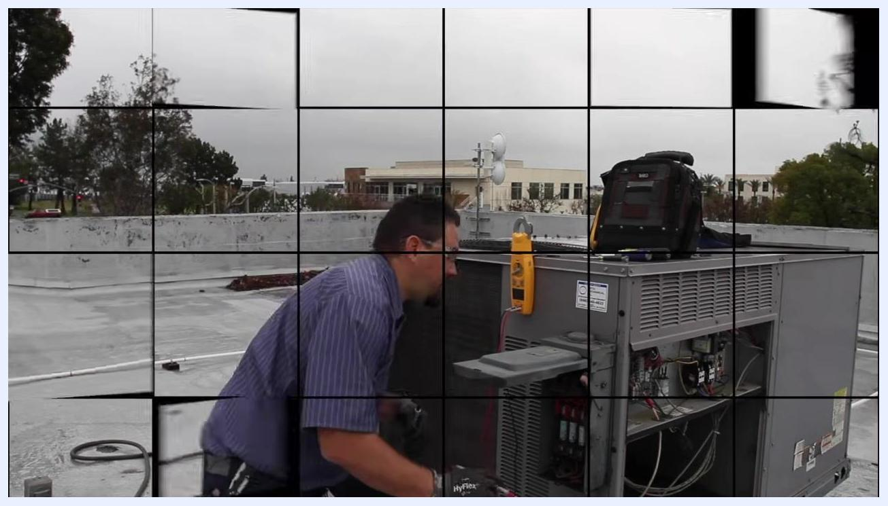
Technician standing next to an HVAC unit on a rooftop with a multimeter and tool bag on the unit; the access panel is open, exposing internal components.

Step 5: Check for water intrusion risks
Ensure there are no standing roof tiles or debris that could allow water to enter the building or damage products inside. Confirm the area around the unit is clear before and after washing.
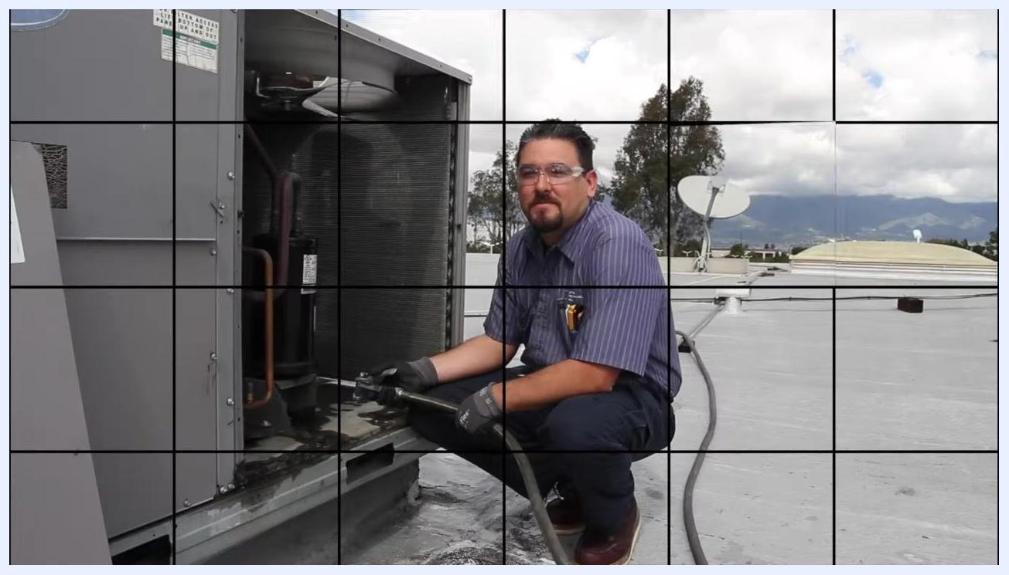
Technician kneeling by the open coil compartment, holding a water hose and preparing to clean the coil.

Step 6: Clean the coil methodically
Begin at one side of the coil and systematically move around the unit, spraying water to remove dirt and debris until the entire coil is clean.
Following these steps ensures the HVAC unit is safely powered down, inspected, and cleaned, providing accurate pressure readings and preventing water damage during maintenance.
Technician kneeling by the open HVAC unit, pointing to the fuse compartment with the multimeter hanging nearby.

Step 7: Inspect all electrical wiring
Open the electrical compartment of the HVAC unit. Visually inspect all wires to ensure they are properly routed and not at risk of being pulled out, and confirm that all wire connections are secure with no loose or exposed wires.
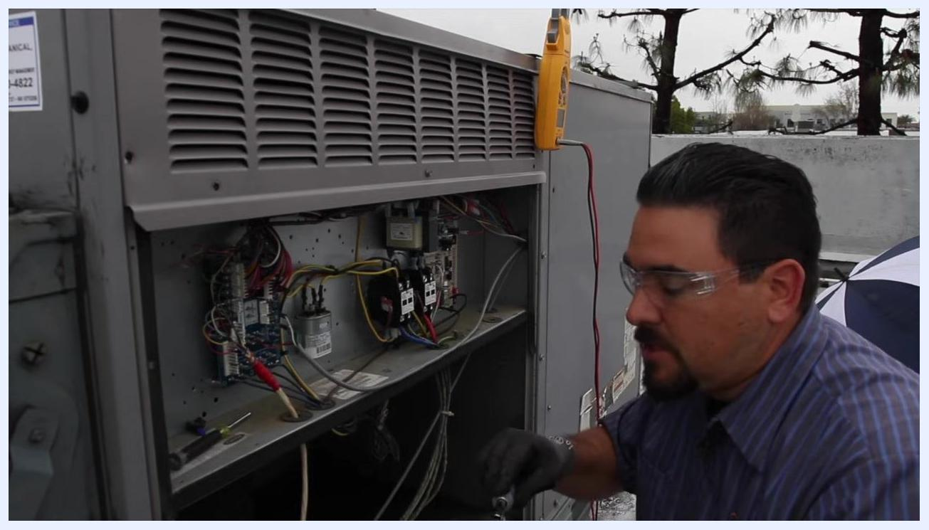
Technician inspecting and tightening wire lugs on contactors inside the HVAC unit's electrical compartment, with a multimeter clipped to the unit.

Step 8: Check and tighten capacitor connections
Locate the capacitors inside the electrical compartment. Use an insulated screwdriver to gently check each terminal connection on the capacitors and tighten any loose connections so all terminals are snug and secure.
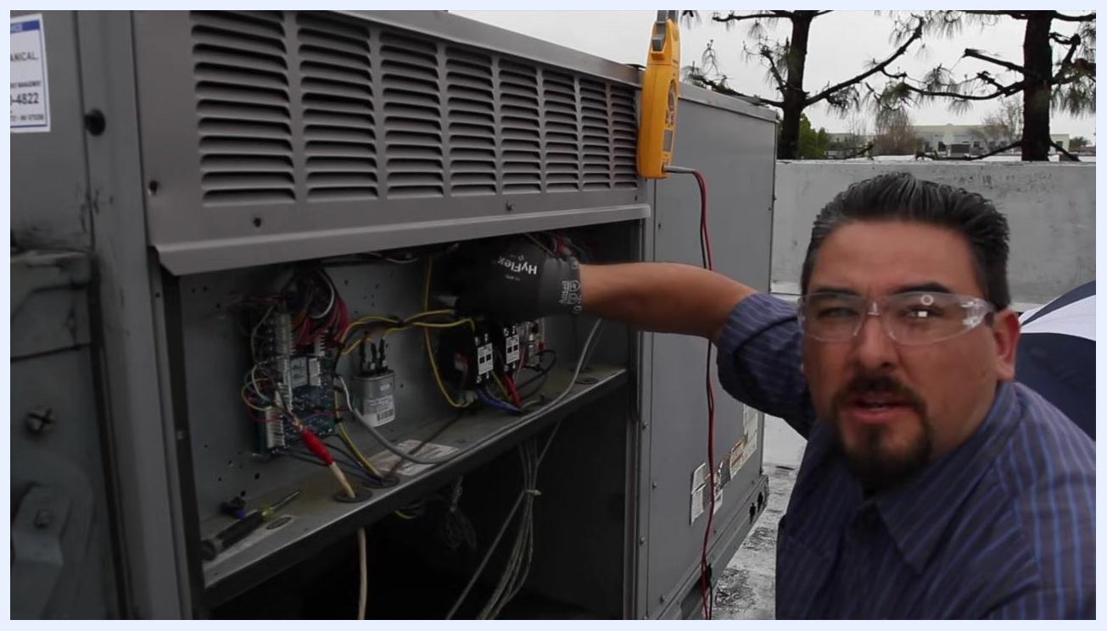
Technician closely inspecting the contactors inside the HVAC unit for signs of pitting or wear, with the electrical compartment open.

Step 9: Secure connections on contactors
Identify the contactors, typically black rectangular components with multiple wire lugs. Check each lug to ensure connections are tight, and use a screwdriver to tighten any loose lugs as needed.

Step 10: Inspect contactors for wear or pitting
Examine the contact surfaces of each contactor for signs of pitting, burning, or excessive wear. If contactors show signs of pitting or damage, plan for replacement. In this case, the contactors show no sign of pitting and appear to have been replaced recently.
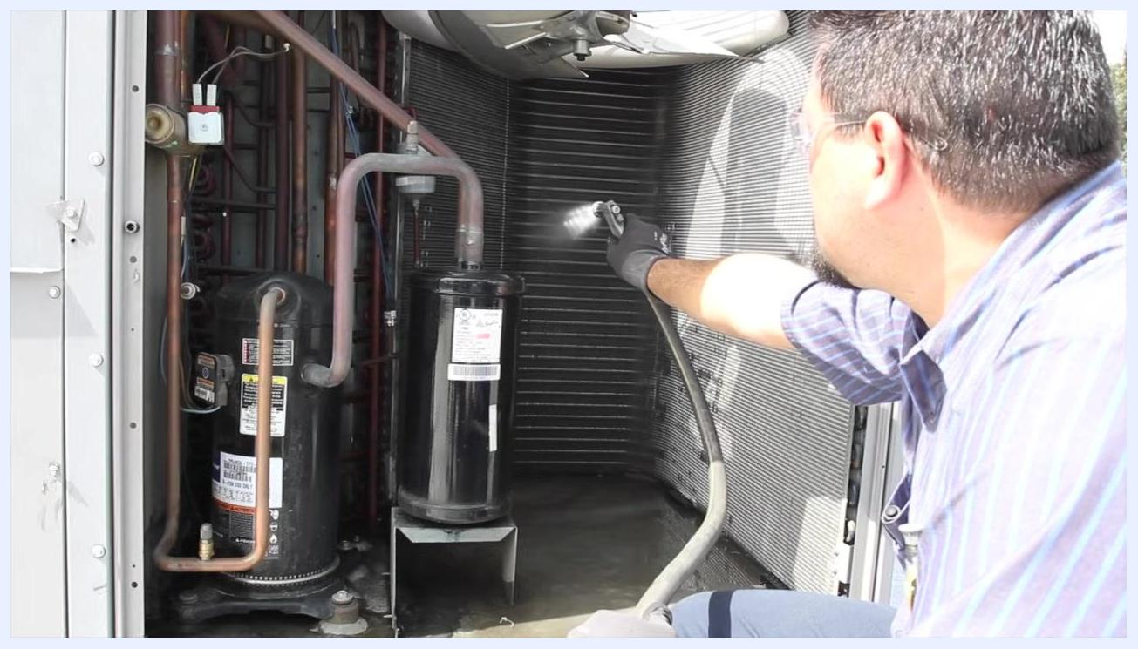
Technician using a screwdriver to check and tighten connections on a capacitor inside the open electrical compartment, with multiple colored wires, circuit boards, and a multimeter visible.

Step 11: Document the condition of electrical components
Note that the inspected contactors are in good condition and do not require replacement at this time. Record any maintenance actions taken, such as tightening connections or replacing components.
Following these steps ensures all electrical connections within the HVAC unit are secure, reducing the risk of electrical faults and prolonging the lifespan of critical components.

Step 12: Test the condenser fan motor capacitor
After completing the electrical wiring assessment, check the capacitor for the condenser fan motor. Identify the capacitor and verify its rating: 5 microfarads (μF) ±6%, with an acceptable range of 4.7 to 5.3 μF.
- Discharge the capacitor before handling by using an insulated screwdriver to ground the terminals of the capacitor to itself, ensuring no stored power remains.
- Disconnect the wires from the capacitor terminals.
- Set your multimeter to the microfarads (μF) setting and measure the capacitance.
In this example, the reading is 3.9 μF, which is below the manufacturer's specification. If the reading falls outside the 4.7–5.3 μF range, the capacitor is out of spec; a low reading causes higher amperage draw on the motors, leading to premature wear. Replace the capacitor if it is out of specification.
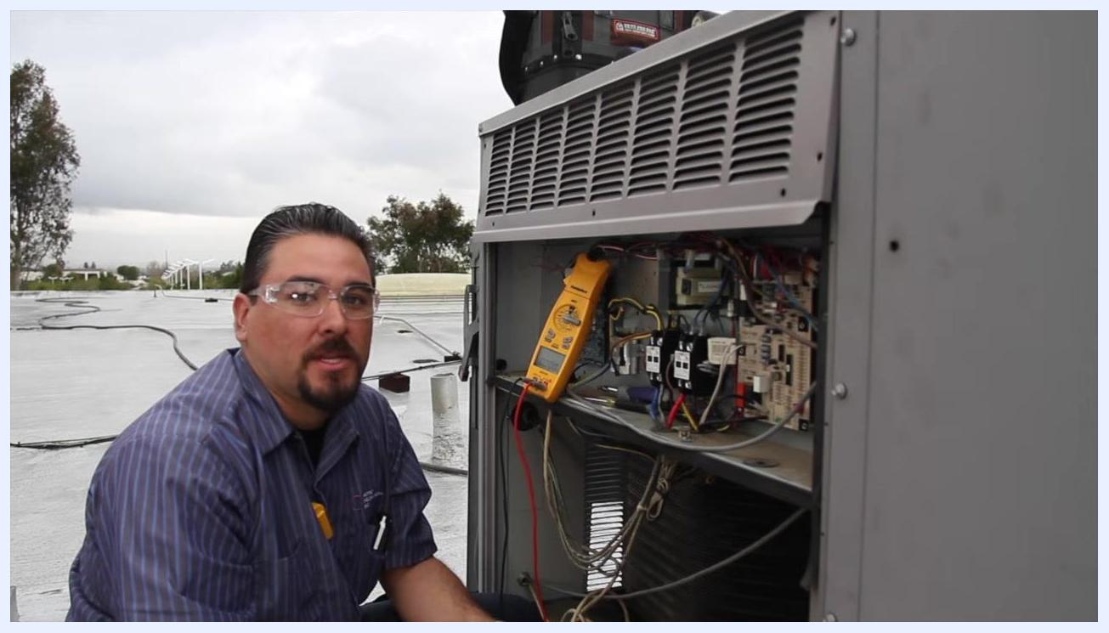
Technician using a multimeter set to microfarads to test the capacitor inside the open electrical compartment.

Step 13: Inspect the blower housing, pulley, and bearings
Check the condition of the blower housing for any signs of damage or debris. Inspect the pulley for proper alignment and verify there is no visible wear or damage. Rotate the bearings by hand to confirm they move smoothly and are not worn out. Examine the sheaves and pulleys for wear and verify alignment between the motor and the pulleys.
Technician inspecting the blower housing and pulley inside the HVAC unit, checking for wear, alignment, and bearing condition.

Step 14: Reinstall the pulley and adjust belt tension
Reinstall the pulley onto the blower shaft if it was removed for inspection, and place the drive belt back onto the pulley. Check the belt tension to ensure it is not too tight or too loose, since proper tension is critical for efficient operation and to prevent premature wear.
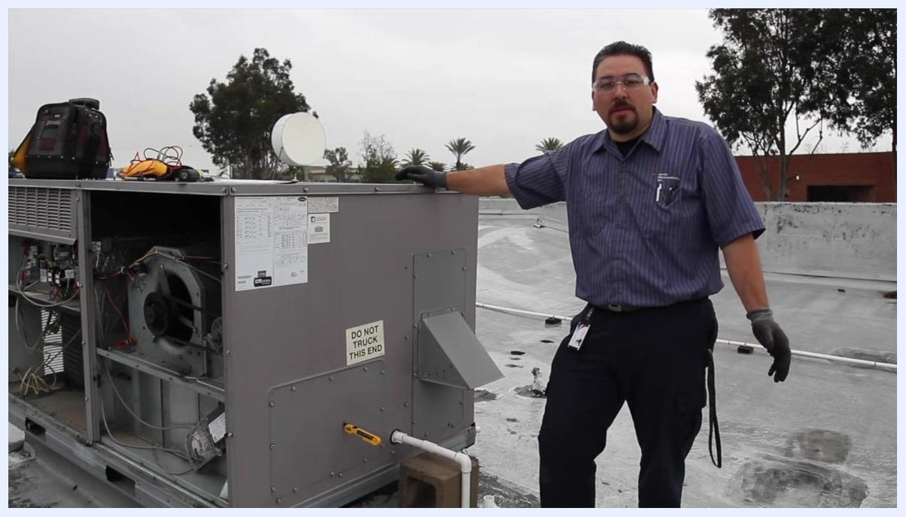
Technician holding the drive belt and preparing to reinstall it onto the blower pulley, with the pulley and belt path clearly visible.

Step 15: Check the economizer, if present
If the unit is equipped with an economizer, inspect the economizer screen. This particular unit does not have an economizer screen. For units that do have one, verify the economizer is functioning correctly, and inspect the louvers and linkage to ensure they move freely and are not obstructed. The economizer allows for free cooling by pulling in fresh air from outside when ambient temperatures are low enough.
Technician standing next to the HVAC unit on a rooftop with the access panels open, explaining the economizer function and inspection.
Following these steps ensures the capacitor is functioning within specifications, the blower and pulley system is in good condition, and the economizer (if present) is operating correctly, helping maintain the efficiency and longevity of the HVAC system.

Step 16: Verify economizer functionality
Confirm that the economizer, if present, is functioning correctly. Stand next to the HVAC unit with the access panels open to visually inspect the economizer components. Reference the unit's wiring diagram and specification labels, typically affixed to the exterior of the unit, for guidance.
Ensure all electrical connections and mechanical linkages associated with the economizer are intact and properly connected. Observe the economizer's operation by cycling the system or using manual controls, if available, to verify the dampers and linkages move as intended. Check for any obstructions or debris that could impede the economizer's movement.
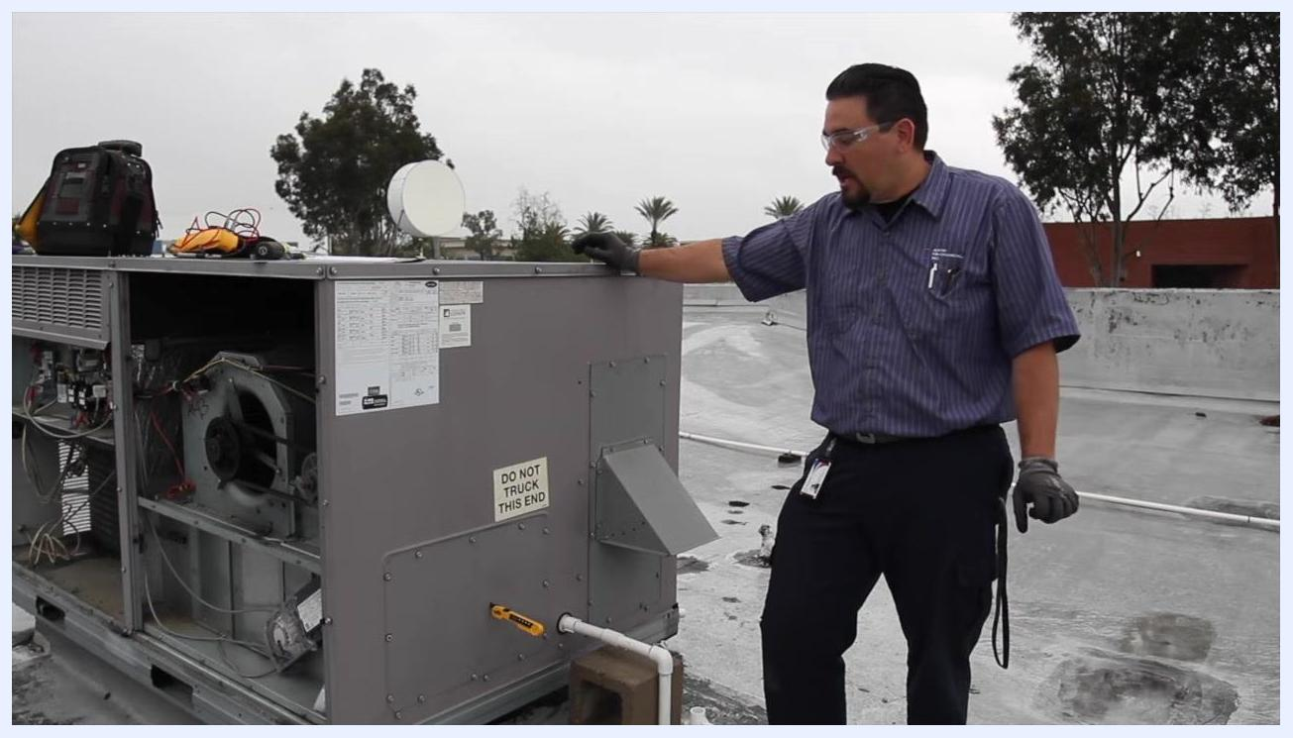
Technician standing on a rooftop next to an open HVAC unit, pointing at the unit while discussing economizer functionality, with internal components and specification labels visible.
If the economizer is not functioning, troubleshoot according to the manufacturer's instructions, checking for electrical faults, stuck dampers, or broken linkages. Document your findings and any corrective actions taken.
Verifying the economizer's operation ensures the HVAC system can utilize free cooling when conditions allow, improving energy efficiency and system performance.

Step 17: Approach the unit for filter and drain maintenance
Approach the rooftop HVAC unit and ensure you are wearing appropriate safety gear, including gloves and safety glasses. This part of the checklist covers a "DO NOT TRUCK THIS END" labeled panel and the unit's internal components.
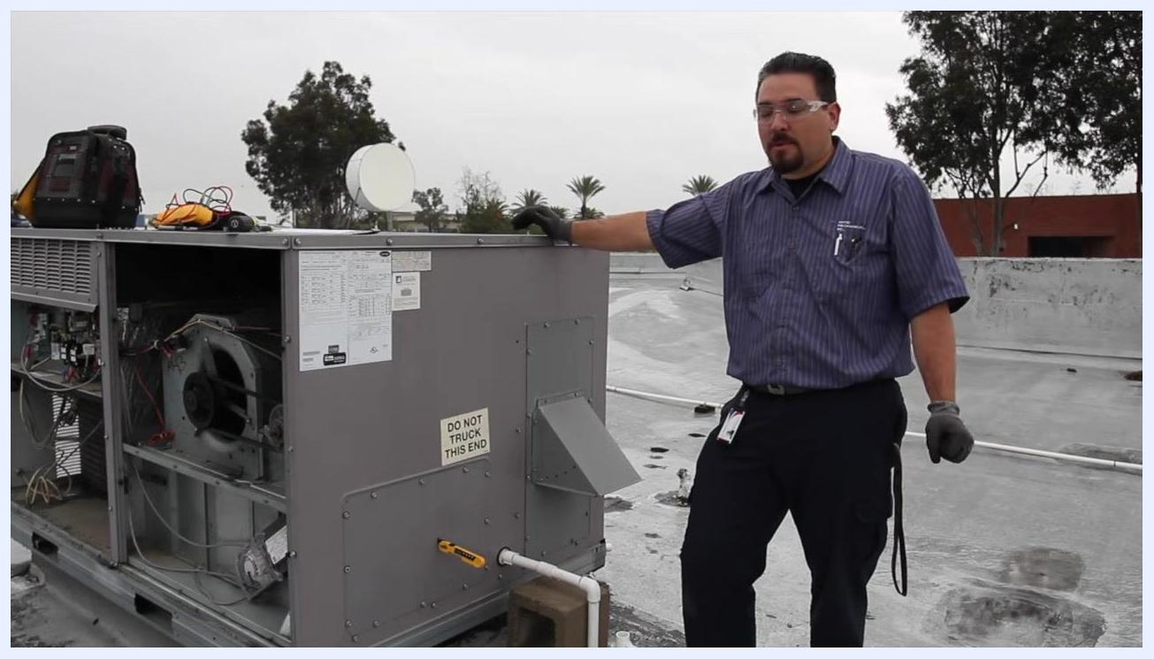
Technician standing next to an open rooftop HVAC unit, with tools and warning labels visible.

Step 18: Inspect the air filters
Open the access panel to expose the air filters and internal components. Inspect the air filters for dirt and debris; if the filters are dirty or clogged, prepare to replace them.
Technician kneeling by the open HVAC unit, reaching inside to inspect air filters, with new replacement filters stacked on top of the unit.

Step 19: Remove the old air filters
Pull out the old filter and prepare to insert a new one in its place.

Step 20: Install new air filters
Insert new air filters into the designated slots, ensuring they are properly aligned and seated.
Technician working inside the HVAC unit, with a used filter on the ground and new filters on top.

Step 21: Flush the drain pan
If the drain pan is plugged or dirty, flush the pan thoroughly to remove any blockages or buildup.

Step 22: Install drain pan tablets
Install panel drain pan tablets (pan taps) to help dissolve and prevent future buildup inside the drain pan.
Technician reaching inside the HVAC unit to check or clean the drain pan.

Step 23: Clear the drain lines
Use CO2 or compressed air to blow out the drain lines, ensuring there are no clogs or obstructions.
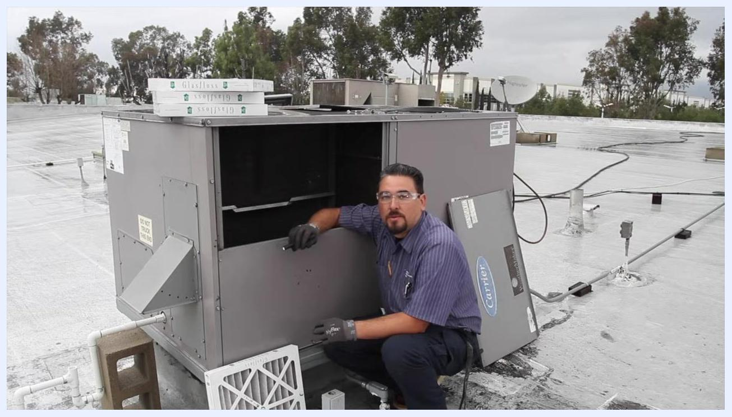
Technician at the HVAC unit, preparing to clear the drain lines.

Step 24: Confirm filter installation
Confirm that the new filters are installed tightly and securely so they will not move or dislodge during operation.
Following these steps ensures the HVAC unit's filters, drains, and refrigerant system are properly maintained, helping to prevent damage and ensure efficient operation.
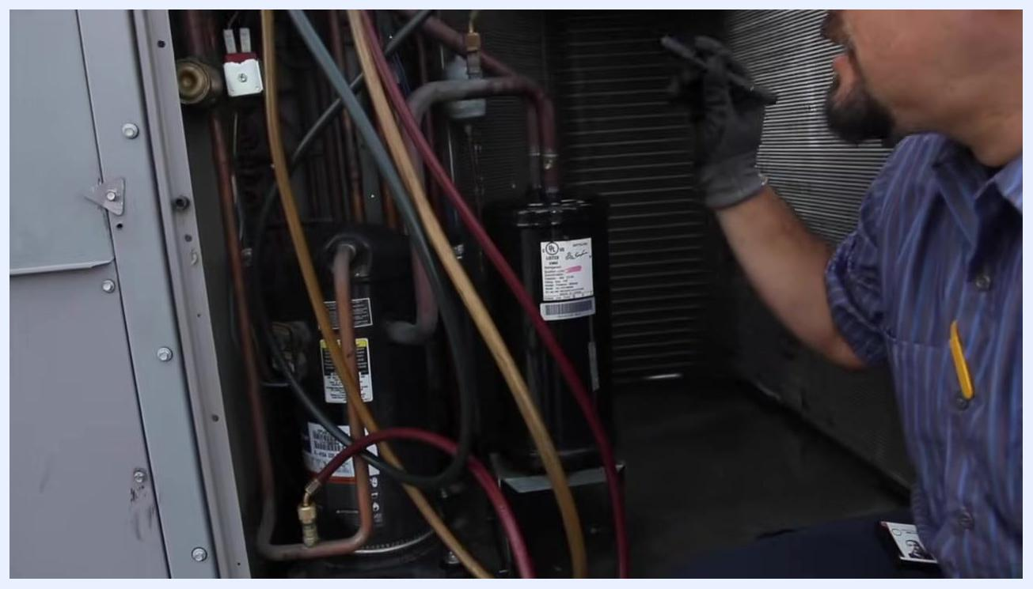
Technician referencing the compressor and electrical connections, preparing to check amp draws.

Step 25: Attach gauges and inspect refrigerant lines
Move to the section of the unit containing the refrigerant lines and compressor. Attach pressure gauges to the service ports to check system pressures, ensuring all connections are tight.
Technician inspecting refrigerant lines and gauges inside the HVAC unit, ensuring connections are tight.

Step 26: Check fittings and connections for leaks
Check all fittings and connections for leaks using appropriate leak detection methods, and ensure all fittings are snug and secure.
Technician inspecting the compressor area and fittings for leaks and tightness.

Step 27: Check amp draw with the unit running
With the unit running, check the amp draw of the compressor and condenser fan motor to verify proper operation.

Step 28: Observe overall system operation
Observe the system for any signs of leaks, abnormal noises, or irregular operation, and address any issues found during inspection.

Step 29: Energize the unit for electrical testing
Ensure the unit is powered on and operational before proceeding with electrical and performance checks.

Step 30: Prepare to check amperage
Prepare to check amperage on the compressor and blower motors. Confirm that all tools and meters are ready for use before taking readings.

Step 31: Open the electrical compartment for amperage testing
Open the access panel to expose circuit boards, relays, contactors, and wiring. Use an appropriate clamp meter to measure amperage, placing it around the wire leading to the compressor.
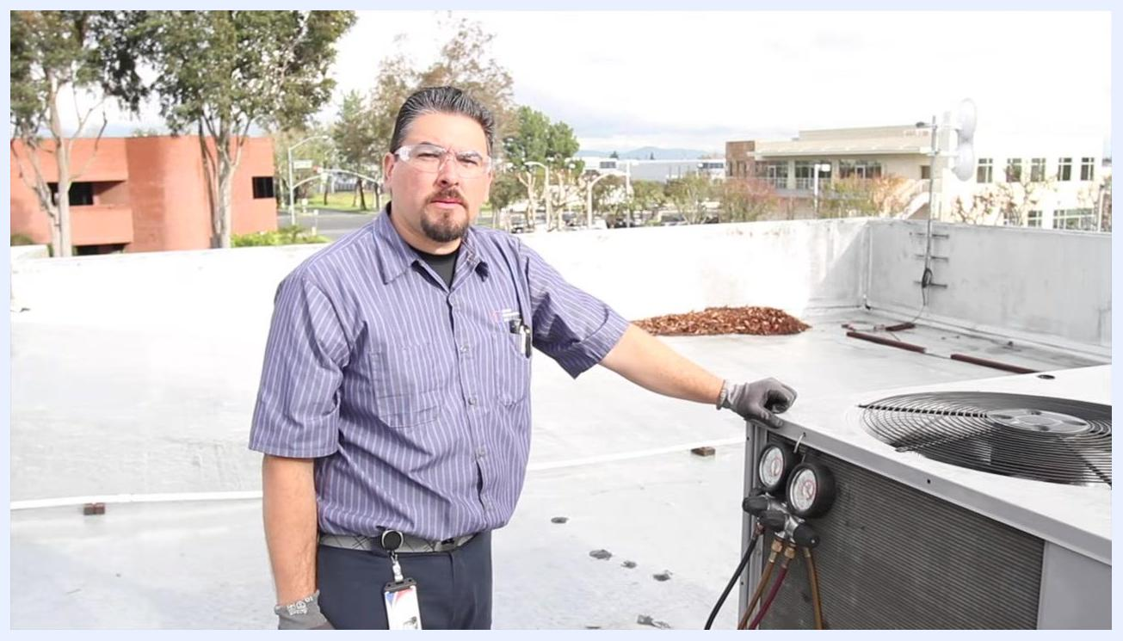
Technician standing next to an energized rooftop HVAC unit, with pressure gauges attached and safety gear on.

Step 32: Measure the compressor amperage
Clamp the meter around the compressor wire and observe and record the amperage reading.

Step 33: Measure the blower motor amperage
Move the clamp meter to the blower motor wire, observe and record the amperage reading. A lower amp reading is expected when the blower is running less hard.
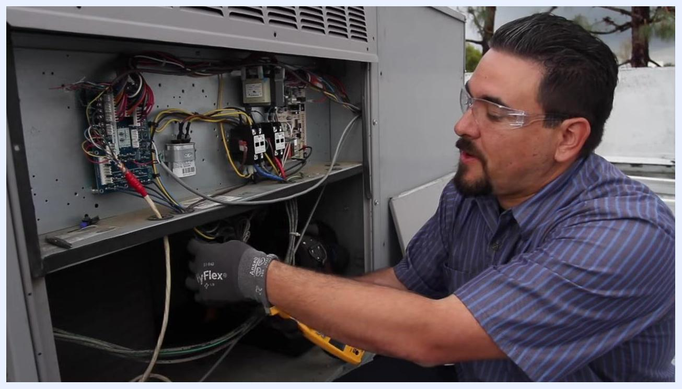
Technician reaching into the electrical compartment to measure condenser fan motor amperage.

Step 34: Check the condenser fan motor amperage
Position the clamp meter around the condenser fan motor wire and take the measurement.
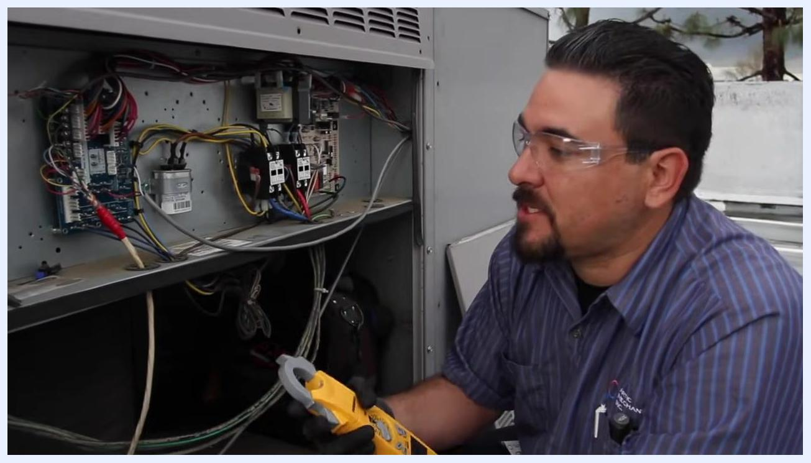
Technician confirming the condenser fan motor amperage reading inside the open electrical compartment.

Step 35: Record the condenser fan motor amperage
Record the reading; in this case, the condenser fan motor is running at 1.5 amps. Compare this value to the manufacturer's specifications to confirm proper operation.
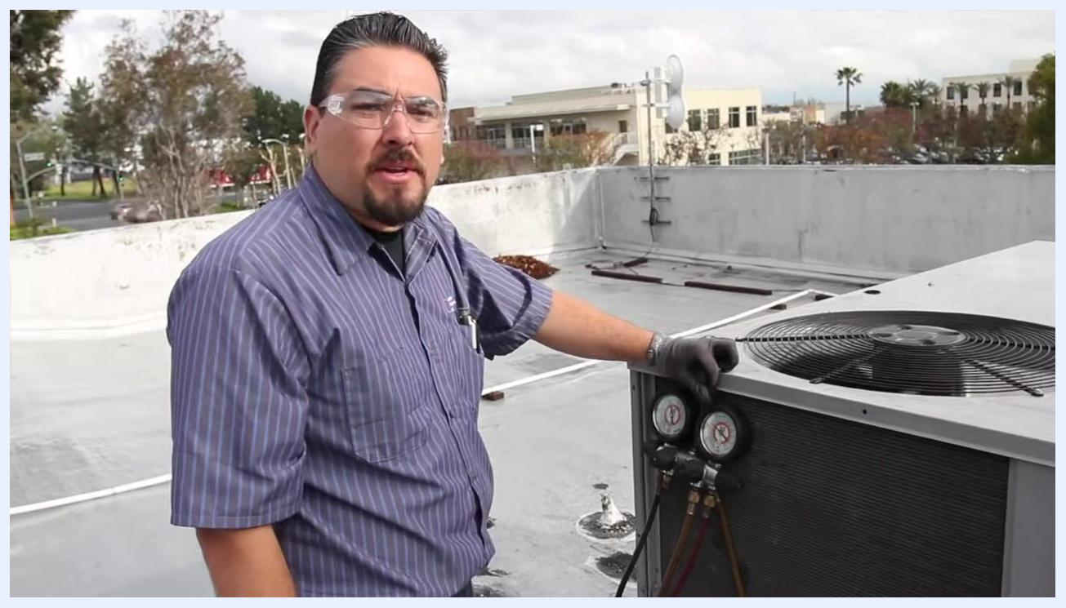
Technician using a clamp meter inside the open electrical compartment, preparing to check compressor amperage.

Step 36: Decide on component replacement if necessary
If amperage readings are outside normal range or performance is suboptimal, plan to replace faulty components. In this case, the capacitor is identified for replacement due to performance issues.
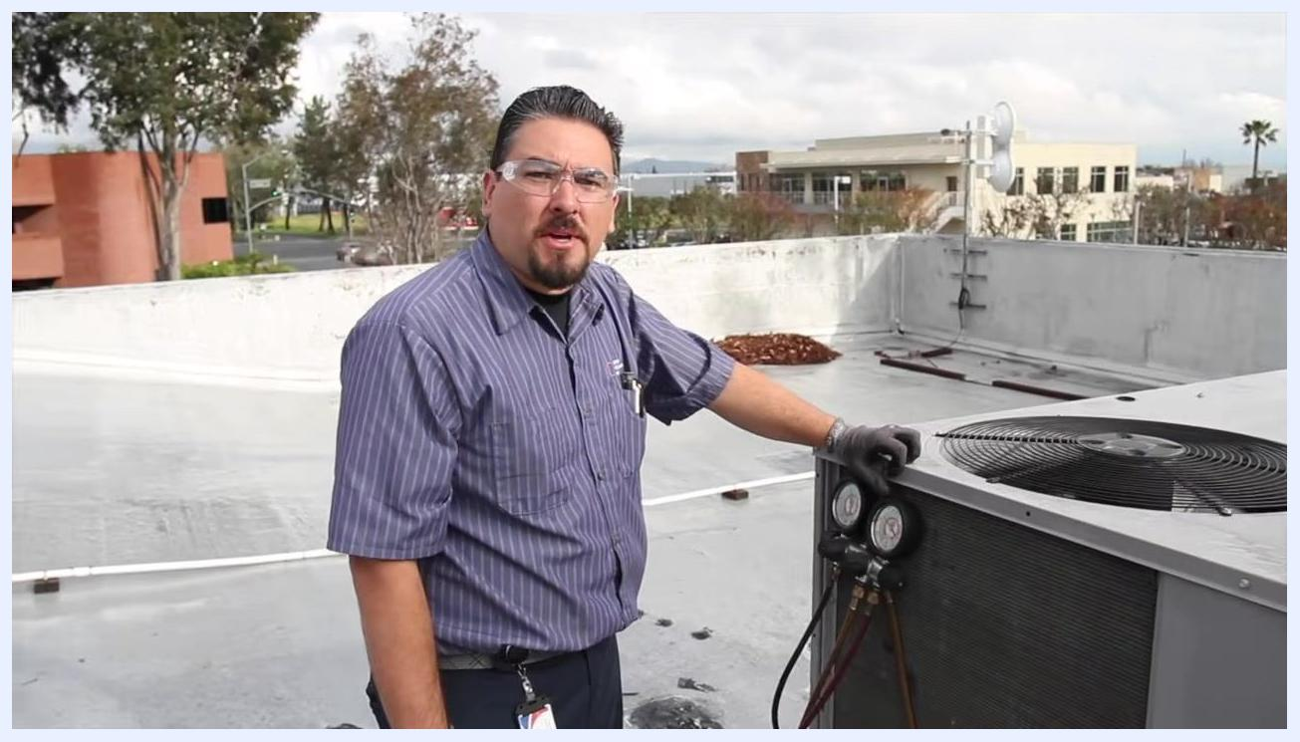
Technician holding a clamp meter, explaining blower motor amperage readings inside the open electrical compartment.
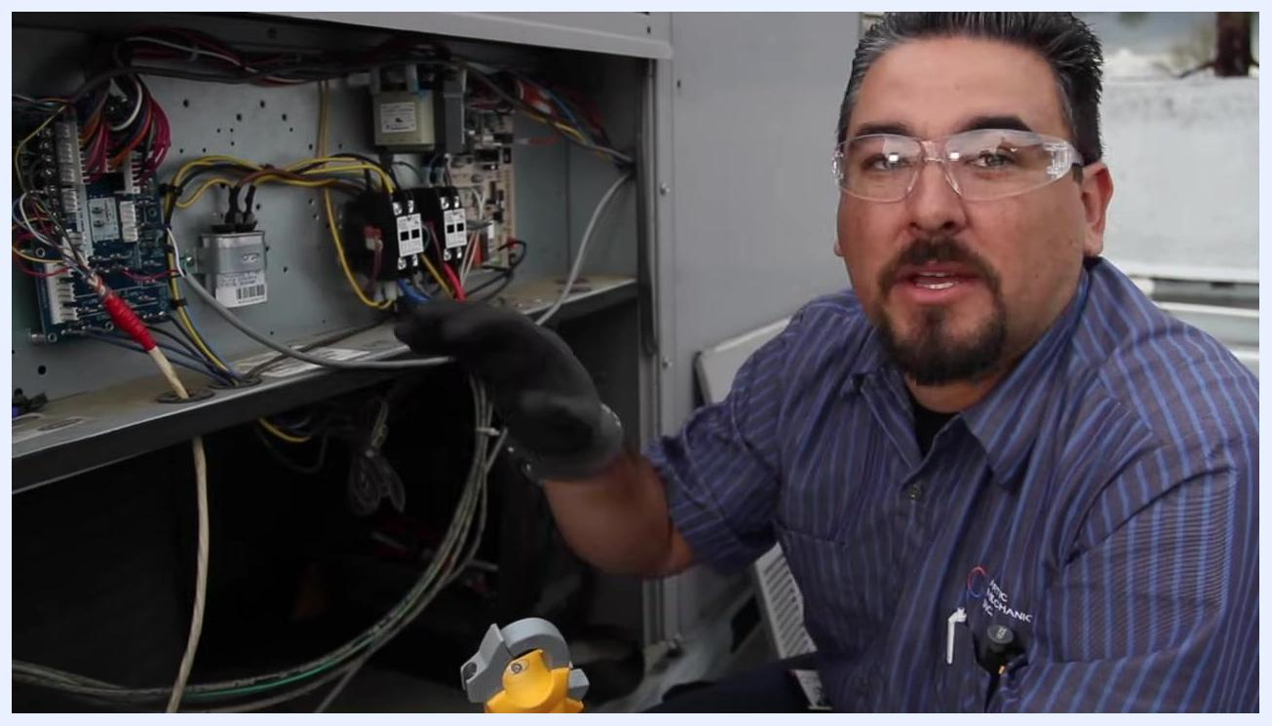
Technician explaining the need to replace the capacitor, holding a clamp meter inside the open electrical compartment.

Step 37: Measure the supply air temperature
Identify the supply vent on the HVAC unit, labeled "DO NOT TRUCK THIS END." Use a digital thermometer or temperature probe to measure the supply air temperature.

Step 38: Measure the return air temperature
Move to the return air section of the unit, often labeled with the manufacturer's name (for example, "WeatherMaker"). Use the same digital thermometer or probe to measure the return air temperature. In this case, the return temperature reading is 66°F.

Step 39: Calculate the temperature differential
Note the supply temperature (46°F) and the return temperature (66°F). Subtract the supply temperature from the return temperature to determine the temperature drop across the coil (ΔT = 66°F − 46°F = 20°F). Ensure the temperature differential is within the manufacturer's recommended range for efficient operation.
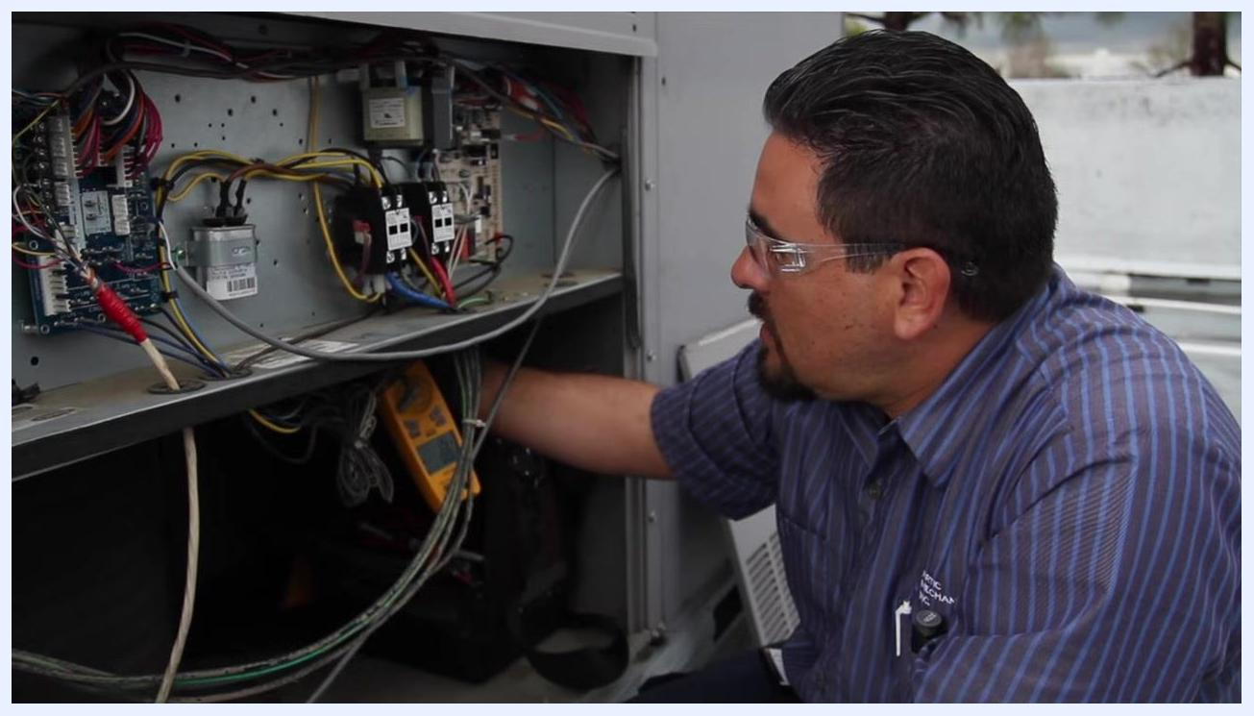
Technician measuring supply vent temperature at the labeled panel of the HVAC unit.
Technician measuring return air temperature at the return section of the HVAC unit, thermometer in hand.
Following these steps completes the electrical, airflow, and temperature performance checks necessary for comprehensive rooftop HVAC unit maintenance, ensuring the system operates safely, efficiently, and within manufacturer specifications.

Step 40: Restore power to the unit
Ensure all maintenance and testing procedures are complete and all tools are removed from the unit. Locate the electrical disconnect box mounted on the side of the HVAC unit and turn the disconnect switch back to the "ON" position to restore power to the equipment.
Technician standing next to a rooftop HVAC unit with one hand near the electrical disconnect box, preparing to restore power.

Verification and summary
This HVAC preventive maintenance checklist covers power verification, coil cleaning, electrical component inspection, capacitor and blower testing, economizer verification, filter and drain servicing, refrigerant system inspection, amperage testing, and temperature differential checks. Confirm that:
- All electrical connections and terminals are tight and free of pitting or wear.
- The capacitor reading falls within the manufacturer's specified microfarad range.
- Air filters are new, properly seated, and secure.
- The drain pan and drain lines are clear of blockages.
- Refrigerant fittings show no signs of leaks.
- Compressor, blower, and condenser fan motor amperage readings match manufacturer specifications.
- The temperature differential across the coil falls within the recommended range.
- Power has been fully restored to the unit before ending the service call.
Technician inspecting refrigerant lines and the compressor area for leaks and proper operation.
Always remember to restore power after servicing and to complete documentation of any parts replaced or issues found during the inspection.

