How to Change the Oil in a Generator: Honda EU2200i Oil Change Procedure

Purpose
This document explains how to change the oil in a generator, specifically the Honda EU2200i, to maintain optimal engine performance and extend the life of the unit. Regular oil changes prevent engine wear and keep your generator running reliably.

Scope
This procedure applies to the Honda EU2200i generator and covers the full oil change process, from consulting the maintenance schedule to reinstalling the maintenance cover and locating professional support if needed.

Required equipment
- Owner's manual for the Honda EU2200i generator
- Flat-tip screwdriver
- Oil drain pan or suitable container
- SAE 10W-30 SJ or later engine oil (approximately 14 ounces / 0.41 liters)
- Small funnel
- Dipstick (built into the generator's oil filler neck)
- Clean rags or cloth for wiping spills

Procedure

1. Consult the maintenance schedule
Refer to the maintenance schedule in the owner's manual to determine when to change the engine oil. The schedule specifies intervals based on months or operating hours. For example, the manual may recommend changing the engine oil every 6 months or 100 hours, whichever comes first.
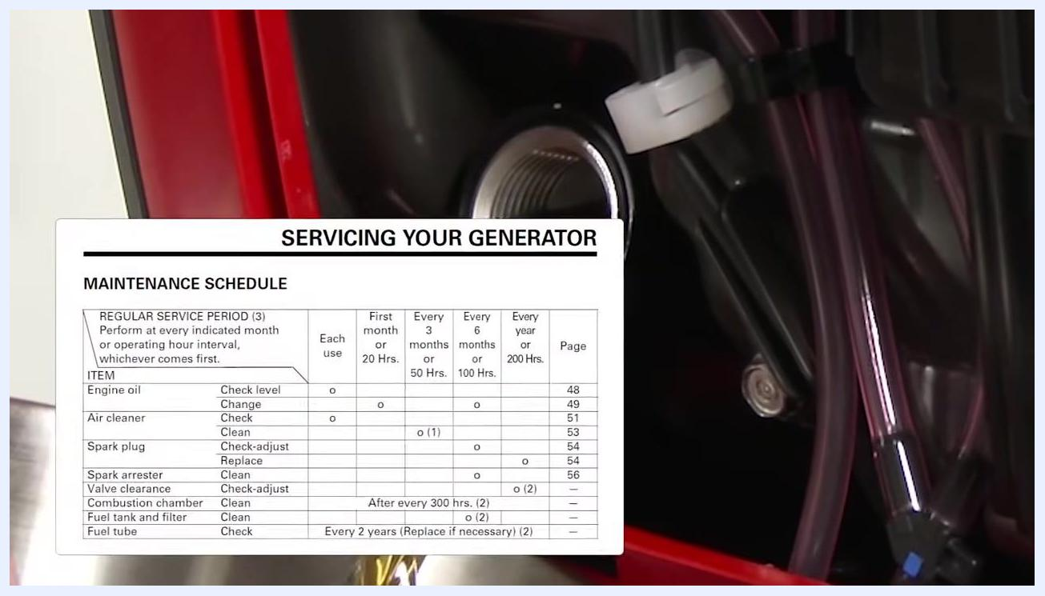
Maintenance schedule showing service intervals for engine oil, air cleaner, spark plug, and other components

2. Prepare for oil draining
Ensure the engine is warm before draining the oil, as warm oil drains more quickly and completely. Turn the engine switch to the OFF position. Move the fuel filler cap vent to the OFF position to prevent fuel leakage during the oil change.

3. Remove the maintenance cover
Use a flat-tip screwdriver to loosen the maintenance cover screw. Remove the maintenance cover and set it aside in a safe location.
Using a screwdriver to remove the maintenance cover screw on the Honda EU2200i generator

4. Position the oil drain pan
Place a suitable container or oil drain pan next to the engine. Position the container so that it will catch the used oil as it drains from the filler neck.
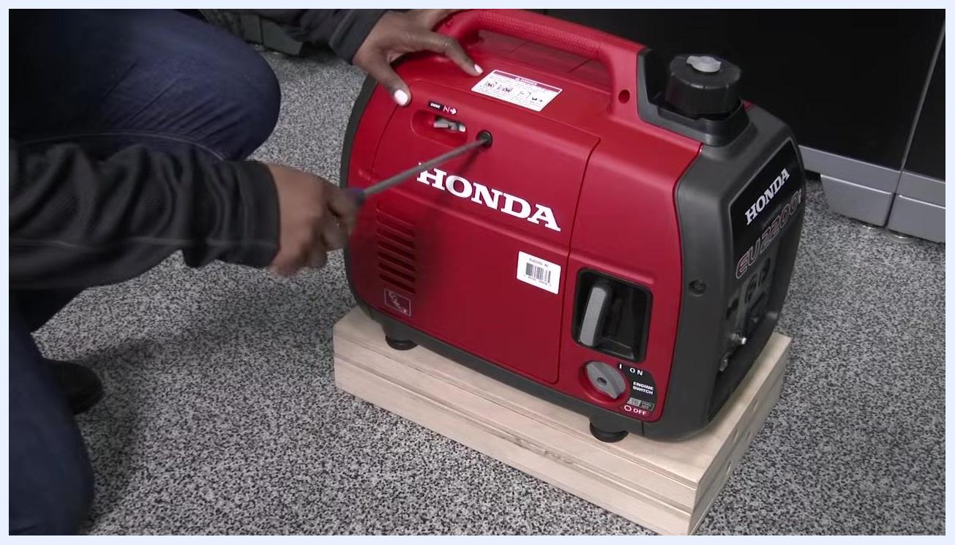
Placing an oil drain pan under the generator with the maintenance cover removed

5. Drain the engine oil
Remove the oil filler cap. Carefully tip the generator toward the drain pan to allow the engine oil to drain out completely. Allow all oil to drain fully before returning the generator to a level position.
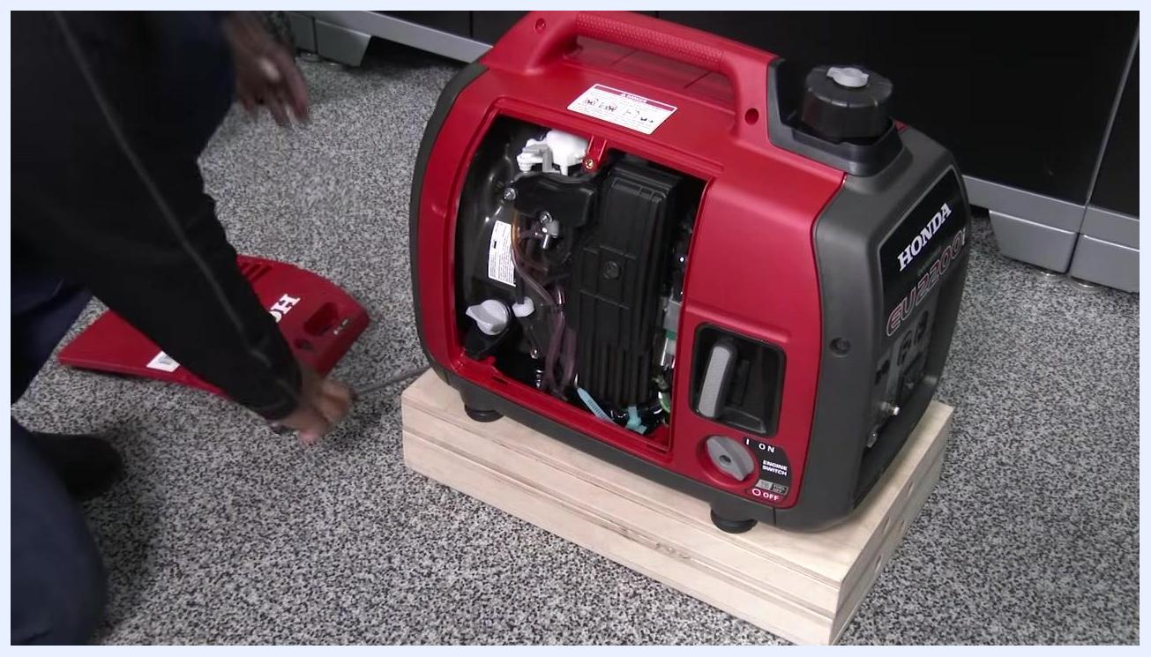
Tipping the generator to drain oil into a pan, with oil visibly flowing out

6. Dispose of used oil
Properly dispose of the used engine oil according to your local laws and regulations. Do not pour used oil down drains or into the environment.

7. Refill with new engine oil
With the generator on a level surface, place a small funnel into the oil filler hole. Pour in approximately 14 ounces (0.41 liters) of SAE 10W-30 SJ or later engine oil. Fill until the oil level reaches the upper limit of the filler neck, just before it would begin to drip out.
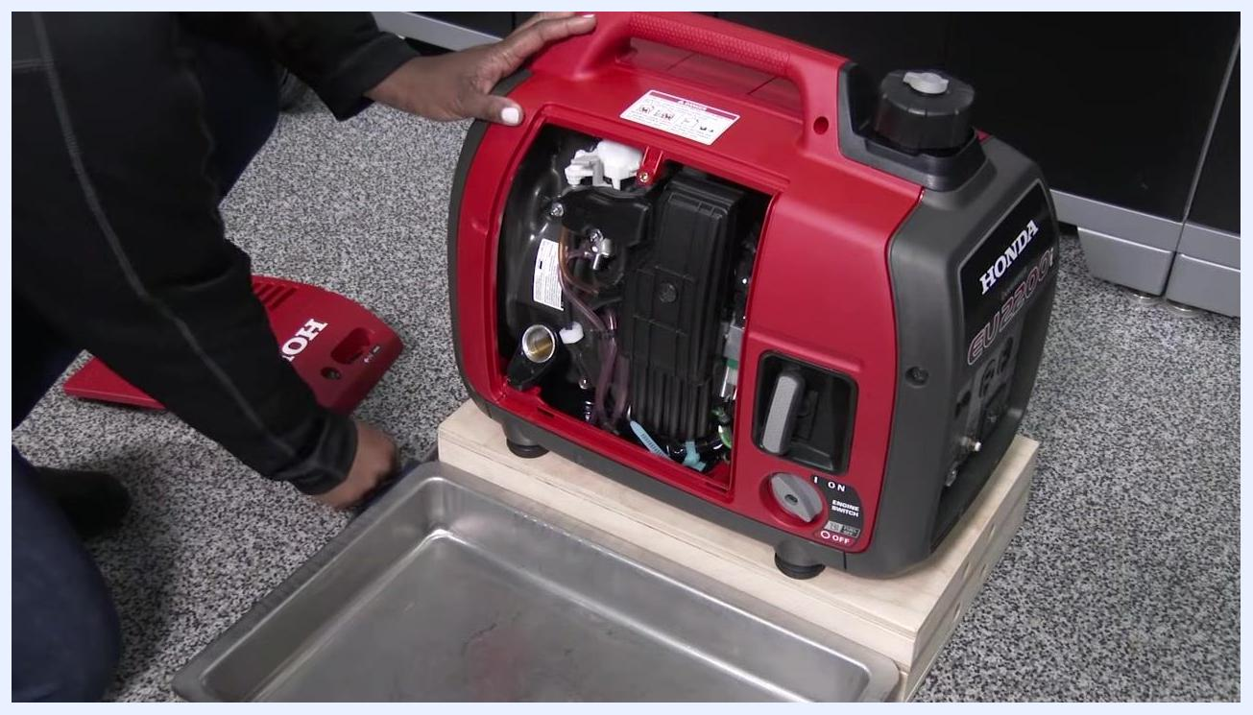
Pouring SAE 10W-30 oil into the generator using a funnel, with the oil bottle label visible

8. Check and adjust the oil level
Insert the dipstick into the filler neck without threading it in. Remove the dipstick and check the oil level. Add or remove oil as necessary to ensure the level is correct.
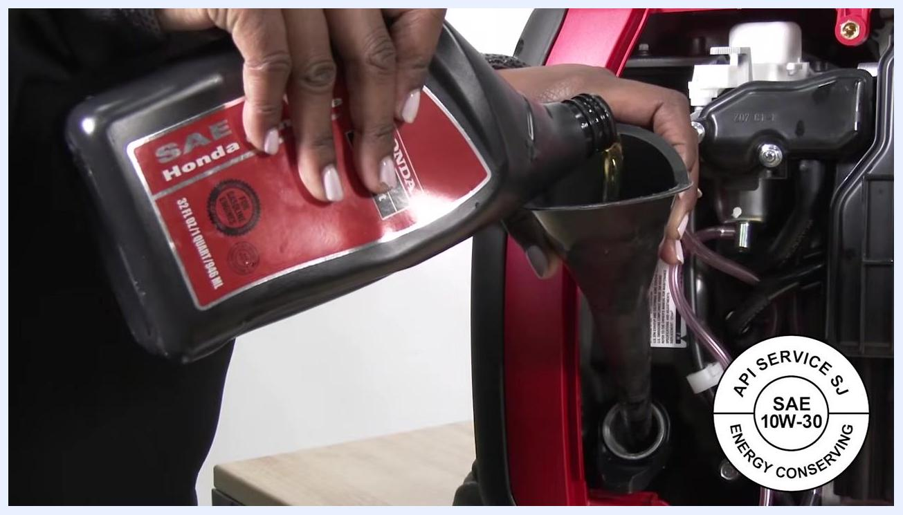
Holding the dipstick next to the oil filler neck to check the oil level

9. Tighten the oil filler cap and clean up
Securely tighten the oil filler cap to prevent leaks. Wipe off any spilled oil from the generator exterior to maintain cleanliness and safety.

10. Reinstall the maintenance cover
Position the maintenance cover back onto the generator. Use a flat-tip screwdriver to tighten the maintenance cover screw securely. Ensure the cover is properly seated and fastened before use.
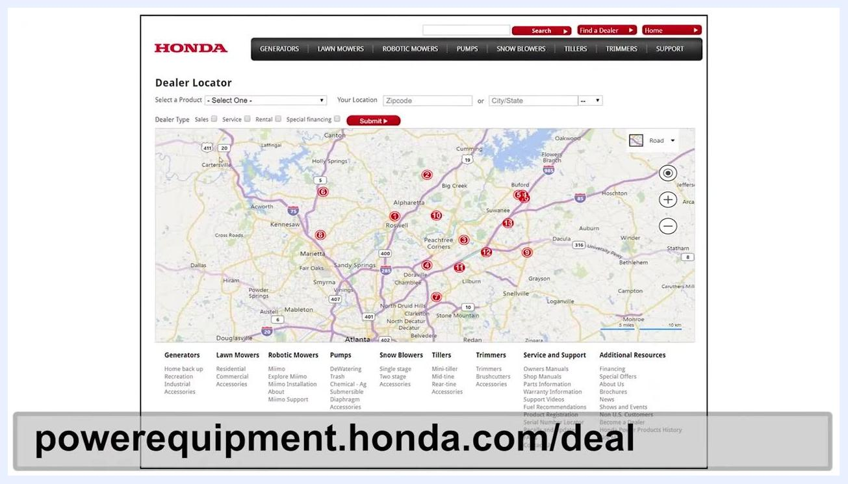
Using a screwdriver to reinstall and tighten the maintenance cover screw on the red Honda EU2200i generator, resting on a wooden block in a workshop setting

Additional resources
For further information regarding maintenance procedures or troubleshooting, refer to your Honda EU2200i owner's manual. If you need professional assistance or have questions, contact your local Honda Power Equipment dealer.

Locating a Honda Power Equipment dealer
Visit the Honda Power Equipment Dealer Locator website at powerequipment.honda.com/dealer-locator. Enter your location (zip code or city/state) to find the nearest authorized dealer for service, parts, or support.
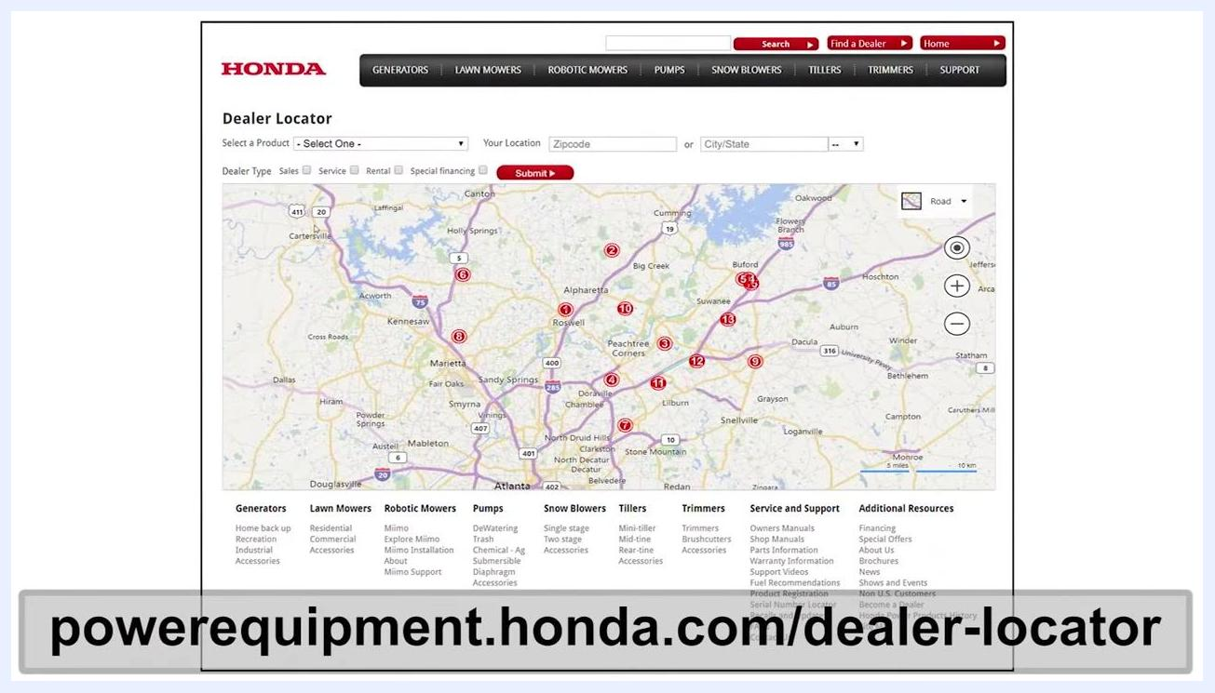
Honda Power Equipment Dealer Locator webpage showing a map with dealer locations and a search interface, with the URL powerequipment.honda.com/dealer-locator displayed at the bottom

Verification and summary
By completing these steps, you have successfully learned how to change the oil in a generator and have properly reassembled your Honda EU2200i for use. Confirm that:
- The oil filler cap is securely tightened with no leaks.
- The maintenance cover is properly seated and fastened.
- The generator exterior is clean and free of oil residue.
For any additional questions or maintenance needs, always refer to your owner's manual or contact an authorized Honda dealer.

