How to Run Reports in EPIC Hyperspace: Create and Download a Team View Report
This guide shows you how to run reports in EPIC Hyperspace by walking through the full process of creating a Team View report, adding participants, and downloading the finished report from your EPIC Administrator account.

Prerequisites
- An active EPIC Administrator account.
- Access to admin.wiley-epic.com.
- Your administrator login credentials.

Step 1: Access the EPIC Administrator site
Open your web browser and navigate to admin.wiley-epic.com, then log in with your administrator credentials. Once logged in, confirm you are on the EPIC dashboard, where you can see your username, credit balance, and menu options.
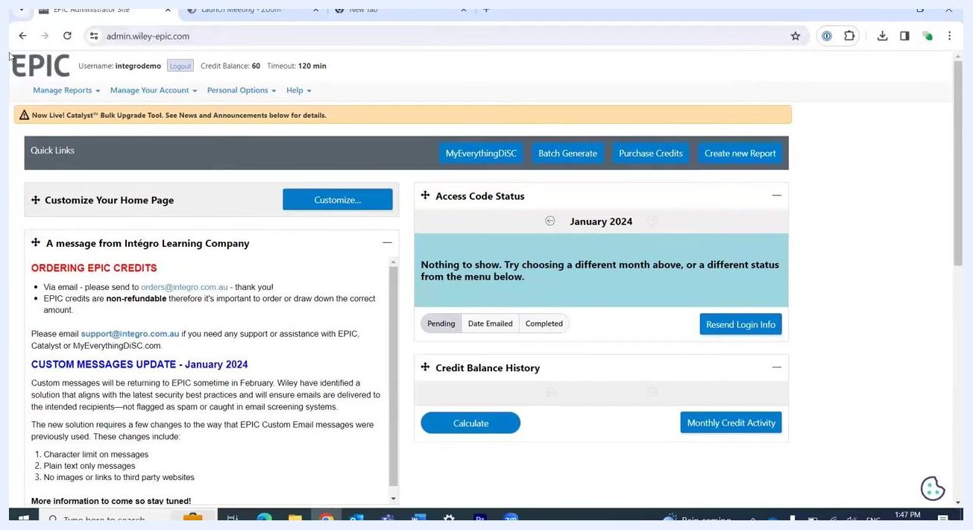
EPIC dashboard showing username, credit balance, menu bar with "Manage Reports," "Manage Your Account," "Personal Options," and "Help." Quick links, access code status, and credit balance history are visible.

Step 2: Navigate to create new report
Hover over the Manage Reports menu at the top of the page. In the dropdown that appears, click Create New Report/Issue Access Codes to begin setting up your report.
Dropdown menu under "Manage Reports" with "Create New Report/Issue Access Codes" highlighted.

Step 3: Select the product family and report type
On the Manage Reports page, locate the section for selecting a Product Family, Product, and Language.
- Set Product Family to Everything DiSC.
- In the Product dropdown, scroll past the profile options and select a report type. For this guide, choose Team View.
- Leave Language as required (for example, English).
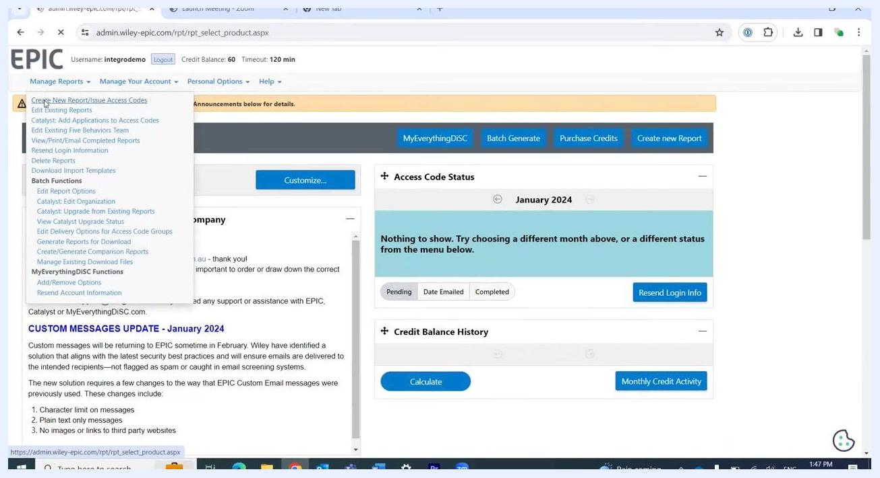
Manage Reports screen with "Everything DiSC" selected as Product Family and the Product dropdown open, showing report options like Group Culture Report, Facilitator Report, Comparison Report, and Team View.

Step 4: Proceed to the next step
After selecting Team View as the product, click the Next button to continue to the report details.
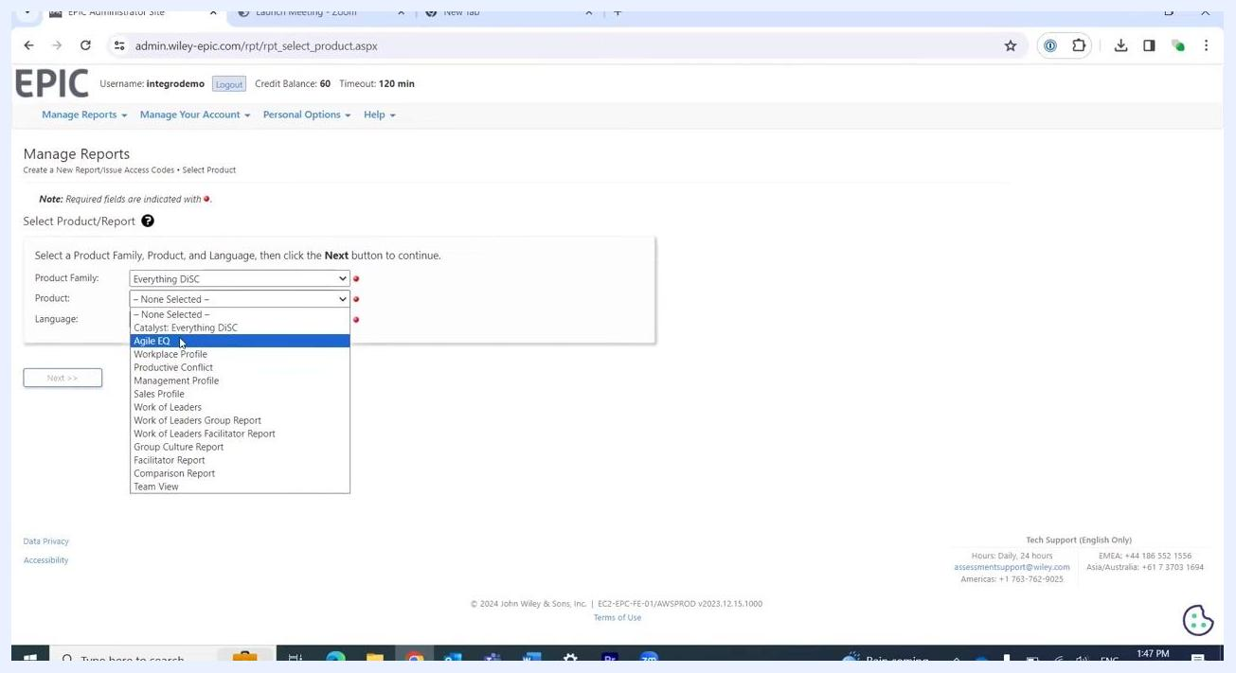
Manage Reports screen with Product Family set to "Everything DiSC," Product set to "Team View," and Language not yet selected.

Step 5: Assign folders and name the report
On the Report Details screen, select an EPIC Folder (for example, Integro Demonstration) and an EPIC Sub Folder (for example, 2012 Participants). You can also create a new folder or subfolder if needed. This organization helps you easily find and download reports in the future.
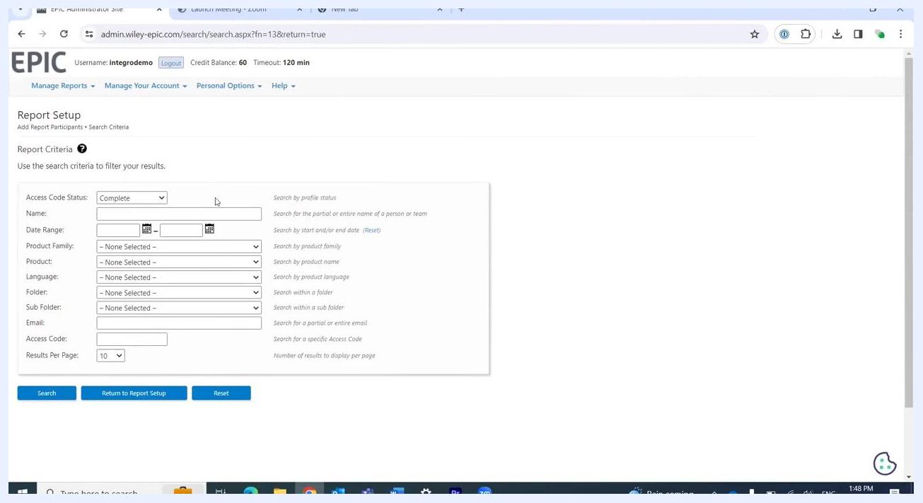
Report Details screen with Product set to "Everything DiSC Team View," Language "English," EPIC Folder "Integro Demonstration," EPIC Sub Folder "2012 Participants," and Report Name field ready for input.
Next, enter a Report Name in the provided field (for example, Integrity). Note that the main title "Team View" is added automatically to the finished report, so you don't need to repeat it in your custom name — choose something that helps you identify the team or department instead.
Report Details screen with "Integrity" being typed into the Report Name field.

Step 6: Add participants to the report
Click the Add button under the Participants section to open the search window, where you can find people to include in your report.

Step 7: Set search criteria for participants
In the Report Setup window, use the search criteria to filter participants:
- Set Access Code Status to Complete.
- Optionally enter a Name, or leave the field blank for a broader search.
- For a wide search, set the Date Range from a past date (for example, 14 years ago) to today.
- Filter further by Product Family, Product, Language, Folder, Sub Folder, Email, or Access Code as needed.
- Set Results Per Page as desired (the default is 10).
Report Setup screen with search criteria fields: Access Code Status set to "Complete," Date Range field being filled, and other filters available.

Step 8: Enter a date range for a wide search
In the Date Range field, enter a start date (for example, 1/3/2010) and an end date (for example, today's date) to include all relevant participants from the past 14 years.
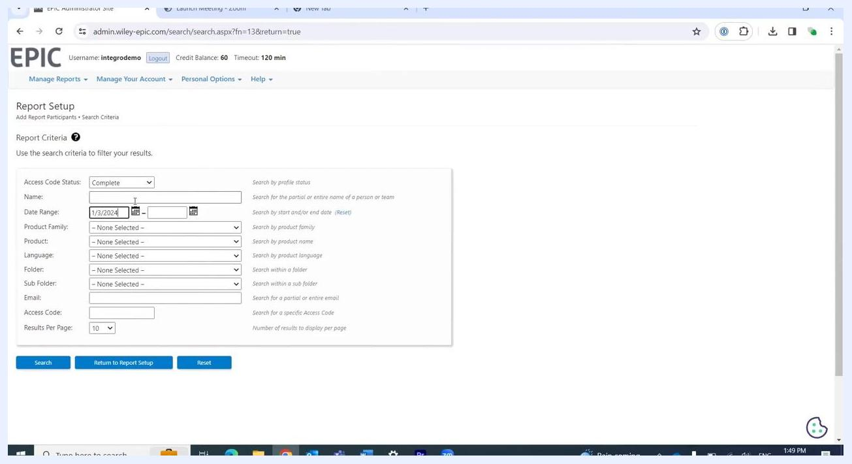
Report Setup screen with Date Range field being filled for a wide search, Access Code Status set to "Complete."

Step 9: Filter participants by product
In the Product dropdown, select Workplace Profile if you only want participants who completed this specific profile within your chosen date range. Confirm your search criteria are set as follows:
- Access Code Status: Complete
- Date Range: 1/3/2010 – 1/3/2024
- Product Family: Everything DiSC
- Product: Workplace Profile
Other fields, such as Language, Folder, Sub Folder, Email, and Access Code, can remain blank unless further filtering is needed. Click the Search button to display matching participants.
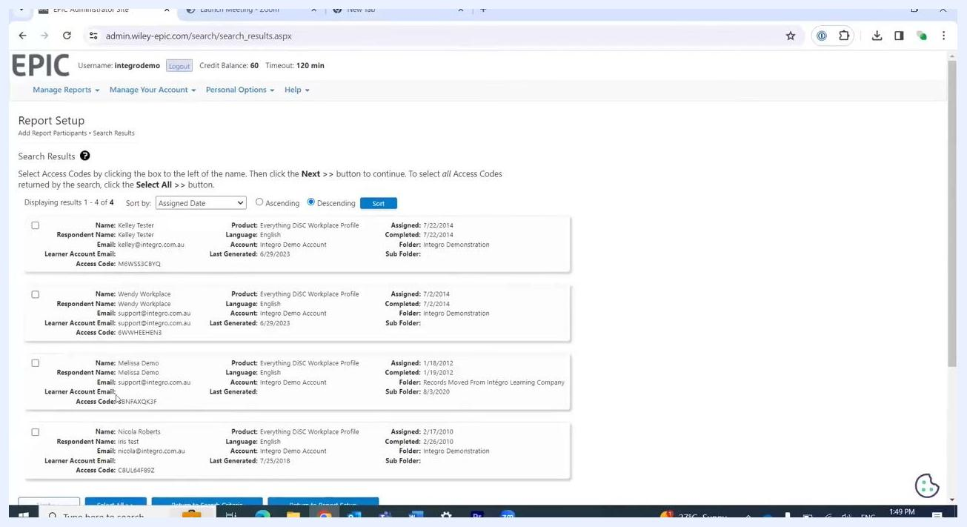
Report Setup screen with Product set to "Workplace Profile," Access Code Status "Complete," Date Range "1/3/2010 – 1/3/2024," and other filters available.

Step 10: Select participants for the report
Review the list of participants returned by your search. You can select participants individually by checking the box next to each name, or click Select All >> to include everyone listed.
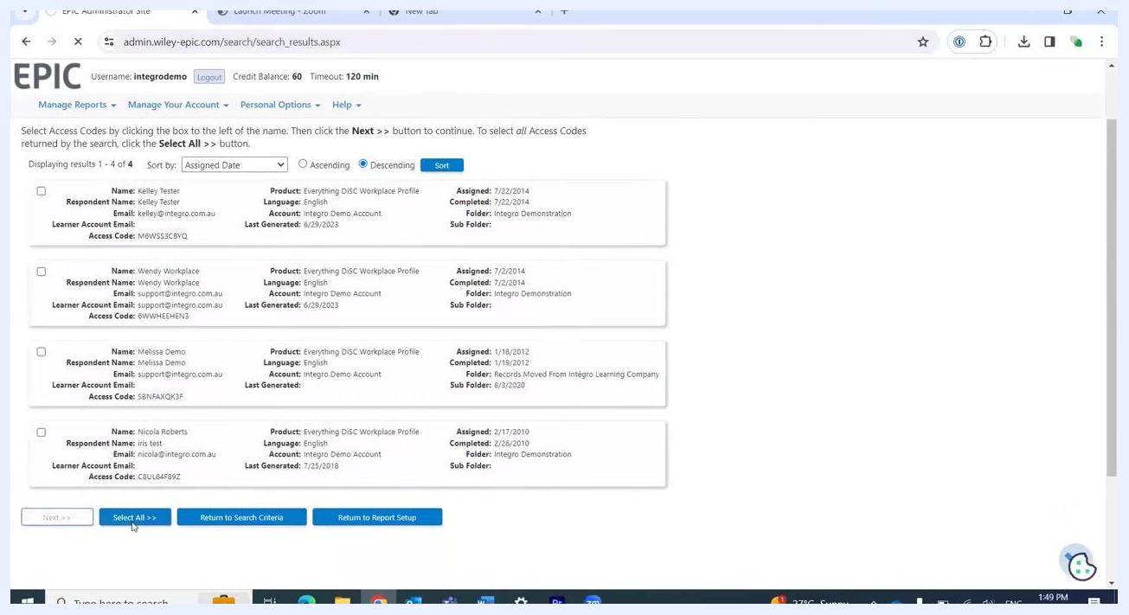
Search Results screen showing four participants with checkboxes, "Select All >>" button highlighted.

Step 11: Add selected participants to the report
After selecting the desired participants, click the Next >> button to add them to your report.

Step 12: Review and edit the participant list
On the report setup screen, review the list of participants you have added.
- If you included someone by mistake, remove them by clicking the X next to their email address.
- If you forgot to add someone, click the Add button to return to the search and include additional participants.
Report Details screen showing participant list with option to remove (X) or add participants.

Step 13: Finalize the participant list
Once your participant list is accurate and complete, click the Next >> button to proceed.
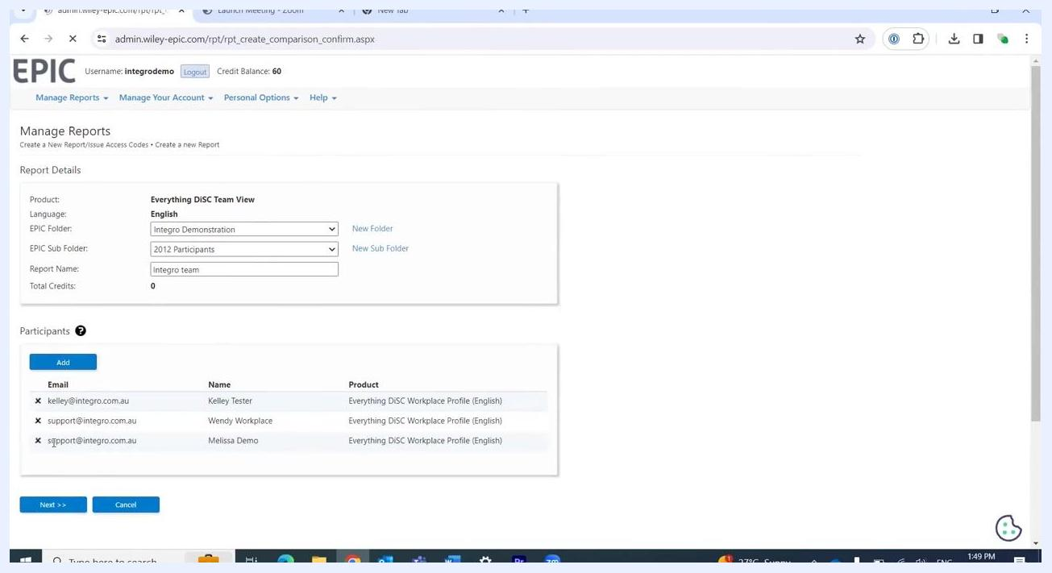
Report Details screen with finalized participant list and "Next >>" button.

Step 14: Review the report summary
Review the summary of your report, including:
- Access Code
- Product: Everything DiSC Team View
- Language: English
- Folder: Integro Demonstration
- Sub Folder: 2012 Participants
- Report Name: Integro team
- Created: 1/2/2024
- Total Credits: 0 (Team View reports do not use credits)
If you were generating a Facilitator or Group Culture report instead, a pop-up would appear to confirm the use of 25 credits before you reach this screen.
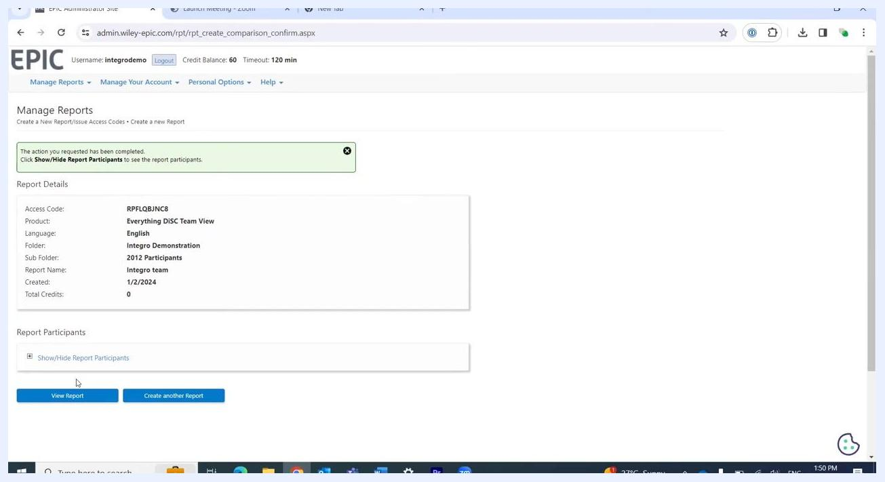
Report summary screen showing report details, access code, and total credits used (0).

Step 15: View or download the report
Click View Report to open the Team View report. You will have the option to view the report online, save it to your computer, or print it.
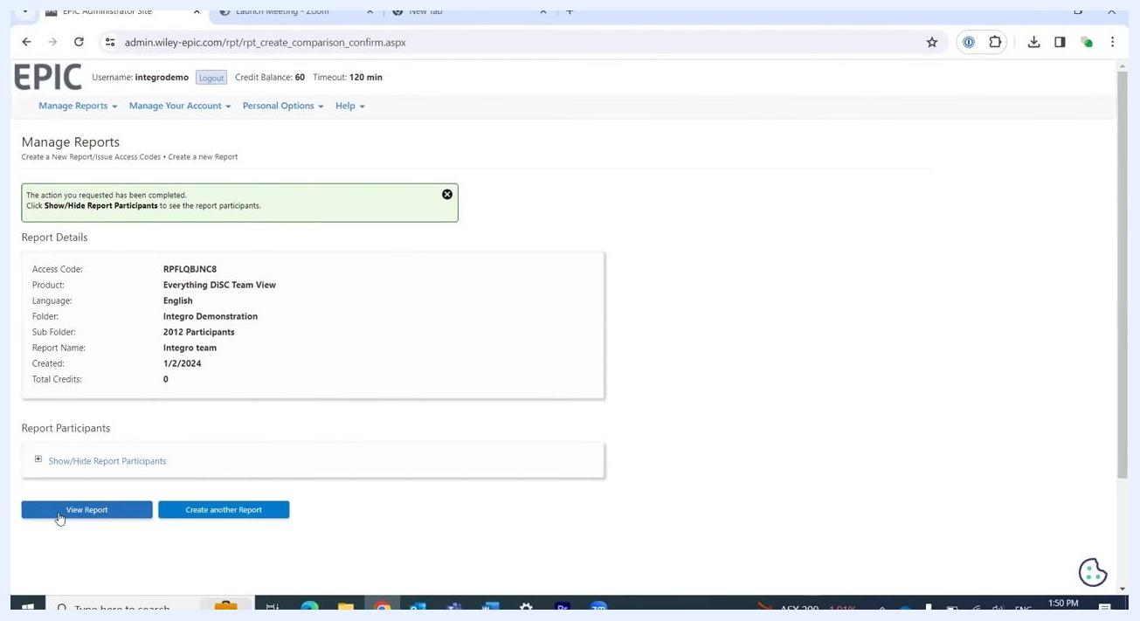
Report summary screen with "View Report" button highlighted.

Step 16: Open the generated report
After clicking View Report, a new browser tab or window opens displaying your completed Team View report as a PDF. You will see three main options for your report:
- View: Opens the report in your browser.
- Save: Downloads the report to your computer.
- Email: Sends the report via email.
Click View to open the report online.
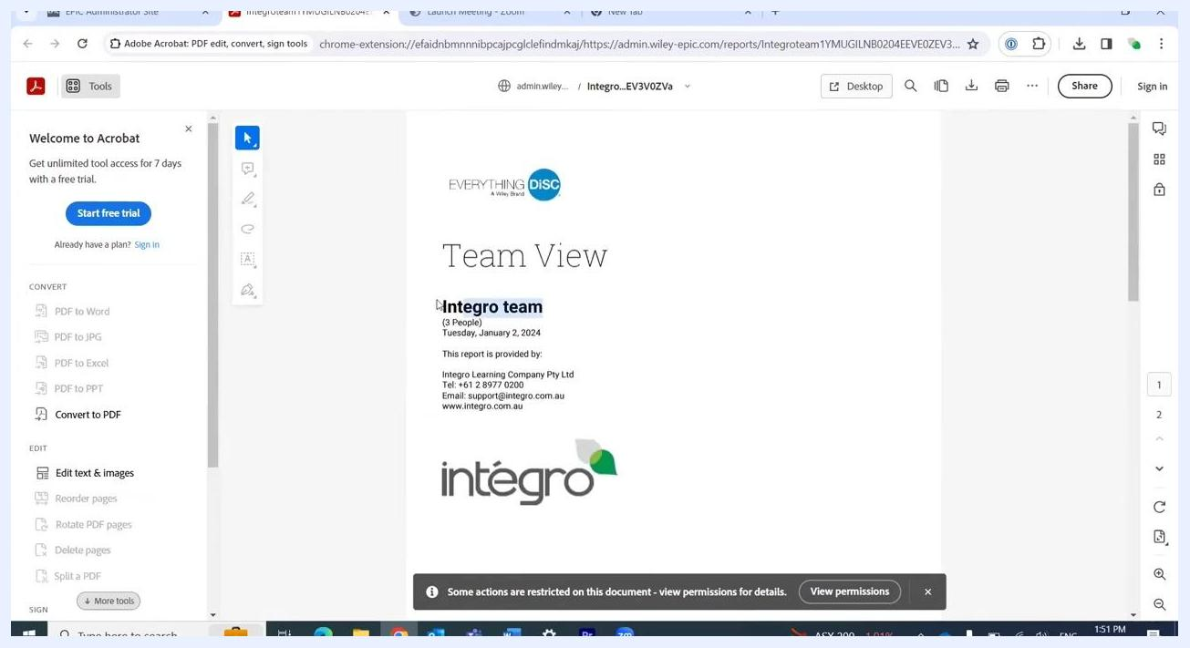
Manage Reports screen in EPIC showing Everything DiSC Team View report with options to View, Save, or Email. The cursor is clicking "View."

Step 17: Review the report title and details
In the new tab, review the cover page of your Team View report and confirm the following details:
- The main title reads Team View.
- Your assigned report name (for example, Integro team) appears under the title.
- The number of people included (for example, 3 People).
- The report creation date (for example, Tuesday, January 2, 2024).
- Provider information, including company name, phone number, email, and website.
- The company logo (for example, integro).
Adobe Acrobat online viewer displaying the Team View report cover page with report name, date, provider details, and logo.

Step 18: View team member DiSC styles
Scroll to the next page of the report to see a summary of the included team members and their DiSC styles. Each participant is listed with:
- Their name (for example, Melissa Demo, Kelley Tester, Wendy Workplace).
- Their DiSC style (for example, SC Style, iD Style, CD Style).
- A visual representation of their DiSC profile.
Use this summary to quickly understand the composition of your team.
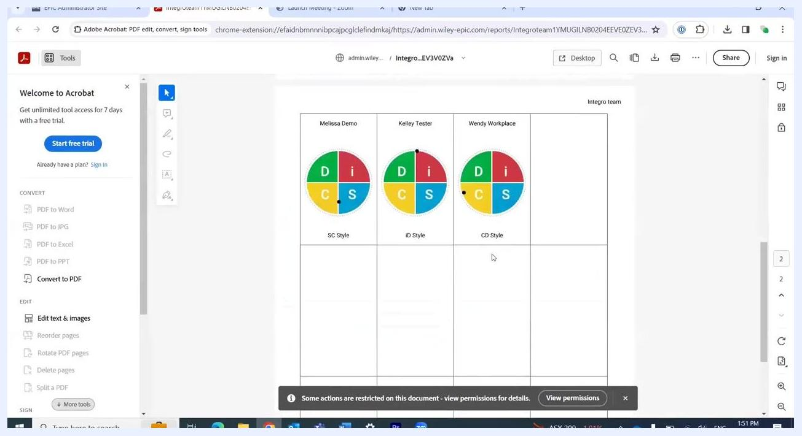
Team View report page showing participant names, DiSC style wheels, and style labels for each team member.

What's next
You now know how to run reports in EPIC Hyperspace, from creating a Team View report and adding participants to reviewing and downloading the finished PDF. You can save, print, or email the report as needed, and use the included DiSC style information to support your team's or department's development.

