How to Delete an Encounter in Epic When Insurance Is Attached
Deleting a patient encounter becomes more involved when insurance, charges, or a kept appointment status are attached to it. This guide walks you through how to delete an encounter in Epic (or a similarly structured EHR) step by step, including how to clear insurance and charges first, cancel the linked appointment, and confirm the encounter is permanently removed.

Prerequisites
- Access to the scheduler, patient chart, and clinical history sections of your EHR system.
- The patient record and encounter you intend to delete should be identified in advance.
- Permissions to edit appointments, remove insurance, and delete encounters.

Steps to delete an encounter in Epic

1. Select the patient with the kept appointment
Open the scheduler view and locate the patient who has a kept appointment along with the encounter you need to delete. The scheduler lists appointments by time, provider, and patient name, so identify the correct patient and appointment slot before proceeding.
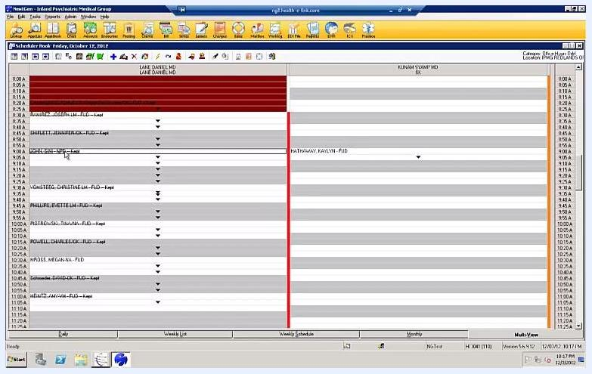
Scheduler view showing patient appointments, providers, and time slots, with a patient selected for a kept appointment.

2. Right-click the appointment to begin deletion
Right-click the selected appointment to bring up the options for managing the encounter. This action prepares the system for you to delete the encounter tied to this appointment.
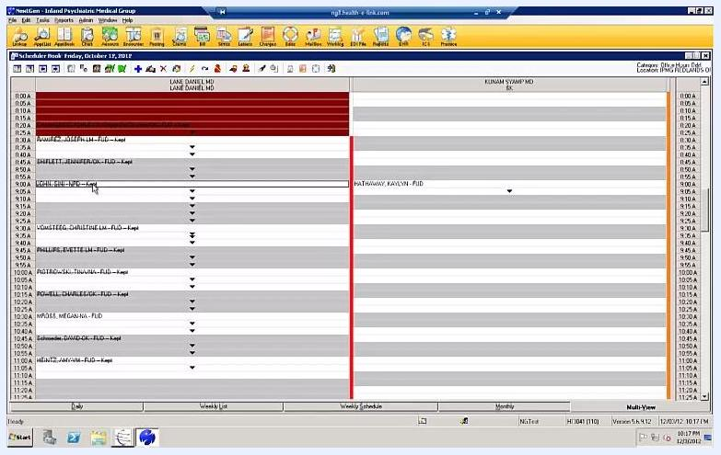
Scheduler view with a right-click menu open on a patient appointment.

3. Open the patient's chart to view encounters
Navigate to the patient's chart to review the full list of encounters. Confirm that the encounter you intend to delete (for example, Encounter #8839) appears in the list.
Patient chart screen showing the encounter list, encounter details, and patient information, with Encounter #8839 visible.

4. Check for attached insurance
Click the Insurance tab within the encounter details to see whether any insurance policies are attached to the encounter. The tab displays all associated insurance records.
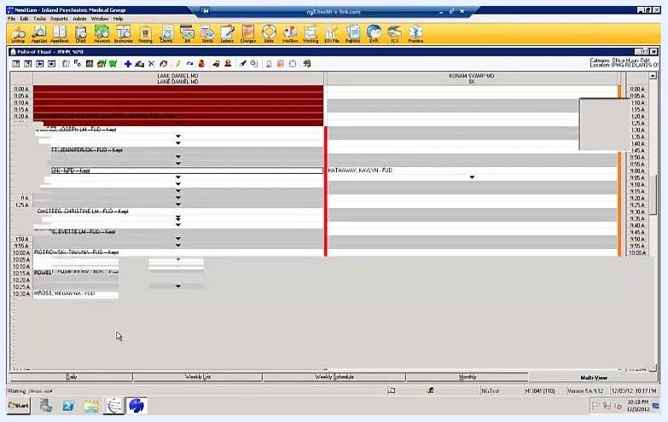
Insurance tab open in the patient chart, displaying insurance details attached to the encounter.

5. Attempt to delete the encounter and review the error
If you try to delete the encounter directly from the General tab while insurance is still attached, the system displays an alert stating the encounter cannot be deleted. This confirms that insurance must be removed before deletion can proceed.
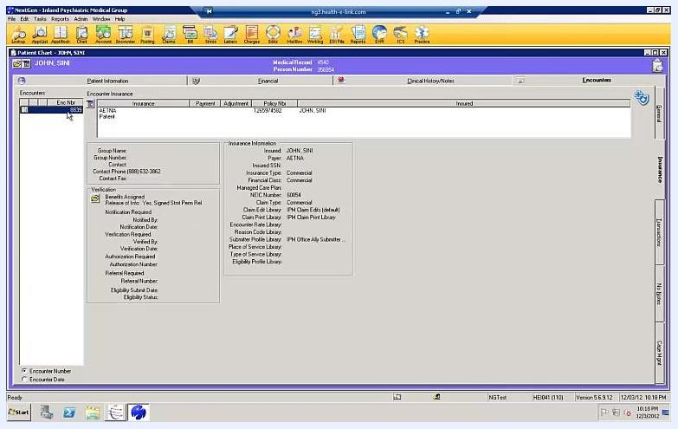
General tab of the patient chart showing the encounter details and an error preventing deletion due to attached insurance.

6. Remove the attached insurance
Right-click the insurance entry under the Insurance tab and select the option to delete it from the encounter. This step must be completed before you can delete the encounter itself.
Insurance tab with an insurance entry selected and ready for deletion via right-click.

7. Return to the General tab and check for charges
After removing the insurance, go back to the General tab in the encounter details. Click the Charges section to check whether any charges are associated with the encounter.
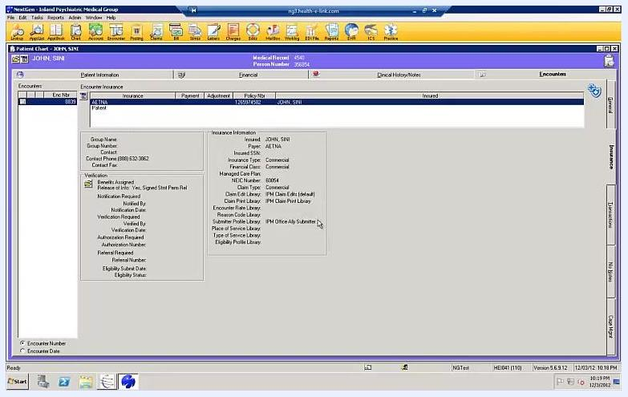
Patient chart with insurance removed, showing the General tab before checking associated charges.

8. Verify that no charges or ICD codes are present
Highlight the encounter in the patient chart and confirm there are no charges linked to it. If no charges exist, no ICD code will be present either. Close the charge posting window using the X in the upper right corner.
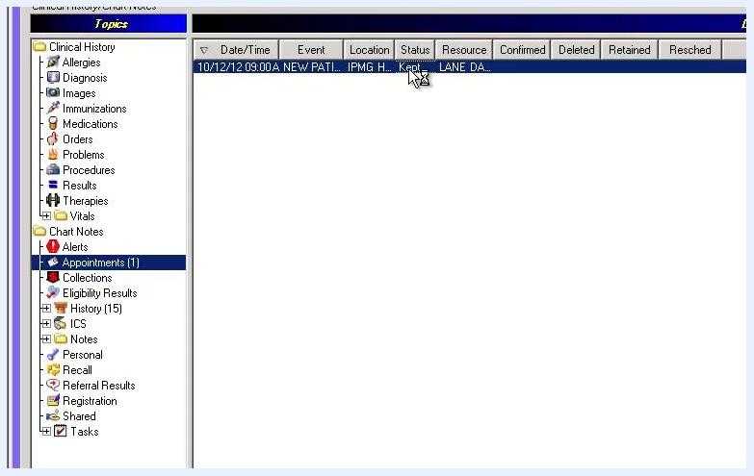
Charge posting screen for the encounter, confirming no charges or ICD codes are present.

9. Navigate to Clinical History and select the appointment
Go to the Clinical History section of the patient chart and locate the appointment in the list; its status should show as Kept. Double-click the appointment to open the edit appointment window.
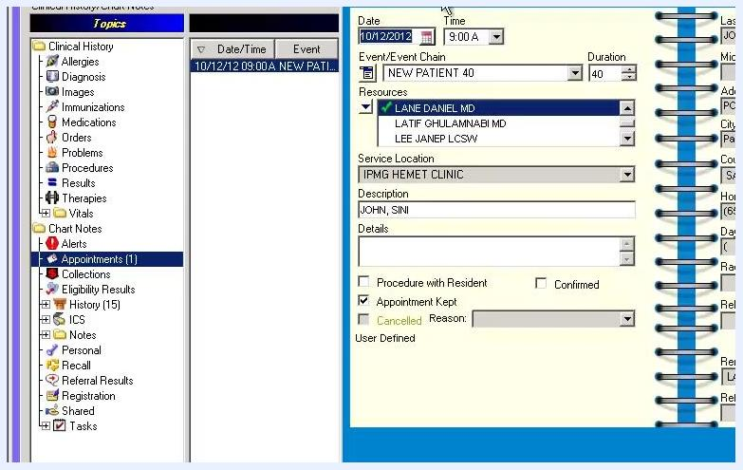
Clinical history section showing the appointment status marked as "Kept" and selected.

10. Remove the encounter from the appointment
In the edit appointment window, locate the encounter field and click the clear/delete icon next to the encounter number to unlink it. Confirm the removal when prompted by clicking OK, and verify the encounter is no longer attached to the appointment.
Edit Appointment window showing the encounter field with the option to clear the linked encounter.

11. Uncheck the "Appointment Kept" option
Since you are deleting both the encounter and the kept appointment, uncheck the Appointment Kept checkbox in the edit appointment window.
Edit Appointment window with the "Appointment Kept" checkbox now unchecked.

12. Cancel the appointment and select a reason
Click Cancelled in the appointment window, then choose a cancellation reason from the dropdown menu. If no specific reason applies, select Other. Click OK to confirm the cancellation.
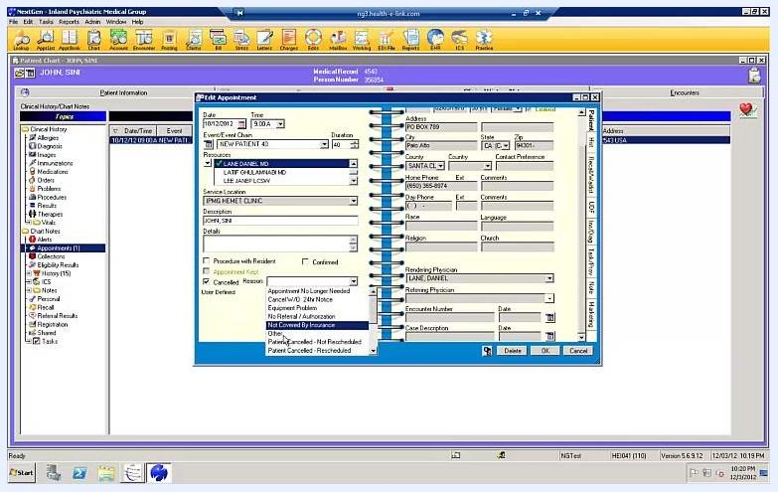
Edit Appointment window with the cancellation reason dropdown open and "Other" selected.

13. Verify the appointment status
Return to the clinical history or appointments list and confirm that the appointment status now reads Cancelled, with the encounter no longer linked.
Appointments list showing the appointment status as "Cancelled" with the encounter unlinked.

14. Delete the encounter from the General tab
Go back to the General tab in the encounter details and click the delete icon to initiate deletion. When the Confirm delete of encounter? dialog appears, click OK to permanently delete the encounter.
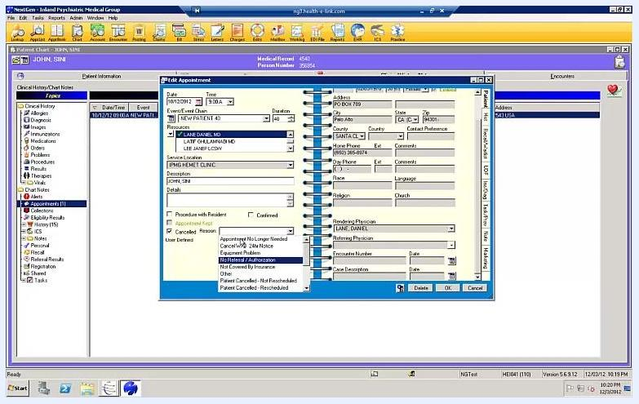
Patient chart General tab with the "Confirm delete of encounter?" dialog visible.

15. Verify the final appointment and encounter status
Open the appointment book or scheduling module and locate the patient's appointment. Confirm the status now shows Cancelled and that the previously linked encounter no longer appears. Review the schedule to ensure the changes have taken effect and the record is accurate.
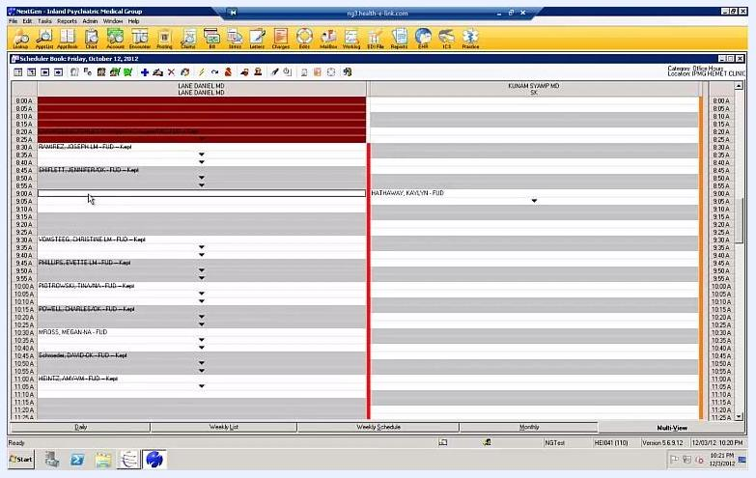
Appointment book showing the patient's appointment as cancelled, with the encounter removed from the schedule.

16. Close the EHR system
Once the cancellation and deletion are confirmed, close the EHR application if no further actions are needed, and return to your desktop.
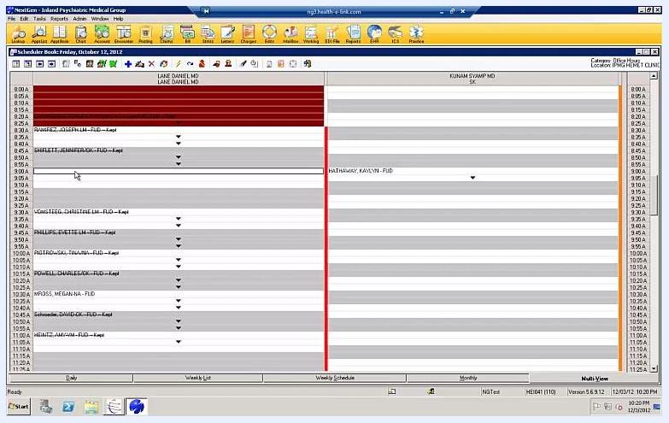
Desktop screen with the EHR application closed, marking the end of the workflow.

Summary
Deleting an encounter with attached insurance requires removing the insurance first, verifying there are no charges or ICD codes, unlinking the encounter from the kept appointment, and cancelling the appointment before the encounter can be permanently deleted. Following these steps in order ensures both the encounter and the associated kept appointment are fully removed, keeping your scheduling and patient records accurate.

