How to Create Order Set Favorites in eClinicalWorks
Order sets group related labs, procedures, and orders under a single code, which is necessary for proper documentation and workflow. This guide walks you through how to create order set favorites in eClinicalWorks, from navigating to the ordering box to confirming your favorite appears in the right panel for quick future access.

Prerequisites
- You must be working within a patient's progress note in eClinicalWorks 11e.
- You should understand that connecting a code with orders is required for accurate documentation.

Step 1: Navigate to the Treatment section
In the main workspace of the progress note, locate the Plan section. Under Plan, find and click Treatment to proceed.
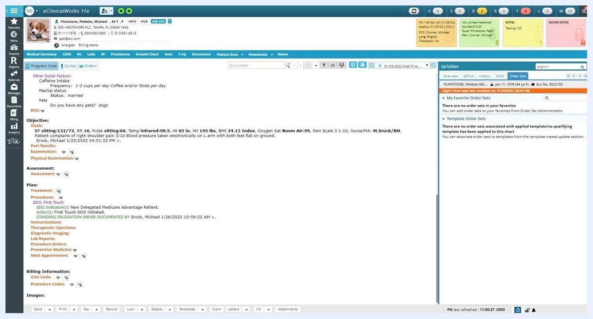
The Plan section is highlighted with Treatment visible and ready to be clicked. The right panel still shows no order sets.

Step 2: Open the ordering box
After clicking Treatment, an ordering box appears on your screen. This is where you will manage order sets. Wait for the box to fully load before continuing.
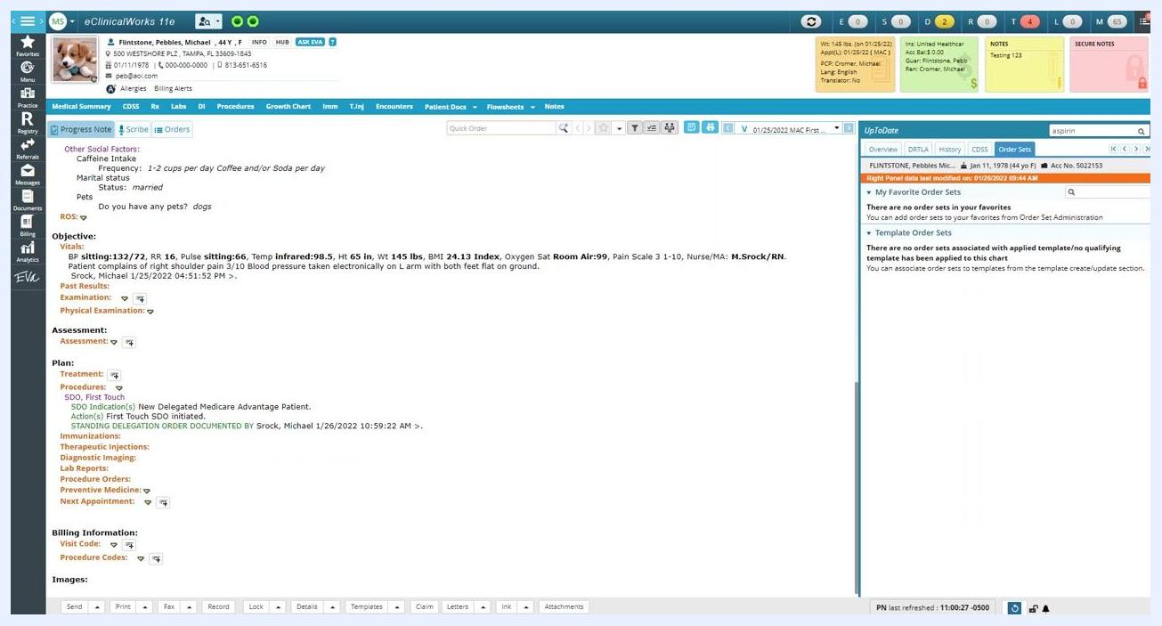
A new ordering box window appears in the center of the screen, overlaying the main interface. The box is currently blank, ready for further action.

Step 3: Open the Order Set section
In the ordering box, locate the button labeled OS (Order Sets) and click it to access the order sets functionality.
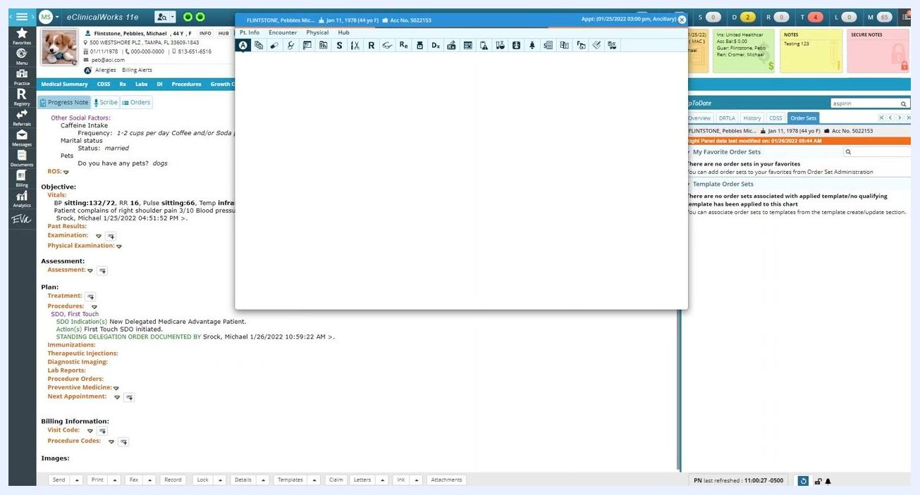
The ordering box now displays tabs and a section labeled Order Set under Other. The OS button is visible and ready to be clicked.
Confirm the ordering box now displays the Order Set area. This confirms you are in the correct section to begin creating or managing order sets.
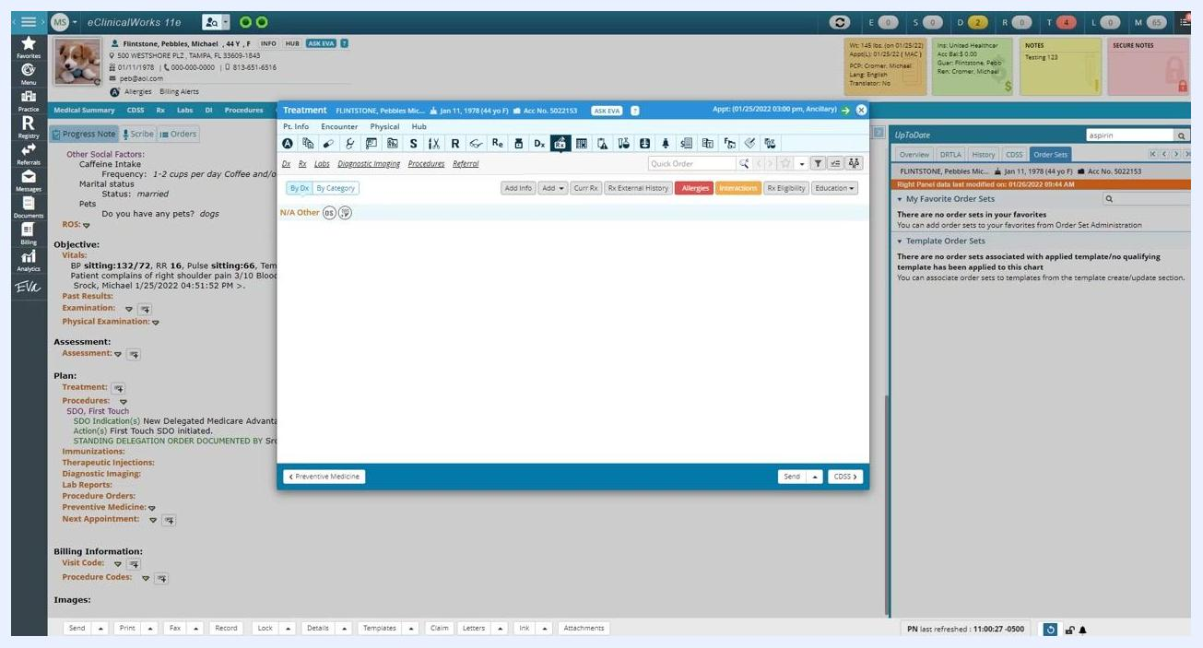
The ordering box shows the Order Set section under Other, confirming you are in the correct area to proceed with order set creation.

Step 4: Acknowledge the medication warning, if applicable
If a notification appears stating you are adding medications to a past encounter, acknowledge the message to continue. In a normal clinical workflow, this situation would not typically arise, but it is acceptable for training purposes.

Step 5: Open the Order Set dropdown menu
In the upper left corner of the ordering box, find the Order Set dropdown menu. By default, it may display an order set such as "A - Abdominal Pain (wm)." Click the arrow next to the field to display the full list of available order sets.
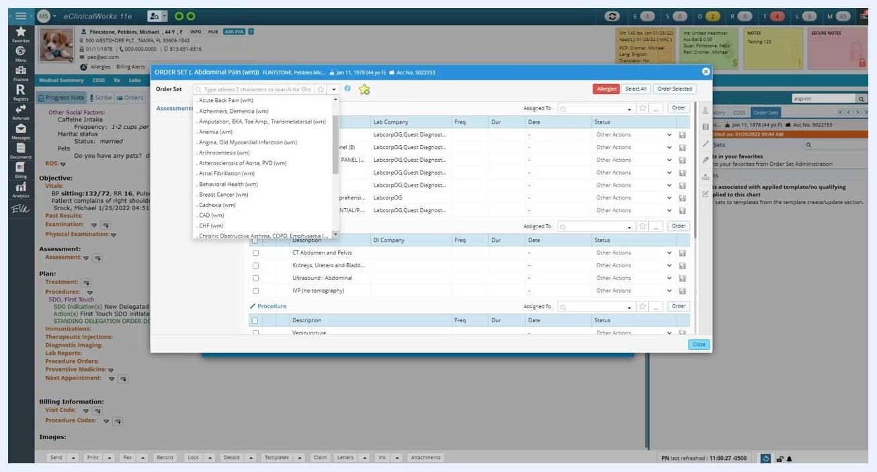
The order set dropdown menu is open, displaying a list of order sets in alphabetical order. The current selection is Abdominal Pain (wm).

Step 6: Select the First Touch Visit order set
Scroll through the alphabetical list of order sets using your mouse or arrow keys until you reach the section under "F" for "First Touch." Click First Touch Visit (wm) from the dropdown list. ("WM" stands for WellMed.)
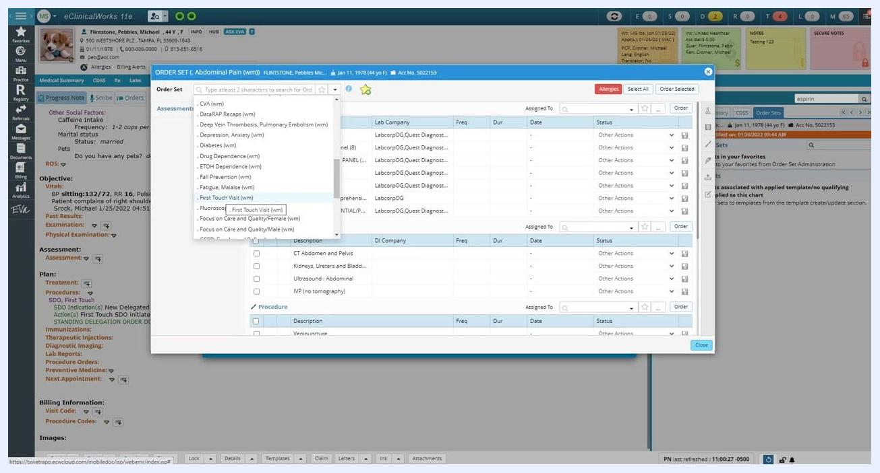
The First Touch Visit (wm) order set is highlighted in the dropdown list, ready to be selected.
Allow a moment for the system to load the selected order set. The list of labs and procedures updates automatically to reflect your selection.
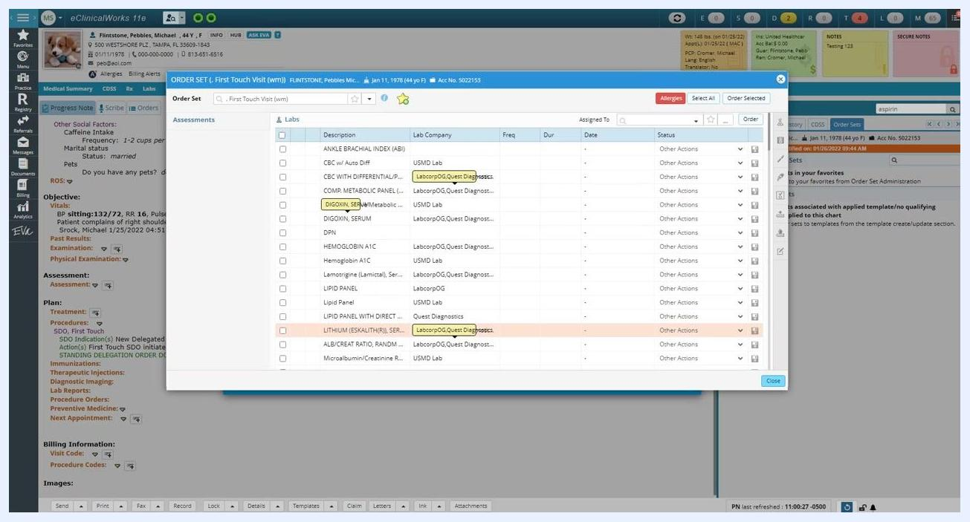
The First Touch Visit (wm) order set is now loaded, displaying a list of labs and associated details such as lab company and status.

Step 7: Mark the order set as a favorite
Locate the yellow star icon with a green plus sign near the top of the ordering box. Click the star icon until it changes to a red X. This adds "First Touch Visit (wm)" to your favorites for quicker access in future visits.
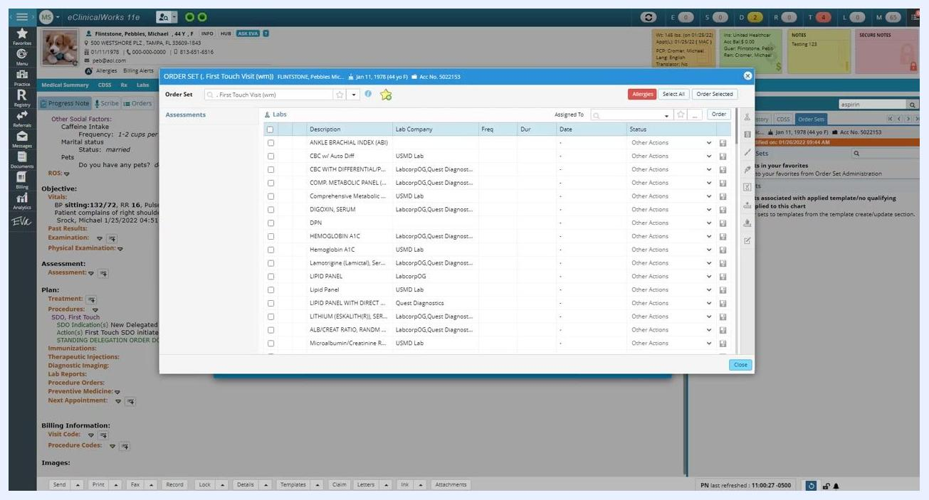
The First Touch Visit (wm) order set is loaded, and the favorite star icon is available to be toggled.

Step 8: Close the order set window
Click the X button in the upper right corner of the order set window to close it. If a separate treatment window is also open, click its X as well to close it.
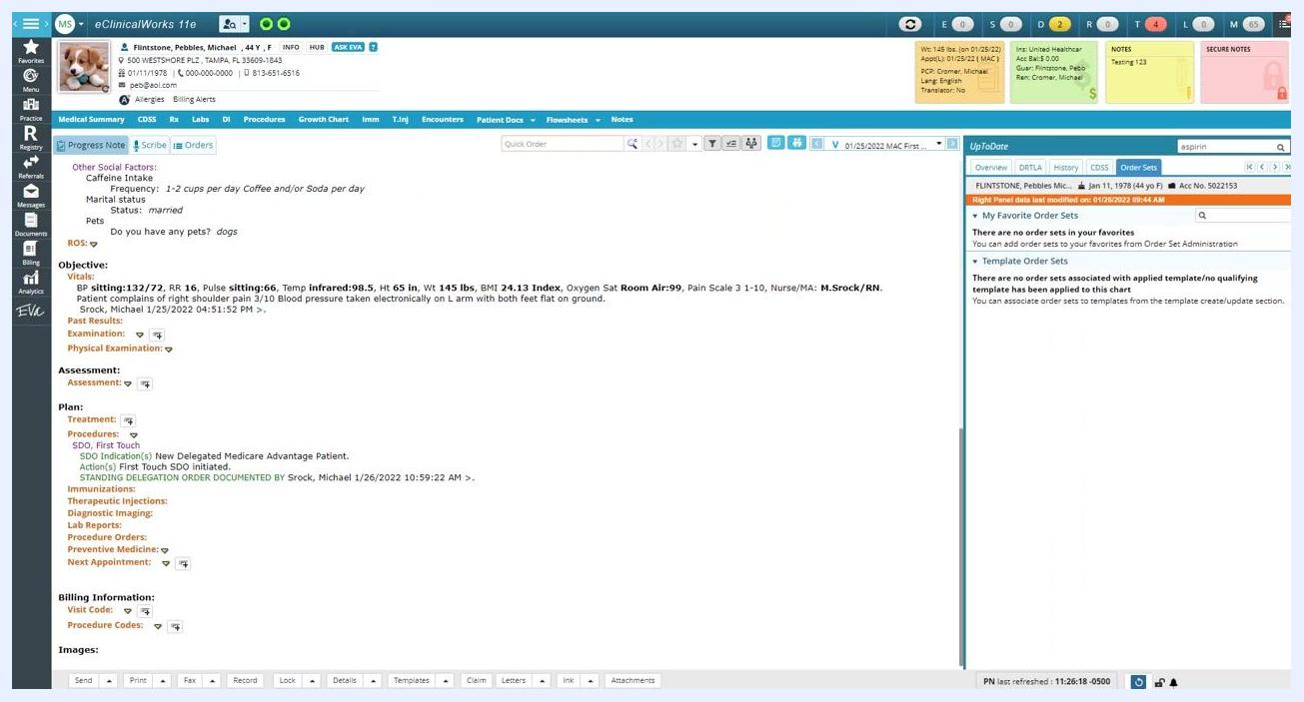
The order set window is still open, ready to be closed. The main patient chart is visible in the background.

Step 9: Verify your order set favorite
Navigate to the right panel of the eClinicalWorks 11e interface and click the Order Sets tab to open the list of order sets. Under My Favorite Order Sets, confirm that "First Touch Visit (wm)" appears in the list with a small "OS" icon next to it, indicating it is saved as a favorite.
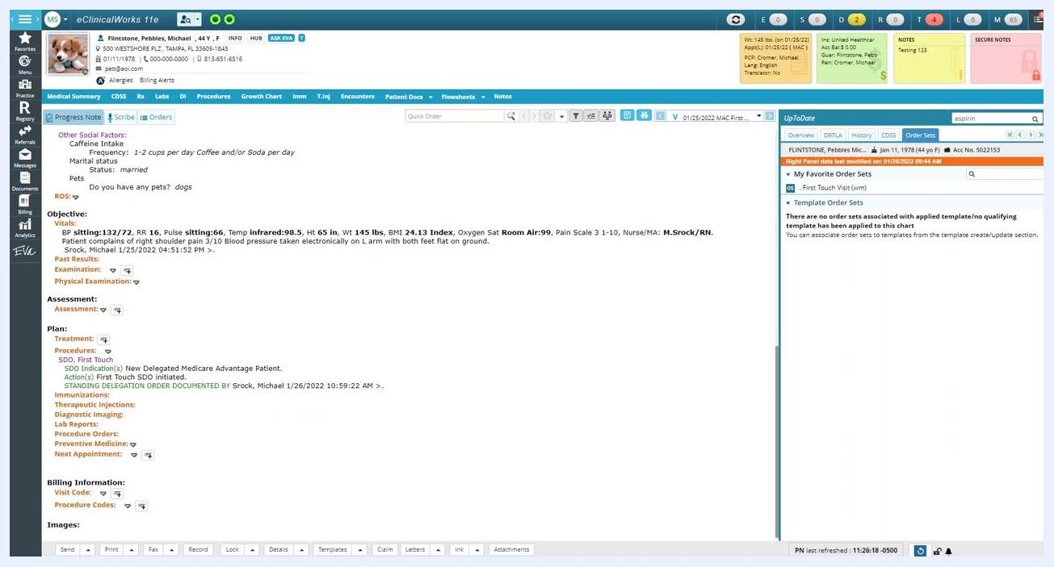
The Order Sets tab is open in the right panel, showing My Favorite Order Sets with First Touch Visit (wm) listed and an OS icon next to it.

Summary
By following these steps, you have successfully navigated to the order set creation area, changed the active order set to "First Touch Visit (wm)," and added it to your favorites in eClinicalWorks 11e. Your favorite order set is now available in the Order Sets tab for faster access in future workflows.

