How to Void a Check in Business Central
When a check is issued incorrectly or needs to be reversed after posting, you can void a check in Business Central even if it was issued in a prior period. This guide walks you through locating the posted check, running the void process, and confirming that the reversal is correctly reflected in your bank account ledger.

Prerequisites
- Access to Dynamics 365 Business Central with permissions to view and process check ledger entries.
- The check number, bank account, and other identifying details of the check you want to void.
- Knowledge of whether the check was applied to a payables invoice, since this determines which void option you select.

Step 1: Start from the Business Central homepage
Open your Dynamics 365 Business Central homepage. The homepage displays company insights, activities, and quick actions, such as summaries of your top customers and recent transactions.
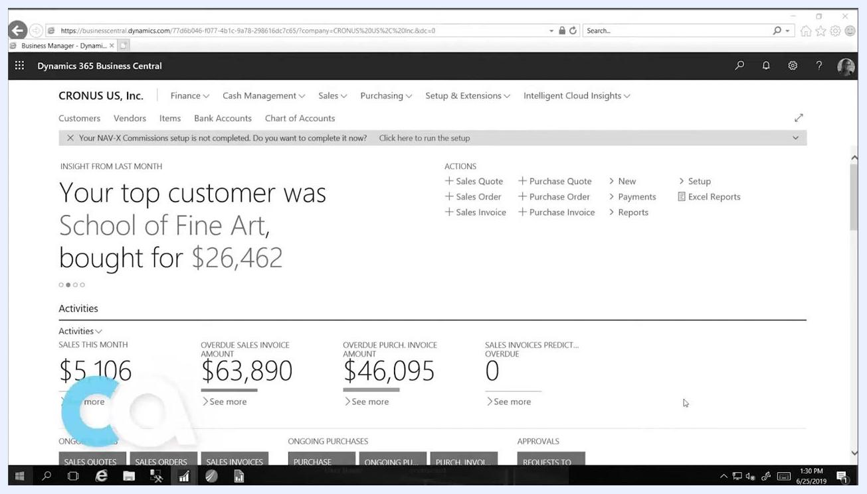
Dynamics 365 Business Central homepage showing company insights, activities, and quick actions

Step 2: Search for check ledger entries
Click the search icon or the Tell Me What You Want To Do bar, then type "check ledger" into the search field. Select Check Ledger Entries from the search results to open the list of posted checks.
Search bar with "check ledger" entered and "Check Ledger Entries" highlighted in the dropdown

Step 3: Review the list of posted checks
In the Check Ledger Entries window, review the columns for Check Date, Check No., Bank Account No., Description, Amount, Entry Status, and Entry No. For example, you might see a check dated 1/1/2017, Check No. 203, Bank Account No. CHECKING, Description "Fabrikam, Inc.," Amount 226.84, with an Entry Status of Posted.
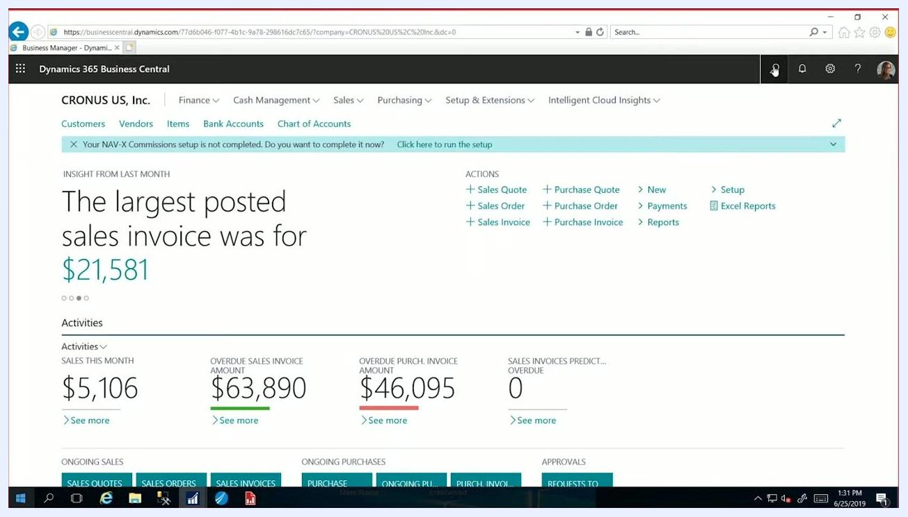
Check Ledger Entries window listing posted checks, with the check from 1/1/2017 selected

Step 4: Select the check you want to void
Click on the row for the specific check you want to void, such as Check No. 203 dated 1/1/2017.

Step 5: Open the void check option
Click the Process menu at the top of the Check Ledger Entries window, then select Void Check from the dropdown menu.
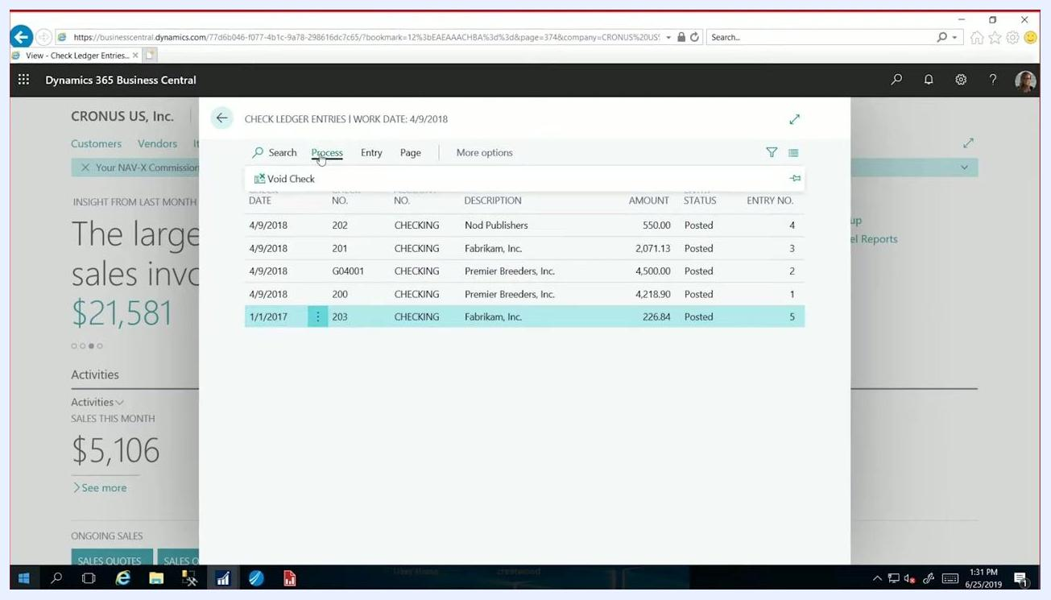
Process menu expanded with the "Void Check" option visible and the check entry selected

Step 6: Confirm the void details
A prompt appears asking, "Do you want to void this check?" Set the Void Date, for example 1/1/2017, then choose the appropriate Type of Void:
- Unapply and void check — select this option if the check was applied to a payables invoice.
- Void check only — select this option if you do not need to unapply the check.
Review the details shown, including Bank Account No. (CHECKING), Check No. (203), Vendor No. (10000), and Amount (226.84). Click Yes to confirm and proceed with voiding the check.
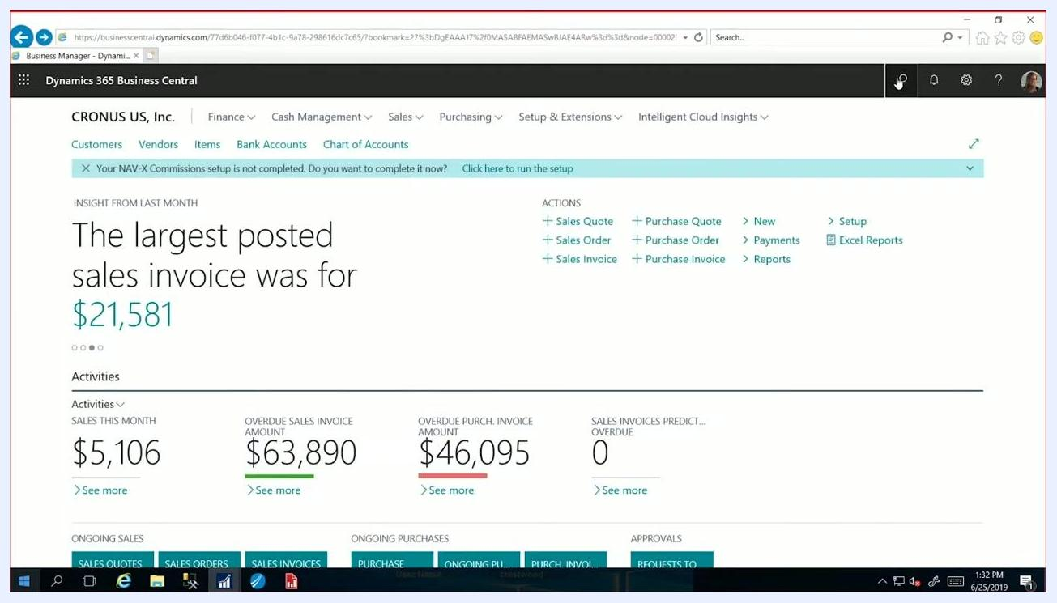
Void check confirmation dialog showing the void date, type of void, and check details

Step 7: Verify the check status has updated
After confirming, the Entry Status for the voided check updates accordingly. The check remains listed in the Check Ledger Entries window but is now marked as voided.
Check Ledger Entries window showing the voided check with its updated status

Step 8: Return to the homepage
Navigate back to the main dashboard to confirm that the voided check is no longer showing as active.
Dynamics 365 Business Central homepage after voiding the check

Step 9: (Optional) Review the bank account
To view the checking account details, go to the Cash Management menu and click Bank Accounts.
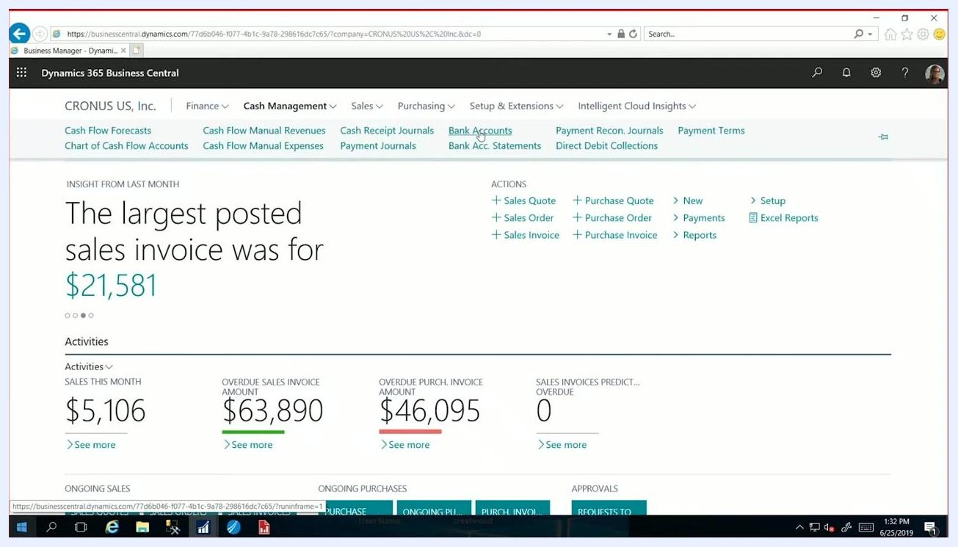
Cash Management menu expanded with "Bank Accounts" highlighted

Step 10: Review the bank account ledger entries
Open the Bank Account Ledger Entries window for the relevant bank account, such as CHECKING, to verify the voided check's impact on the account balance. Examine the list of entries that make up the checkbook account balance:
- Locate the original payment entry for the voided check, for example Payment, Document No. 203, Description "Fabrikam, Inc.," Amount -226.84.
- Identify the voiding entry that reverses the original payment, for example Description "Voiding check 203," Amount 226.84.
- Confirm that both the deduction (original payment) and the reversal (void entry) appear in the ledger.
Note that both entries use the posting date 1/1/2017 by default, since this was the default value during the void process. You can change the posting date during the void process if you need the voided transaction to reflect a different date.
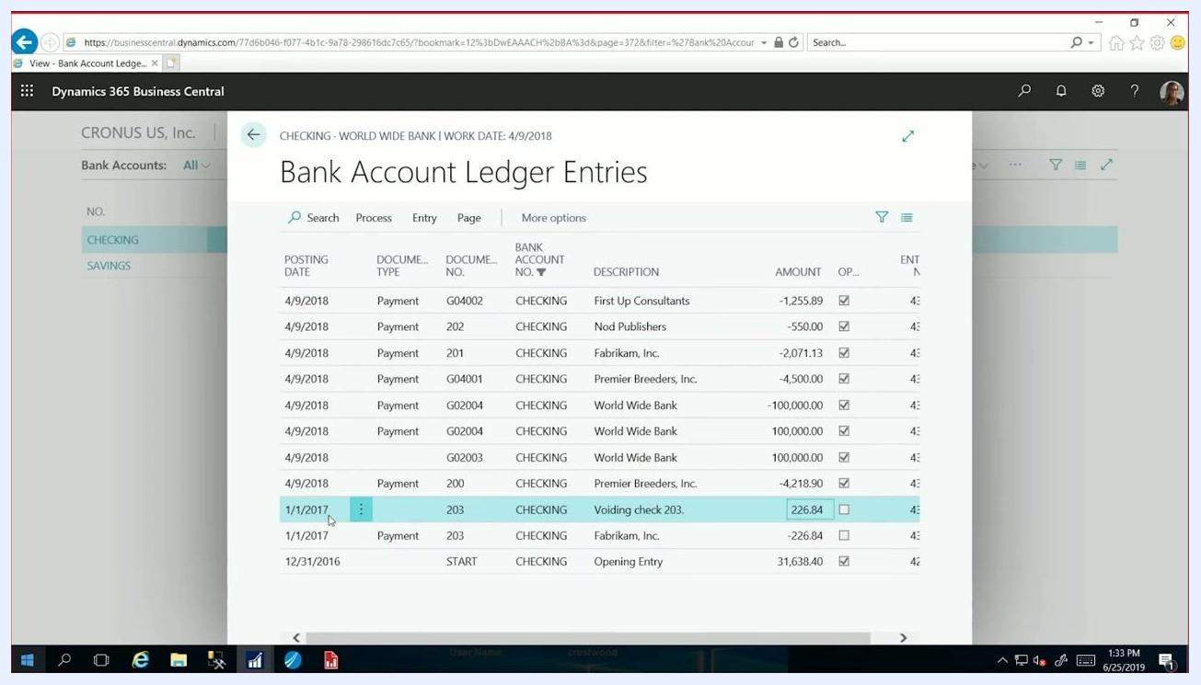
Bank Account Ledger Entries window showing both the original payment and the voiding entry for check 203, with posting date 1/1/2017

Summary
Once the voiding entry appears alongside the original payment in the Bank Account Ledger Entries window, the ledger accurately reflects both the deduction and the reversal for the voided check, and no further action is required. This confirms that the check has been properly voided and that your bank account ledger is accurate.

What's next
If you need to adjust the transaction date, you can repeat the void process and change the posting date as needed. For further assistance with voiding checks or other Business Central procedures, consult your Dynamics 365 documentation.
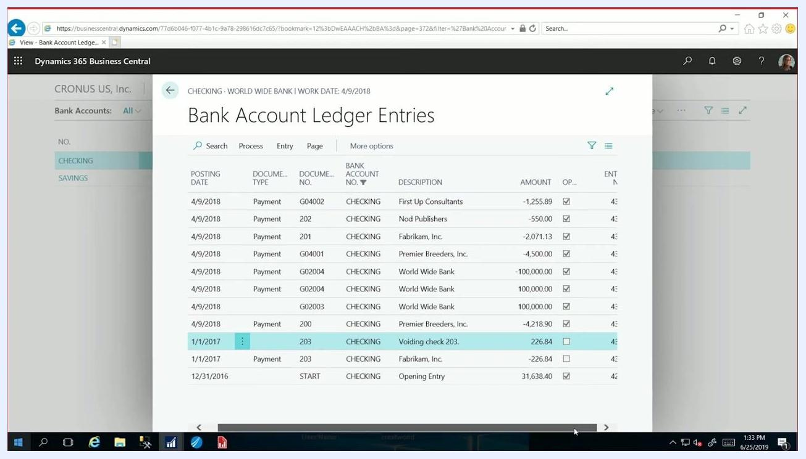
Crestwood Associates logo and website URL on a blue gradient background

