How to Create a Purchase Order in Business Central
This guide walks you through how to create a purchase order in Business Central, from opening the dashboard to posting a completed order. You'll learn how vendor and item selections automatically populate order details, and how to review totals before finalizing the transaction.

Prerequisites
Before you begin, make sure you have access to Microsoft Dynamics 365 Business Central with permissions to create purchasing documents. You should also know which vendor and items you intend to purchase.

Step 1: Access the Business Central dashboard
Open Microsoft Dynamics 365 Business Central and confirm you are on the main dashboard. Here you'll see company information (such as CRONUS USA, Inc.), navigation menus including Finance, Cash Management, Sales, and Purchasing, along with activity summaries for sales, purchases, and overdue invoices.
The right side of the screen displays insights such as best-selling items and quick action links for sales and purchase documents.
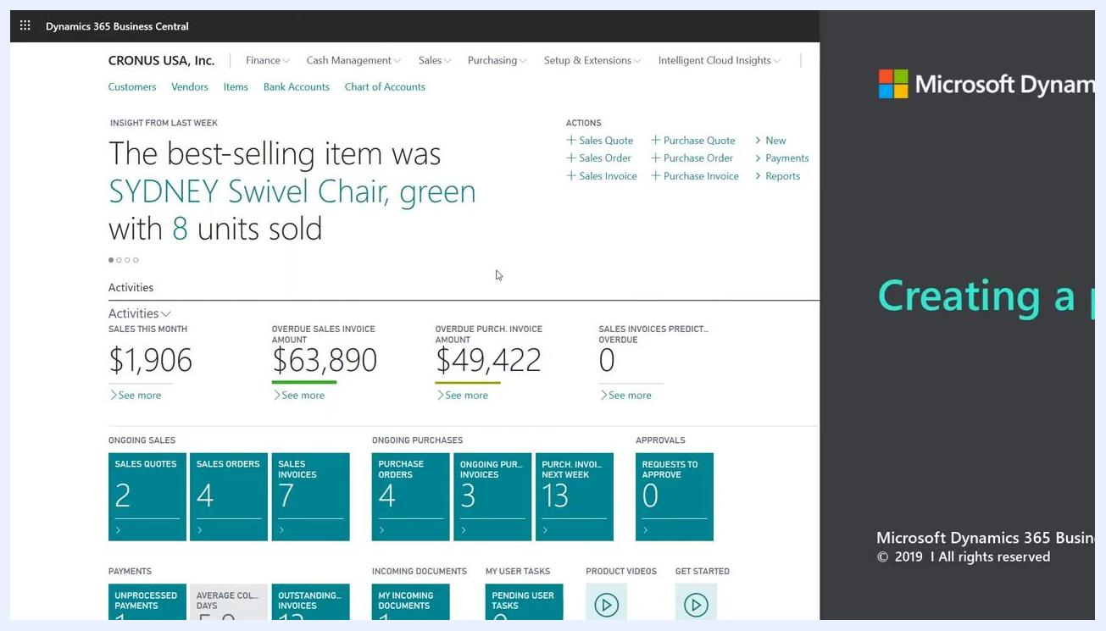
Business Central dashboard showing company information, navigation menus, activity summaries, and quick action links

Step 2: Understand purchase document types
Business Central offers two main purchase documents: Purchase Invoices and Purchase Orders. Use a purchase order when the supplier will only partially ship your order. Both document types are similar, but this partial-shipment capability is the key distinction.

Step 3: Search for purchase orders
Use the search function at the top of the dashboard and type Purchase Orders into the search bar. In the search results, select the Purchase Orders link to navigate to the purchase orders list.
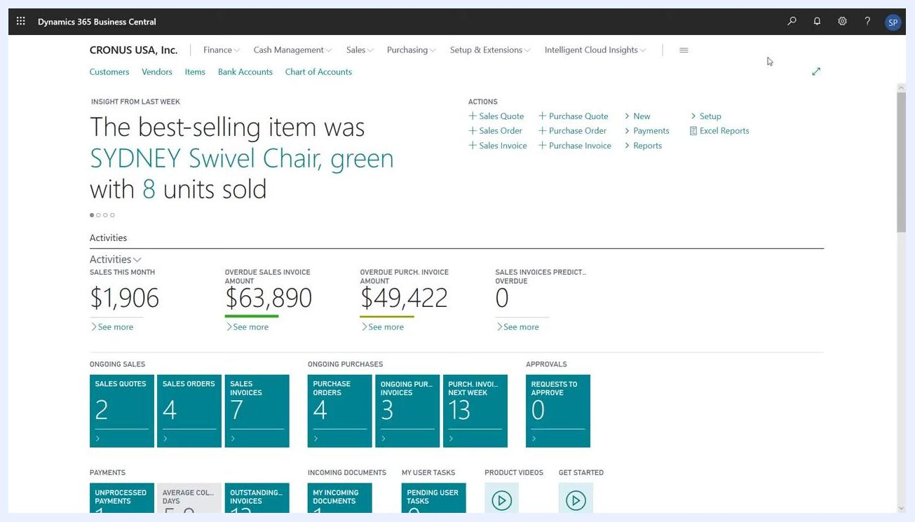
Dashboard displaying search results and navigation options for purchase orders

Step 4: Create a new purchase order
On the Purchase Orders page, click New to start a new purchase order.

Step 5: Select the vendor
In the new purchase order form, choose the vendor you are buying from. When you select a vendor, Business Central automatically fills in the purchase header fields using information from the vendor card, including:
- Vendor name (for example, Graphic Design Institute)
- Contact (for example, Bryce Jasso)
- Address (for example, 33 Hitech Drive, Miami, FL, 37125, US)
- Payment terms and posting details
You can edit any of these fields if necessary.
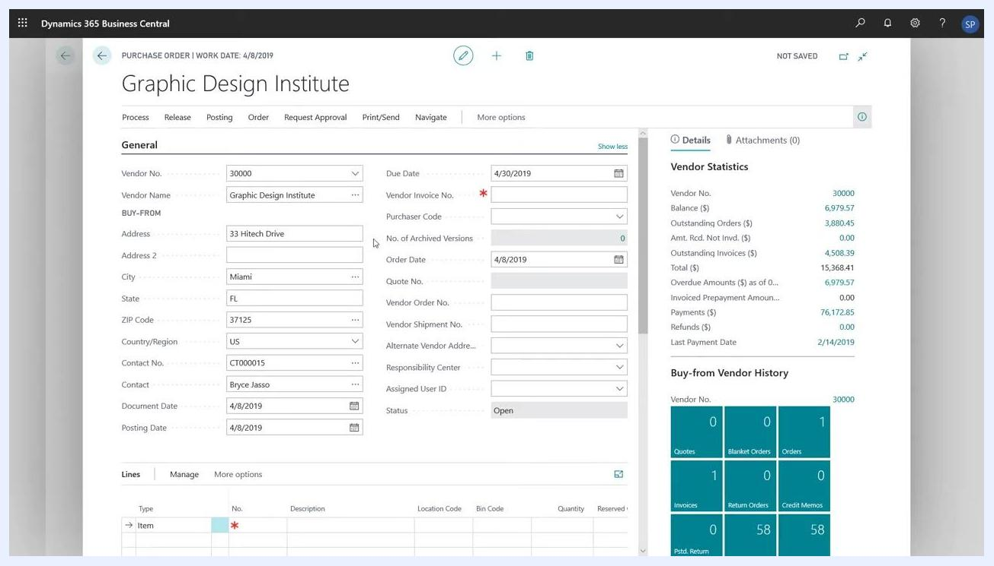
Purchase order form with vendor details auto-filled, including vendor name, contact, address, and other fields

Step 6: Review the automatically filled fields
Check that the following fields are populated based on the work date and vendor information:
- Document Date (for example, 4/8/2019)
- Posting Date (for example, 4/8/2019)
- Order Date (for example, 4/8/2019)
- Due Date, calculated from the document date and payment terms (for example, 4/30/2019)
Adjust any of these fields as needed before proceeding.
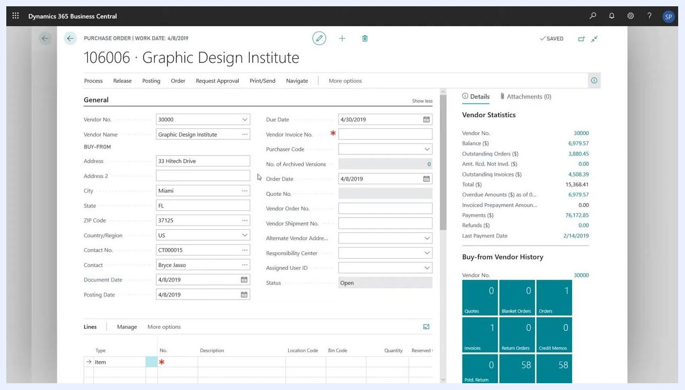
Purchase order form showing populated dates and vendor details

Step 7: Add purchase lines
Scroll to the Lines section of the purchase order and click to add a new line. A dropdown will appear for the line type. Business Central supports five types of purchase lines:
- Comment
- General Ledger (G/L) Account
- Item
- Fixed Asset
- Charge (Item)
Select the type that matches your purchase. For example, choose Comment if you want to add a message to your vendor in the description field.
Purchase order lines section with dropdown showing line types: Comment, G/L Account, Item, Fixed Asset, Charge (Item)

Step 8: Choose the line type for your item purchase
Click the dropdown under the Type column in the Lines section and select Item from the list. Use G/L Account instead if you are purchasing services or non-inventory items. For this example, select Item to purchase an inventory item.
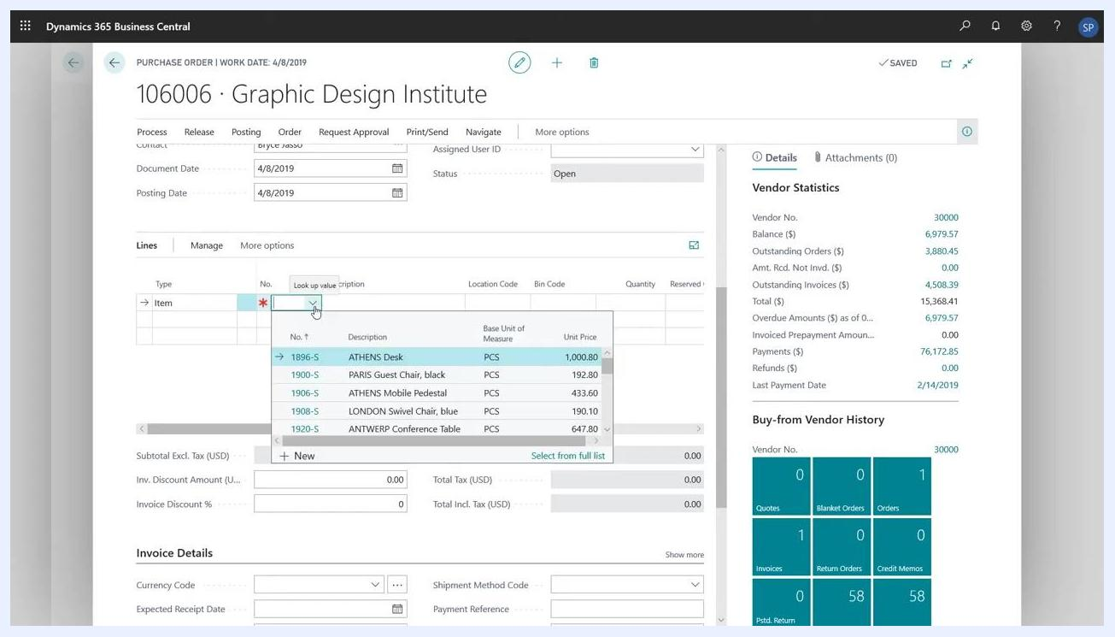
Purchase order line type dropdown open, with "Item" selected among the available options

Step 9: Select the item to purchase
In the No. field, click the lookup button to open the list of available items. Browse or search for the item you want to purchase, then click to select it (for example, "1908-S LONDON Swivel Chair, blue"). Business Central automatically fills in related fields such as Description, Base Unit of Measure, and Unit Price.
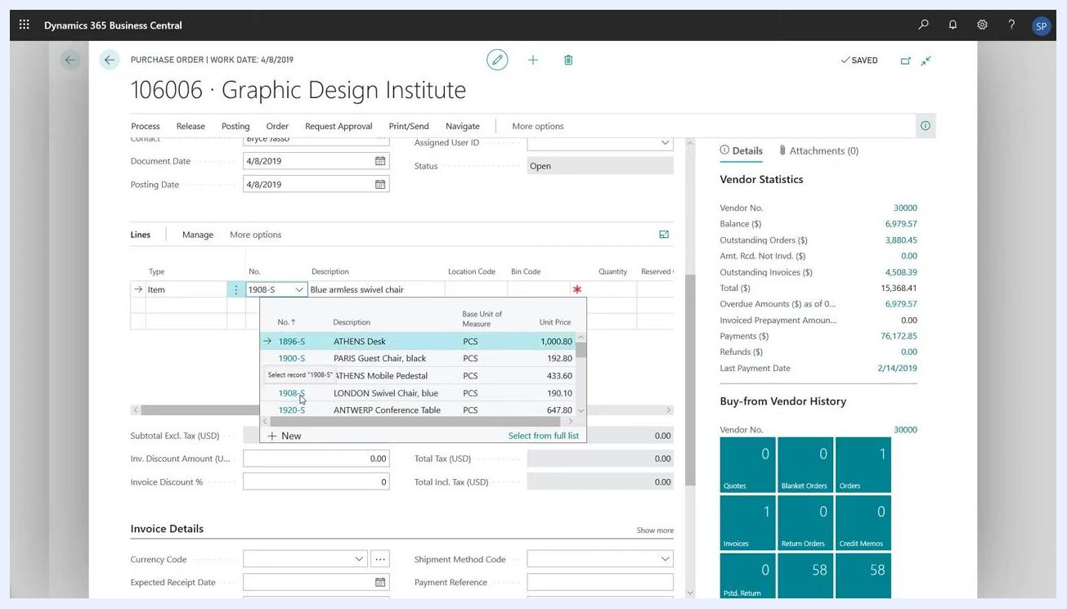
Item selection dropdown showing item numbers, descriptions, units, and prices, with "1908-S LONDON Swivel Chair, blue" highlighted

Step 10: Review and complete the line details
Confirm that the following fields are auto-filled based on the selected item:
- Description (for example, "Blue armless swivel chair")
- Unit of Measure Code (for example, "PCS")
- Direct Unit Cost Excl. Tax (for example, "148.10")
- Tax Area Code (for example, "ATLANTA, GA")
- Tax Group Code (for example, "FURNITURE")
Enter the desired quantity in the Quantity field (for example, "3"), and double-check that the unit cost and other details are correct.
Purchase order line filled with item details, including type, description, unit of measure, direct unit cost, tax area, tax group, and a quantity field ready for input

Step 11: Add additional items (optional)
To purchase more items, add new lines by clicking below the existing line. Repeat the process: select Item as the type, choose the item, and enter the quantity. Each new line is auto-filled with the relevant item details.
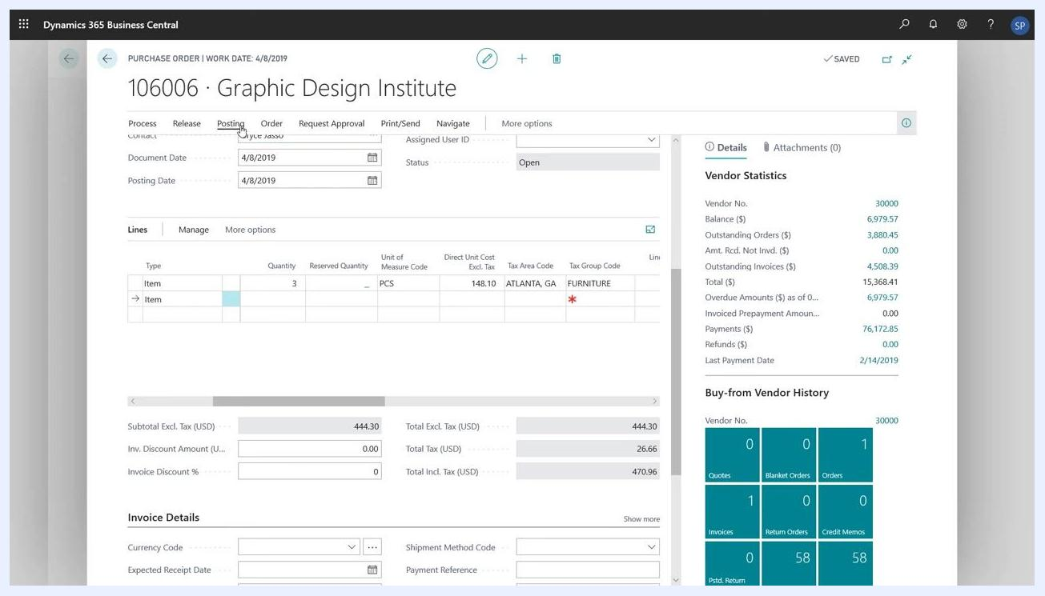
Purchase order with two item lines, each showing quantity, unit of measure, direct unit cost, and tax details

Step 12: Review the purchase order summary
Before posting, check the summary fields at the bottom of the form:
- Subtotal Excl. Tax (USD) (for example, "444.30")
- Total Excl. Tax (USD) (for example, "444.30")
- Total Tax (USD) (for example, "26.66")
- Total Incl. Tax (USD) (for example, "470.96")
Confirm that other invoice details, such as currency code and expected receipt date, are correct.

Step 13: Post the purchase order
Once all lines and details are correct, click Posting at the top of the screen. Choose the appropriate action, such as Post or Post and Print, to finalize the purchase order. The screen will clear or update to confirm the order has been posted.
Purchase order form with multiple item lines, summary totals, and the "Posting" menu highlighted at the top

Summary
By following these steps, you have successfully created and posted a purchase order in Microsoft Dynamics 365 Business Central. Your vendor details, item lines, and order totals are now accurately recorded in the system.

