How to submit a termination form in Dayforce
This guide explains how to submit a termination form in Dayforce, from locating the employee record to submitting the completed form for HR and Payroll processing. Follow these steps whenever you need to formally terminate an employee in the system.

Prerequisites
- You must have manager-level access to view your direct reports and their profiles.
- You need a copy of the employee's resignation letter (or relevant supporting document) ready to upload.
- Confirm the employee's last day of work and last pay date before starting the form.

Find the employee

1. Navigate to your home page
Start on the home page of the HR system. At the top, confirm that your name and role are displayed correctly (for example, "Sideshow Bob 3, Area Manager - Platypus VIC 1 - Retail Field Support - Platypus").
Locate the My Team section, which lists your direct reports (for example, "Homer Simpson 2, Platypus Store Manager"). At the bottom of the page, you'll also see the Events and Actions tabs, with Events selected by default and showing "No Upcoming Events."
To find the employee you wish to terminate, click View Hierarchy on the right side of the My Team section.
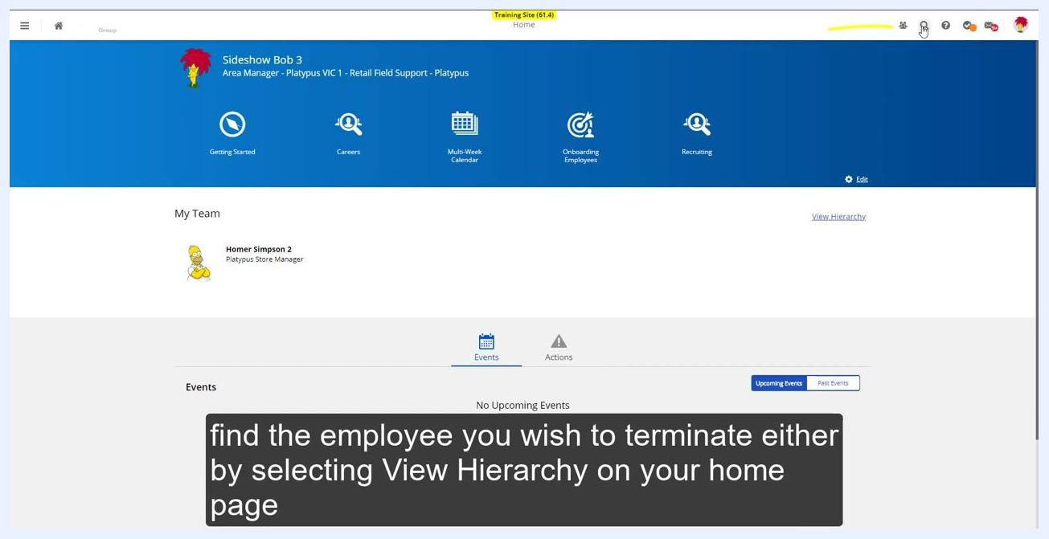
HR system home page showing the My Team section, the View Hierarchy link, and the Events/Actions tabs. On-screen instruction: "Find the employee you wish to terminate either by selecting View Hierarchy on your home page."

2. Select the employee to terminate
In the hierarchy or people search, locate the employee you wish to terminate (for example, "Lisa Simpson 8, Platypus Sales Assistant"). Click the employee's name to open their profile summary.
In the pop-up that appears, click View Profile.
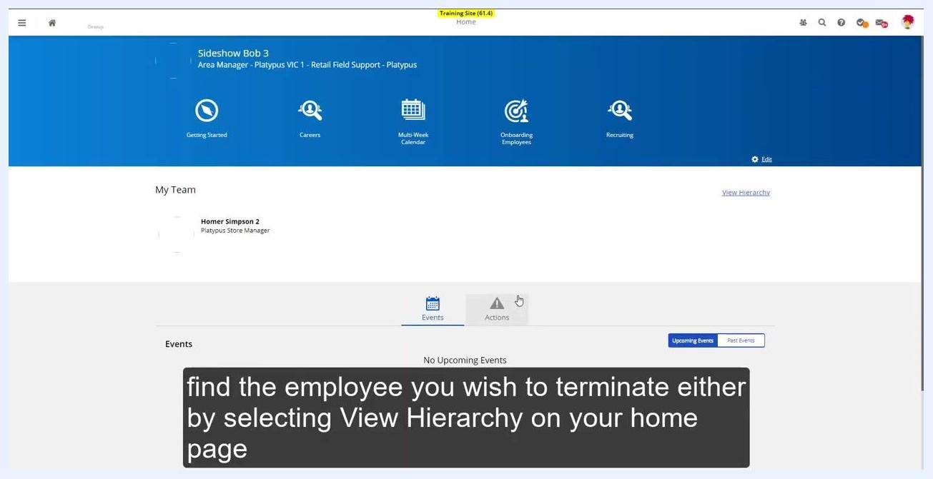
Employee profile summary pop-up for Lisa Simpson 8, showing View Profile and View Hierarchy options. On-screen instruction: "Select View Profile."

3. Access the employee's forms
Review the employee's overview and employment details on their profile page. On the left navigation menu, click Forms.
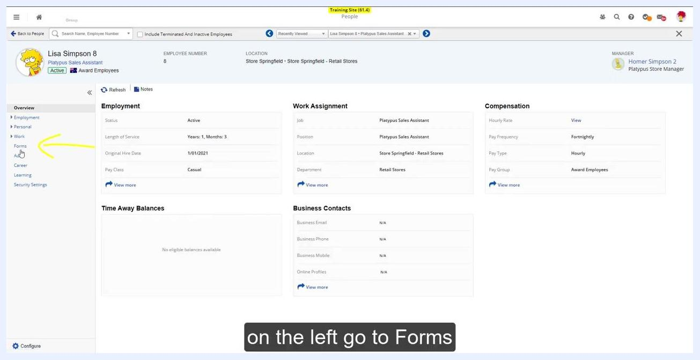
Employee profile overview with the left navigation menu highlighting Forms. On-screen instruction: "On the left, go to Forms."

4. Select the termination form
Under Available Forms, expand the Termination/Leave section and click Terminate an Employee - Accent.
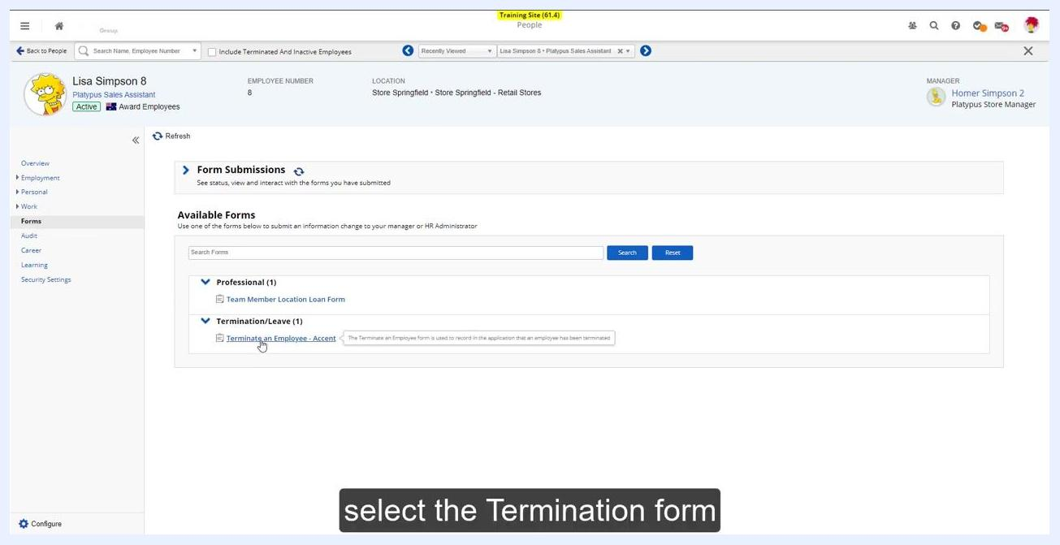
Available Forms section with "Terminate an Employee - Accent" highlighted. On-screen instruction: "Select the Termination form."

Complete the termination form

5. Enter termination details
In the Terminate an Employee form, fill in the following fields:
- Termination Date: Select the employee's last day of work (for example, 23/04/2022).
- Status: Set to "Terminated."
- Reason: Open the dropdown and select the appropriate reason. Unless instructed otherwise by HR, always select "Resignation."
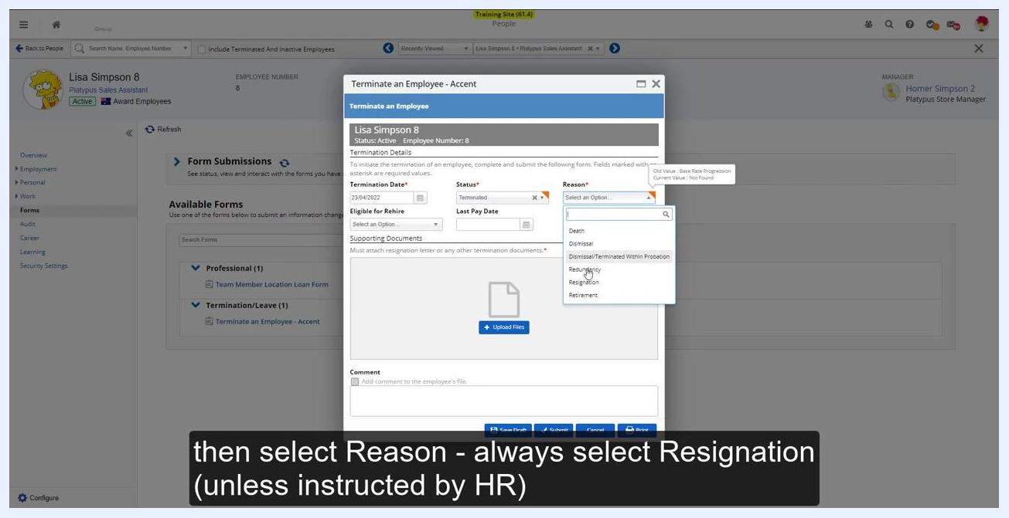
Termination form with the Termination Date, Status, and Reason fields being completed. On-screen instruction: "Then select Reason - always select Resignation (unless instructed by HR)."

6. Enter the last pay date
In the Last Pay Date field, select the same date as the termination date (for example, 23/04/2022).
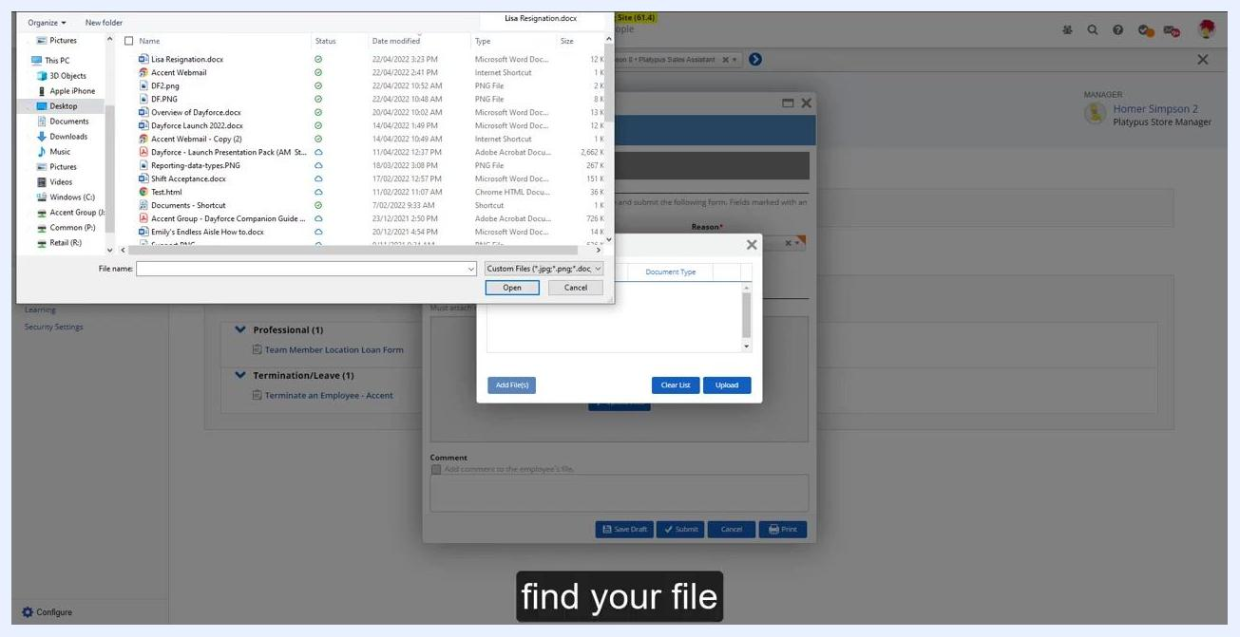
Termination form with the Last Pay Date calendar open. On-screen instruction: "Enter the last pay date (this will be the same as the termination date)."

7. Upload the resignation letter
In the Supporting Documents section, click Upload Files. You must supply a resignation letter to proceed.
Termination form with the Upload Files button highlighted. On-screen instruction: "You must supply a resignation letter by selecting Upload Files."
In the file upload dialog, browse to the location of the resignation letter (for example, "Lisa Resignation.docx" on the Desktop). Select the file and click Open to attach it.
File upload dialog open, showing file selection for the resignation letter. On-screen instruction: "Find your file."
After selecting the file, confirm it appears in the Supporting Documents section of the form. The file should be listed with its name, document type, last updated date and time, and last modified by information. Verify that the correct document is attached before proceeding.
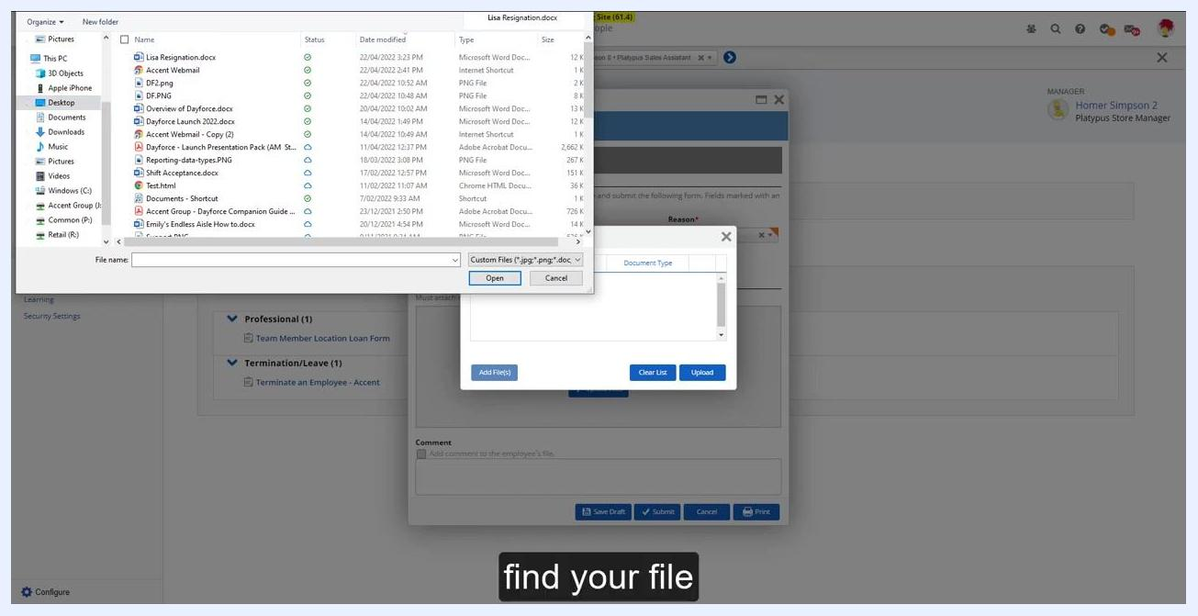
Termination form showing the resignation letter successfully attached in the Supporting Documents section, with file details including name, date/time, and user visible.

 | Note: Complete any additional required fields, such as "Eligible for Rehire" and "Comment," according to your organization's policy before submitting the form.

8. Add optional comments
If required by your organization, enter any additional context or information regarding the termination in the Comment field at the bottom of the form.

9. Submit the termination form
Before submitting, review all entered information for accuracy:
- Termination Date: 23/04/2022
- Status: Terminated
- Reason: Resignation
- Last Pay Date: 23/04/2022
- Eligible for Rehire: (select according to policy)
- Supporting Documents: Confirm the resignation letter is attached
Click Submit at the bottom of the form to send the termination request. Once submitted, the request is sent to HR and Payroll for processing.
Completed termination form ready for submission, with all fields filled in and the resignation letter attached. On-screen caption: "This will then get sent to HR and Payroll for processing."

10. Save or print for your records (optional)
If you want to keep a copy of the form, click Save Draft or Print before or after submitting it.

Summary
Submitting a termination form in Dayforce involves locating the employee through View Hierarchy, opening their Forms section, and completing the Terminate an Employee - Accent form with the termination date, status, reason, last pay date, and a supporting resignation letter. Once submitted, the request and its supporting documents are routed to HR and Payroll for further processing.

Note: Ensure all required fields and documents are completed before submitting to avoid processing delays.

