How to Create a Page in Confluence
Knowing how to create a page in Confluence is one of the most useful skills for organizing team content in Confluence Cloud. You can create a new page from the main navigation bar or directly from the page tree in a space's sidebar, then customize it with titles, templates, emojis, and header images. This guide walks you through both methods, plus how to structure and personalize your new page.

Prerequisites
- Access to a Confluence Cloud workspace.
- Permission to create pages in the space where you want to add content.

Method 1: Create a page from the main navigation bar

- Locate the main navigation bar at the top of your Confluence workspace.
- Click the blue Create button in the navigation bar to start a new page. This method works similarly to the classic Confluence experience.
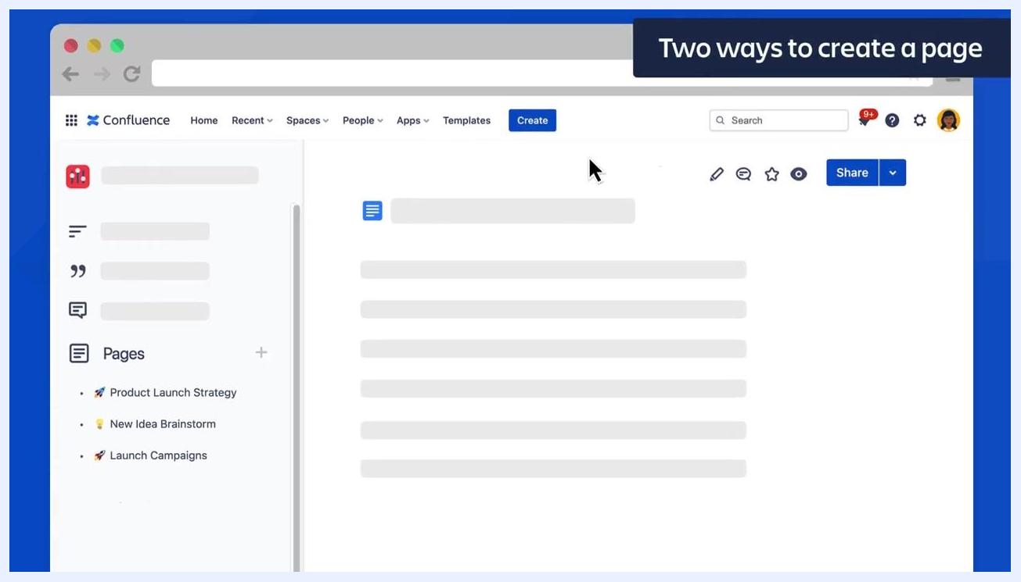
Confluence interface showing the main navigation bar with the 'Create' button highlighted, the sidebar with the 'Pages' section, and a sample page open

Method 2: Create a page from the space page tree

- Once you are inside a space, look at the left sidebar to find the Pages section.
- To create a new top-level page, click the plus (+) icon next to the "Pages" label in the sidebar.
- To create a child page under an existing page, hover your cursor over any page listed in the page tree (for example, "Product Launch Strategy"). A plus (+) icon appears next to the page name.
- Click this plus icon to create a new child page directly beneath the selected parent page.
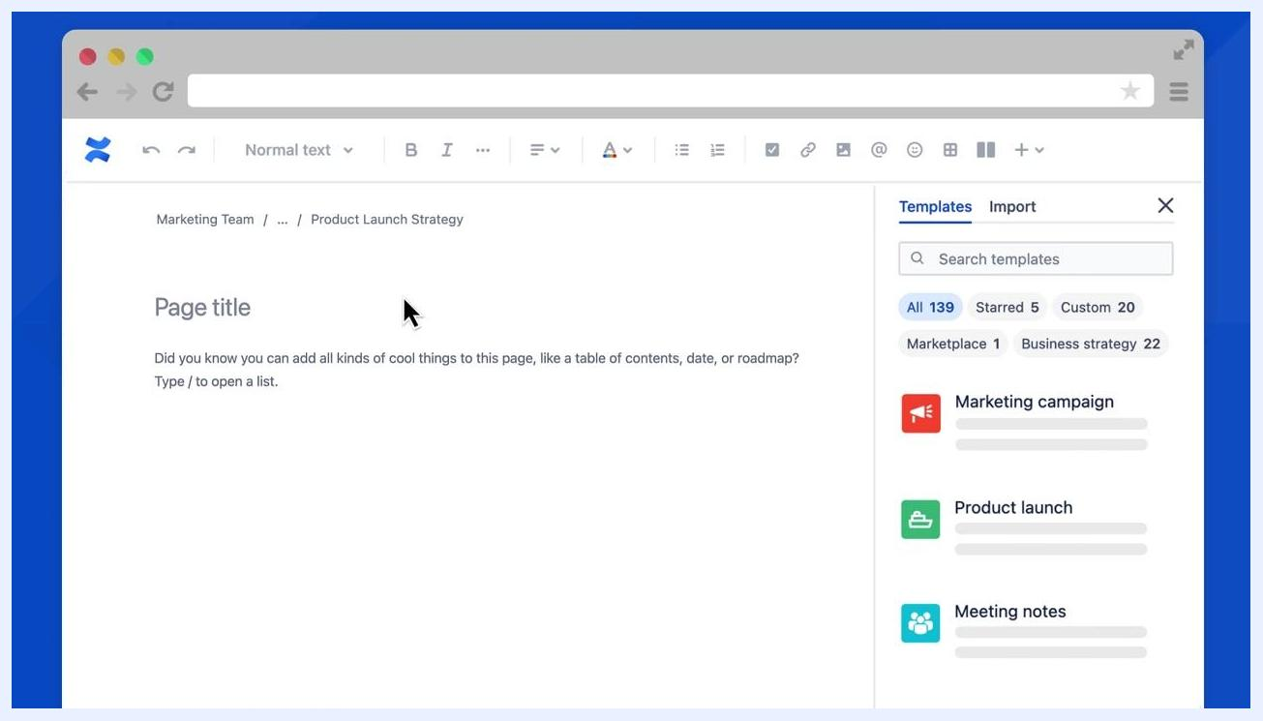
Close-up of the sidebar showing the 'Pages' section and the plus (+) icon used to add a new page
Close-up of the sidebar showing the 'Product Launch Strategy' page with the plus (+) icon used to add a child page

Add a title and content to your new page

- After creating a new page or child page, you are taken to the page editor.
- At the top of the editor, confirm the page's location within the space (for example, "Marketing Team / Product Launch Strategy").
- Enter your Page title and begin adding content. The editor displays a prompt letting you know you can add elements like a table of contents, date, or roadmap by typing "/" to open a list of options.
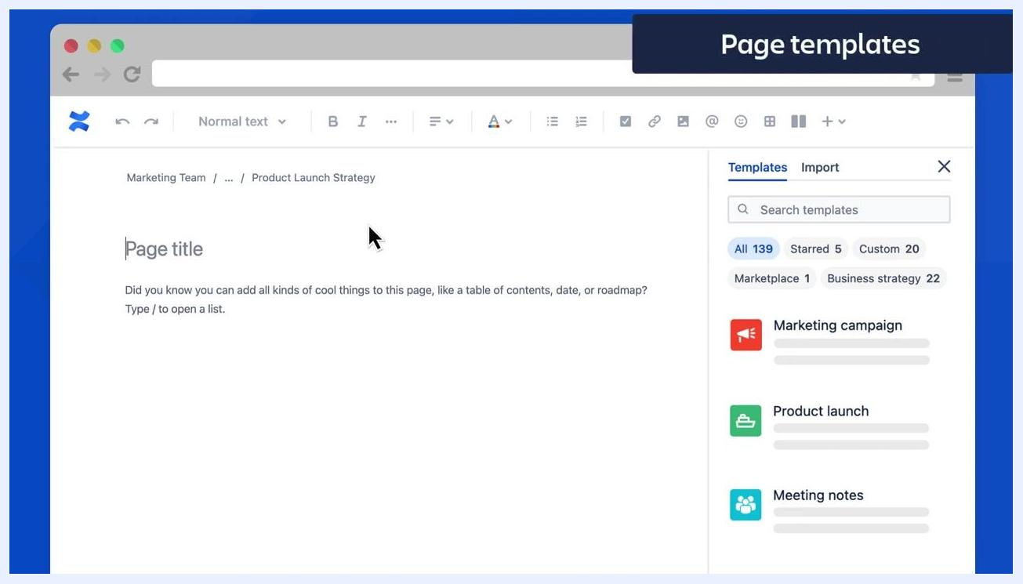
Confluence page editor showing breadcrumb navigation, the page title field, and the template panel on the right

Apply a page template

- On the right side of the editor, find the Templates panel.
- Use the search bar or the filters (such as All, Starred, Custom, Marketplace, or Business strategy) to browse hundreds of pre-formatted page templates. Example templates include "Marketing campaign," "Product launch," and "Meeting notes."
Templates panel open on the right side of the editor, showing the search bar, filter tags, and several template options
Cursor selecting the 'Product launch' template in the Templates panel

- Hover your cursor over any template to preview it before selecting.
- Click a template (for example, "Product launch") to automatically populate your new page with that template's content.

Customize your page with an emoji and header image
Adding an emoji to your page title and a custom header image makes your pages more engaging and easier to find.

Add an emoji to the page title

- Hover your cursor over the page title area at the top of the editor.
- Click the Add emoji button that appears above the page title field.
- In the emoji picker dialog, browse or search for an emoji that represents your page. For example, select the "pepperoni pizza" emoji from the Frequent section.
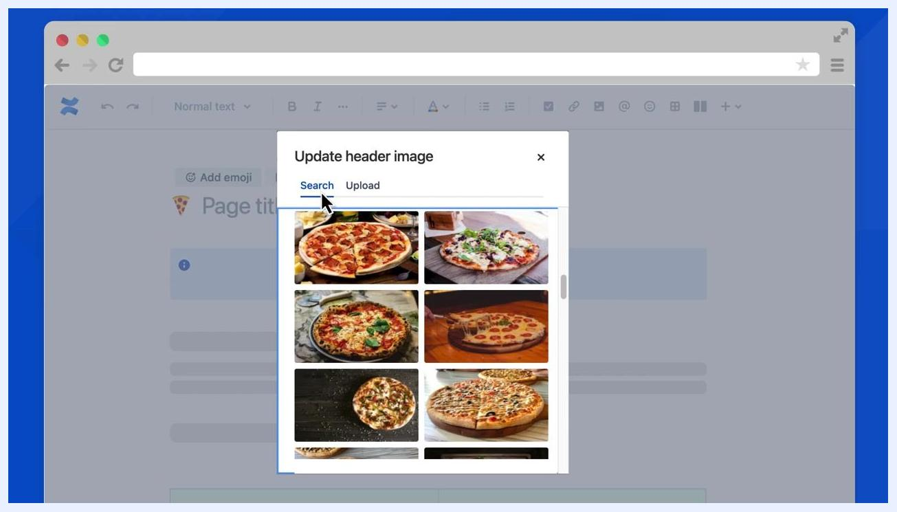
Confluence page editor with the emoji picker open and the cursor selecting a pizza emoji for the page title

- The selected emoji appears next to your page title. Emojis in page titles help your pages stand out in search results, making them easier to locate later.

Add a header image

- Hover over the page title area again and click the Add header image button.
- In the "Update header image" dialog, choose either:
- Search: Browse a gallery of free images by keyword.
- Upload: Add your own custom image from your device.

- Use the search feature to find a suitable image, or scroll through the available options. For example, select a pizza image from the search results.
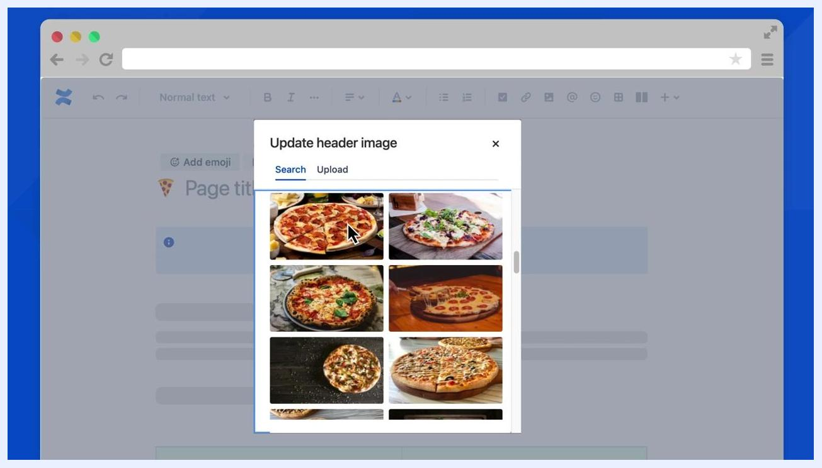
Update header image dialog showing a selection of pizza images with the cursor selecting one
Confluence page editor showing the selected pizza header image and pizza emoji in the page title

- The chosen image displays as a banner above your page title, giving your page a unique and visually appealing look.

Tips
- Creating child pages directly from the page tree helps keep your content organized and saves time.
- Use templates to quickly structure your pages and add visual appeal for your readers.
- Emojis and header images personalize your pages while also improving navigation and discoverability within Confluence.
- Experiment with different emojis and images to match the theme or purpose of your page.

What's next
Now that you know how to create a page in Confluence, apply a template, and add an emoji or header image, you have a solid foundation for building well-organized, visually engaging pages. Continue exploring additional templates and page tree structures to keep your team's content organized and easy to navigate.
Atlassian University logo on a white background, indicating the end of the training and next steps

