How to Create AutoText in Cerner PowerChart
AutoText in Cerner PowerChart lets you insert pre-built documentation templates into your clinical notes with just a few keystrokes, saving time and ensuring consistency across your charting. This guide walks you through how to use existing AutoText entries, how to create AutoText in Cerner PowerChart from scratch, how to edit existing templates, and how to insert your saved AutoText into a note.

Prerequisites
- Access to a documentation section in Cerner PowerChart (such as Subjective/History of Present Illness, Objective/Physical Exam, or Review of Systems).
- Text you want to save as a reusable template, if you plan to create a new AutoText entry.

Using existing AutoText

1. Navigate to a documentation section
Go to the section of your workflow where you need to enter new data, such as Subjective/History of Present Illness, Objective/Physical Exam, or Review of Systems. Each section in the Cerner interface includes a text entry area and a formatting toolbar.
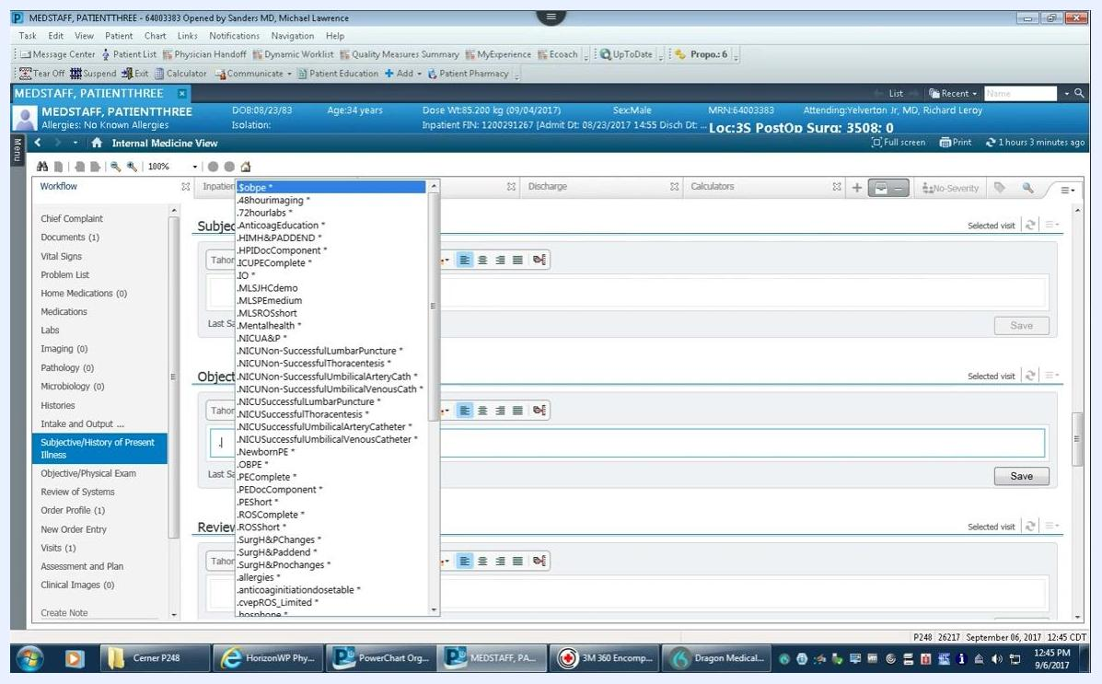
Cerner documentation screen showing the Subjective/History of Present Illness, Objective/Physical Exam, and Review of Systems sections with editable text fields and formatting options

2. Trigger the AutoText menu
Begin your entry with a punctuation mark, typically a period (.). After you type the period, a dropdown menu appears listing both built-in and personal AutoText templates, such as .8hourimaging, .72hourlabs, and .PEE.
Dropdown menu showing available AutoText templates after typing a period in the text entry field
AutoText entries are case sensitive, so make sure you use the correct capitalization when typing your abbreviation.
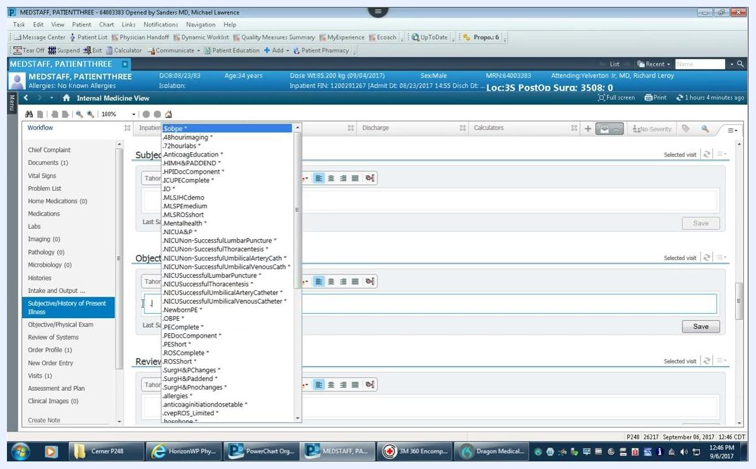
Dropdown menu showing AutoText templates, highlighting the importance of case sensitivity

3. Select and insert the template
Select the desired AutoText template from the dropdown using your mouse or keyboard. For example, typing .PEE (case sensitive) filters the list to show matching templates, such as .mlsRO2, .mlsRQ3, or .mlssuperPE.
AutoText dropdown filtered by initials, showing matching templates for selection
Once you select a template, it automatically populates the text entry area with the predefined content. For example, selecting an AutoText for the physical exam inserts a detailed template covering General, Eye, HENT, Neck, Lungs, Heart, Abdomen, Musculoskeletal, Skin, Neurologic, and Psychiatric findings.
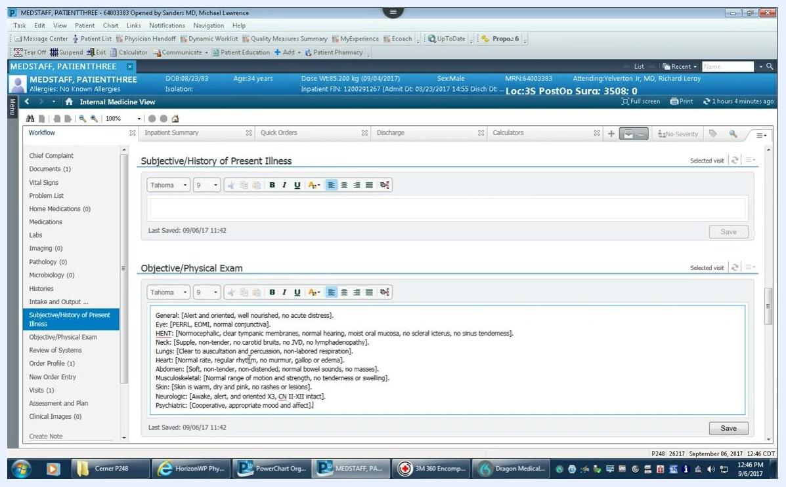
Text entry area populated with detailed AutoText content for the Objective/Physical Exam section

Creating a new AutoText

4. Copy the content you want to save
Highlight the default or existing text in the entry area that you want to save as AutoText. Right-click and select Copy to copy the content, then click the Manage Auto Text icon (a document with a red "A") in the formatting toolbar above the text entry area.
Highlighted text in the entry area next to the Manage Auto Text icon in the toolbar

5. Start a new AutoText entry
In the Manage Auto Text window, click the plus sign (+) to create a new AutoText entry. The window displays fields for Abbreviation, Description, and a main content area for your AutoText phrase, with your existing AutoText entries listed on the left along with their abbreviations and descriptions.
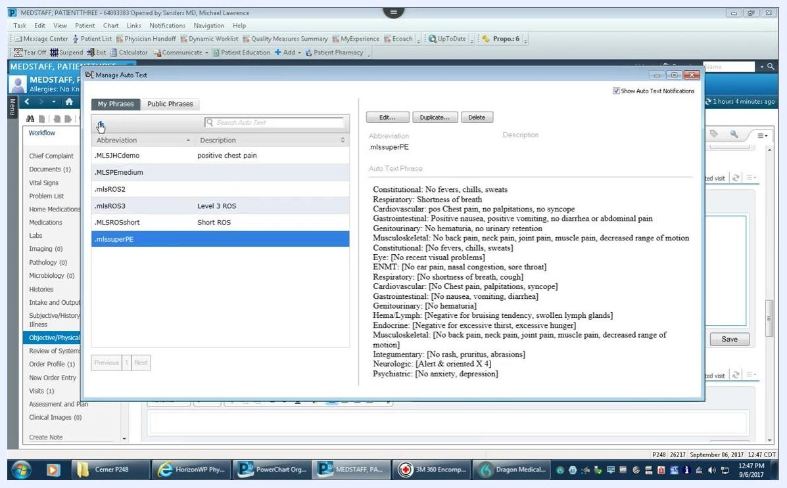
Manage Auto Text window with the plus sign selected to create a new AutoText entry

6. Paste your content
Right-click in the blank content area and select Paste to insert the text you copied earlier. The pasted content appears in the main text area, ready for editing.

7. Set the abbreviation
In the Abbreviation field, enter your desired shortcut. Start with a punctuation mark such as a period (.), comma (,), or backslash (\), followed by your lowercase initials as a prefix (for example, .mls), and a descriptive suffix such as PE for Physical Exam — resulting in an abbreviation like .mlsPE.
Manage Auto Text window with the abbreviation field showing .mlsPE and the pasted content

8. Add a description
In the Description field, enter a brief explanation of the AutoText's purpose. For example, type Complete PE to indicate a complete physical exam template.
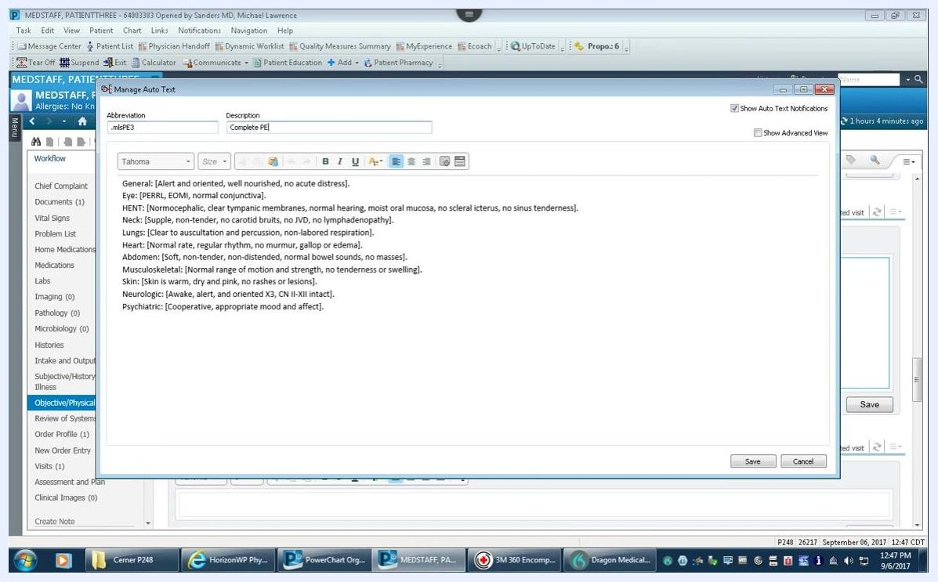
Manage Auto Text window with abbreviation .mlsPE3 and description "Complete PE"

9. Customize the template content
You can use brackets [ ] to define editable fields within your template. Each bracketed section is treated as a separate field. For example:

General: [Alert and oriented, well nourished, no acute distress].
Eye: [PERRL, EOMI, normal conjunctiva].
HENT: [Normocephalic, clear tympanic membranes, normal hearing, moist oral mucosa, no scleral icterus, no sinus tenderness].
Neck: [Supple, non-tender, no carotid bruits, no JVD, no lymphadenopathy].
Lungs: [Clear to auscultation and percussion, non-labored respiration].
Heart: [Normal rate, regular rhythm, no murmur, gallop or edema].
Abdomen: [Soft, non-tender, non-distended, normal bowel sounds, no masses].
Musculoskeletal: [Normal range of motion and strength, no tenderness or swelling].
Skin: [Skin is warm, dry and pink, no rashes or lesions].
Neurologic: [Awake, alert, and oriented X3, CN II-XII intact].
Psychiatric: [Cooperative, appropriate mood and affect].
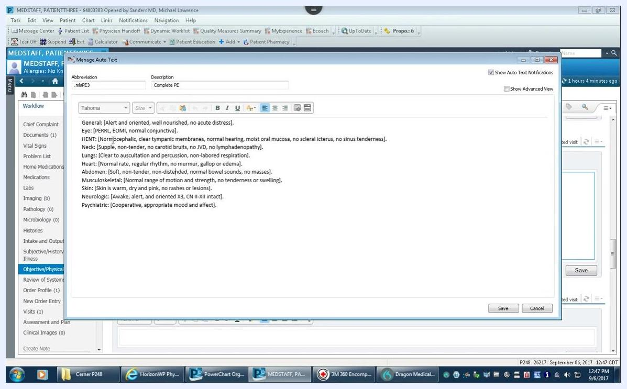
Manage Auto Text window showing bracketed fields for each section of the physical exam
If you use voice dictation tools such as Dragon, each bracketed field can be navigated with the "next field" command or arrow keys on your microphone. Saying "next field" highlights the entire bracketed section, letting you overwrite the default text if needed.
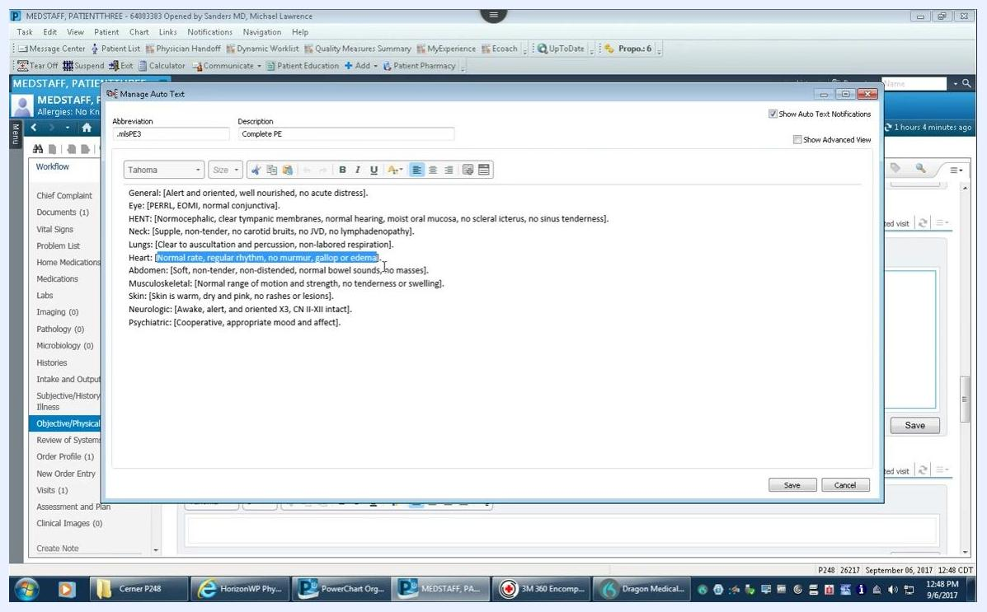
Manage Auto Text window with a bracketed field highlighted, ready for dictation or editing
For each field, enter the default value you most commonly dictate. For example, for the Heart section, use [Normal rate, regular rhythm, no murmur, gallop or edema] as the default. If a patient has a different finding, use the "next field" command to highlight and replace the default text — for instance, with "tachycardic and had a two over six systolic ejection murmur."
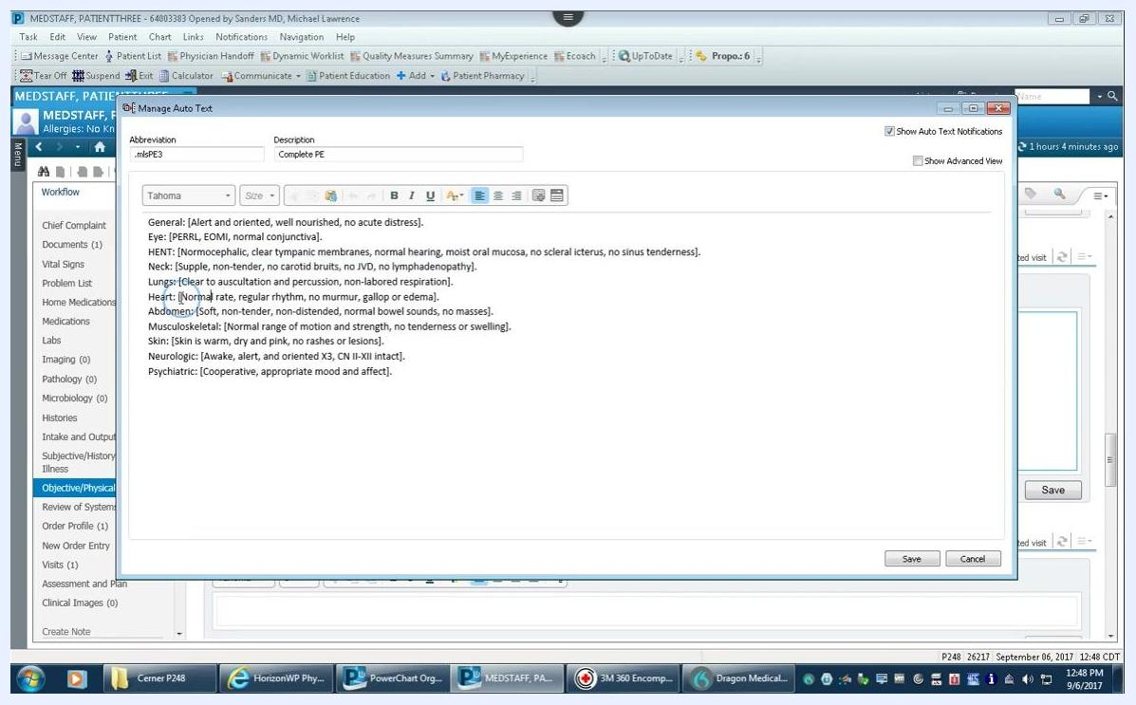
Manage Auto Text window showing default values in bracketed fields for each exam section

10. Review your entry
Before saving, review your abbreviation, description, and content for accuracy. Confirm that all fields are bracketed as needed and that defaults are set appropriately.

11. Save your AutoText
Click Save in the Manage Auto Text window to store your template. Your abbreviation (for example, .mlsPE3) and description ("Complete PE") now appear in your list of AutoText entries, and the content area displays the full template, including all bracketed fields and default values.
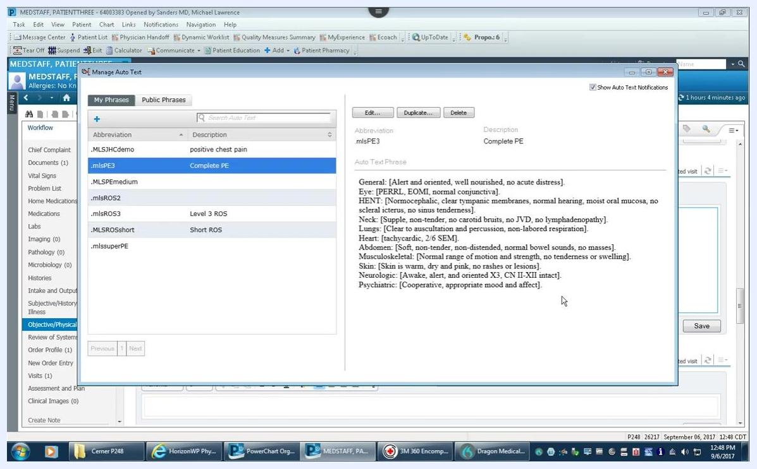
Manage Auto Text window showing .mlsPE3 saved with description "Complete PE" and the full template content

12. Confirm the new entry
In the Manage Auto Text window, confirm that .mlsPE3 appears under My Phrases with the correct description and content. You can then close the Manage Auto Text window.

Editing an existing AutoText
To edit an AutoText entry you've already created:
- Select the AutoText from the list in the Manage Auto Text window.
- Click Edit to modify the content or abbreviation as needed.
- Click Save to update your changes.

Inserting your AutoText into a note

13. Open the documentation area
Navigate to the documentation area where you want to use your AutoText, such as the Objective/Physical Exam section, and clear any existing content in the text area if needed.

14. Insert the template
Type your AutoText abbreviation — for example, .mlsPE3 — into the documentation field and press Enter. The full AutoText template automatically populates the field, including all bracketed fields and default values.
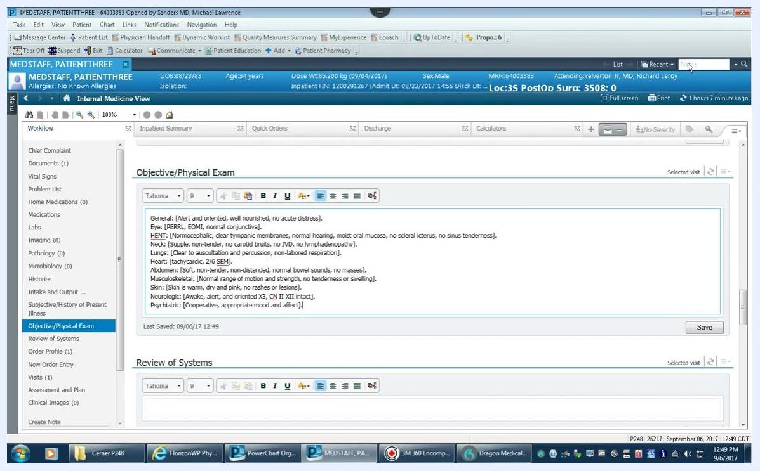
Objective/Physical Exam section with the AutoText template inserted after typing .mlsPE3

15. Edit the inserted template
Use voice commands (such as "next field") or keyboard navigation to move between bracketed fields, and overwrite the default values with patient-specific findings as needed.

16. Save your documentation
Click Save in the documentation area to store your completed note.

What's next
By following these steps, you can use, create, and manage AutoText templates in Cerner PowerChart to streamline your documentation workflow and keep your clinical notes consistent. Once you're comfortable with the basics, consider building additional AutoText templates for other frequently used sections of your notes.

