How to Use Power Copy in CATIA V5
Power Copy is a reusable feature in CATIA V5 that lets you capture a piece of geometry, such as a boss with draft, and instantiate it elsewhere in your model using reference points and lines as inputs. This guide walks through how to use Power Copy in CATIA V5, from setting up reference geometry to creating, instantiating, and editing the Power Copy feature.

Prerequisites
- CATIA V5 installed and ready to launch.
- A basic understanding of sketching, pads, and drafts in CATIA V5.

Step 1: Start CATIA V5 and open a new part file
Launch CATIA V5 and open a new part file to begin modeling. The workspace displays the default planes (xy, yz, zx) and an empty tree structure.
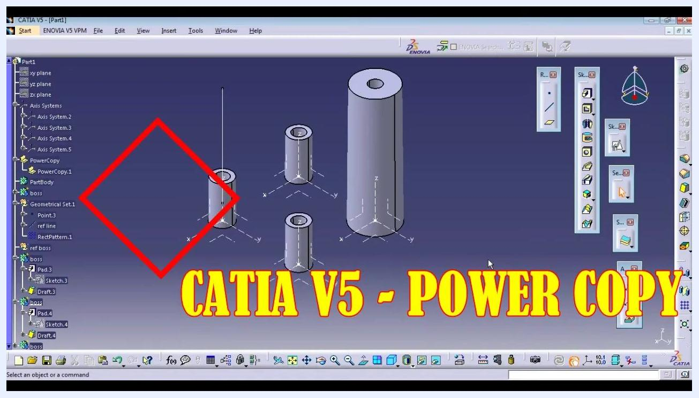
CATIA V5 interface showing the part tree, three cylinders, and the title "CATIA V5 - Power Copy"

Step 2: Create a reference point
In the tree, go to Geometrical Set and insert a new point (for example, Point.3) into the workspace.

Step 3: Create a reference line
With the point selected, open the Line Definition dialog box. Set Line type to Point-Direction, choose the point you created (for example, Point.3) as the Point, and select a Direction (for example, the Z Component).
Line Definition dialog box with Point.3 selected and direction options displayed
Set Start to 4mm and End to 30mm, then click OK to create the reference line.
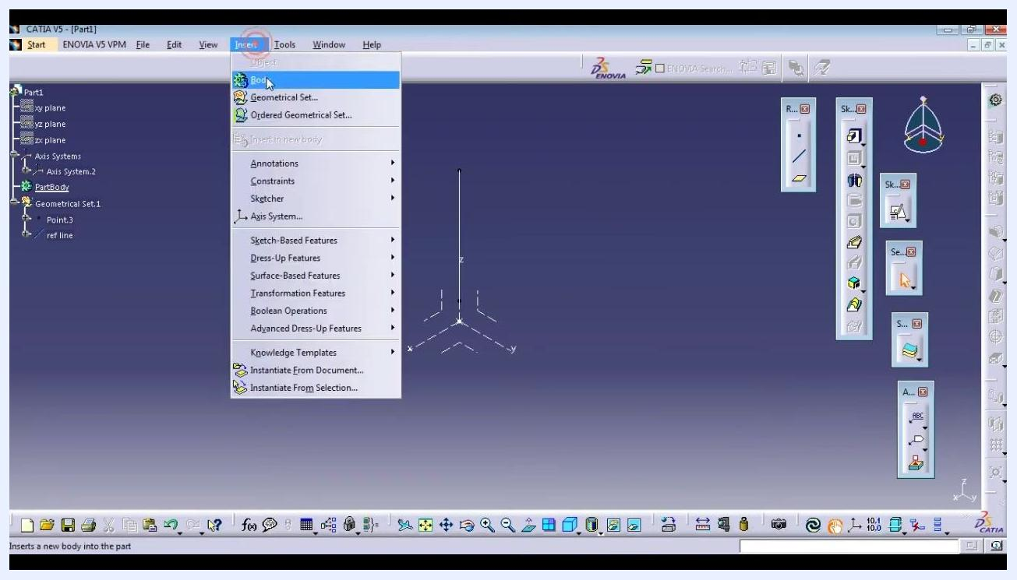
Line Definition dialog box with Z Component selected, start set to 4mm, end set to 30mm, and the line visible in the workspace

Step 4: Insert an axis system
Go to Insert in the top menu, then select Axis System.... Insert a new axis system at the origin or as required by your design.
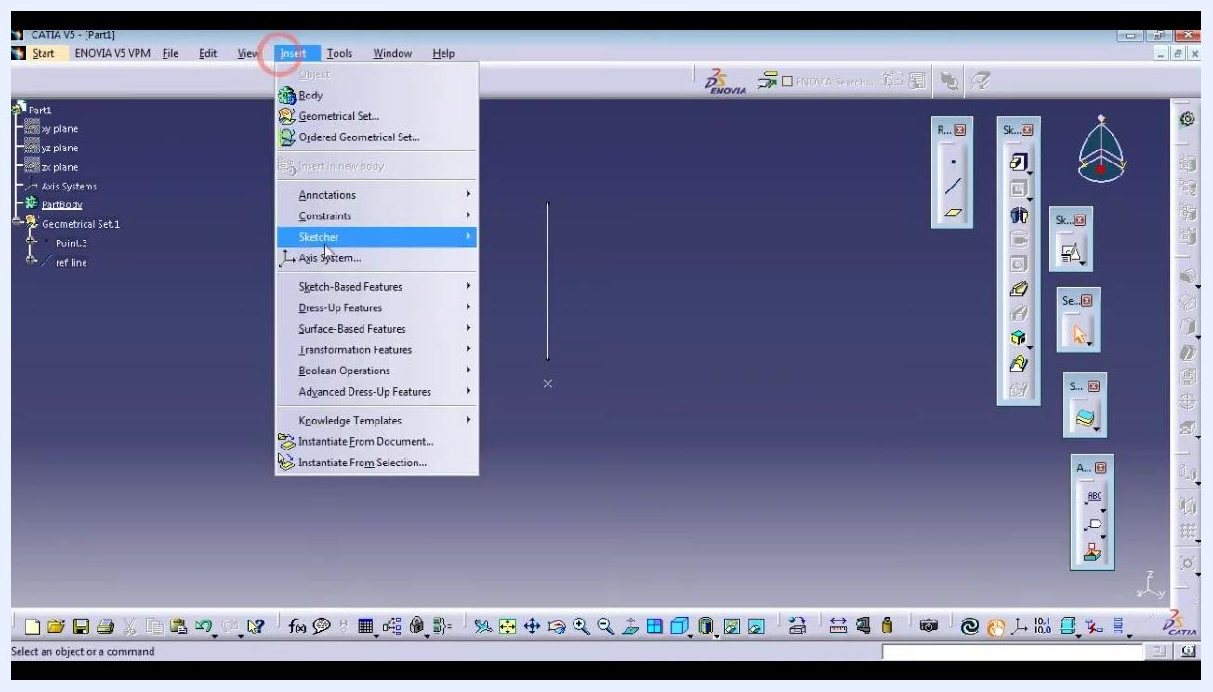
Insert menu open with Axis System option visible, along with the line and axis system in the workspace

Step 5: Insert a new body
Go to Insert again and select Body to add a new body to the part. Give it a descriptive name (for example, "creative pose").
Insert menu open with the Body option highlighted, and the axis system and line visible in the workspace

Step 6: Open the subtree of the new body
Right-click the new body in the tree and select Open Sub-Tree to expand it and work within this body.
Right-click menu on the body with Open Sub-Tree highlighted, axis system and line visible

Step 7: Create a sketch on the reference line
With the new body active, create a new sketch. In the Sketch Positioning dialog box, set Type to Positioned, Reference to the appropriate plane (for example, Axis System.2/XY Plane), Origin to Projection point referencing your point (for example, Point.3), and Orientation to Parallel to line referencing the line you created.
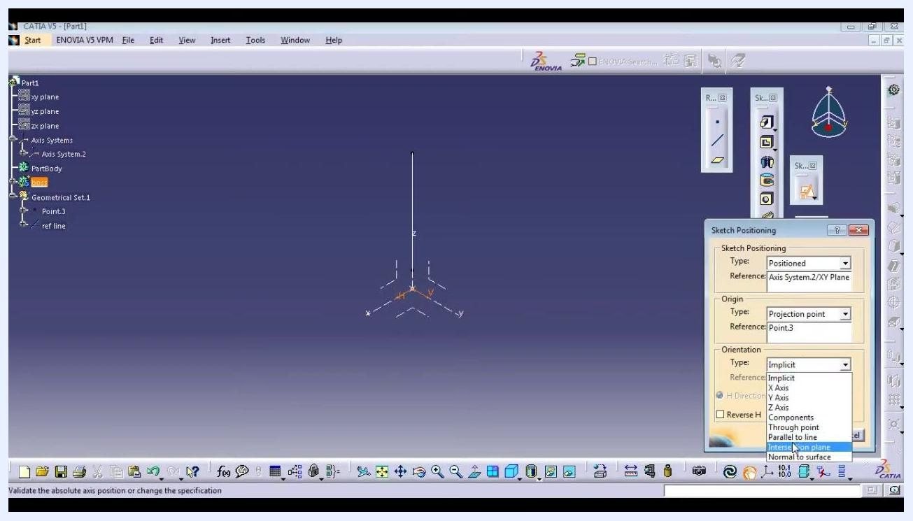
Sketch Positioning dialog box with orientation options shown and Parallel to line highlighted

Step 8: Draw and dimension a circle
In the sketch, draw a circle centered at the projection point. Open the Constraint Definition dialog box, set the diameter to 5mm, and click OK to apply the dimension.
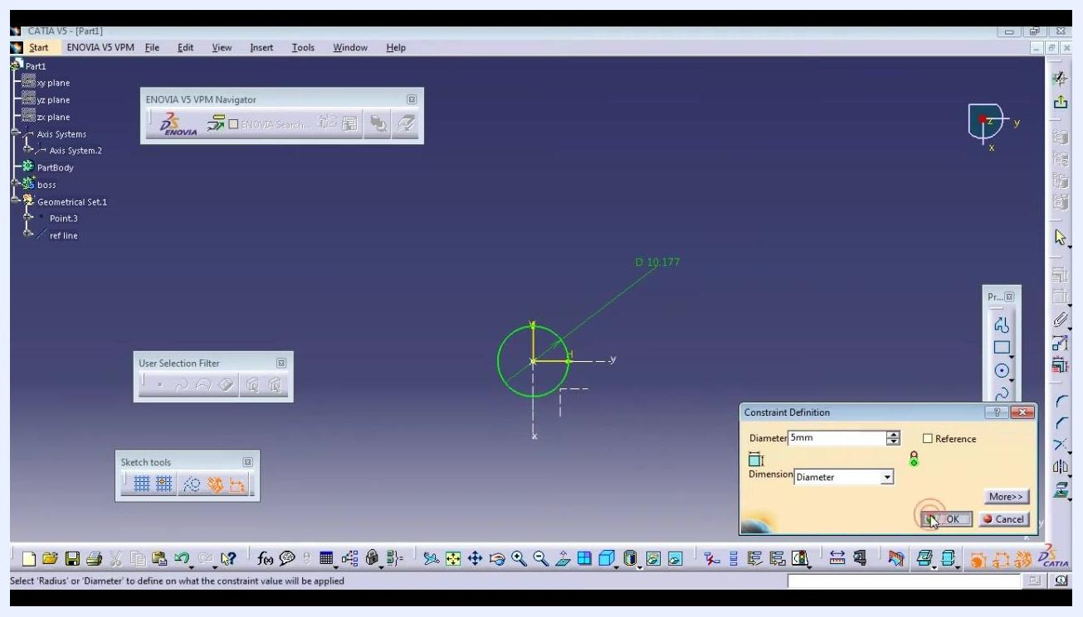
Sketch with a circle, diameter set to 5mm, and the Constraint Definition dialog box open

Step 9: Cut the sketch if required
Use the appropriate tool to cut or trim the sketch as needed for your design.

Step 10: Create the next circle
Enter the sketching environment on the appropriate plane and use the circle tool to draw a new circle centered at the origin or projection point. The circle should be concentric with the previous geometry.
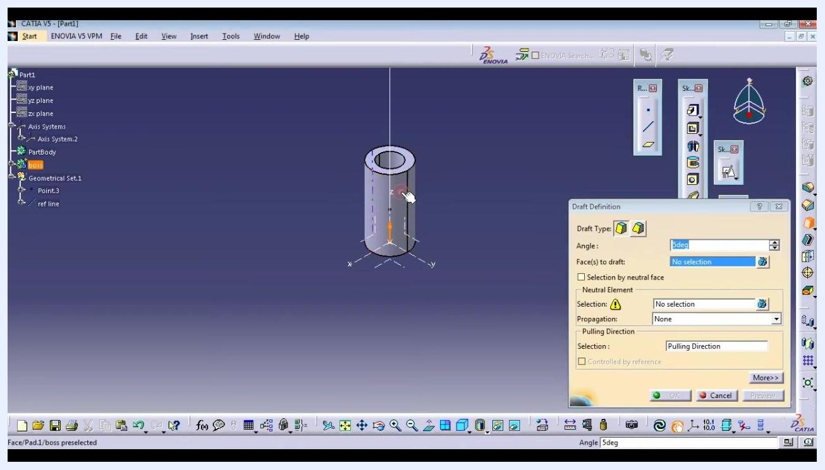
Sketching a new circle centered at the origin, with the circle tool active and coordinates shown in the Sketch tools bar

Step 11: Add a diameter constraint
Open the Constraint Definition dialog box, set the diameter of the new circle to 3mm, and click OK to confirm.
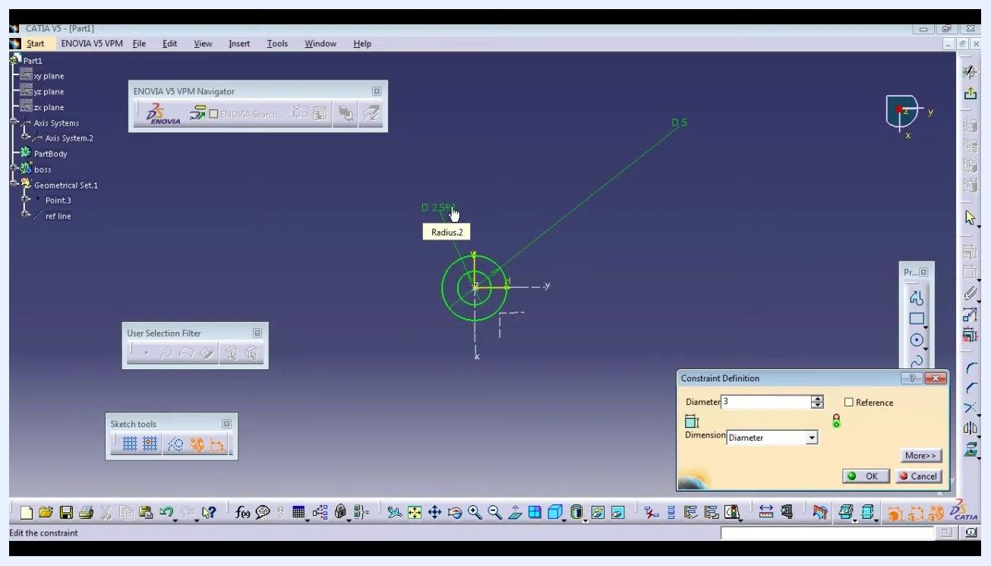
Constraint Definition dialog box with diameter set to 3mm and the new circle visible with its dimension label

Step 12: Create a boss using the reference line and point
Use the boss feature to create a solid based on the reference line and the point, ensuring it is properly aligned with the reference geometry.

Step 13: Apply draft to the boss faces
Exit the sketch, return to the 3D workspace, and select the cylindrical boss feature. Open the Draft Definition dialog box and select the two faces of the boss that require drafting.
Draft Definition dialog box open, boss selected, faces being chosen for draft, angle set to 5 degrees
In the Draft Definition dialog box, set the draft angle to 0.5 degrees and confirm that both required faces are selected.
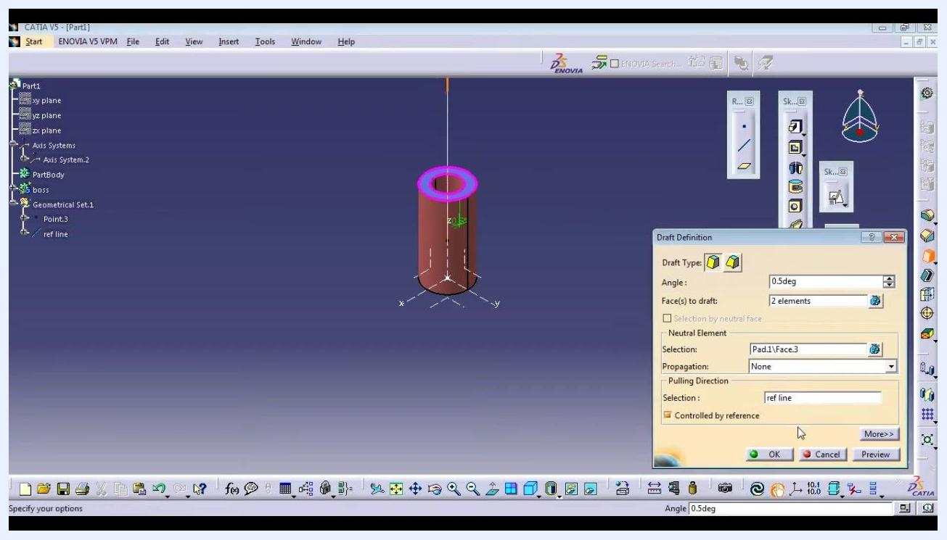
Draft Definition dialog box with angle set to 0.5 degrees, two faces selected, and the reference line set as pulling direction
In the same dialog box, set Pulling Direction to the reference line you created earlier (for example, ref line), then click OK to apply the draft.

Step 14: Initiate Power Copy creation
Go to Insert, navigate to Knowledge Templates, and select Power Copy....
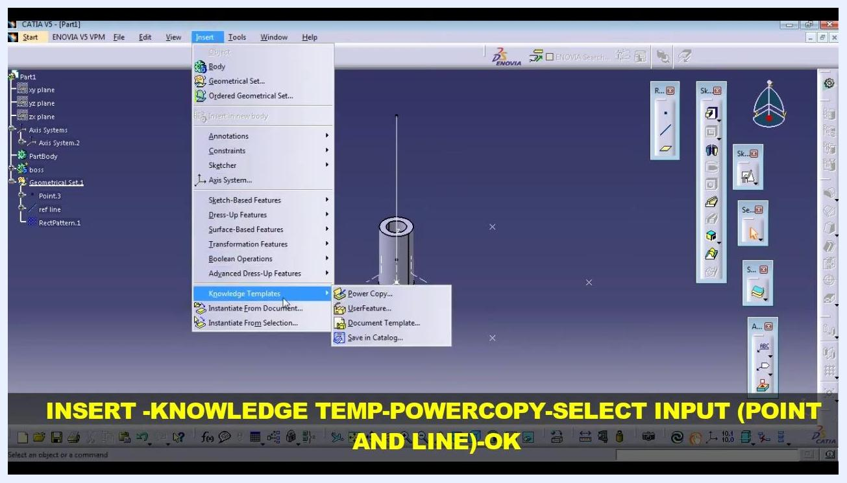
Insert menu open with the Knowledge Templates submenu expanded and Power Copy highlighted, boss visible in the workspace

Step 15: Define Power Copy inputs
In the Powercopy Definition dialog box, select the boss as the main feature. Under Inputs of components, select only the point (for example, Point.3) and the reference line (for example, ref line) as the Power Copy inputs, then name the Power Copy appropriately (for example, "PowerCopy").
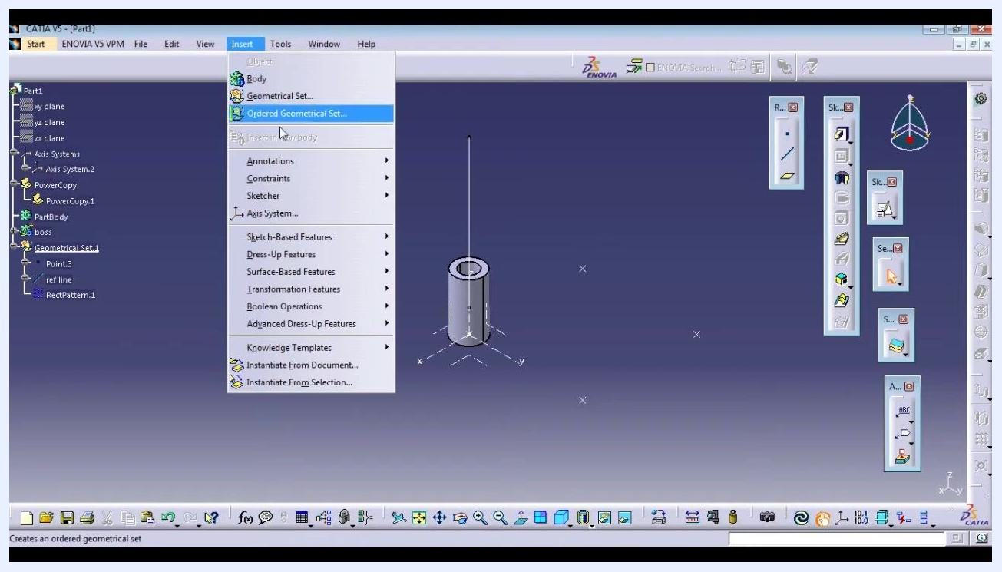
Powercopy Definition dialog box with the boss, point, and reference line selected as inputs, workspace showing the boss and reference geometry

Step 16: Attempt to instantiate the Power Copy
Open the Insert Object dialog box and select PowerCopy.1 as the reference. Set the instantiation mode to One step instantiation and attempt to set the destination as Geometrical Set.1, selecting Point.3 and ref line as the required inputs.
If you see an error stating "The destination cannot be defined in Work Object," click OK to close the error dialog box.
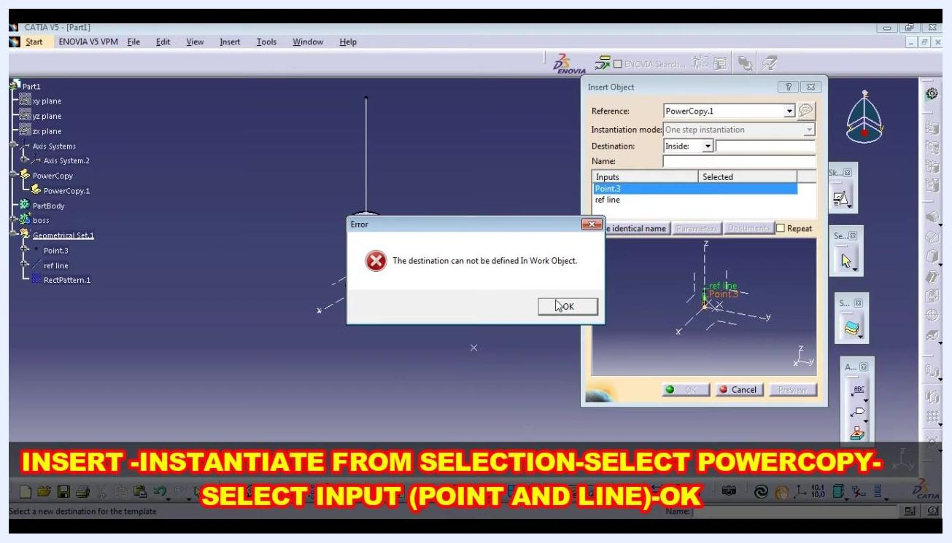
Error dialog box reading "The destination can not be defined In Work Object" while instantiating PowerCopy.1 into Geometrical Set.1, with the Insert Object dialog box open

Step 17: Create a new geometrical set for reference
Cancel the current instantiation. Go to Insert and select Geometrical Set... to create a new geometrical set. Name it ref boss (or another appropriate name) and confirm creation.

Step 18: Instantiate the Power Copy into the new geometrical set
Go to Insert, navigate to Knowledge Templates, and select Instantiate From Selection.... In the Insert Object dialog box, set the destination to the newly created ref boss and select Point.3 and ref line as the required inputs.
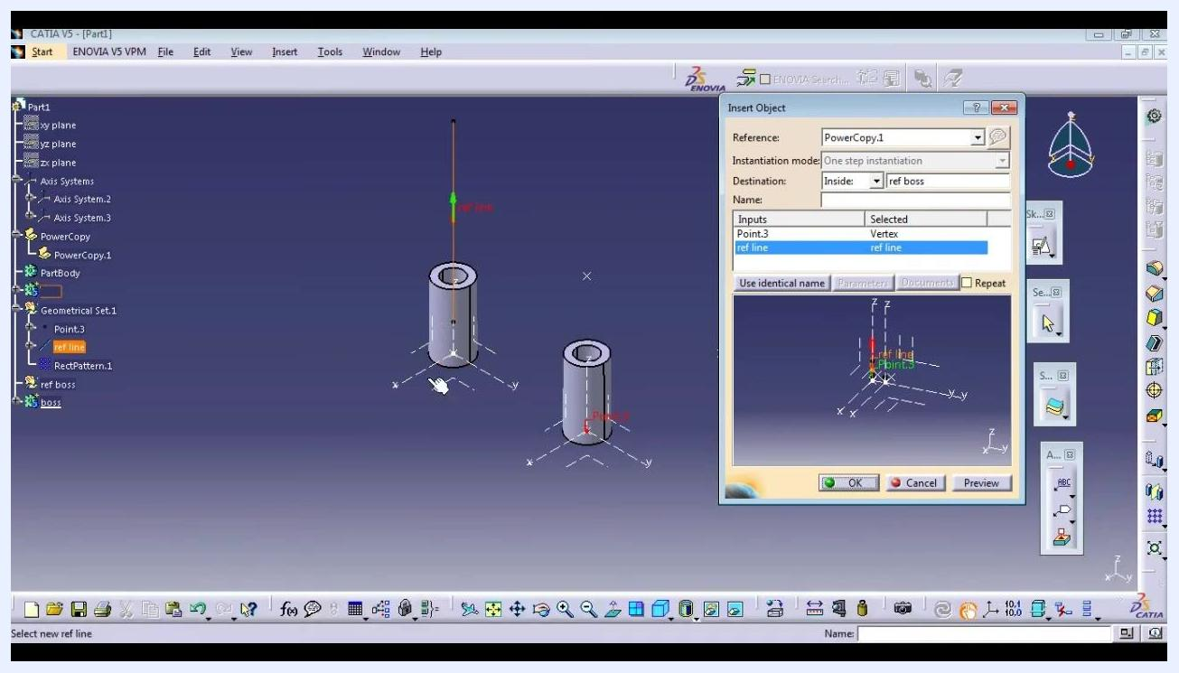
Insert Object dialog box with PowerCopy.1 selected, destination set to ref boss, inputs Point.3 and ref line selected, workspace showing the boss and reference geometry
In the workspace, select the reference line (for example, ref line) to define the direction, and confirm it is correct and supported for the instantiation. Click OK to instantiate the Power Copy.

Step 19: Repeat Power Copy instantiation for additional geometry
If you need to instantiate the Power Copy on another part, go to Insert and select Instantiate From Selection... again. Choose PowerCopy.1 as the reference and set the destination to the appropriate geometrical set or position (for example, After boss). Select the next point and reference line as inputs.
Use the Preview button to check the instantiation, enable the Repeat option if you want to instantiate multiple times, and click OK to confirm or Cancel to abort.
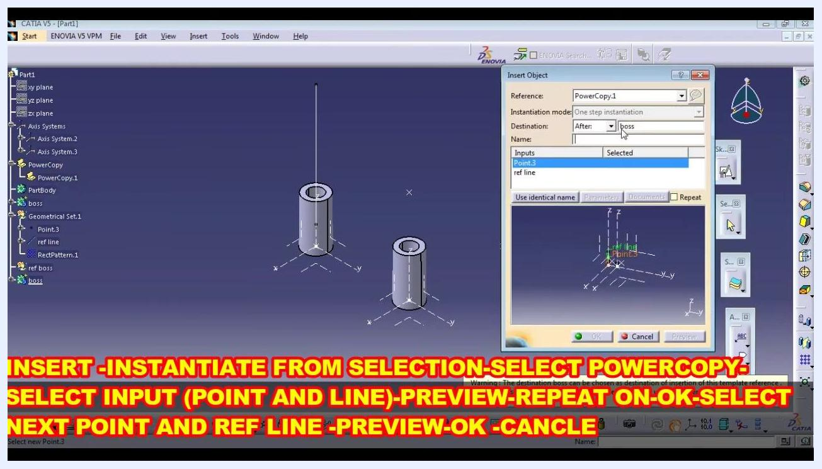
Insert Object dialog box with destination set to After boss, inputs selected, two bosses visible in the workspace, ready for repeat instantiation

Step 20: Verify and adjust instantiated features
After instantiating, check the direction and alignment of the new features. Select the correct point and reference line for each instantiation if necessary, and use the Preview function to verify placement before finalizing. Repeat the process for additional points and lines as needed.
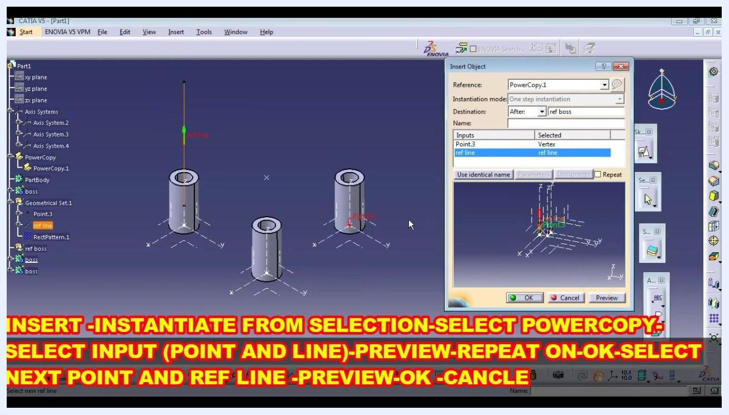
Three bosses visible in the workspace, Insert Object dialog box open, inputs selected, repeat instantiation in progress

Step 21: Modify feature parameters, such as height
To change the height or other parameters of a created boss, select the boss feature in the tree (for example, boss under ref boss) and double-click it to open its definition dialog box (for example, Pad Definition). Change the Length value to the desired height (for example, Length = 31mm) and click OK to apply the change.
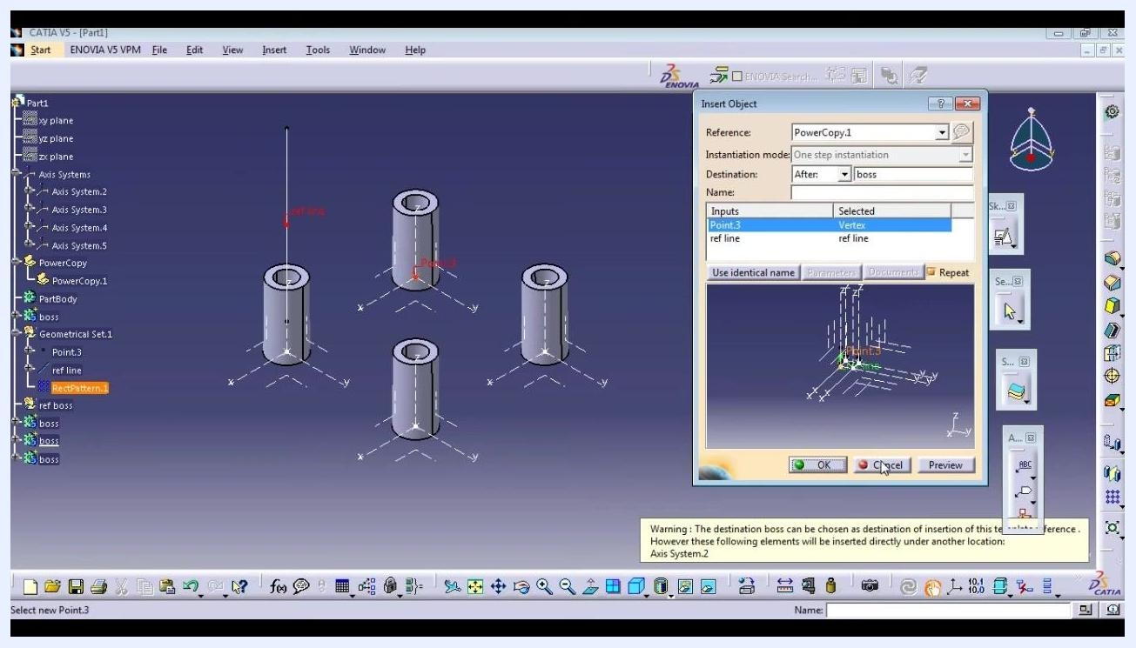
Pad Definition dialog box with Length set to 31mm, boss feature highlighted in the workspace, editable parameters visible

Step 22: Edit the sketch of a feature
To modify the underlying sketch of a boss, expand the boss feature in the tree to locate its sketch (for example, Sketch.3) and double-click it to open the sketcher workbench. Make the necessary changes to the sketch geometry or constraints, such as changing the diameter by editing the constraint value.
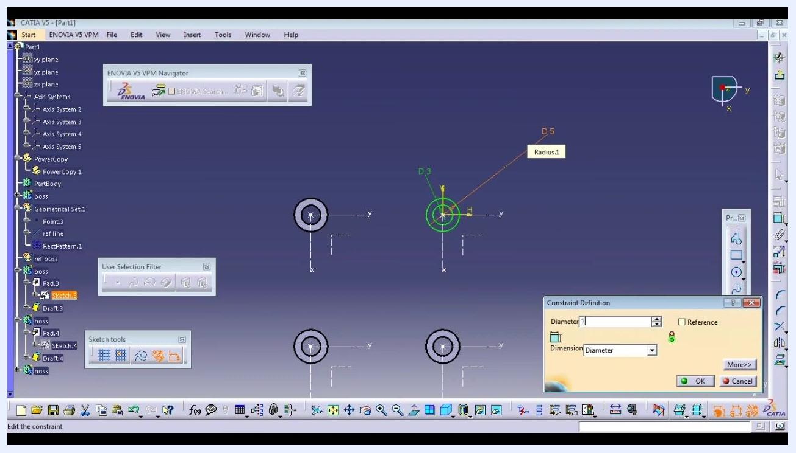
Sketch.3 open in the sketcher, Constraint Definition dialog box open, diameter being edited, multiple bosses visible in the workspace

Step 23: Update feature constraints
In the sketch, select the dimension or constraint you want to modify (for example, Diameter) and enter the new value (for example, changing diameter from 1 to 10). Click OK in the Constraint Definition dialog box to confirm the change.
Constraint Definition dialog box with diameter set to 10, sketch geometry visible, ready to confirm changes

Step 24: Perform a local update of the model
After editing the sketch or feature parameters, perform a local update to apply the changes. Right-click the feature or geometrical set and select Local Update, or use the update button in the toolbar. Verify that the changes are reflected in the 3D model and that all dependent features are updated accordingly.

Summary
By following these steps, you have learned how to use Power Copy in CATIA V5 to create foundational reference geometry, define a Power Copy, instantiate it across your model, and edit instantiated features. This workflow keeps your model flexible and fully parametric for future modifications.

