How to Make an Animation in CATIA: Animating a 3D Crank
This guide shows you how to make an animation in CATIA V5 by building a simple crank mechanism and animating it to rotate from 0 to 360 degrees. You will create the individual parts, assemble them with constraints, convert the assembly into a kinematic mechanism, and compile a playable simulation of the crank's rotation.
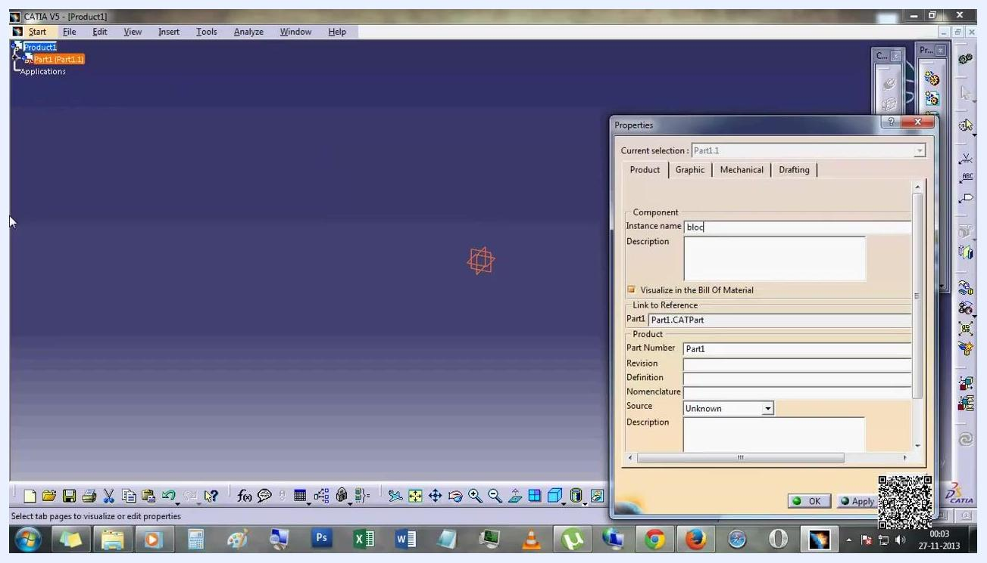
Introductory message describing the tutorial's objective: animating a 3D crank in CATIA V5 to rotate from 0 to 360 degrees

Prerequisites
- CATIA V5 installed and ready to launch.
- Basic familiarity with the CATIA Part Design and Assembly Design workbenches.

Setting up the product structure

1. Open CATIA V5 and prepare the product structure
Launch CATIA V5. You see a workspace titled CATIA V5 - [Product1], with a product tree on the left showing Product1 containing Part1 (Part1.1).
Open the Properties dialog for Part1.1. In the Component section, set Instance name to block. Make sure Visualize in the Bill Of Material is checked. The Product section shows Part Number: Part1.
CATIA V5 workspace with the Properties dialog open for Part1.1, instance name set to "block"

2. Insert an existing component
In the menu bar, click Insert, then select Existing Component... from the dropdown. This adds another part to the product structure.
The product tree now shows block (block) under Product1.
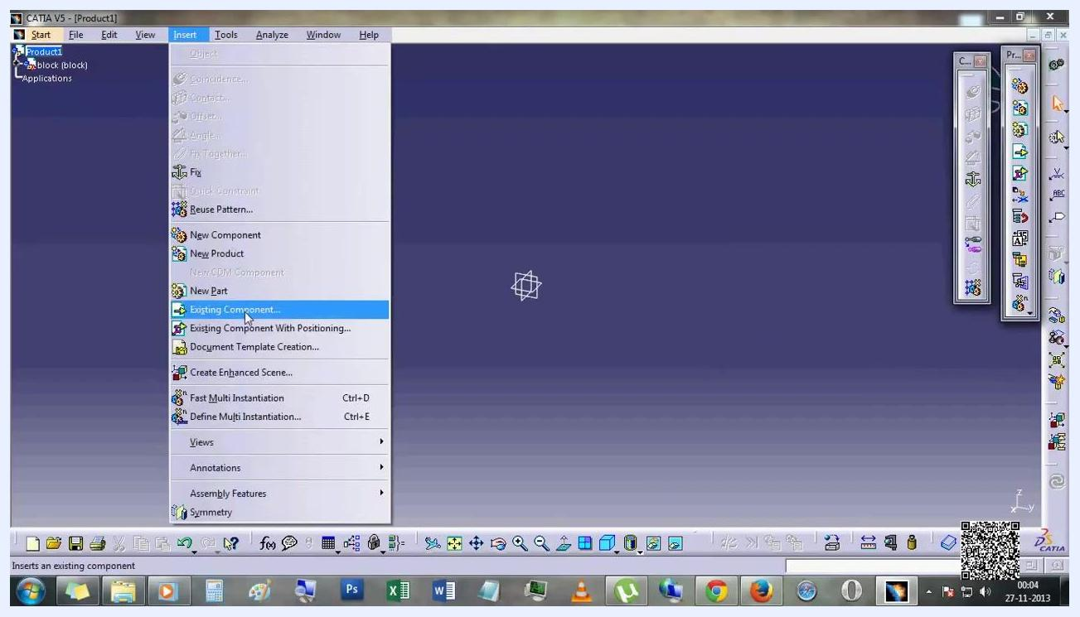
Insert menu open with "Existing Component..." highlighted, product tree showing "block (block)"

3. Set properties for the new component
The Properties dialog opens automatically for the newly inserted component, Part1.2. In the Product section, set Part Number to crank.
The product tree now lists both block (block) and Part1 (Part1.2) under Product1.
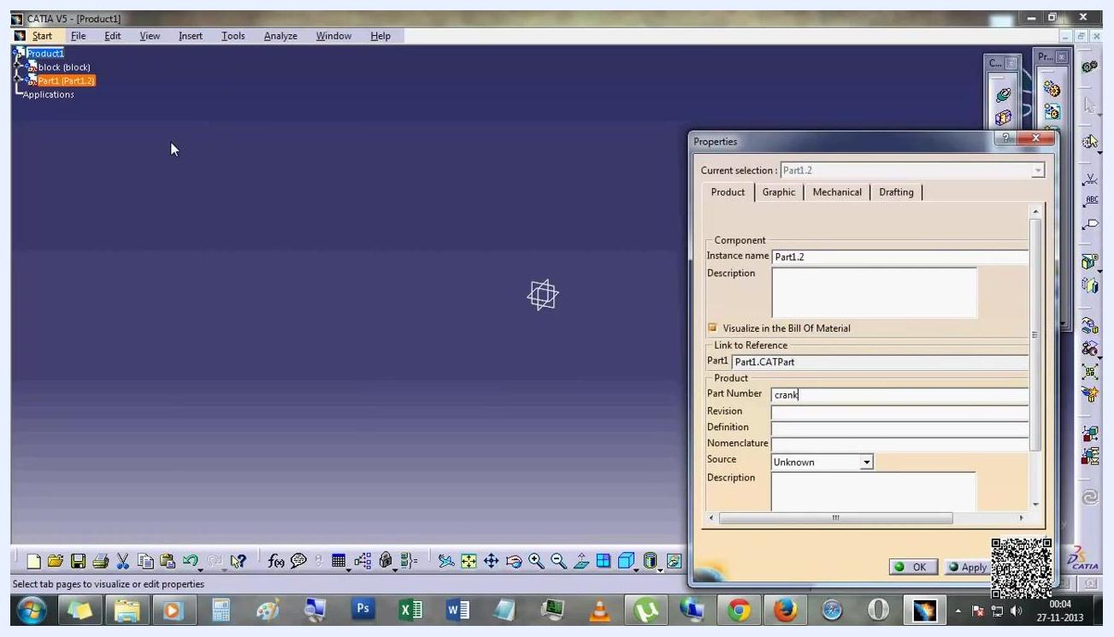
Properties dialog for Part1.2 with Part Number set to "crank", product tree showing both components

Building the block and crank

4. Sketch the block
Enter the sketching environment for the block part. Use the rectangle tool to draw a square on the grid, positioned at the origin where the X and Y axes intersect.
The rectangle's dimensions appear as: Second Point H = 90 mm, V = -100 mm, Width = 90 mm. The Sketch tools toolbar is visible at the top of the workspace.
Sketching a rectangle for the block, with grid and dimensions visible

5. Pad the sketch into a 3D block
Exit the sketch and open the Pad Definition dialog. Set First Limit type to Dimension and enter Length = 20mm. Confirm Profile/Surface is set to Sketch.1.
Click OK to create a 3D block from the rectangle.
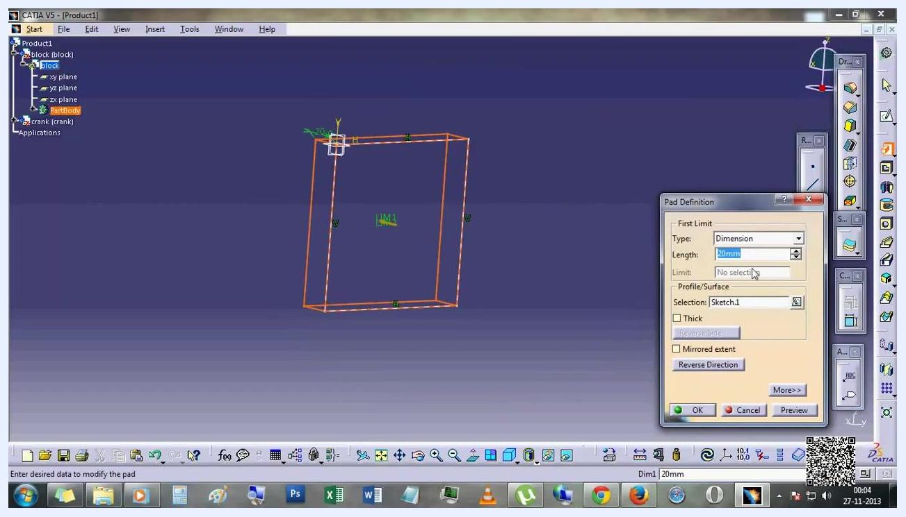
Pad Definition dialog open with Length set to 20mm, previewing the 3D block

6. Sketch the crank
Enter the sketching environment for the crank part and draw a circle on the grid. In the Circle Definition dialog, set Center Point to H = 50 mm, V = -50 mm, with an initial Radius of 22.361 mm.
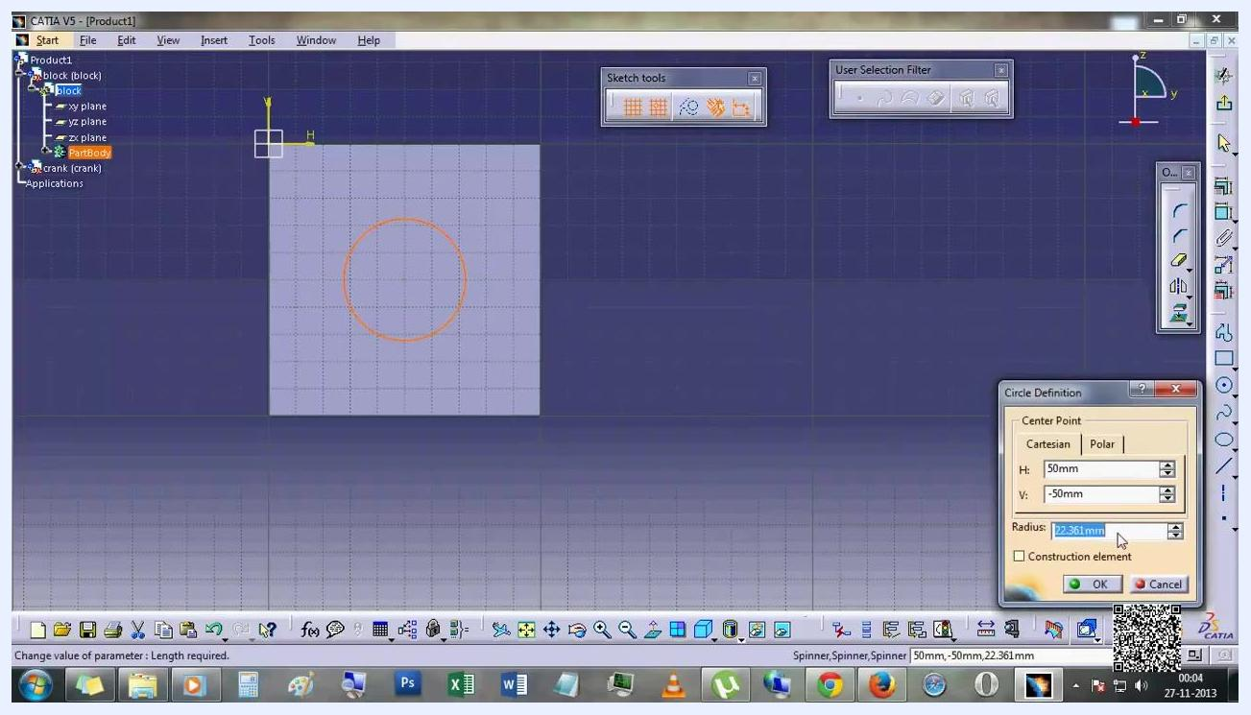
Circle Definition dialog open, center at (50mm, -50mm), radius 22.361mm

7. Adjust the circle radius
In the Circle Definition dialog, change the radius value to 25mm and click OK to confirm.
The circle updates to reflect the new radius.
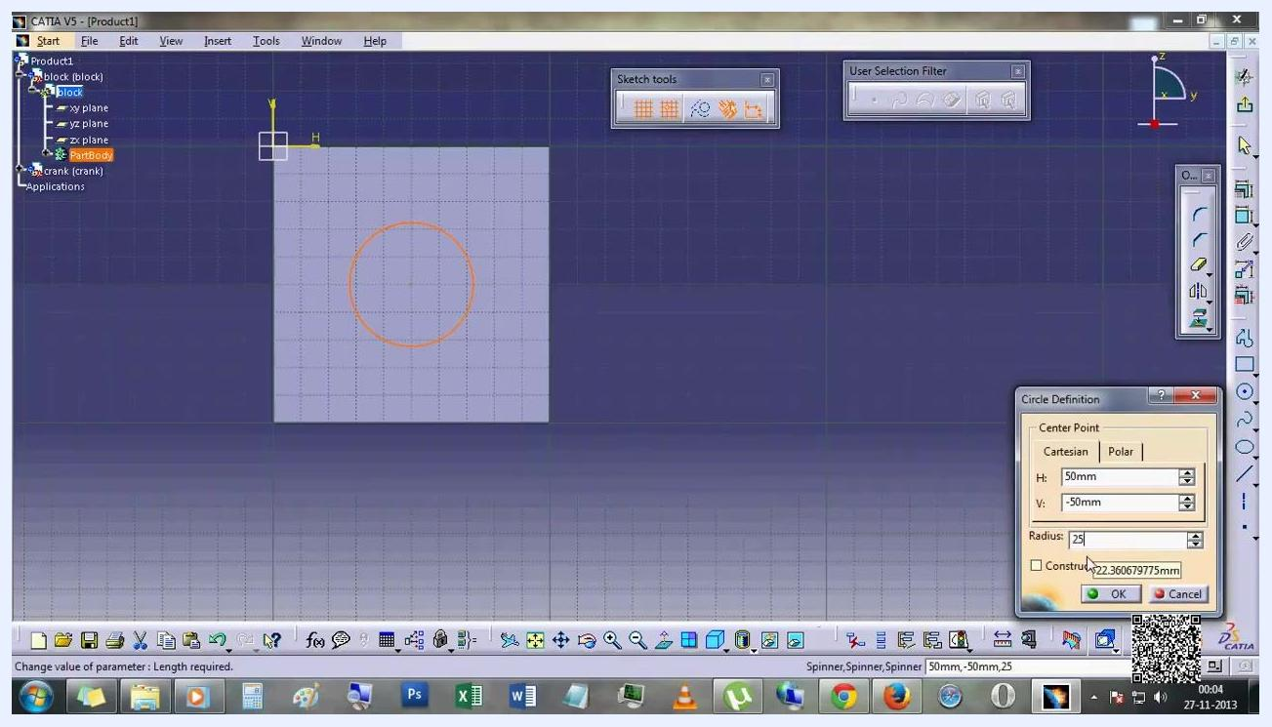
Circle Definition dialog with radius changed to 25mm, circle updated accordingly

8. Visualize the assembled block and crank
Exit the sketching environment. The 3D view now shows a block with a cylindrical crank protruding from its face, and the product tree lists both block and crank under Product1.
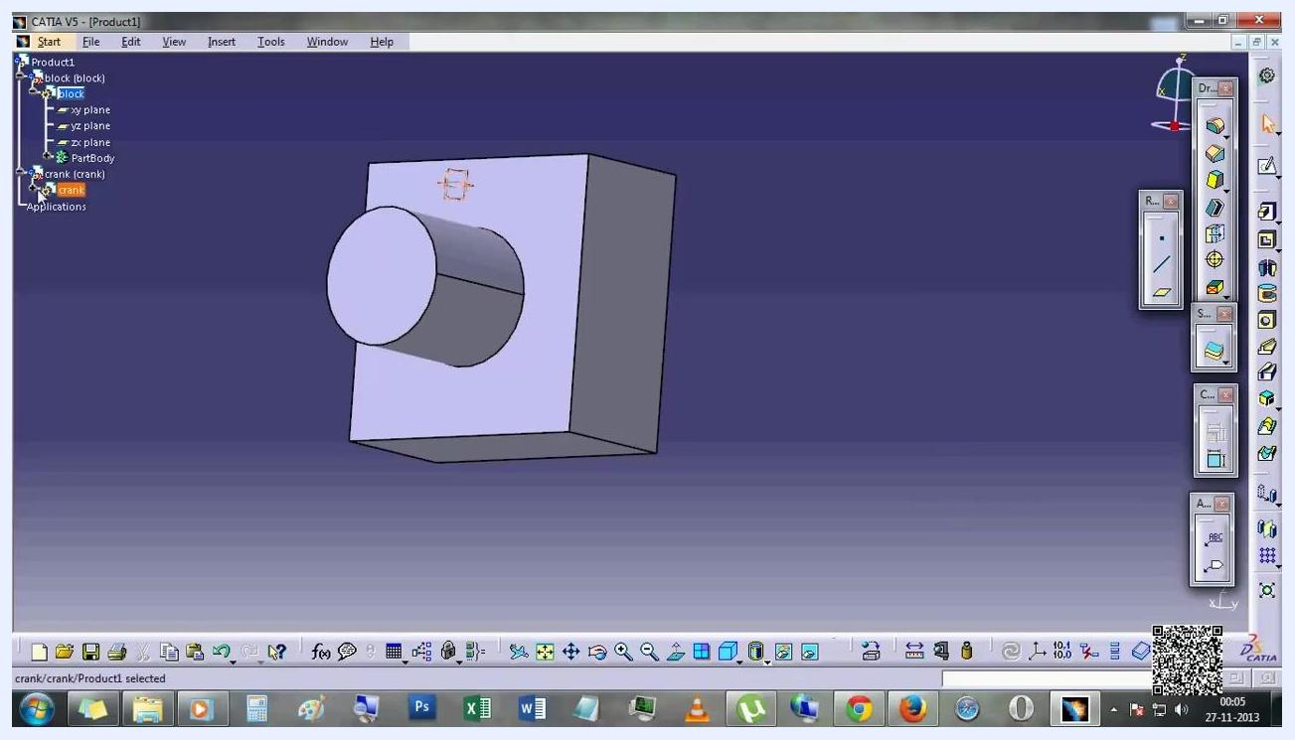
3D view of the block with the cylindrical crank, product tree showing both components

Sketching the crank arm

9. Begin the crank arm sketch
Enter the sketching environment for the crank part again. Draw a large rectangle on the grid, starting from the left of the circle.
The rectangle's dimensions appear as: Second Point H = 300 mm, V = -80 mm, Width = 190 mm.
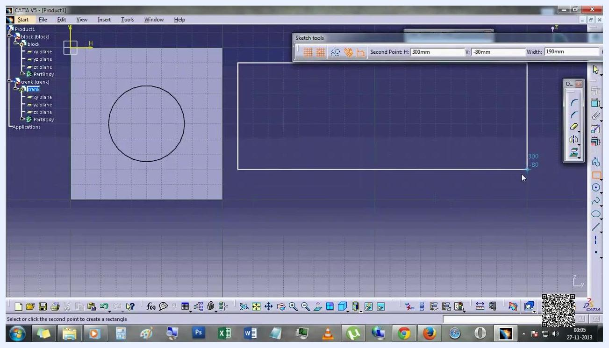
Sketching a large rectangle for the crank arm, with grid and dimensions visible

10. Add circles to the crank arm sketch
With the large rectangle (crank arm) and the previously drawn circle at the left end in view, draw two additional circles, one at each end of the rectangle. Position them tangent or nearly tangent to the rectangle's shorter sides.
These circles form the basis for the holes or pivots in the crank arm.
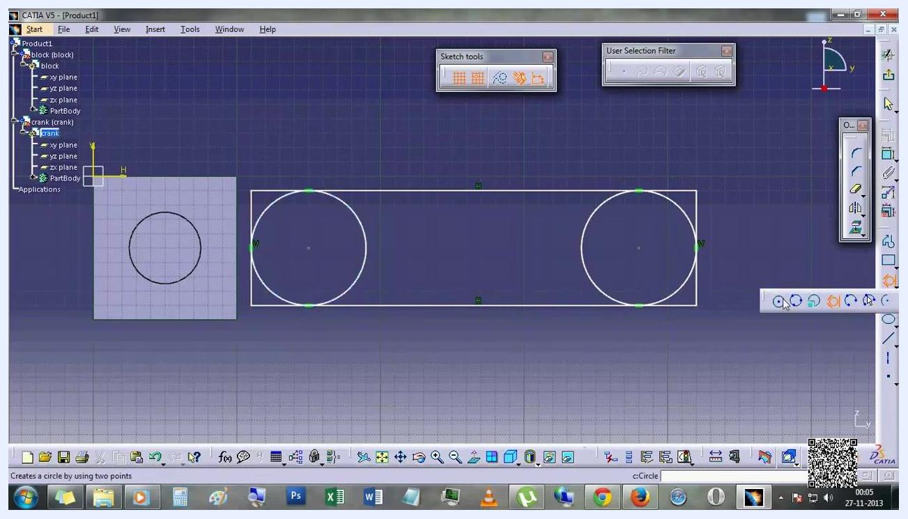
Sketch showing a rectangle with two circles at each end, forming the crank arm profile

11. Add an inner circle for the pivot hole
Draw an inner circle concentric with the leftmost large circle. In the Circle Definition dialog, set Center Point to H = 150 mm, V = -50 mm, with Radius = 25mm.
Make sure Construction element is unchecked so the circle becomes a solid feature, then click OK.
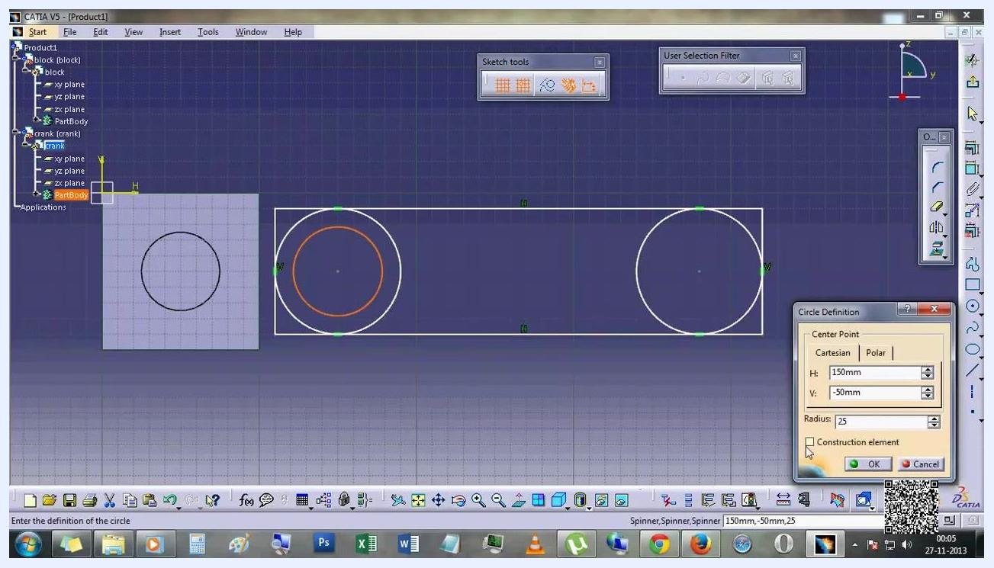
Circle Definition dialog open, adding the inner circle at (150mm, -50mm) with 25mm radius

12. Finalize the crank arm sketch
Confirm the sketch now contains a large rectangle (the crank arm body), two large circles at each end, and an inner circle at the left end (the pivot hole). Exit the sketching environment to proceed with 3D operations.
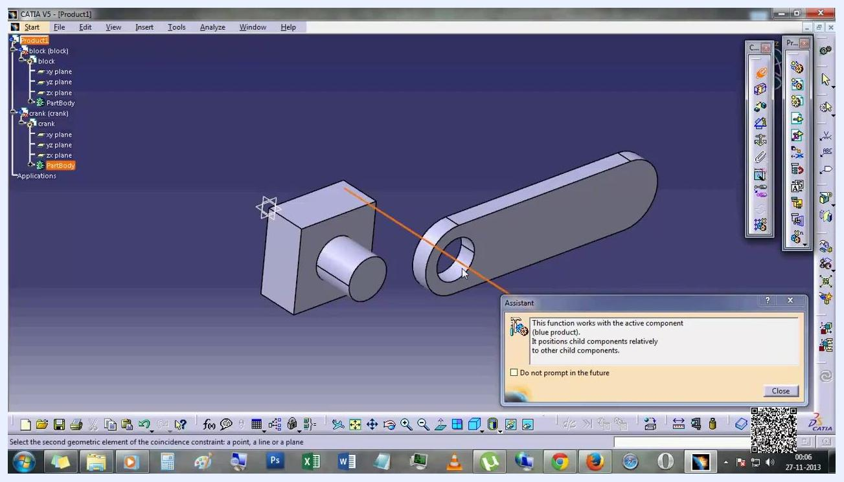
Finalized sketch with rectangle, two large end circles, and an inner circle at the left end

13. Pad and assemble the crank arm
Use the Pad feature to extrude the crank arm sketch into a 3D solid. The 3D view now shows the block and the crank arm as separate solid bodies, with the crank arm displaying rounded ends and a hole at the left end that matches the block's cylindrical protrusion.
3D view showing the solid block and crank arm, with the crank arm's hole visible at the left end

Assembling the parts

14. Position the crank arm
Use the Manipulation panel to drag the crank arm along the Z axis or rotate it as needed for alignment. The crank arm is highlighted in orange to indicate it is the active component being positioned.
Make sure the crank arm's hole aligns with the block's protrusion.
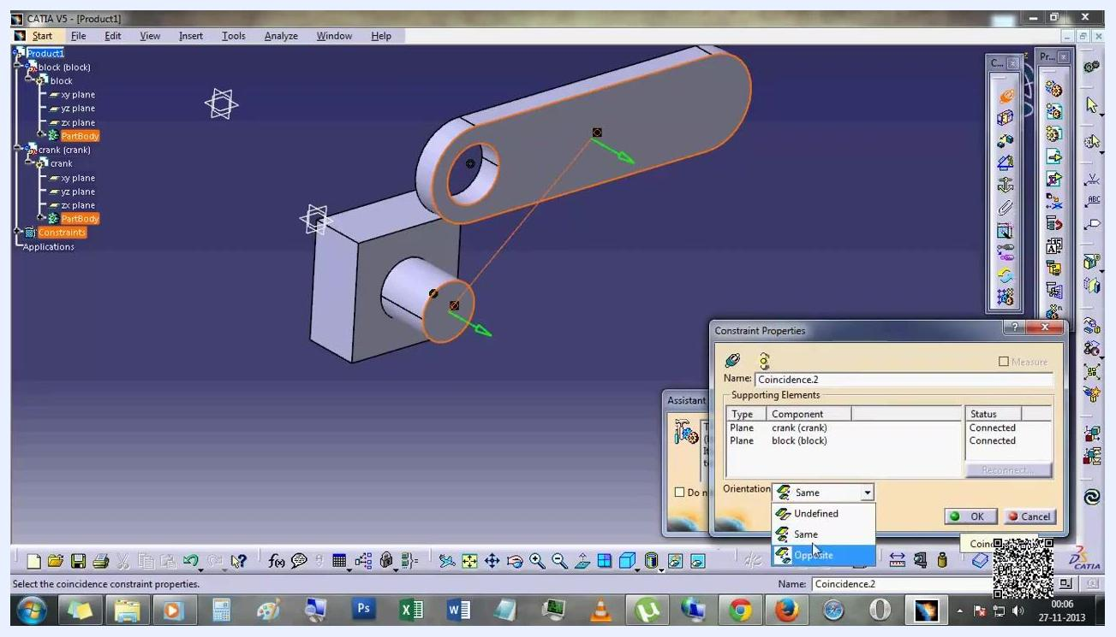
Crank arm highlighted with the Manipulation panel open, being positioned for assembly

15. Apply a coincidence constraint
Enter the Assembly Design workbench. Select the cylindrical face of the block's protrusion and the inner cylindrical face of the crank arm's hole, then apply a Coincidence constraint to align the two faces.
An Assistant dialog explains: "This function works with the active component (blue product). It positions child components relatively to other child components." Click Close to dismiss it.
Assembly workspace with block and crank arm separated, orange selection lines, and the Assistant dialog visible

16. Set coincidence constraint properties
The Constraint Properties dialog appears for Coincidence.2, showing Supporting Elements of type Component, with Plane: crank (crank) and block (block), and Status: Connected.
Set Orientation to Opposite if needed for correct alignment, then click OK to apply the constraint.
Constraint Properties dialog open for Coincidence.2, orientation set to Opposite

17. Verify the assembly and fix the block
Confirm the crank arm is now assembled onto the block, with its hole fitting over the block's cylindrical protrusion. In the constraints tree, verify:
- Coincidence.1 (crank, block)
- Coincidence.2 (crank, block)
- Fix.3 (block) — fixes the block in space to prevent movement
The assembly is now ready for animation.
Final assembled view with the constraints tree showing Coincidence and Fix constraints, block and crank arm properly aligned

Setting up DMU kinematics

18. Switch to the DMU Kinematics workbench
Open the Start menu from the top left and navigate to Digital Mockup > DMU Kinematics. Select DMU Kinematics to enter the kinematic simulation environment.
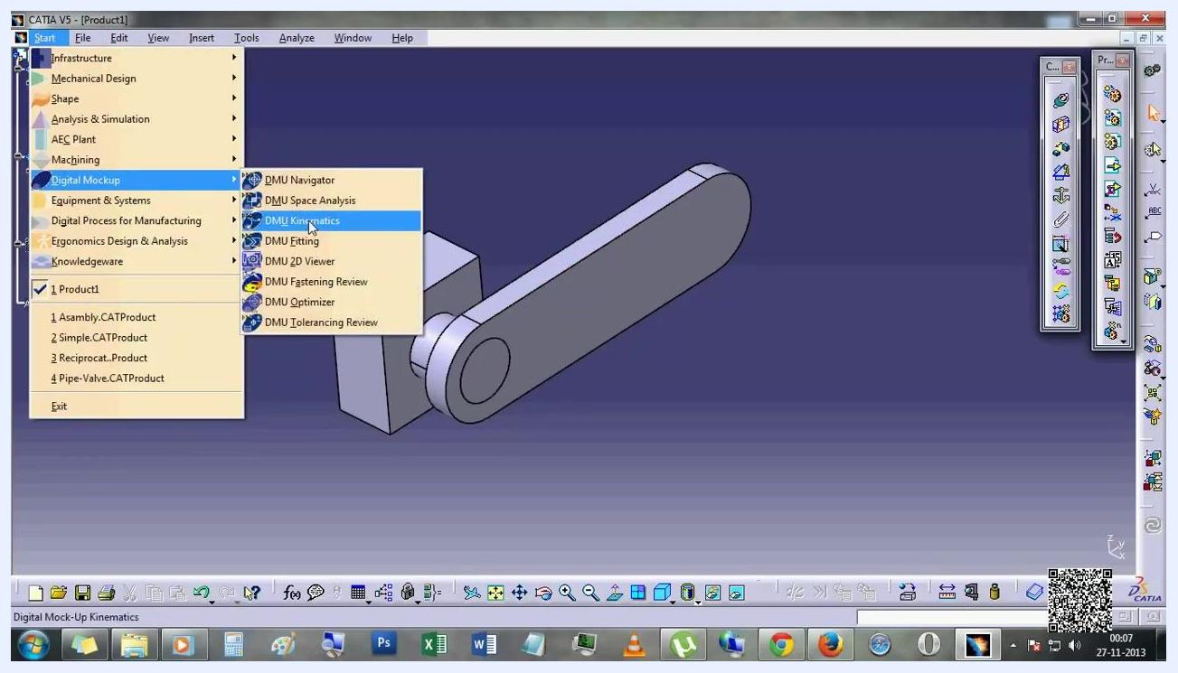
Start menu open with Digital Mockup > DMU Kinematics highlighted

19. Start the assembly constraints conversion
The workspace displays the assembly with the Assembly Constraints Conversion dialog open at the bottom right. In the dialog, the Mechanism dropdown is set to New Mechanism, and the dialog is ready for mechanism creation.
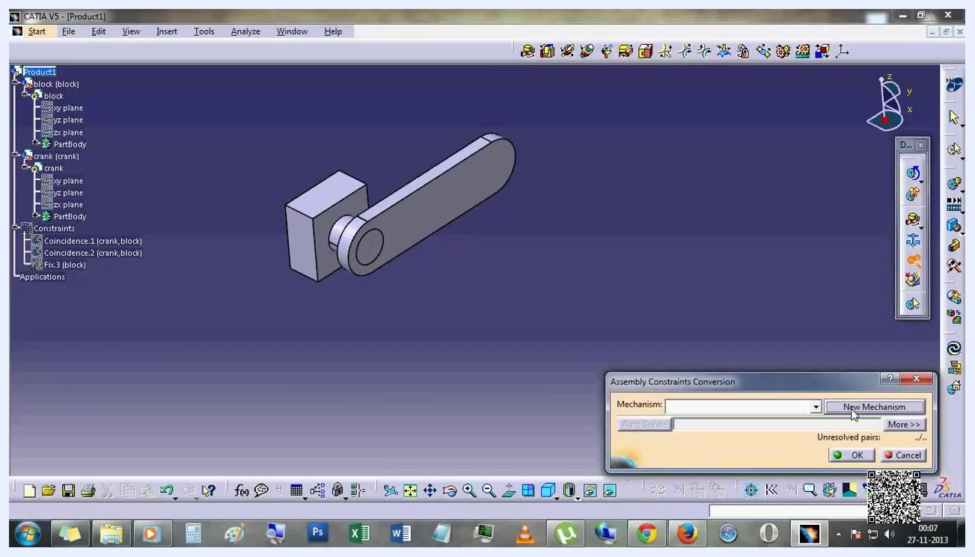
Assembly Constraints Conversion dialog open with Mechanism set to New Mechanism

20. Create and name the mechanism
In the Assembly Constraints Conversion dialog, click to create a new mechanism. A Mechanism Creation dialog appears, prompting you for a name.
Enter the desired mechanism name and click OK to confirm. The name then appears in the dialog.
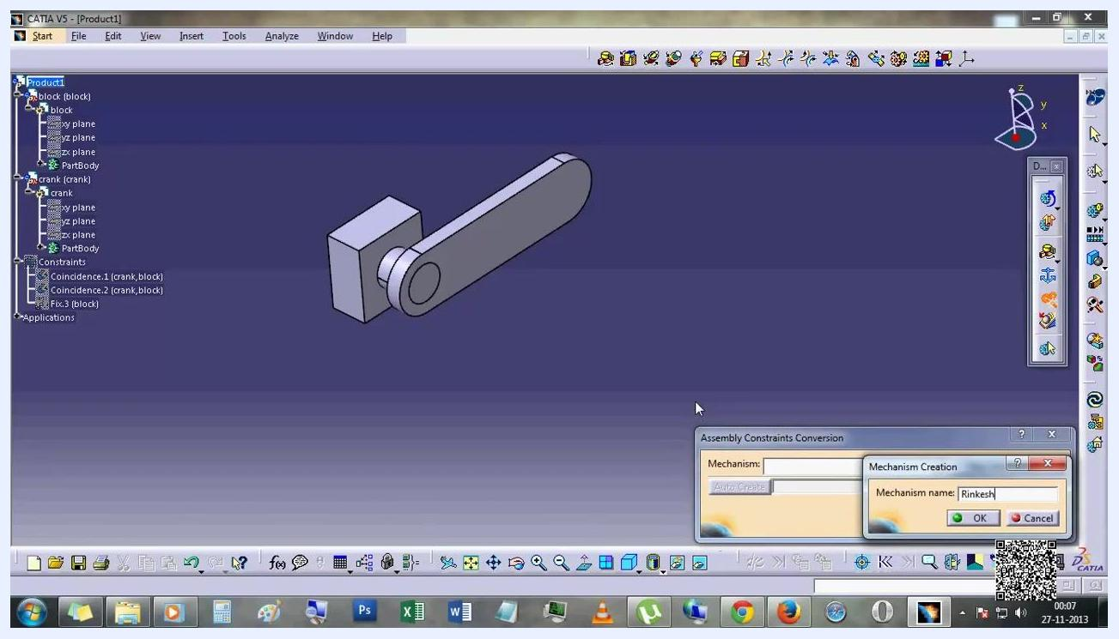
Mechanism Creation dialog open with the mechanism name being entered

21. Verify mechanism creation
Check that the mechanism is now listed under Applications in the tree on the left, for example as "DOF=1" (Degree of Freedom = 1). The mechanism contains joints (such as Revolute.1 (crank, block)), commands, a fixed part (block), and any laws or speeds-accelerations.
The assembly remains unchanged visually, confirming successful mechanism creation.
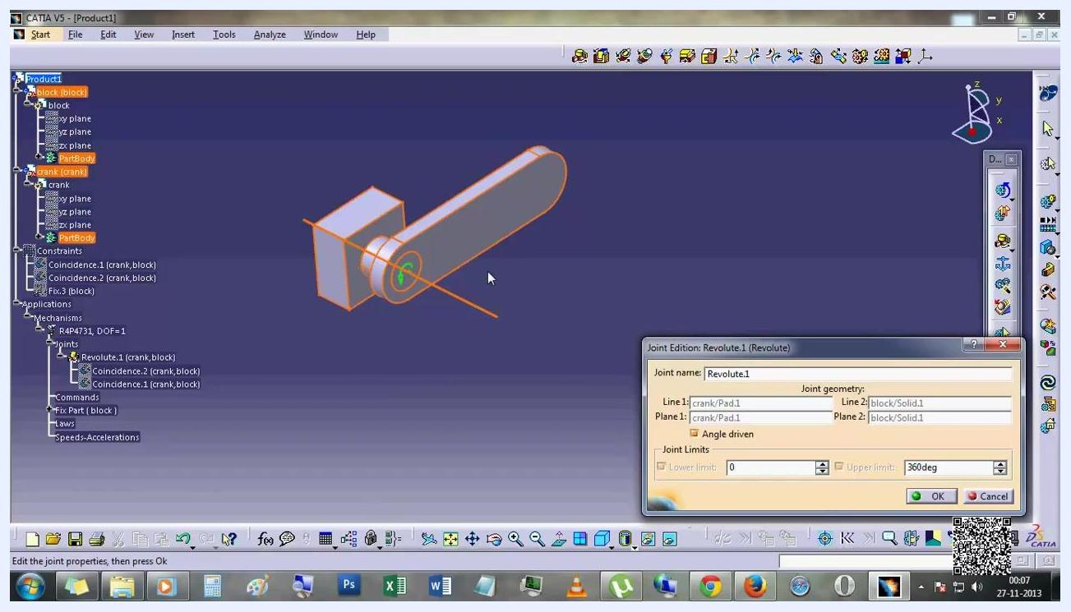
Mechanism listed under Applications, tree expanded to show joints and commands

22. Edit the revolute joint properties
In the Joint Edition: Revolute.1 dialog, set the joint geometry: Line 1: crank/Pad.1, Line 2: block/Solid.1, Plane 1: crank/Pad.1, Plane 2: block/Solid.1.
Check Angle driven to control the rotation, and set joint limits to Lower limit: 0° and Upper limit: 360°. Click OK to confirm.
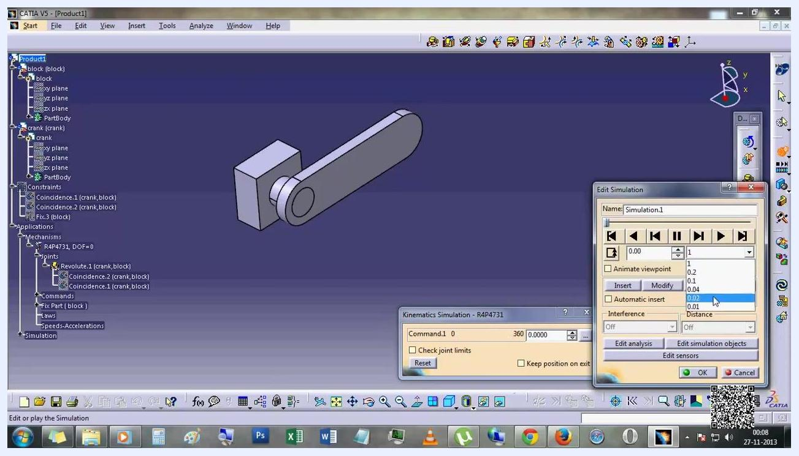
Joint Edition dialog with Revolute.1 properties set, Angle driven checked, limits 0-360 degrees

23. Open the kinematics simulation settings
The Kinematics Simulation dialog appears, showing Command.1 ranging from 0 to 360, with an option to check joint limits and reset.
The Edit Simulation dialog also opens, letting you name the simulation (for example, "Simulation.1"), use playback controls, insert or modify steps, enable Automatic insert, and set interference checking.
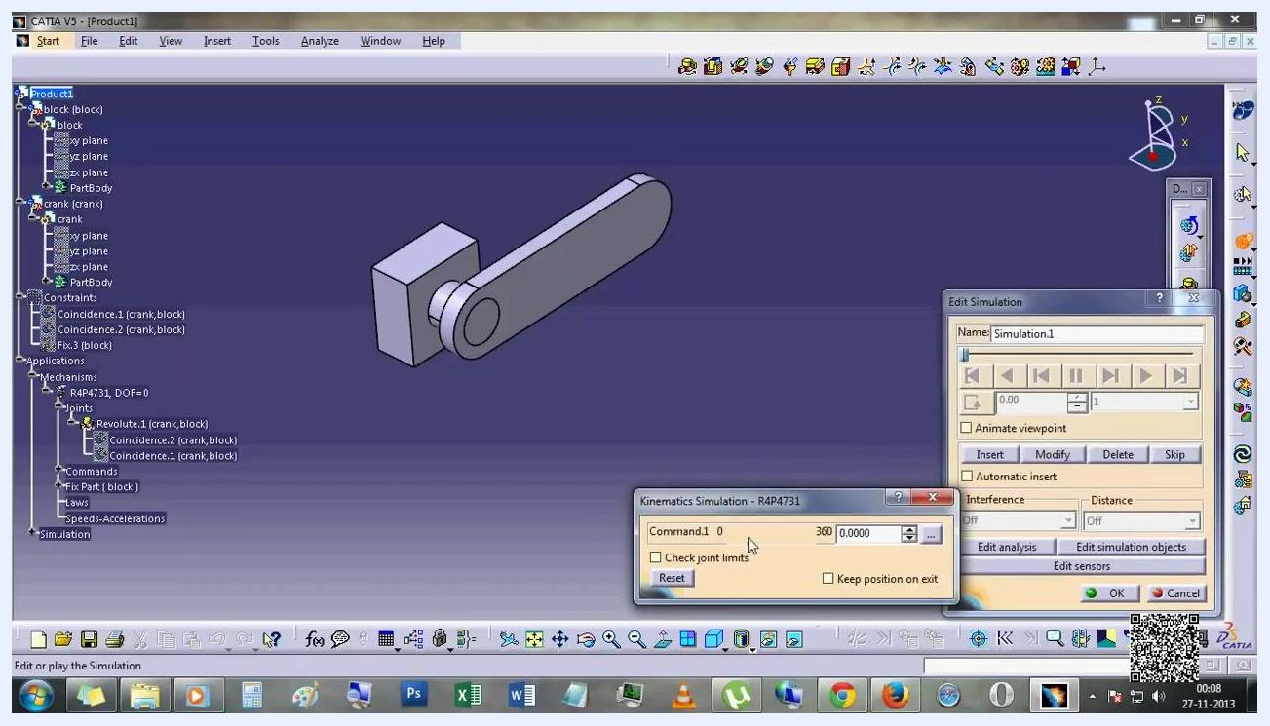
Kinematics Simulation and Edit Simulation dialogs open, showing simulation controls and command range

24. Set the simulation step size
In the Edit Simulation dialog, use the dropdown to select a step size value (for example, 0.02). This determines the increment for each simulation step.
Make sure Automatic insert is checked if you want steps added automatically.
Edit Simulation dialog with the step size dropdown expanded, 0.02 selected, Automatic insert checked

Compiling and playing the simulation

25. Compile the simulation
In the Compile Simulation dialog, check Generate a replay and enter the replay name as Replay.1. Optionally, check Generate an animation file and select a format (such as Microsoft AVI) if you want to export the animation.
Under Definition, confirm Simulation name is set to Simulation.1, and set the Time step value (for example, 0.02). Optionally, check Animate viewpoint if you want the camera to move during the simulation.
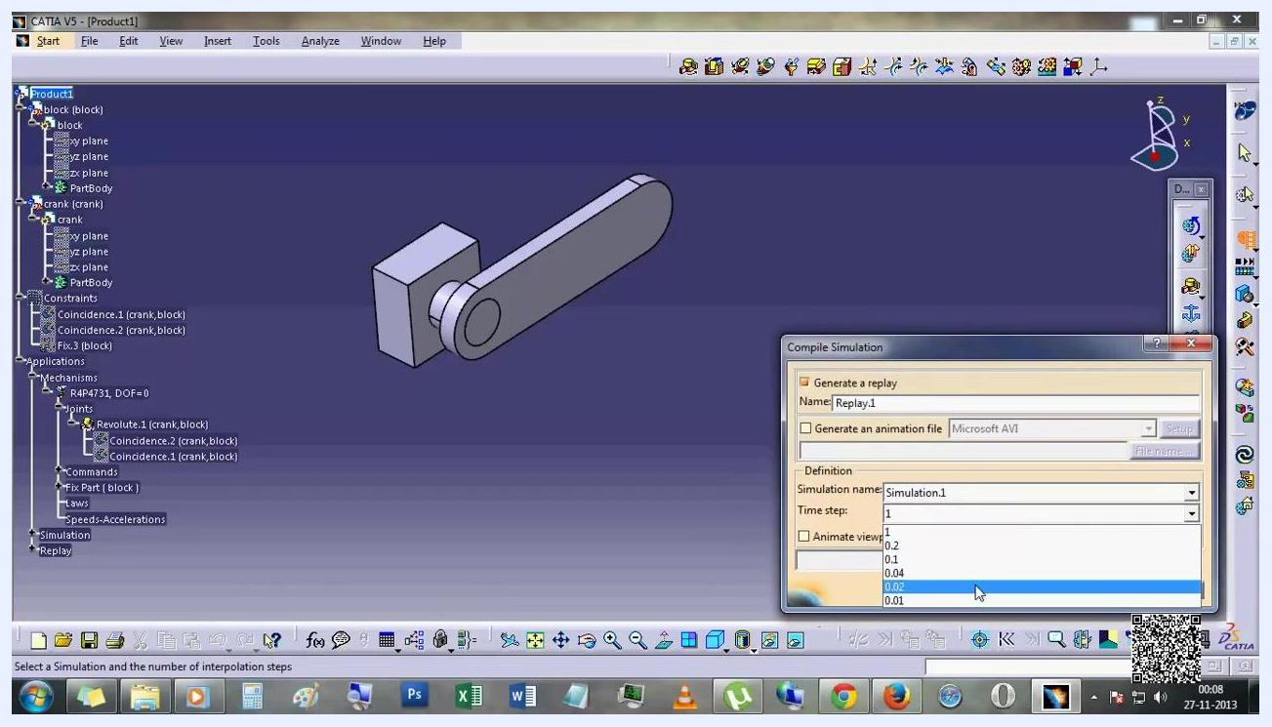
Compile Simulation dialog open with Replay.1 as the name, Simulation.1 selected, and time step set to 0.02

26. Play the simulation replay
Once the simulation is compiled, a Player window appears at the bottom right, and the assembly is shown in the main workspace, ready for replay. The replay (Replay.1) is now listed under the Simulation section in the tree.
Use the player controls to start the replay and observe the mechanism's motion.
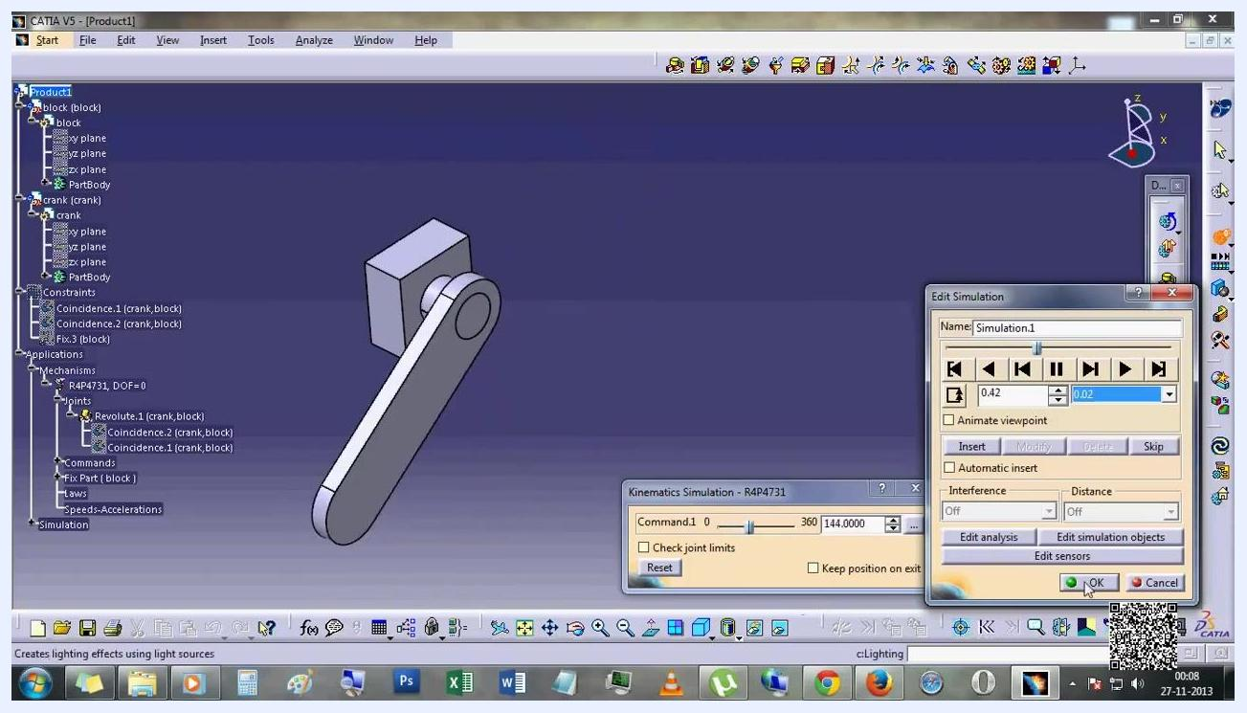
Simulation replay ready, with the Player window visible and Replay.1 listed in the tree

27. Interact with the simulation view
Rotate, zoom, or pan the 3D view during or after the simulation to inspect the mechanism from different angles. The simulation continues to play, showing the full range of motion defined by the constraints and commands.
The Player window displays the current simulation time, for example 0.46s.
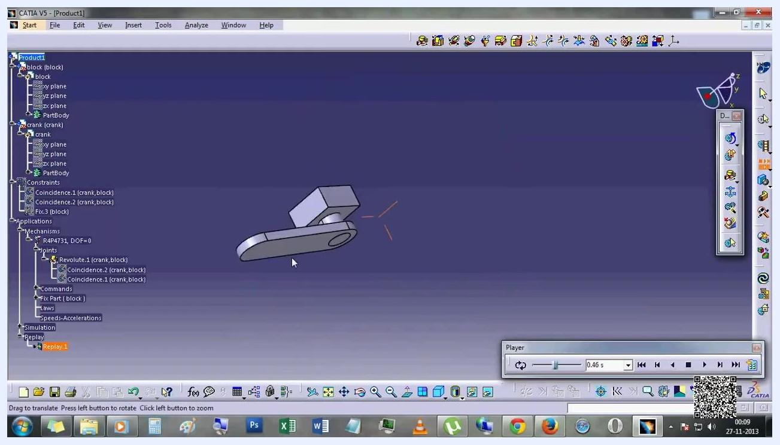
Simulation view rotated to show the crank in a different position, Player window showing 0.46s

Summary
You have now learned how to make an animation in CATIA V5 by building a block and crank, assembling them with coincidence constraints, converting the assembly into a kinematic mechanism with a revolute joint driven from 0 to 360 degrees, and compiling a replay to visualize the crank's rotation.

