How to Add a Package Policy in Applied Epic
This guide walks you through how to add a package policy in Applied Epic, from locating the client account to issuing the completed policy. You'll learn how to enter policy details, add multiple lines of business, remove placeholder entries, and confirm the final policy is active.

Prerequisites
- Access to Applied Epic with permissions to add and edit policies.
- The client account for which you want to add the package policy.
- Policy details on hand, including policy number, effective and expiration dates, issuing company, and premium amounts.

Navigating to the client account

1. Open the client account and access Policies
Open Applied Epic and go to the client account for which you want to add the package policy. In the left navigation pane, click Policies. The main Policies screen displays the current and renewed policies for the client.
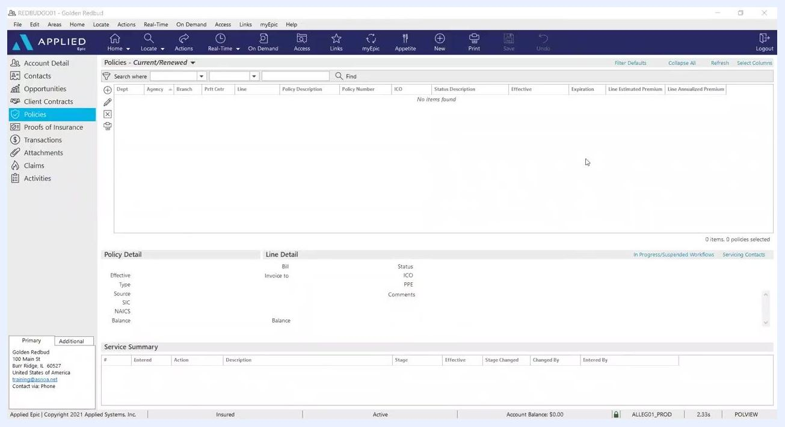
Policies section open, showing no items found in the policy list. Left navigation highlights 'Policies'.

2. Start a new policy
Click the plus sign (+) or the Add a Policy button to begin entering a new policy.

Entering policy details

3. Select the policy line type
In the Policy Detail section, set the Type field. For a personal lines package policy, enter or select PCK1. For a commercial lines package policy, enter or select CPKG. You can optionally customize the Description field to clarify the package type.
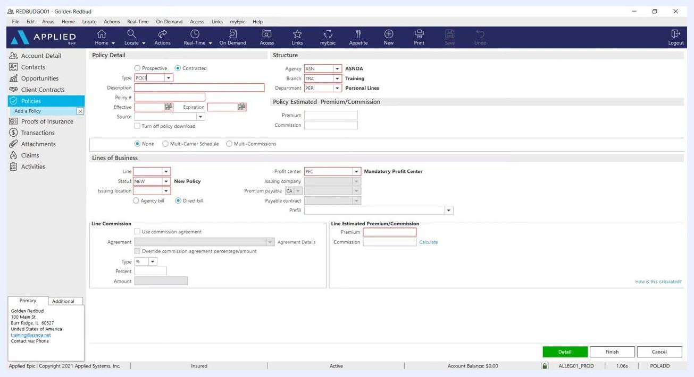
Add a Policy screen with Policy Detail and Lines of Business sections. The 'Type' field is set to PCK1, the Description field is editable, and other fields are ready for input.

4. Enter the policy number and dates
Enter the policy number in the Policy # field, then enter the Effective Date and Expiration Date for the policy. Fill in the Source field if applicable.

5. Verify the structure information
Review the Structure section on the right side of the screen. Confirm that the Agency, Branch, and Department fields accurately reflect your agency's information. If the Department (for example, Personal Lines or Commercial Lines) needs to be changed, manually select the correct department from the dropdown.
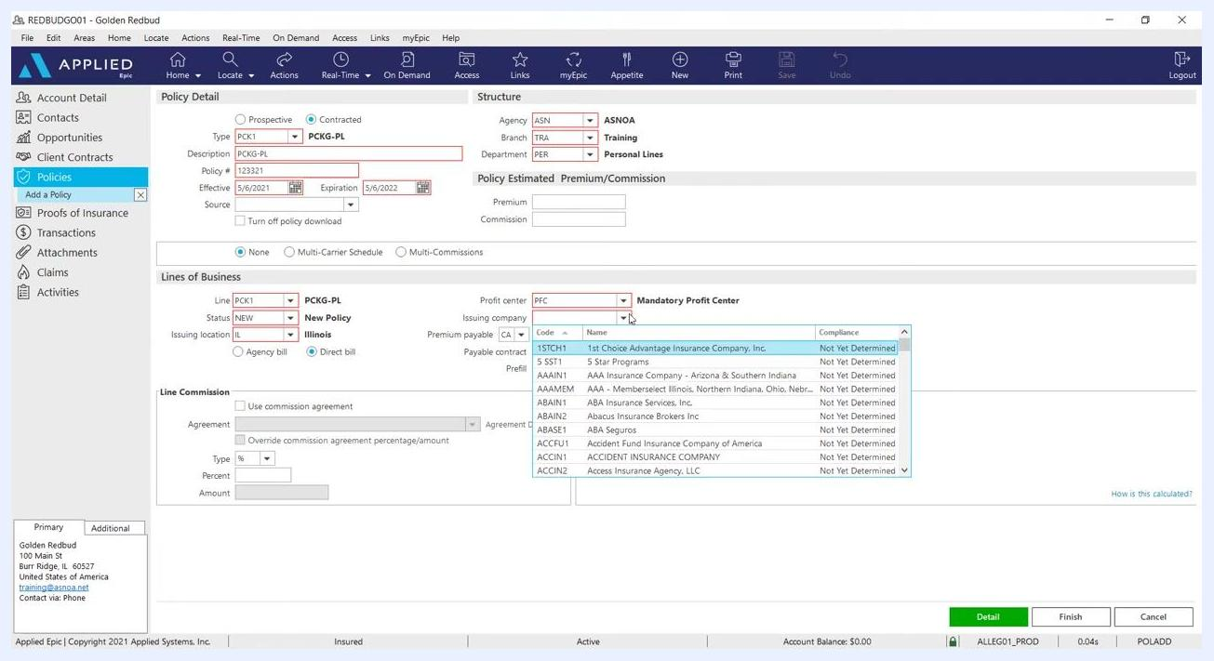
Structure section highlighted with Agency, Branch, and Department fields. The Department dropdown is open, showing options such as Administrative, Commercial Lines, Life, and Personal Lines.

Completing the lines of business

6. Complete the initial line of business
In the Lines of Business section, set the Line field (for example, PCK1 for personal lines) and set the Status to NEW. Select the Issuing Location (for example, IL for Illinois), and complete other required fields such as Profit Center, Issuing Company, and Premium Payable as needed.
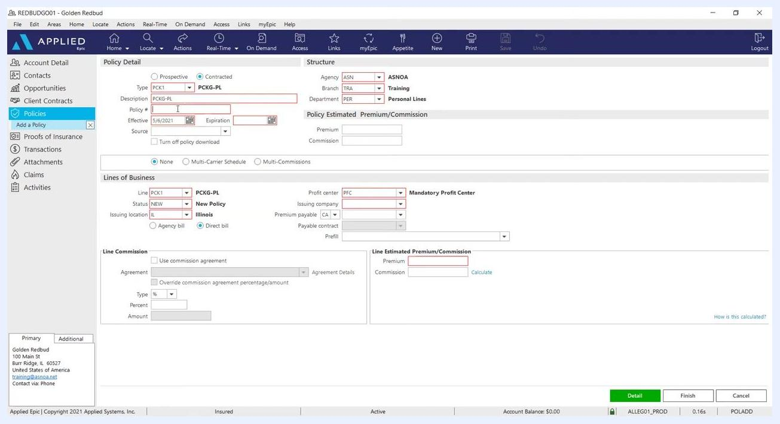
Policy entry screen with PCK1 selected, description filled, policy number and dates ready for input, and the Lines of Business section partially filled.

7. Select the issuing company
In the Issuing Company field, click the dropdown and select the appropriate company. For this example, select NATGEN – National General.
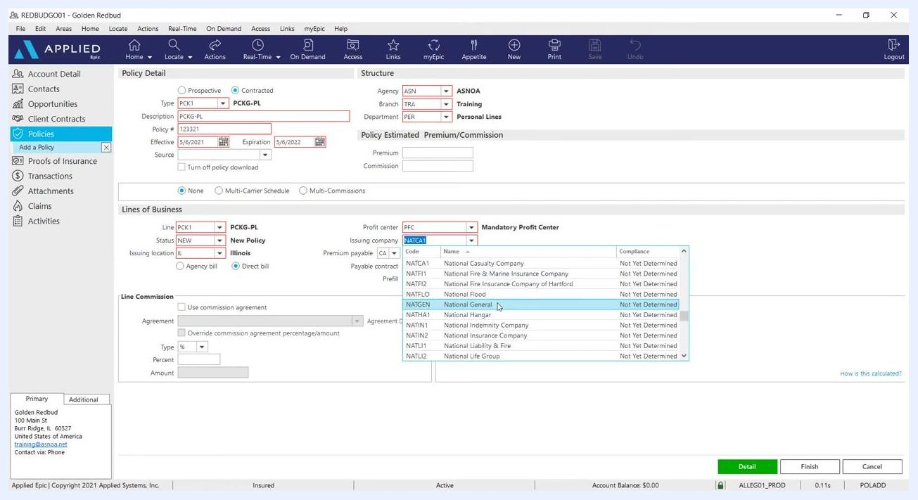
Issuing Company dropdown open, with National General highlighted and selected.

8. Set the commission agreement (if applicable)
Check the Use commission agreement box if your agency uses commission agreements. It's acceptable if no percentage or commission value populates automatically at this stage.

9. Enter the premium amount
In the Line Estimated Premium/Commission section, enter the premium for this package. For this example, enter 600 in the Premium field.
Premium field filled with 600 under Line Estimated Premium/Commission. All other fields remain as previously entered.

10. Proceed to detail and close the activity
Click the Detail button at the bottom right to continue with the package policy format. If prompted with an activity window, review the details and click Finish to close the activity. If a confirmation dialog appears stating "Activity contains tasks that have not been completed. Do you wish to continue?", click Yes to proceed.
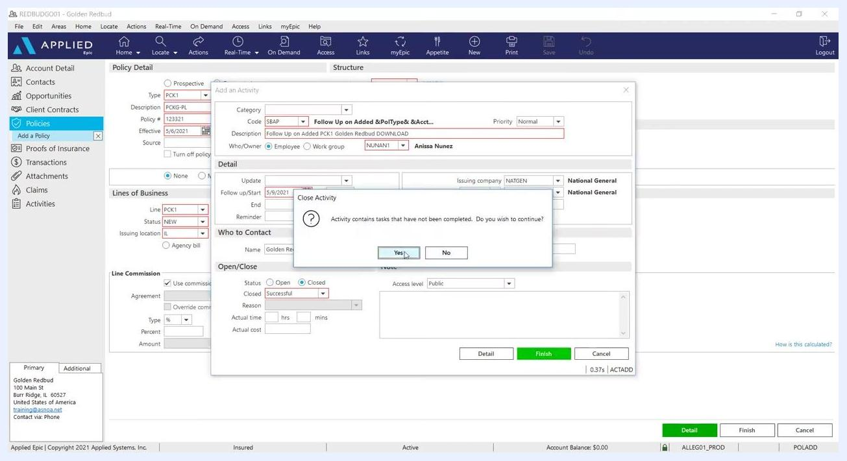
Activity window open with the Finish button highlighted, and a confirmation dialog asking to close the activity with Yes selected.

11. Review the policy entry
After closing the activity, review the completed policy entry. The Lines of Business section now displays the new policy line (for example, PCK1) with the effective and expiration dates, issuing location, profit center, issuing company, and estimated premium ($600.00).
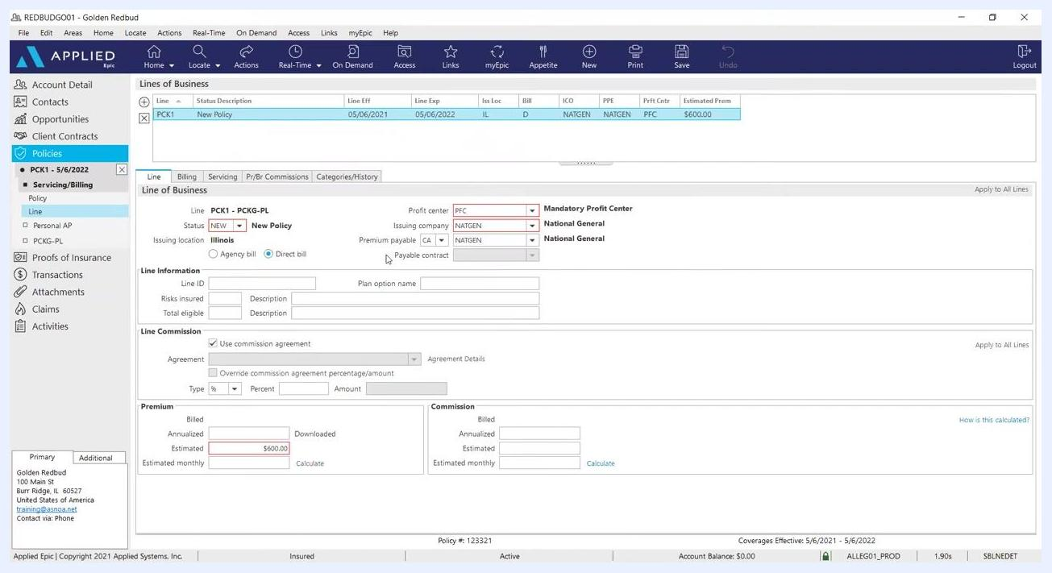
Lines of Business section showing the new policy line PCK1, effective/expiration dates, Illinois location, National General as issuing company, and a $600.00 estimated premium.

Adding additional lines of business

12. Add the Auto line of business
In the Add a Line of Business window, set the following fields:
- Line: AUTO (Personal Automobile)
- Status: NEW (New Policy)
- Issuing Location: IL (Illinois)
- Profit Center: PFC (Mandatory Profit Center)
- Issuing Company: NATGEN (National General)
Check the Use commission agreement box.
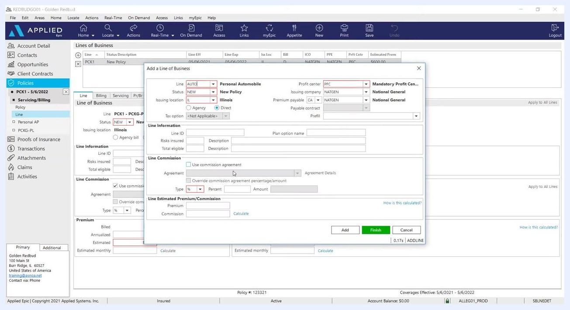
Add a Line of Business window with AUTO selected, the commission agreement box highlighted, and all required fields filled for Personal Automobile.
If the default commission agreement is not correct for this line of business, click the Agreement dropdown and select the appropriate agreement, such as "CA - Auto - New & Renew," "Personal Auto & RV - New & Renew," or "Premier Auto (when bundled w/Home) - New & Renew."
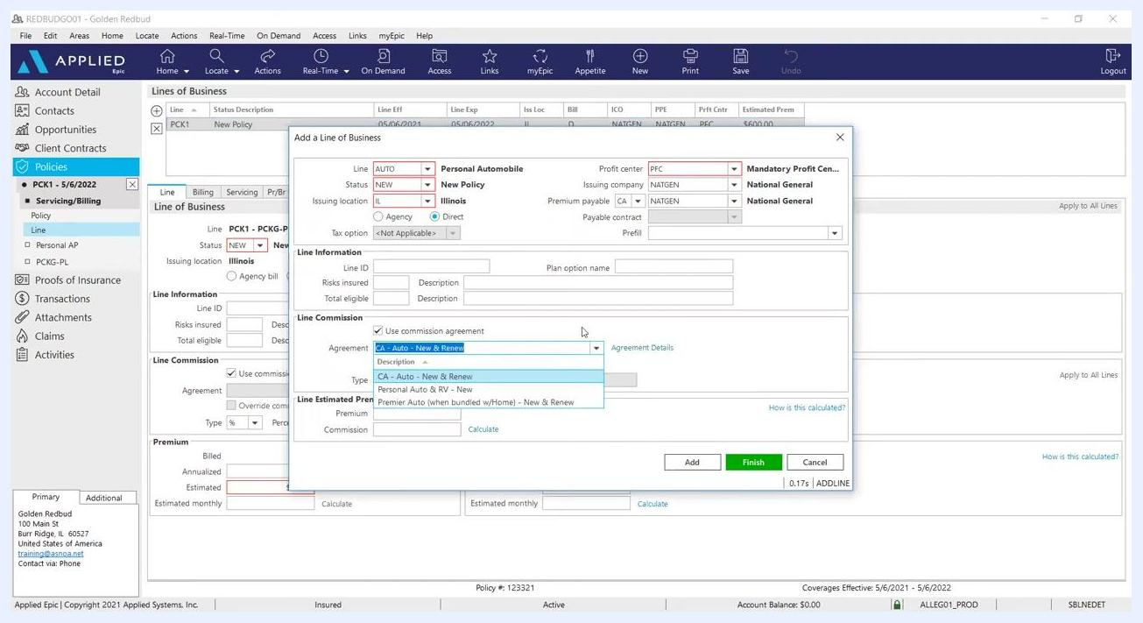
Commission agreement dropdown open with multiple agreement options visible for selection.
In the Line Estimated Premium/Commission section, enter the premium amount (for example, $200), then click Add to save this line and prepare to add the next one.

13. Add the Home line of business
Set the following fields:
- Line: HOME (Homeowners)
- Status: NEW (New Policy)
- Issuing Location: IL (Illinois)
- Profit Center: PFC
- Issuing Company: NATGEN
Check the Use commission agreement box, enter the premium amount (for example, $200), and click Add to save this line.
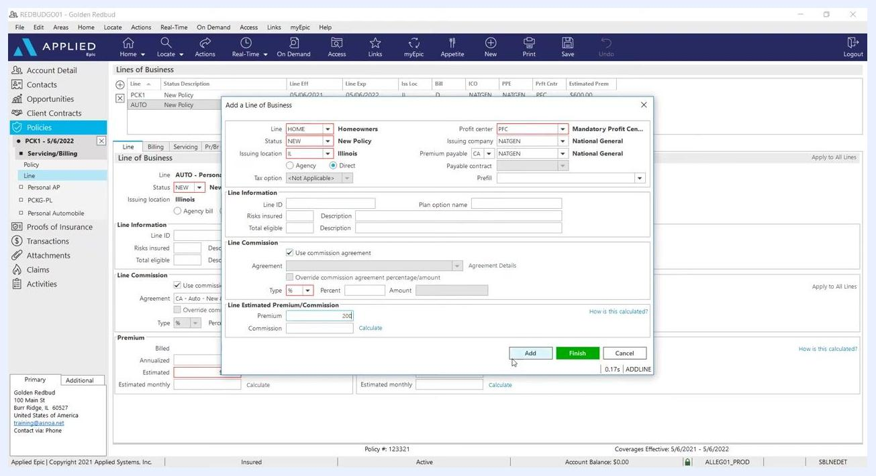
Add a Line of Business window with HOME selected, commission agreement checked, and the premium entered as 200.

14. Add the Umbrella line of business
Set the following fields:
- Line: PUMB (Umbrella - Personal Lines)
- Status: NEW (New Policy)
- Issuing Location: IL (Illinois)
- Profit Center: PFC
- Issuing Company: NATGEN
Check the Use commission agreement box and enter the premium amount (for example, $200). Click Finish after all desired lines of business have been added.
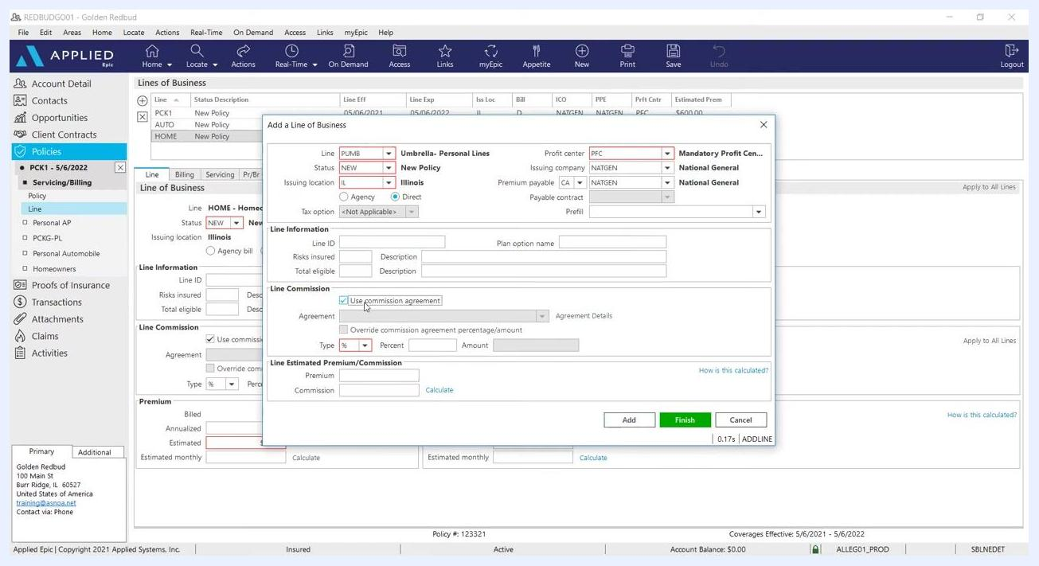
Add a Line of Business window with PUMB (Umbrella - Personal Lines) selected, commission agreement checked, and the premium field ready for entry.

Finalizing the package policy

15. Remove the initial package line (PCK1)
Before finalizing, delete the initial PCK1 line of business. In the Lines of Business list, highlight the PCK1 entry and click Delete. When prompted with "Are you sure you wish to delete this line?", click Yes to confirm.
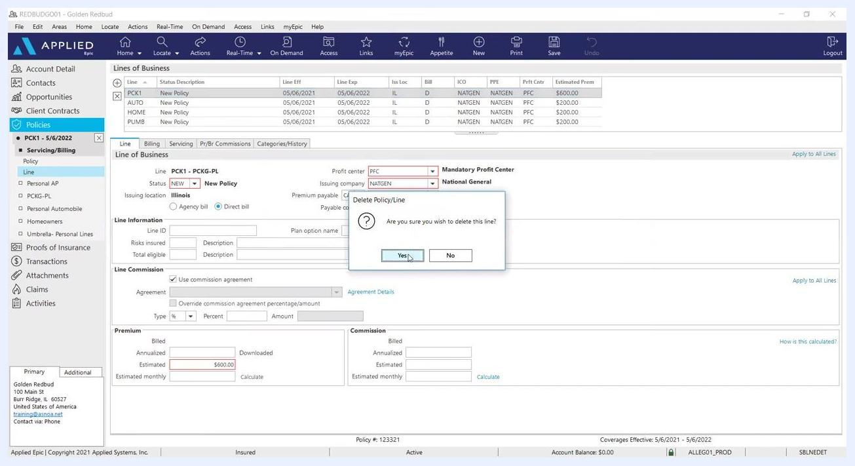
Delete Policy/Line confirmation dialog with Yes selected, and PCK1 highlighted for deletion.

16. Review the final set of lines of business
Confirm that only the intended lines of business remain (Auto, Home, Umbrella), each with the correct details and premium amounts (for example, $200 each). If you are adding policies for several producers, ensure the correct PR BR Commission agreements are set for each producer on the back end. If your system is already defaulted and set up, no further action is needed.
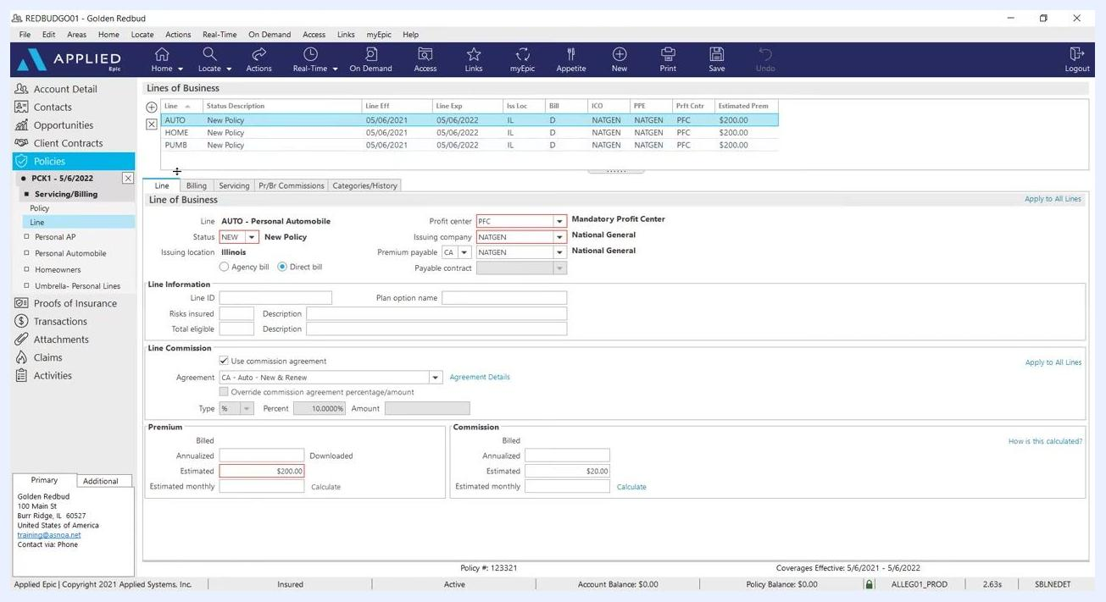
Lines of Business section showing only AUTO, HOME, and PUMB lines, each with a $200 premium, and commission agreement details visible.

Issuing or not issuing the policy

17. Close the current policy window
When you have completed all necessary policy entry and edits, locate and click the "X" on the left-hand side of the policy window to exit.
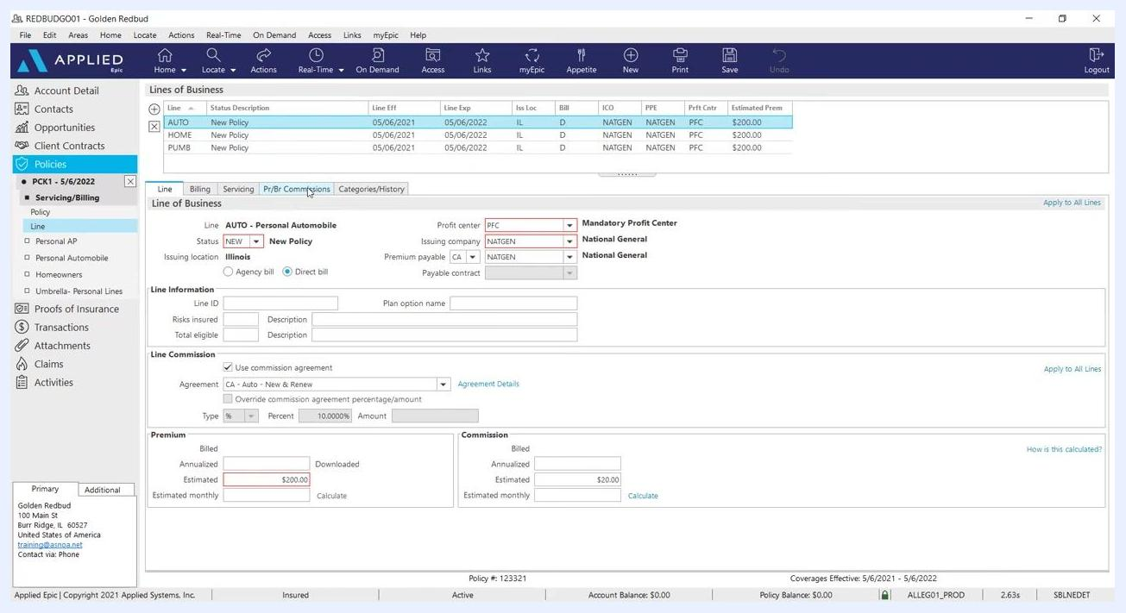
The Applied Epic interface showing the policy entry screen with various fields filled, including policy status, issuing company, premium, and commission details. The navigation panel on the left highlights 'Policies' and the active policy.
If the insurance carrier does not provide automatic downloads, you'll need to manually issue the policy. A dialog titled "In Process Policy" appears. Confirm that you have completed policy editing, select "Yes, perform action:", choose the appropriate action from the dropdown menu, and click the green Finish button to proceed.
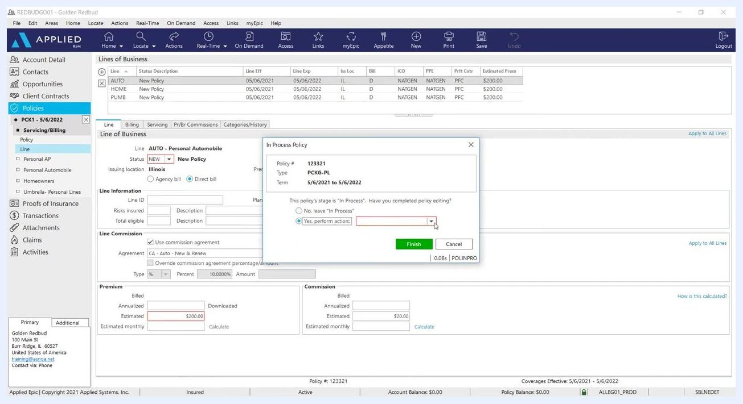
A dialog box titled 'In Process Policy' is open over the Applied Epic policy entry screen. It asks whether policy editing is complete, with options to leave it 'In Process' or perform an action. 'Yes, perform action:' is selected, and the Finish button is visible.

18. Close out any open activities
If prompted, a window titled "Issue / Not Issue Policy" appears. Verify the policy number (for example, 123321), effective and expiration dates (5/6/2021 to 5/6/2022), and line details. Ensure the issuing company and premium payable fields are set to "NATGEN National General," and confirm the status is "NEW New Policy." Click the green Finish button to finalize and close the activity.
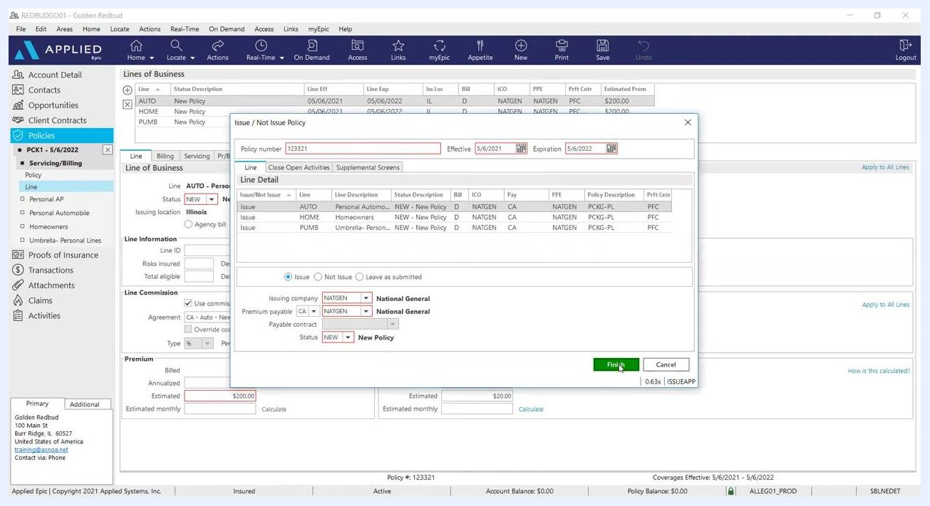
A dialog box titled 'Issue / Not Issue Policy' is open, showing the policy number, effective and expiration dates, and line details for multiple lines. The issuing company and premium payable are set to 'NATGEN National General,' and the Finish button is highlighted.

Confirming the policy was added

19. Review the updated policy list
The "Policies - Current/Renewed" screen displays all current policies. Verify that your new policy (for example, PCK1, policy number 123321, effective 5/6/2021 to 5/6/2022) appears in the list with the correct details and premiums. Check the "Policy Detail" and "Line Detail" sections for confirmation.
The Applied Epic 'Policies - Current/Renewed' screen showing a list of policies, including the newly added package policy with details such as line, policy number, effective and expiration dates, and premiums.

20. Verify the policy is active
Double-check the policy details, including effective dates, type, and agency balance. Confirm that the policy status is "Active" and the account balance is $0.00.
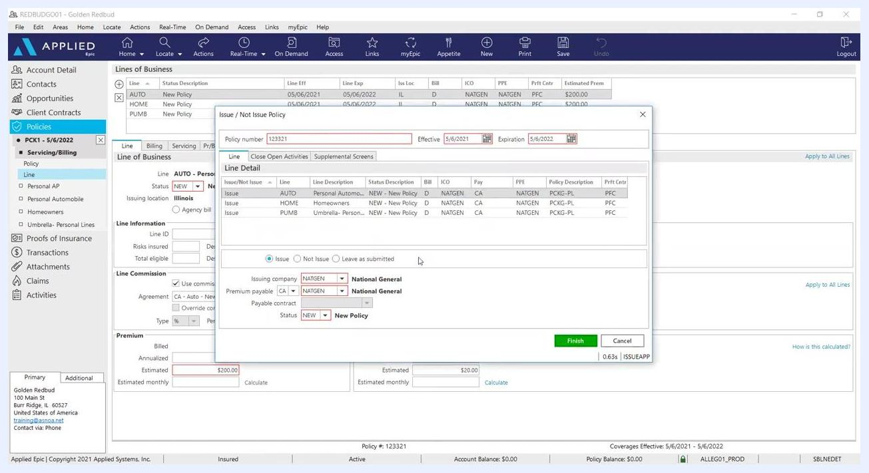
The Applied Epic 'Policies - Current/Renewed' screen remains open, showing the policy list and details for the selected policy, confirming successful addition.

Summary
You've now learned how to add a package policy in Applied Epic, including setting up the initial policy line, adding Auto, Home, and Umbrella lines of business, removing the placeholder PCK1 entry, and issuing the policy. Once the policy appears in the "Policies - Current/Renewed" screen with an "Active" status and a $0.00 balance, the package policy is successfully added and ready for use.

