How to Enter a Bill in AppFolio Using Smart Bill Entry
This guide walks you through how to enter a bill in AppFolio using the Smart Bill Entry feature. You'll learn how to upload bill files, let the system process them, and review and save the extracted details so they appear correctly in your Payables list.
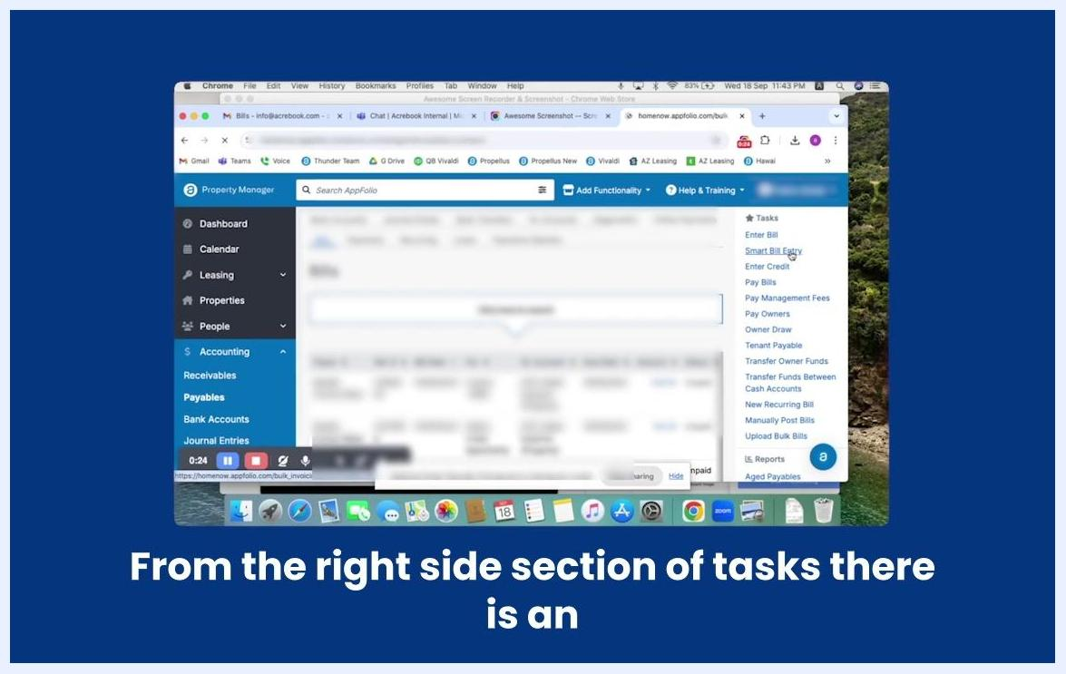
The Payables section is open. The right sidebar under Tasks lists options including Enter Bill, Smart Bill Entry, Enter Credit, Pay Bills, and more.

Prerequisites
- An active AppFolio account with access to the Accounting module.
- Digital copies of the bill files you want to upload (for example, PDF or image files saved on your computer).

Step 1: Log in to AppFolio
Open your web browser and log in to your AppFolio account to access the dashboard.

Step 2: Open Accounting and Payables
Click Accounting in the left navigation menu. The Accounting section expands to show additional options.
Under the expanded Accounting menu, click Payables. The Payables screen opens, displaying a list of bills and related actions.
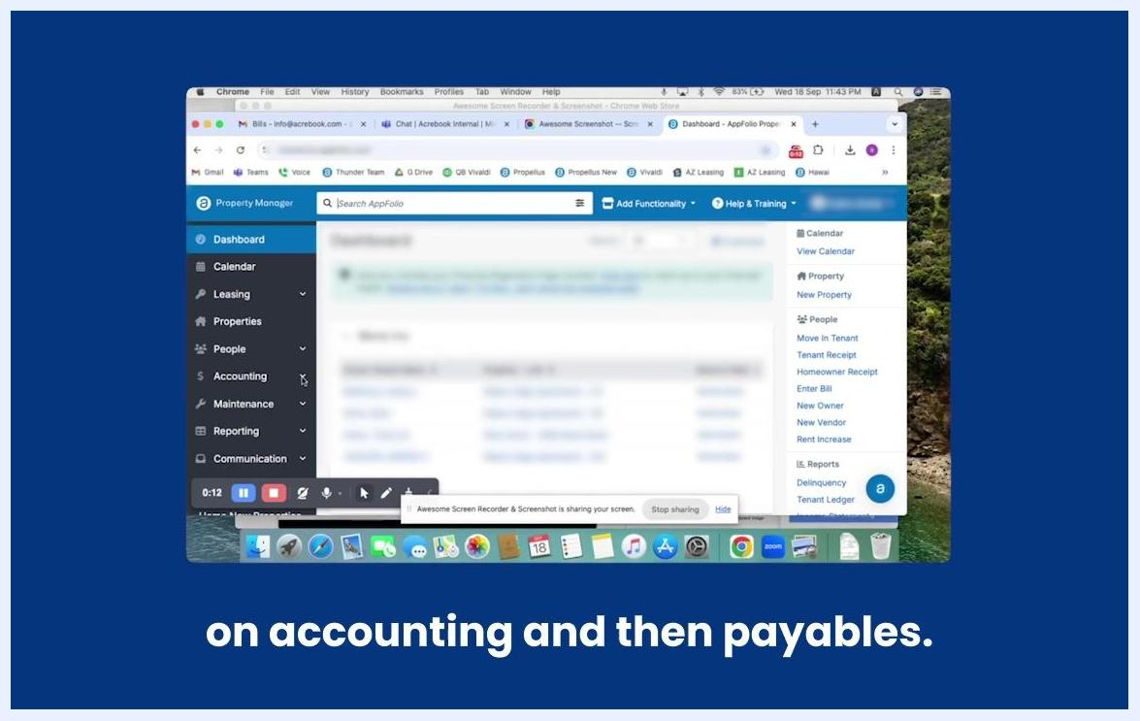
The AppFolio dashboard is open in a Chrome browser. The left sidebar shows navigation options: Dashboard, Calendar, Leasing, Properties, People, Accounting, Maintenance, Reporting, Communication. The cursor is near the Accounting section. The right side shows a task list.

Step 3: Open Smart Bill Entry
On the right side of the Payables screen, locate the Tasks section and click Smart Bill Entry.

Step 4: Choose files to upload
On the Smart Bill Entry screen, click Choose Files to Add to open a file selection dialog.
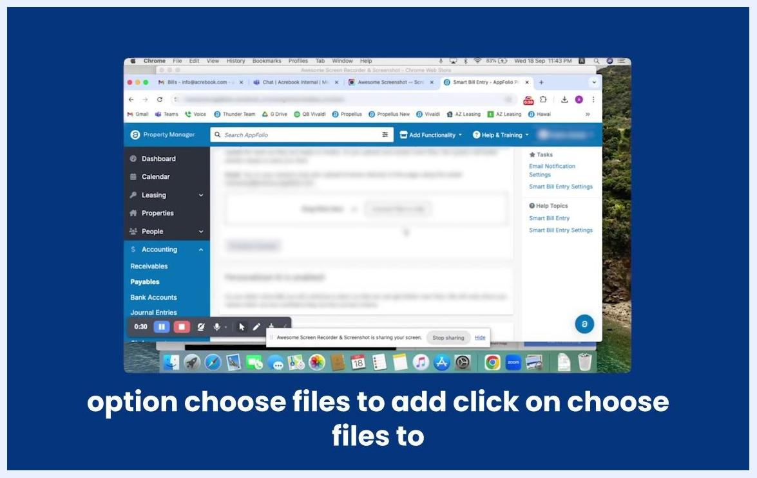
The Smart Bill Entry screen is displayed. The center shows a file upload area with a button labeled "Choose Files to Add". The right sidebar lists Tasks and Help Topics.
In the file selection dialog, navigate to the location on your computer where your bill files are stored. Select the files you want to upload — for example, two bill files — then click Open to attach them.
A file selection dialog is open, showing the Downloads folder. Two bill files are selected, ready to be attached.

Step 5: Process the uploaded invoices
Once your files are attached, click Process Invoices to begin processing the uploaded bills.
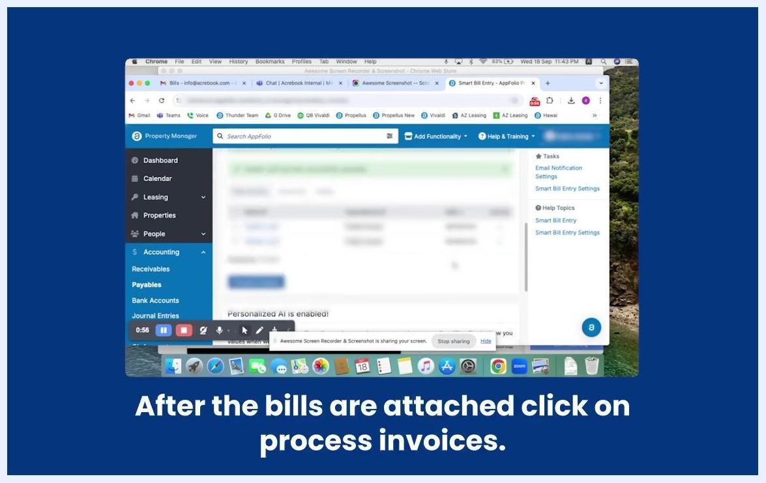
The Smart Bill Entry screen now shows the attached files. The Process Invoices button is visible.

Step 6: Monitor processing status
Monitor the status of your uploaded bills in the status table. The table displays information such as file name, uploader, date, and time.
A table is displayed showing the status of uploaded bills, including file names and other details.
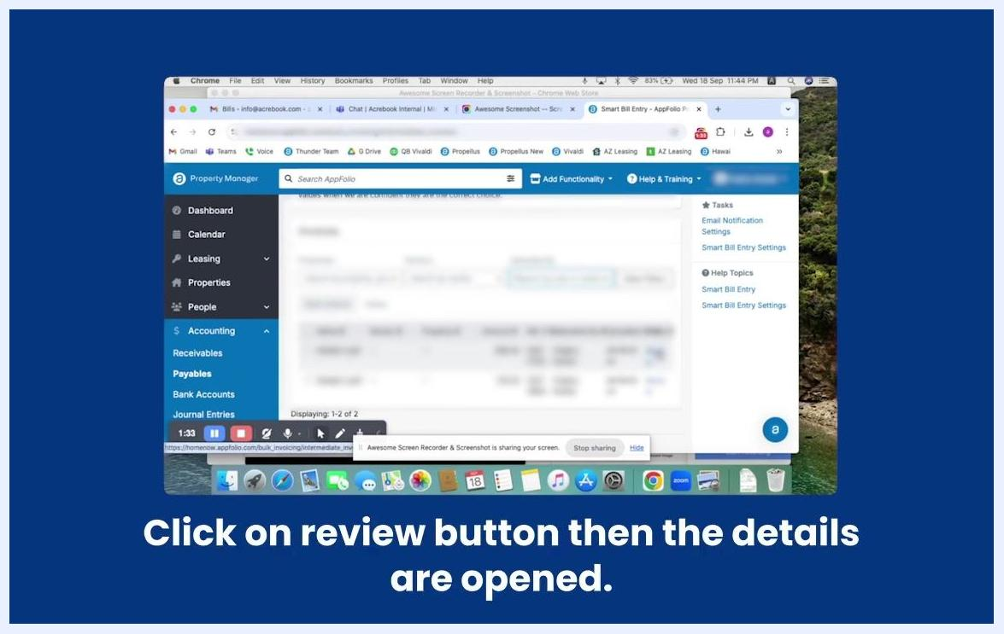
The table now shows that the invoices have been processed.
Once the invoices finish processing, review their status in the table to confirm that processing is complete.

Step 7: Open a bill for review
To review the details of a processed bill, click the Review button next to the bill entry. The bill details open for further review and action.
The table includes a Review button next to each processed bill. The instruction is to click Review to open the bill details.

Step 8: Verify the uploaded bill image
On the bill review screen, verify that the uploaded file is visible. If needed, use the zoom feature to enlarge and inspect the bill image for clarity.
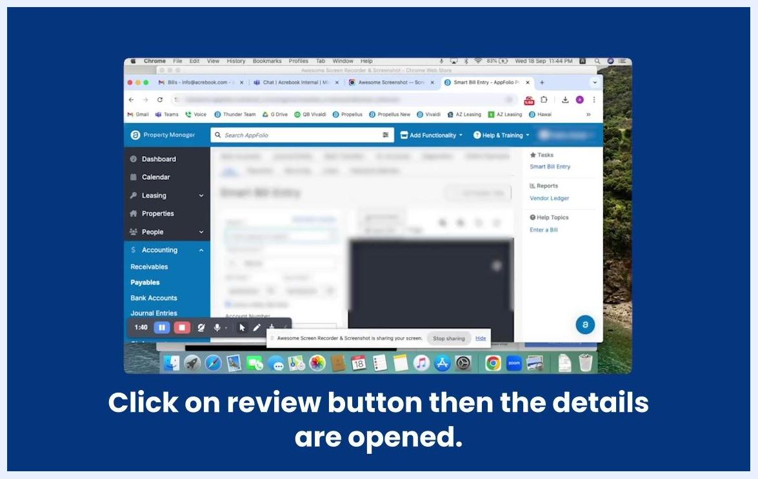
The Smart Bill Entry screen displays the uploaded bill file with a zoom option. The right sidebar shows Tasks, Reports, and Help Topics.

Step 9: Select the vendor
Select the Pay field and choose the current vendor for this bill.
The bill entry screen is shown with the vendor pay field being selected. The bill image is visible in the center.

Step 10: Confirm the bill amount
Confirm that the Amount field is automatically populated based on the bill image, and double-check the amount for accuracy.
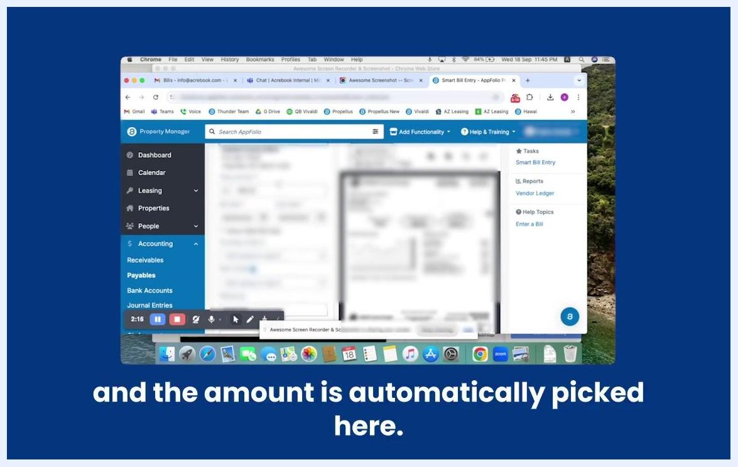
The bill entry screen shows the amount field automatically filled in. The bill image is visible.

Step 11: Select the property
Select the Property associated with this bill. Use the property dropdown or search to find and select the correct property.
The bill entry screen highlights the property selection field. The bill image is visible.

Step 12: Add a description
Enter a Description for the bill. Type any relevant notes or details to clarify the bill's purpose.
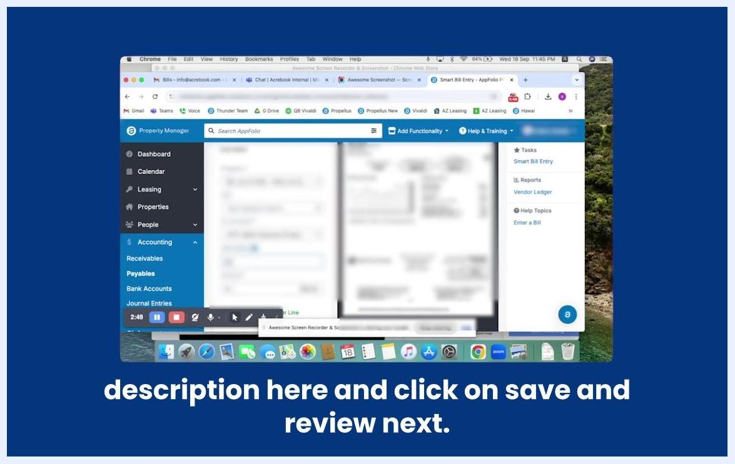
The bill entry screen shows the description field being filled out. The bill image is visible.

Step 13: Review all entered details
Review all entered details for accuracy. Ensure the vendor, amount, and property fields are correct, and add any additional notes or lines if necessary.
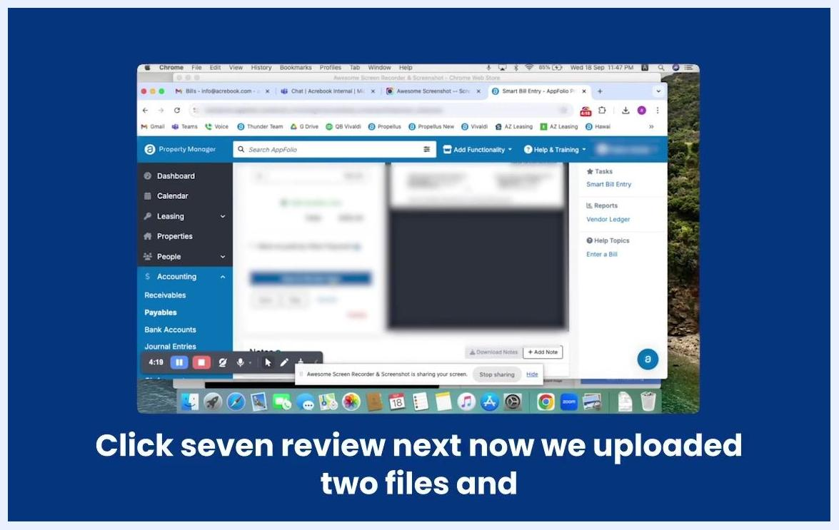
The bill entry screen displays all fields filled out for the new invoice, with options to add another line or notes.

Step 14: Save the bill
Click Save and Review Next to save the current bill and automatically move on to the next bill for entry. Alternatively, click Save if you only want to save this bill without moving to the next one.
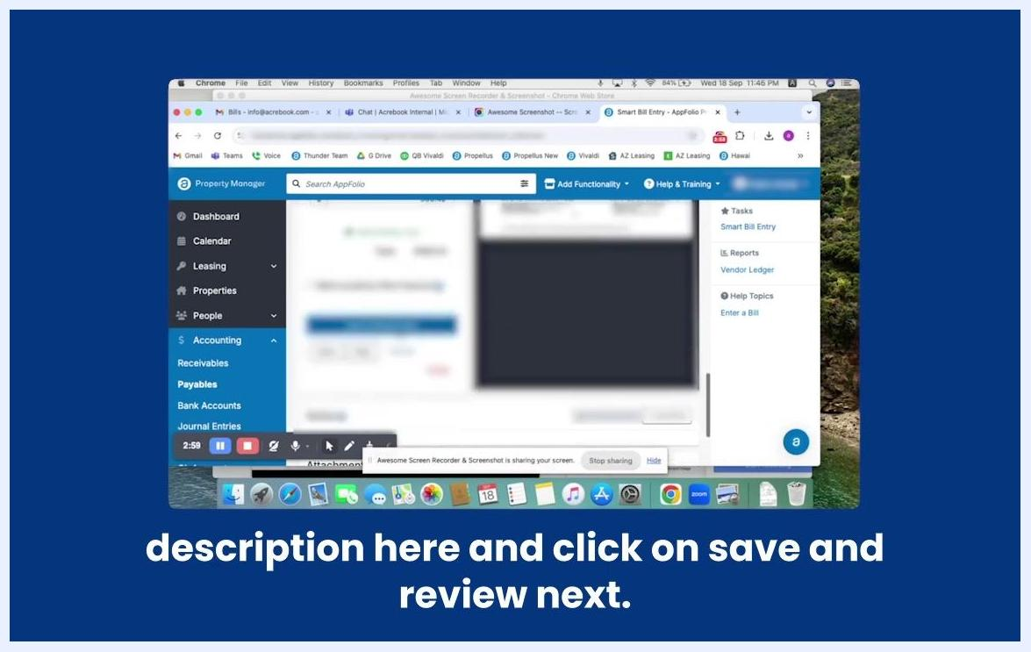
The bill entry screen displays the Save and Review Next button. The bill image is visible, and the action is being performed.

Step 15: Confirm the bill in Payables
Navigate back to Accounting > Payables to verify that the entered bills are reflected in the system.
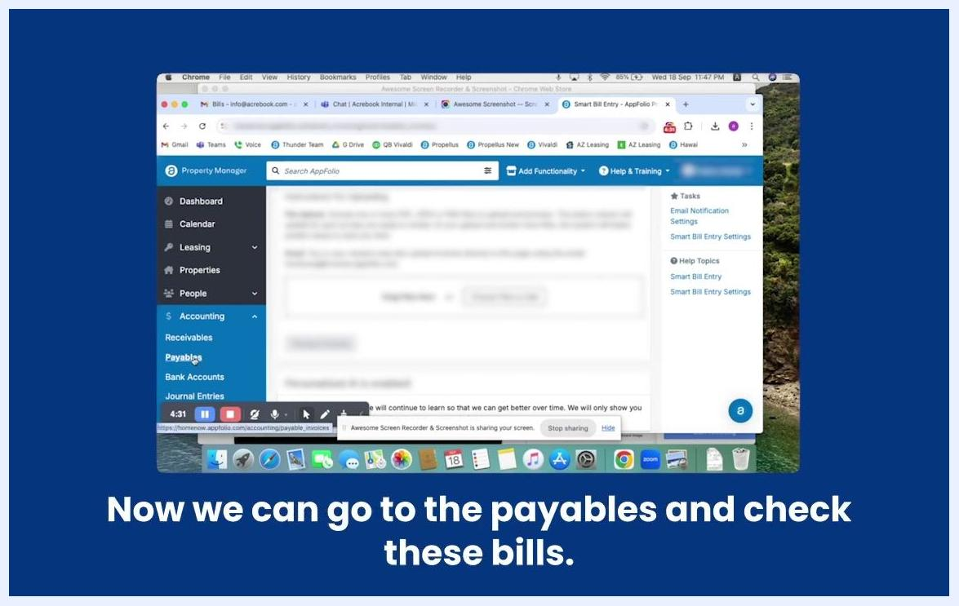
The Payables section is accessed from the Accounting menu to check the entered bills.
Confirm that the newly entered bills are listed in the Payables section. Review the list to ensure both invoices are present, with correct details such as date, property, amount, and status (for example, unpaid).
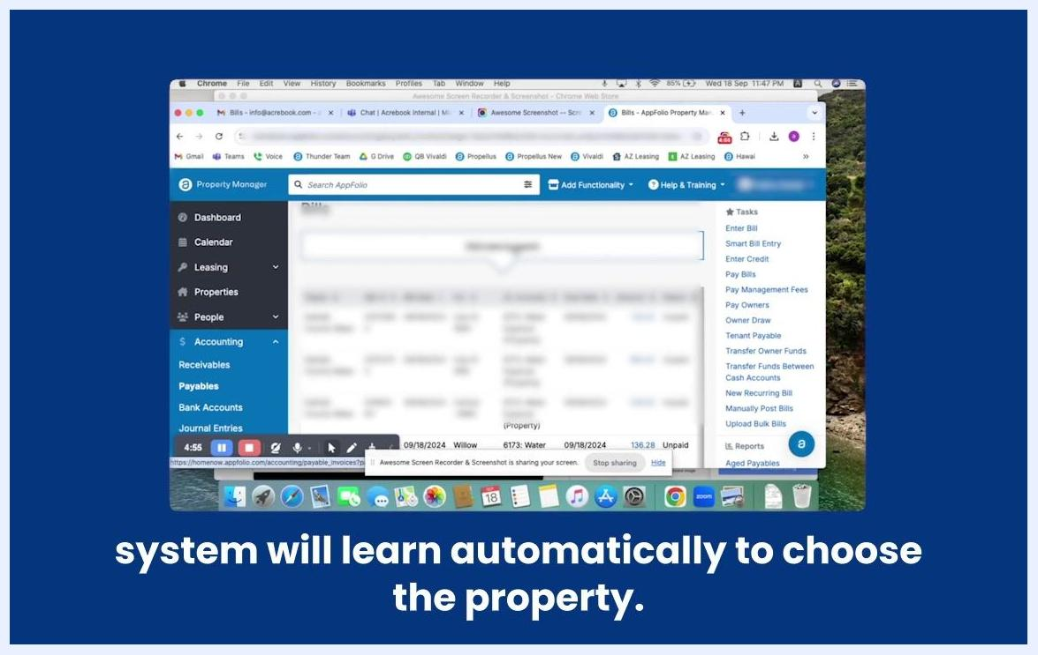
The Payables screen displays a list of bills, including the newly entered invoices with their details.
The Smart Bill Entry system continues to improve over time: as it learns from your entries, it will begin to automatically suggest or select the correct property and other details for future invoices.

Summary
Now you know how to enter a bill in AppFolio using Smart Bill Entry — from uploading and processing bill files to reviewing extracted details and confirming them in Payables. The system automates data capture, reduces manual entry, and becomes more accurate as it learns from your usage. Always verify each bill's details before saving, and check the Payables section afterward to confirm successful entry.

