How to View Your Pay Stubs in ADP
If you're a former employee and need to access your pay records, this guide walks you through how to view your pay stubs in ADP, as well as how to download them individually or all at once. The process involves signing in, verifying your identity, and navigating to the Download Statements page.

Prerequisites
Before you begin, make sure you have the following information ready, as it was previously shared with your employer:
- Your first name and last name
- Your date of birth
- Your Social Security Number
- Your personal mobile phone number (the one associated with your ADP account)

Step 1: Go to the ADP website
Open your web browser and navigate to . You'll see the ADP homepage, which includes navigation options such as What We Offer, Who We Serve, Why ADP, Resources, and About. A red Sign In button appears in the upper right corner.
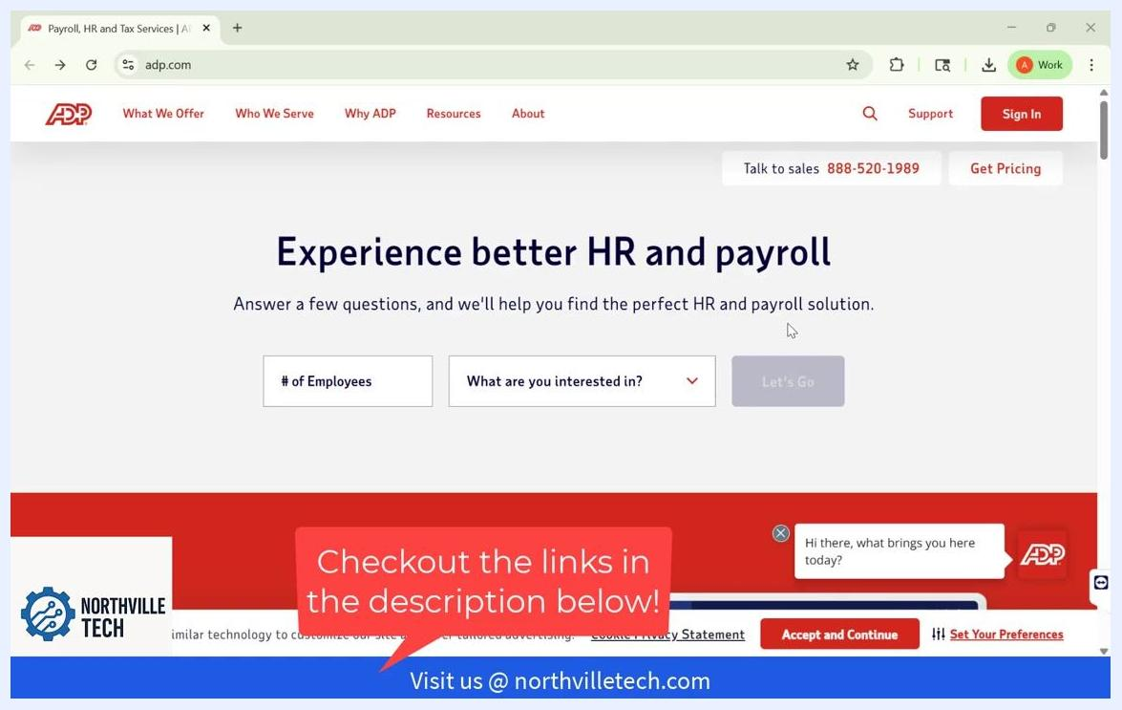
ADP homepage with navigation menu and a Sign In button, along with a banner about HR and payroll solutions.

Step 2: Sign in to your account
Click the Sign In button in the upper right corner of the screen to begin the sign-in process.
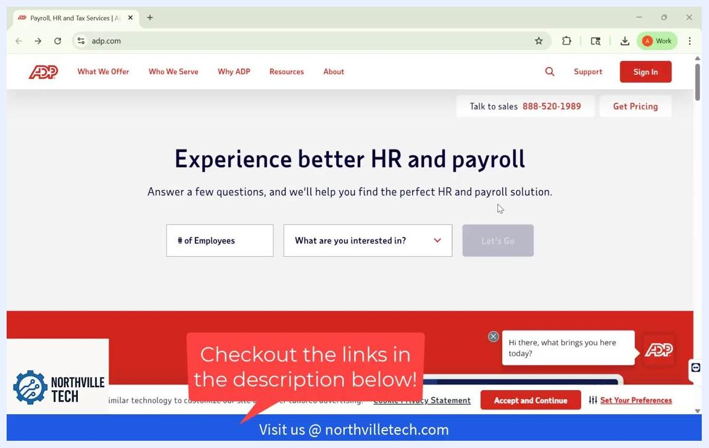
ADP homepage with the Sign In button highlighted in the upper right corner.

Step 3: Select your employment status
On the Sign in to ADP page, select the description that applies to you. If you're a former employee, choose My former employer uses ADP.
Other available options include:
- My former employer is out of business
- My current employer uses ADP
- I am an administrator/owner of a company that uses ADP
- I am an accountant for a company that uses ADP
- I am a financial advisor for a company that uses ADP
After selecting your option, click Next to continue.
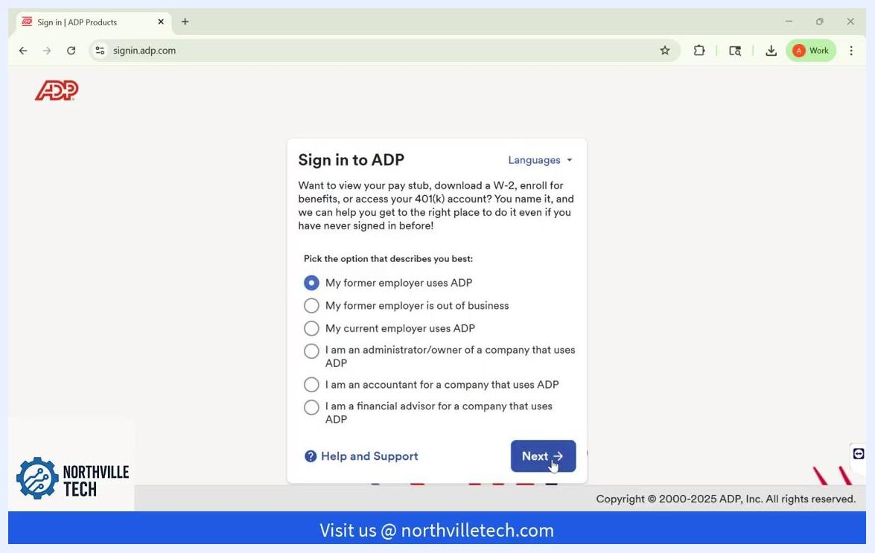
ADP sign-in options screen with "My former employer uses ADP" selected and the Next button visible at the bottom.

Step 4: Enter your personal information
Fill in the required fields to verify your identity:
- First Name
- Last Name
- Date of Birth (select Month, Day, Year)
- Social Security Number
Once all fields are complete, click Continue.
Identity verification form requesting First Name, Last Name, Date of Birth, and Social Security Number.

Step 5: Enter your mobile phone number
Enter your personal mobile phone number in the field provided. Use the number that is associated with your ADP account to ensure successful verification.
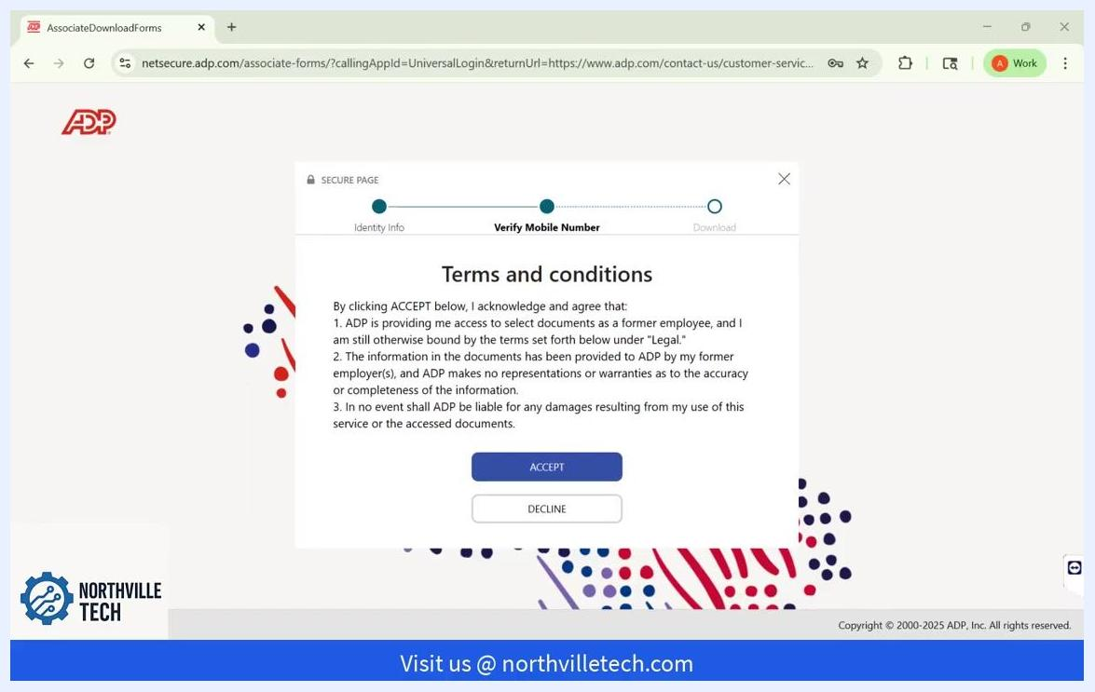
Screen requesting a personal mobile phone number for identity verification.

Step 6: Verify your phone number
Click Verify Phone Number to receive a verification code via text message.
Screen with the Verify Phone Number button highlighted after the mobile number has been entered.

Step 7: Enter the verification code
Enter the verification code sent to your phone in the field provided, then click Continue to proceed.

Step 8: Review the terms and conditions
Read through the Terms and Conditions presented on the next screen. Review the information carefully before continuing.
Terms and Conditions screen with Accept and Decline buttons.

Step 9: Accept the terms
If you agree to the terms, click Accept to proceed.
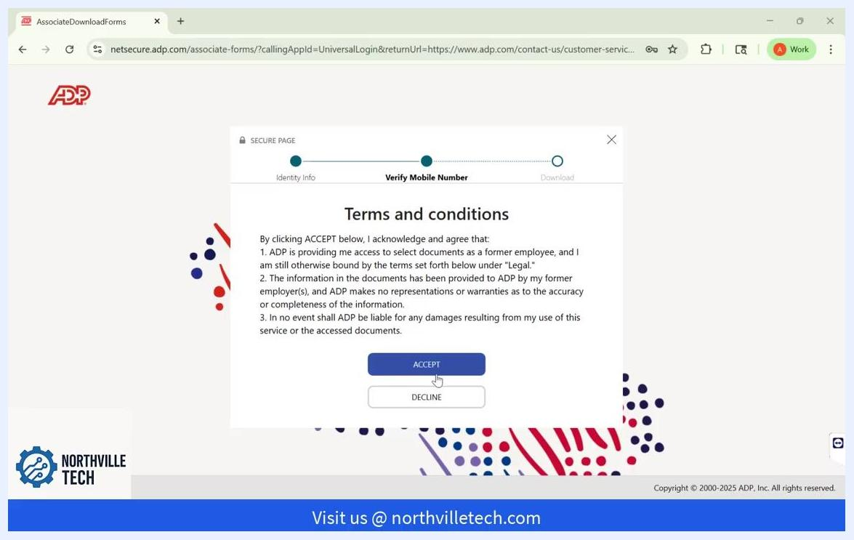
Terms and Conditions screen with the Accept button highlighted.

Step 10: Open the Download Statements page
You'll now see the Download Statements page. Click the Pay Statements tab to view your pay statements. A list of all your available pay statements will appear, including employer names and pay dates.
Download Statements page showing a list of pay statements with employer names and pay dates, with the Pay Statements tab selected.

Step 11: Open a specific pay statement
To view a specific pay statement, click the arrow (>) next to the statement you want to open.
Cursor pointing to the arrow icon next to a specific pay statement entry.

Step 12: Download a single pay statement
To download an individual pay statement, click the Download button at the bottom of the screen.

Step 13: Download all pay statements at once
If you want to download all of your pay statements at once, scroll down on the Download Statements page. Click the Download All (5) button located at the bottom of the pay statements list.
This action downloads all available pay statements at once. The button label displays the total number of statements available for download, for example "Download All (5)".
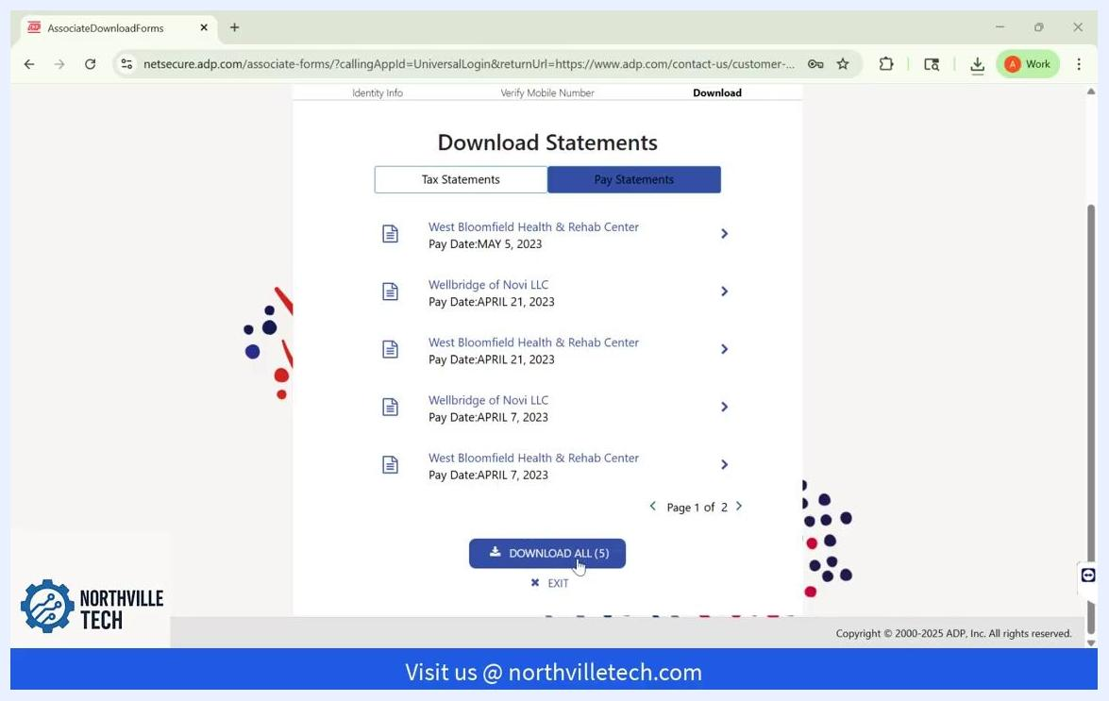
Download Statements page with the "Download All (5)" button highlighted at the bottom, showing the pay statements list and page navigation.

Step 14: View and download individual statements
After downloading, you can still view individual statements by clicking the arrow (>) next to any pay statement entry. On the document view screen, click Download to save that single statement.
The document view screen displays the selected pay statement along with Close and Download buttons at the bottom.
Pay statement document view with Close and Download buttons at the bottom; statement details are blurred for privacy.

Step 15: Exit the Download Statements page
When you're finished, click Exit on the Download Statements page to log out or return to the previous menu.

Summary
By following these steps, you now know how to view your pay stubs in ADP and securely download them, either one at a time or all together, as a former employee.

