How to Request Time Off in ADP
This guide shows you how to request time off in ADP using the mobile application. You'll learn how to check your time off balances, submit a new request, review your request history, and cancel a pending request if your plans change.

Prerequisites
- The ADP mobile app installed on your device
- An active ADP account with access to the "Time Off" feature

Steps to request time off in ADP

1. Access the ADP home screen
Open the ADP mobile app to view your dashboard. The home screen displays your name, clock status, pay statement, and recommended actions such as "Timecard," "Pay," and "Time Off." Locate the Time Off button in the Recommended section.
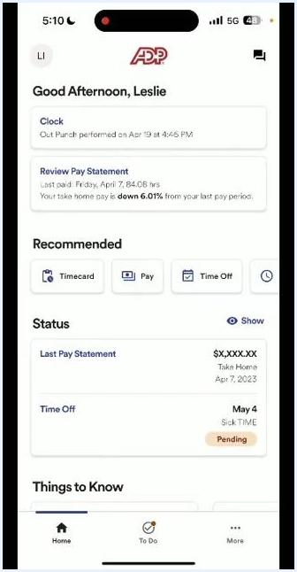
ADP home screen showing user greeting, clock, pay statement, recommended actions, and status section

2. View your time off balances
Tap Time Off to review your current balances as of the displayed date (for example, April 19, 2023). You'll see your available hours for Sick Time (for example, 20 hours) and Vacation (for example, 17.83 hours). Note that pending requests are not included in these balances. Tap Request time off to begin a new request.
Time Off screen showing balances for Sick Time and Vacation, with the Request time off button

3. Start a new time off request
On the Request Time Off screen, under Step 1: Add Time Off Request, select the type of request:
- Sick Time
- Unpaid Time Off
- Vacation
For this example, select Vacation.
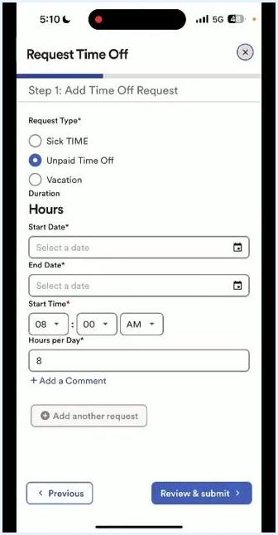
Request Time Off screen with options for Sick Time, Unpaid Time Off, and Vacation

4. Enter the time off details
Set the Start Date by selecting the calendar icon and choosing your desired date (for example, April 27, 2023). The End Date automatically matches the start date; if you need multiple days, update the end date (for example, April 28, 2023). Set the Start Time (the default is 08:00 AM; adjust if needed) and enter the Hours per Day (for example, 8).
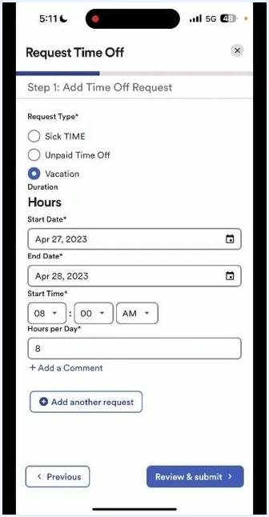
Request Time Off form with Vacation selected, showing date and hour fields

5. Add a comment (optional)
Tap + Add a Comment to provide additional information for your supervisor, such as "Family Trip."
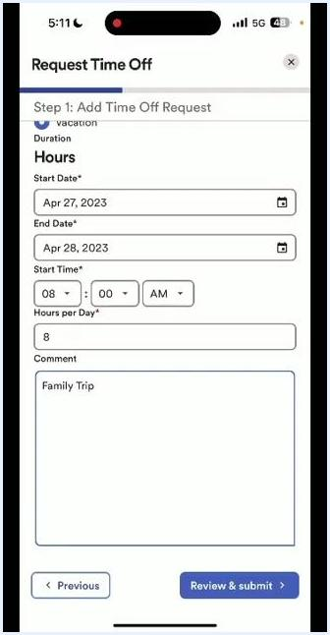
Request Time Off form with comment field filled in as "Family Trip"

6. Add another request (optional)
If you need to submit multiple requests at once, tap Add another request and fill out the additional request details.

7. Review and submit your request
Once all details are entered, tap Review & submit to proceed.
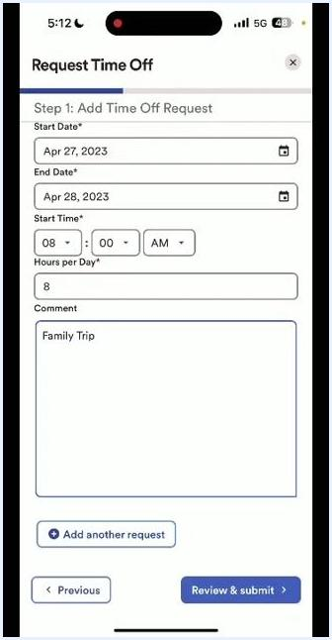
Completed Request Time Off form with Vacation, dates, hours, and comment, ready to submit

8. Review your time off request
Carefully review all entered information on the Request Time Off form:
- Start Date: April 27, 2023
- End Date: April 28, 2023
- Start Time: 08:00 AM
- Hours per Day: 8
- Comment: Family Trip
Confirm all details are correct, then tap Review & submit at the bottom right.
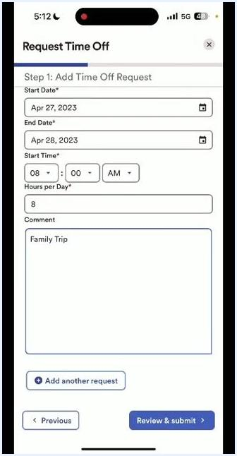
Request Time Off form with all fields filled in and the Review & submit button highlighted

9. Submit your time off request
On the Step 2: Review & submit screen, verify your request summary: Vacation (Hours), April 27, 2023 – April 28, 2023, 8 hours/day, starting at 8:00 AM, with the comment "Family Trip." If changes are needed, tap Edit or Delete. To add another request, tap Add another request. When ready, tap Submit request.
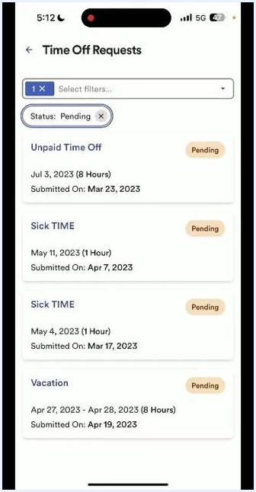
Review & submit screen showing the vacation request summary and the Submit request button

10. Return to the Time Off screen
After submitting, you're returned to the Time Off screen, where your updated balances are displayed (for example, Sick Time: 20 Hours, Vacation: 17.83 Hours). Tap View time off requests to see your request history.
Time Off screen showing updated balances and the View time off requests button

11. View pending time off requests
On the Time Off Requests screen, view all pending requests. Each request displays its type (for example, Unpaid Time Off, Sick Time, Vacation), the dates and hours requested, the submission date, and the status (for example, Pending). Your recently submitted vacation request appears at the bottom of the list.
Time Off Requests screen showing multiple pending requests, including the new vacation request

12. Filter and review request history
Use the filter dropdown at the top to view requests by status:
- Pending
- Approved
- Cancelled
- Rejected
Select the desired status to filter your request history and review the status of all your requests.
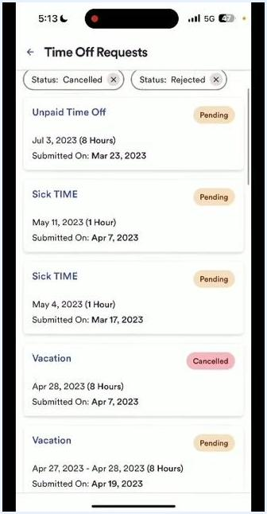
Time Off Requests screen with filters for Pending, Cancelled, and Rejected requests

13. Return to the home screen
Tap the back arrow or use the navigation bar to return to the home screen. Your most recent time off request and its status (for example, Pending) appear in the Status section.
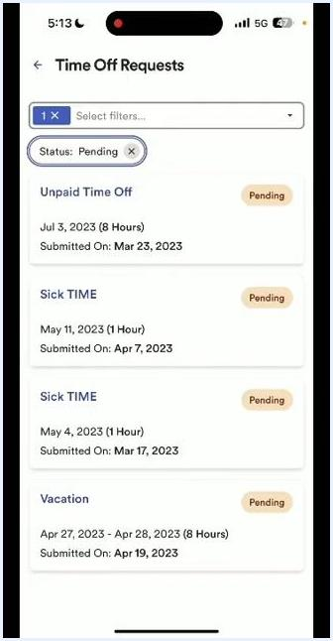
ADP home screen showing the status of a recent time off request as Pending

How to cancel a time off request in ADP
Once a time off request is submitted, it cannot be edited. If you need to make a change, you must cancel the request and submit a new one.

14. Open the request you want to cancel
Go to the Time Off section and tap View time off requests. On the Time Off Requests screen, locate the request you wish to cancel. Each request displays its type (for example, Unpaid Time Off, Sick Time, Vacation), the dates and hours requested, the submission date, and the status (for example, Pending). Tap the specific request you want to cancel — for example, the Vacation request for April 27, 2023 – April 28, 2023.
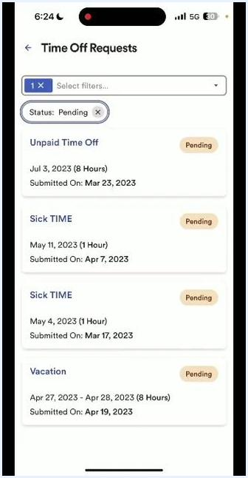
Time Off Requests screen showing multiple pending requests, including a vacation request

15. Initiate the cancellation
On the request details screen, review the dates, hours, status, and any comments you previously added (for example, "Family Trip"). Tap Cancel time off. A confirmation dialog titled "Cancel time off" appears at the bottom of the screen. Optionally, tap Add a Comment to provide a reason for canceling. Tap Yes, cancel to proceed, or tap No, go back if you change your mind.
Request details screen with the Cancel time off button and confirmation dialog, including options to add a comment or confirm cancellation

16. Verify the cancellation
After confirming, you're returned to the Time Off Requests screen. The canceled request no longer appears under the Pending status filter, and only your active pending requests are displayed.
Time Off Requests screen showing the updated list with the canceled request removed

What's next
If you need to submit a corrected request, return to the Time Off section and follow the steps above to create a new request with the correct information. The previously canceled request will not appear under your Pending requests. Always double-check your entries before submitting, since edits aren't possible once a request is submitted.

