How to Register for an Account in ADP Workforce Now
This guide walks you through how to register for an account in ADP Workforce Now, from entering your registration code to signing in for the first time. Follow each step in order to create your login credentials and access your employee dashboard.

Prerequisites
Before you begin, make sure you have the following:
- A registration code obtained from your company's payroll or HR department
- Your First Name and Last Name as they appear in company records
- One identity verification item: the last 4 digits of your SSN, EIN, or ITIN; your Associate ID; or your birth month and day
- A valid email address and phone number for account security

Step 1: Go to the ADP Workforce Now website
Open your web browser and navigate to www.workforcenow.adp.com. Alternatively, you can use the registration link provided by your organization, if available.
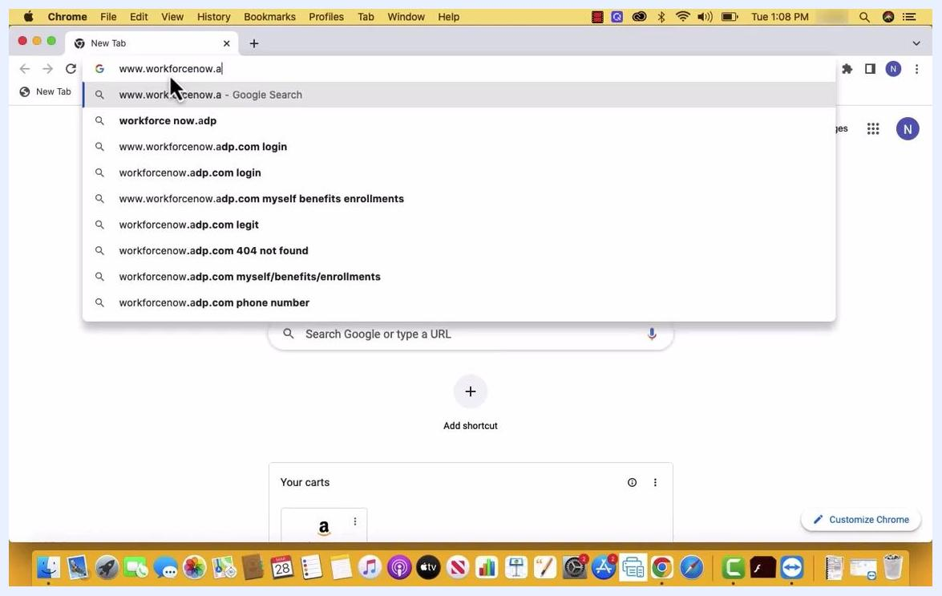
A Chrome browser window with the URL "www.workforcenow.adp.com" being entered in the address bar. Autocomplete suggestions appear below the address bar, and the desktop shows a macOS environment with application icons in the dock.
The site will direct you to the Create Your Account page.

Step 2: Select the registration option
On the Create Your Account page, you will see two options: Find me and I have a registration code. Select I have a registration code to continue, since you will need the code provided by your payroll or HR department.
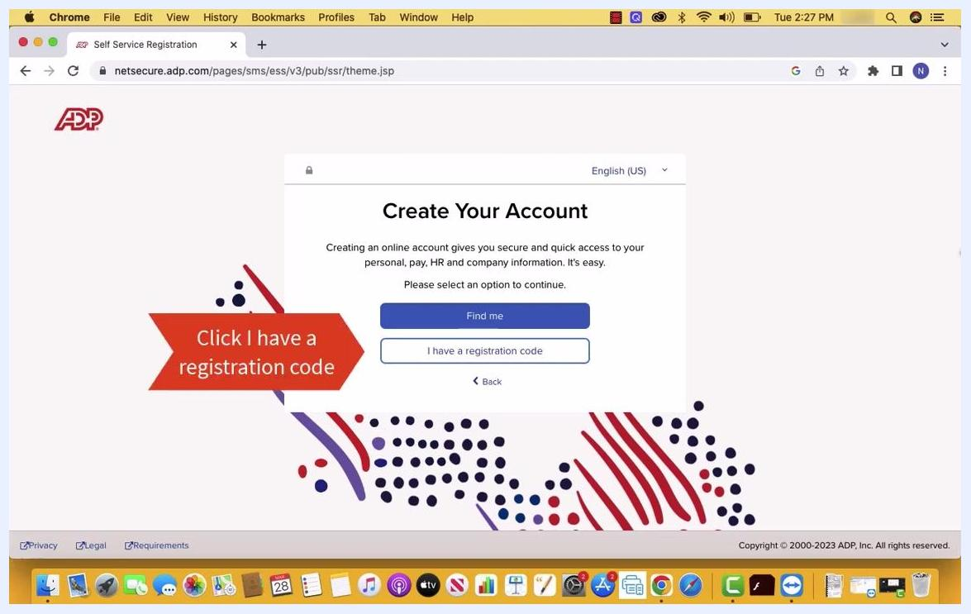
The "Create Your Account" screen on ADP's Self Service Registration page, showing two buttons: "Find me" and "I have a registration code," with a red arrow pointing to the "I have a registration code" button.

Step 3: Enter your registration code and personal details
Click I have a registration code, then enter the code in the field provided. Next, enter your First Name and Last Name in the respective fields.

Step 4: Verify your identity
Provide one of the following to verify your identity:
- Last 4 digits of your SSN, EIN, or ITIN
- Associate ID
- Birth Month and Day
Select the appropriate option, enter the required information, and click Continue.
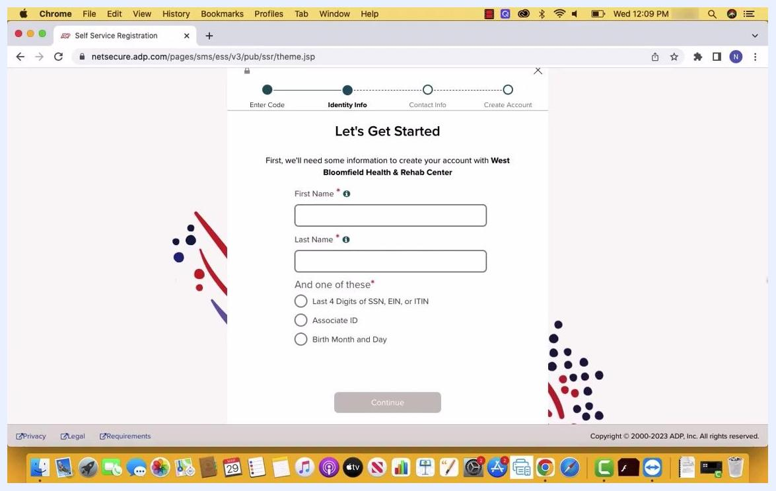
The "Let's Get Started" form on ADP's registration page, showing fields for First Name and Last Name, along with identity verification options for the last 4 digits of SSN/EIN/ITIN, Associate ID, or Birth Month and Day.

Step 5: Add your contact information
On the Help Us Protect Your Account page, enter your primary contact details:
- Your email address, with the type selected (for example, Personal)
- Your phone number, with the type and country code selected (for example, Personal or Other)
You can also add backup contact information, such as an additional email or phone number, if you wish. Click Continue when finished.
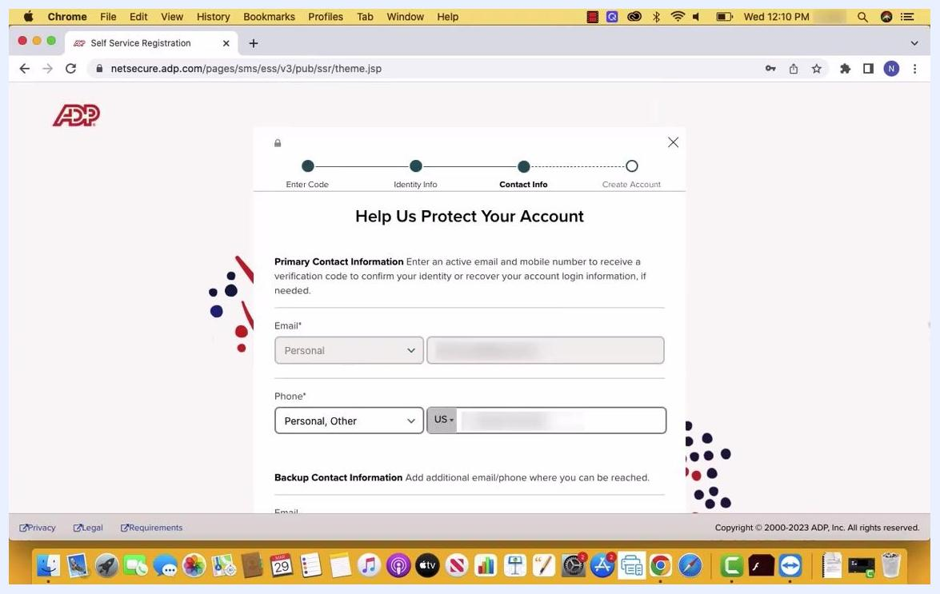
The "Help Us Protect Your Account" screen showing fields for primary email and phone information with type-selection dropdowns, along with optional backup contact fields.

Step 6: Create your login credentials
On the One more step page, set up your login information:
- Enter your desired User ID in the Create UserId field.
- Enter your desired password in the Create Password field. Your password must be 8 to 64 characters and include letters, numbers, and special characters.
- Re-enter your password in the Confirm Password field.
- Check the box to confirm you have read and agree to the Employee Access Terms and Conditions.
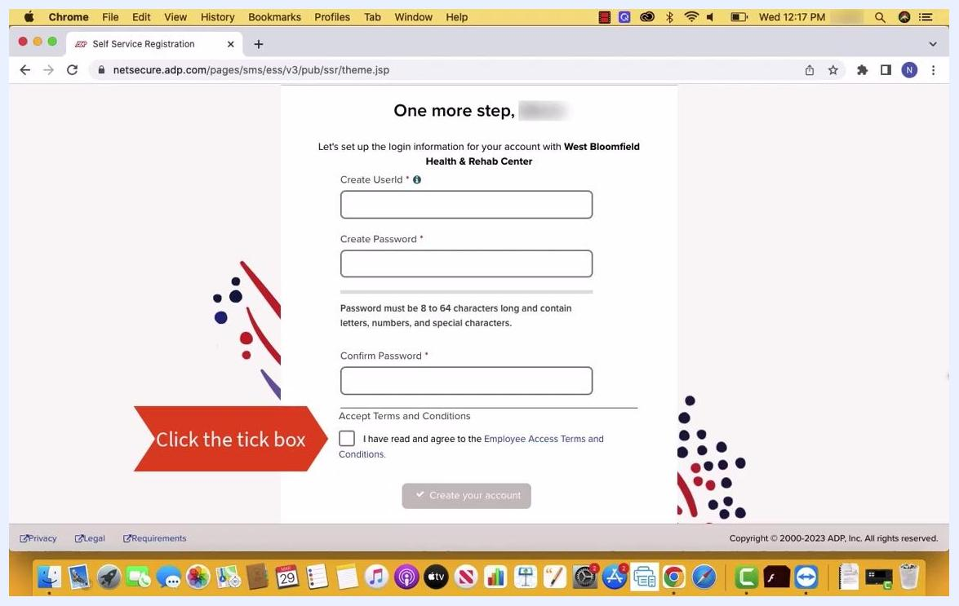
The "One more step" screen for setting up login information, showing fields for User ID, Password, Confirm Password, and a checkbox for accepting terms and conditions, with a red arrow pointing to the checkbox.

Step 7: Submit your registration
Once you have entered your User ID, password, confirmed your password, and accepted the Employee Access Terms and Conditions, click Create your account to submit your details and complete the registration process.
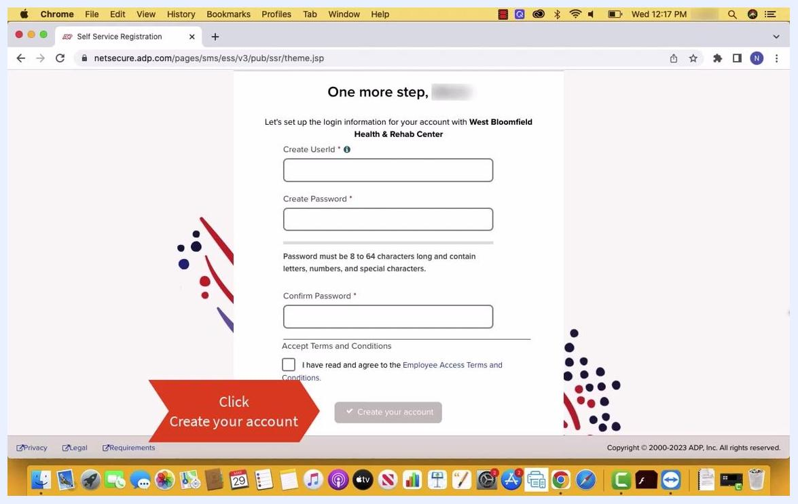
The "One more step" registration screen on ADP, showing User ID, password, and confirm password fields along with the terms and conditions checkbox, and a red arrow pointing to the "Create your account" button.

Step 8: Confirm your account creation
After submitting, a confirmation screen appears with the message "Account Created! Please Sign In." This screen displays:
- Your User ID
- Options to access 401K Services and ADP Workforce Now
- Instructions to activate your mobile phone within 24 hours by responding to messages sent to your registered number
- Download links for the ADP Mobile App on the App Store and Google Play
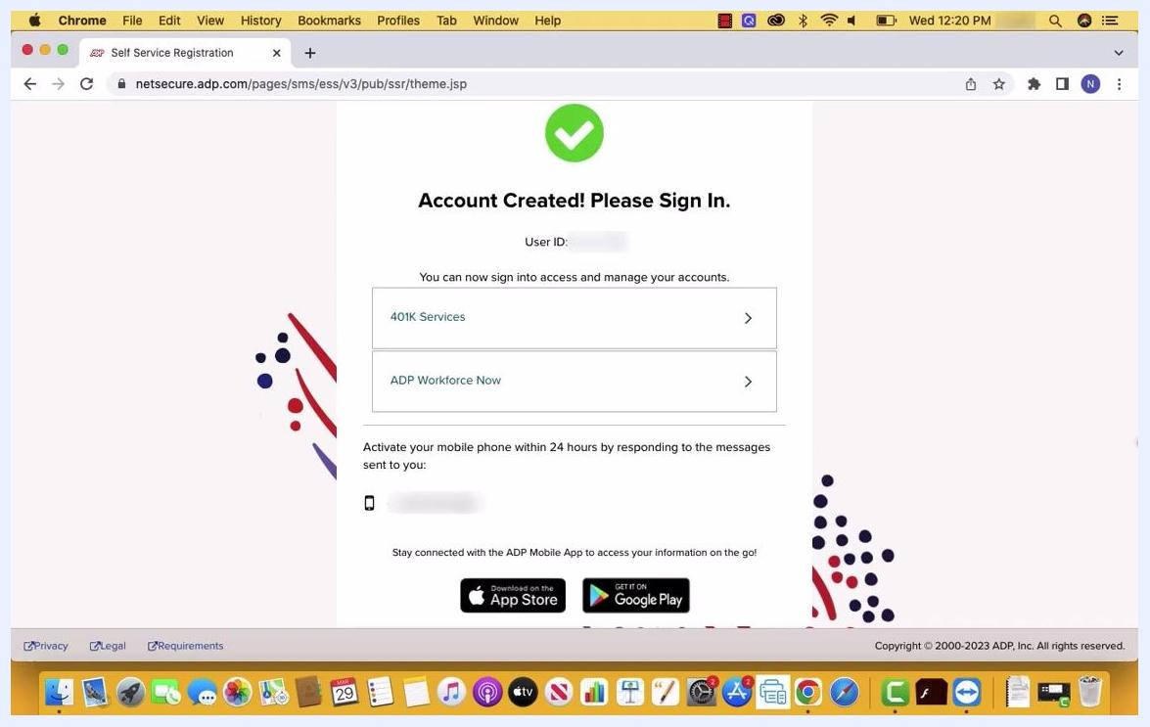
The "Account Created! Please Sign In." confirmation screen, displaying the User ID, options for "401K Services" and "ADP Workforce Now," mobile phone activation instructions, and app download links.

Step 9 (optional): Activate your mobile phone
Respond to the verification message sent to your registered phone number within 24 hours to complete mobile phone activation.

Step 10 (optional): Download the ADP Mobile App
Click the App Store or Google Play button on the confirmation screen to install the ADP Mobile App for on-the-go access to your account.

Step 11: Sign in to your dashboard
Click ADP Workforce Now on the confirmation screen to proceed to your employee dashboard and begin using your new account.
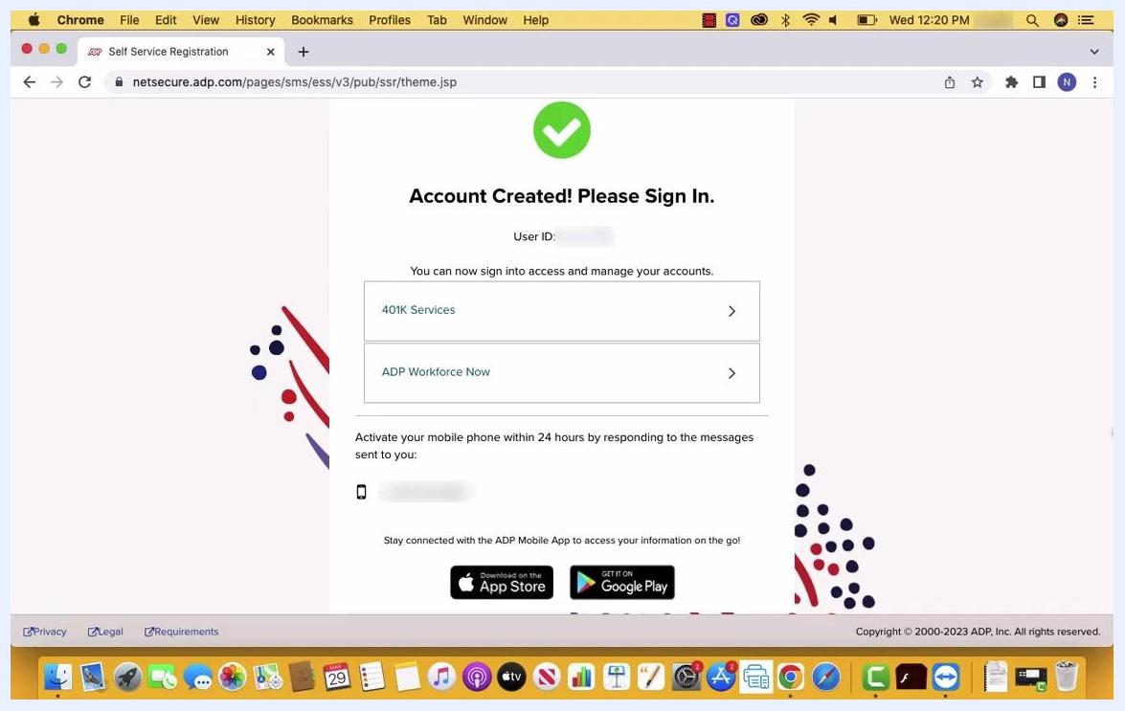
The "Account Created! Please Sign In." confirmation screen with options to access "401K Services" and "ADP Workforce Now," along with app download links.

Summary
You have now successfully registered for an account in ADP Workforce Now. Your account is active, and you can sign in to manage your payroll, benefits, and other employment information.

