How to Change Your Tax Withholding in ADP
This guide shows you how to change your tax withholding in ADP, covering both federal and state-level updates. You'll learn how to log in to the platform, navigate to the correct section, complete your W-4 form, and electronically sign your changes. The steps below also cover updating your Michigan state tax withholding, including city selection and exemptions.

Prerequisites
- An active ADP account with a valid User ID and password
- Access to the phone number or email address registered with your account for identity verification
- Your filing status, dependent information, and any additional withholding amounts you want to apply

Changing your federal tax withholding

Step 1: Access ADP
Open the ADP app or go to the ADP website (for example, ) in your browser. Enter your User ID in the provided field.
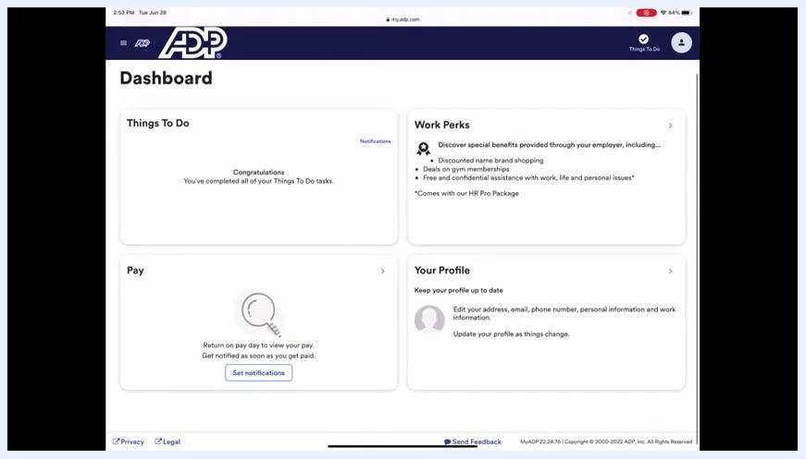
ADP login screen with the User ID field filled in, showing "Sign in to ADP" and the "Next" button

Step 2: Log in to your account
Enter your password on the login screen, then click Sign In to access your account.
ADP login screen with User ID and password entered and the "Sign In" button visible

Step 3: Navigate to the Pay section
Once logged in, locate the Pay section on your dashboard and click on the Pay tile to proceed.
ADP dashboard showing the "Things To Do," "Work Perks," "Pay," and "Your Profile" sections

Step 4: Scroll to the tax withholding section
On the Pay page, scroll down to find the Tax Withholding section. Click on Federal under Tax Withholding to begin adjusting your federal withholding.
ADP Pay page with the "Tax Withholding" section expanded, showing options for Federal and various states

Step 5: Verify your identity
ADP prompts you to verify your identity for security purposes. Enter the verification code sent to your registered phone number or email address.

Step 6: Begin the W-4 federal tax withholding process
The system displays a welcome screen for Federal Tax Withholding (W-4). Read the instructions and click to proceed.
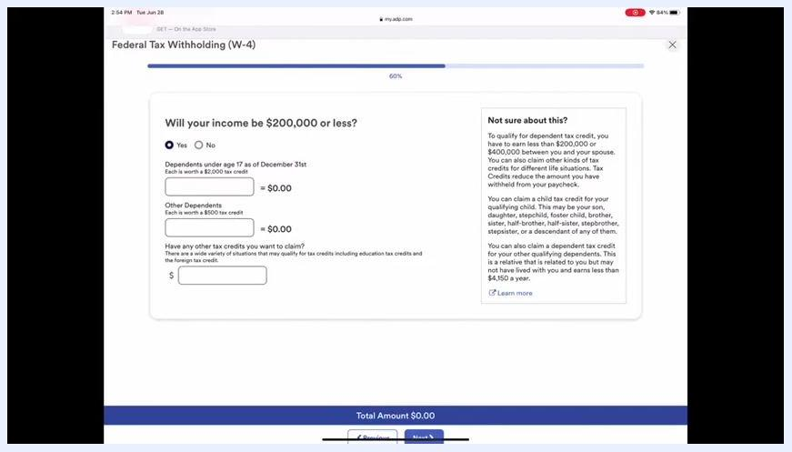
Federal Tax Withholding (W-4) introduction screen with instructions and a link to the IRS estimator

Step 7: Select your filing status
Choose your filing status from the following options:
- Single or Married Filing Separately
- Married Filing Jointly (or Qualifying Widow(er))
- Head of Household
Click Next to continue.
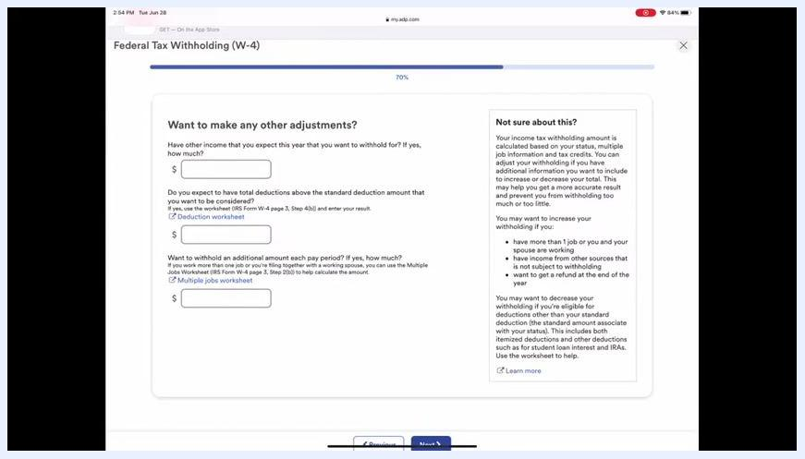
W-4 filing status selection screen with three options and explanatory text

Step 8: Enter dependent and credit information
Indicate whether your income will be $200,000 or less. Enter the number of dependents under age 17 and other dependents, if applicable, and add any other tax credits you wish to claim. Click Next to proceed.
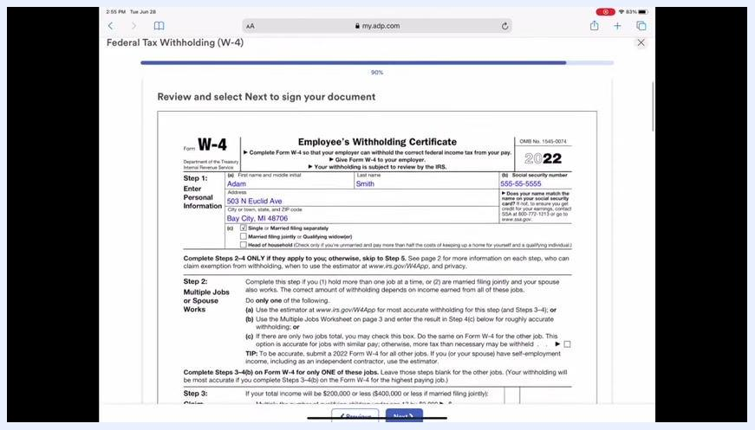
W-4 screen for income, dependents, and tax credits, with input fields and explanatory text

Step 9: Specify additional withholding amounts
In the "Want to make any other adjustments?" section, enter any additional amount you want withheld each pay period in the appropriate field. Use the "Multiple jobs worksheet" if you have more than one job. Click Next to continue.
W-4 adjustments screen with fields for additional withholding, a deduction worksheet, and a multiple jobs worksheet

Step 10: Review your W-4 summary
Carefully review all the information you have entered, including your personal details, filing status, dependents, and extra withholding amount. Ensure everything is accurate before proceeding.
W-4 summary screen showing the completed form with personal information, filing status, and extra withholding amount

Step 11: Electronically sign and submit
Type your full name in the signature field, check the box to certify your information, and click Next or Submit to finalize your changes.
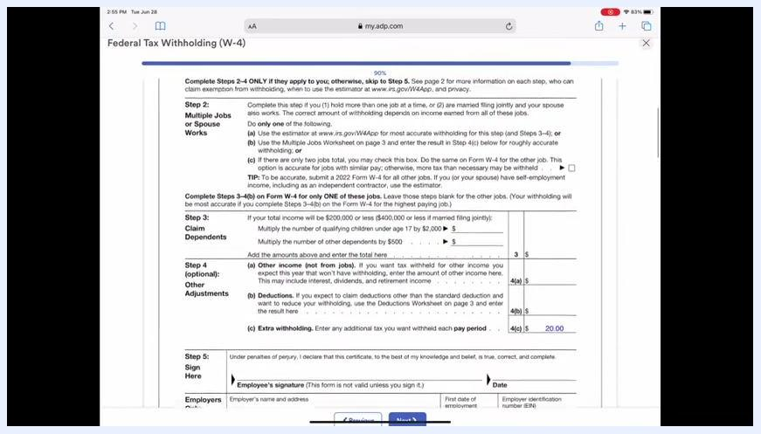
W-4 form signature section with the employee signature field and certification checkbox
Once you complete these steps, your federal tax withholding is updated in ADP, including any additional amount you specified to be withheld each pay period.

Changing your Michigan state tax withholding

Step 1: Review your federal withholding changes
After submitting your federal W-4, scroll down on the Pay page to the Tax Withholding section. Under the Federal header, review the summary box to confirm your changes (for example, Filing Status: Single or Married filing separately, Additional Withholding Amount: $20.00).
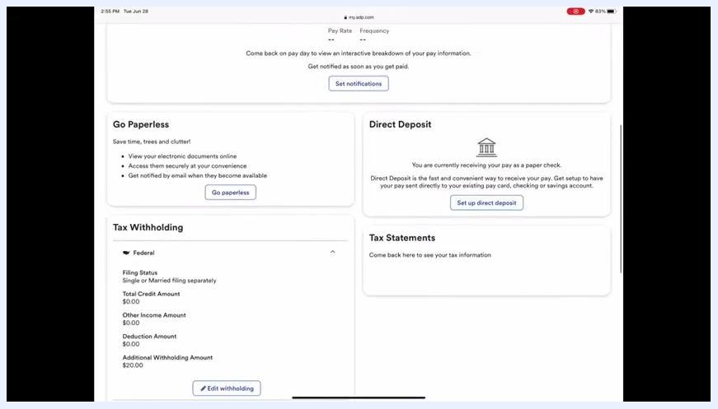
ADP Pay page showing the Tax Withholding summary under Federal, including filing status and additional withholding amount

Step 2: Begin the Michigan state withholding update
In the Tax Withholding section, find and select Michigan from the list of states. If you are employed in a different state, use the search or dropdown menu to select your state instead.

Step 3: Select your city, if applicable
If you live or work in a taxing city, select the appropriate city from the dropdown menu labeled Select Option. If your city is not listed, you may not need to complete a city-specific form.
Michigan Tax Withholding (MI-W4) screen prompting for city selection, if applicable

Step 4: Verify and update your personal information
Ensure your personal information is correct on the Michigan Tax Withholding (MI-W4) screen, and update any incorrect details before proceeding.
Michigan Tax Withholding (MI-W4) screen with a personal information prompt and city selection dropdown

Step 5: Indicate new hire status, exemption, and exemptions claimed
Answer whether you are a new hire and indicate if you are exempt from Michigan tax. Enter the number of withholding exemptions you wish to claim (personal and dependent exemptions). If you claim 10 or more exemptions, you must submit a copy of your Michigan Form MI-W4 to the Michigan Department of Treasury.
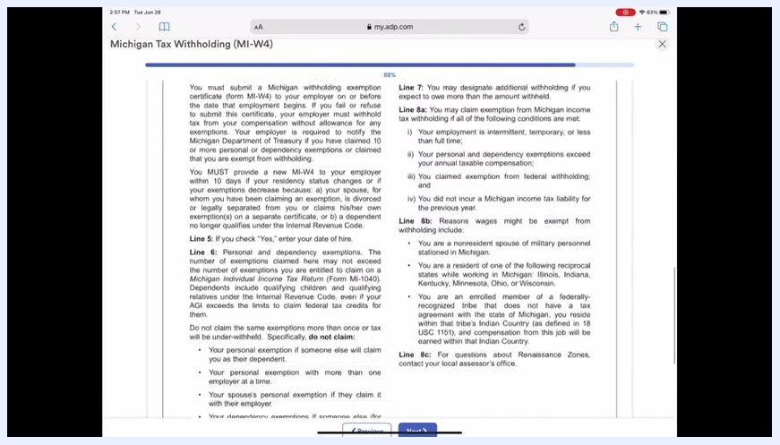
Michigan Tax Withholding (MI-W4) screen asking about exemptions and providing guidance

Step 6: Specify an additional withholding amount
Enter any additional dollar amount you want withheld from each paycheck in the provided field (for example, $10). Review the guidance on the right side of the screen to help decide whether you should withhold extra.
Michigan Tax Withholding (MI-W4) screen with a field for additional withholding amount and guidance

Step 7: Review the Michigan W-4 instructions
Read the detailed instructions and legal information regarding Michigan withholding exemptions, requirements, and special cases. Scroll through the information to confirm you understand your obligations and options.
Michigan Tax Withholding (MI-W4) instructions and legal information screen

Step 8: Electronically sign and submit the Michigan W-4
In the Electronic Signature popup, check the box to certify your information, type your full name in the signature field (for example, Adam Smith), and click Submit to finalize your Michigan W-4 changes.
Electronic Signature popup for the Michigan W-4, showing the certification checkbox, signature field, and Submit button

Step 9: Review and confirm your Michigan withholding changes
After submission, return to the Pay page, scroll down, and click the dropdown bar under Michigan in the Tax Withholding section to view your updated state withholding details.
ADP Pay page with the Tax Withholding section, showing dropdowns for Federal, Alaska, Florida, and Michigan

Step 10: Contact your employer for assistance
If you have any questions or need further assistance, contact your employer as directed on the ADP platform.
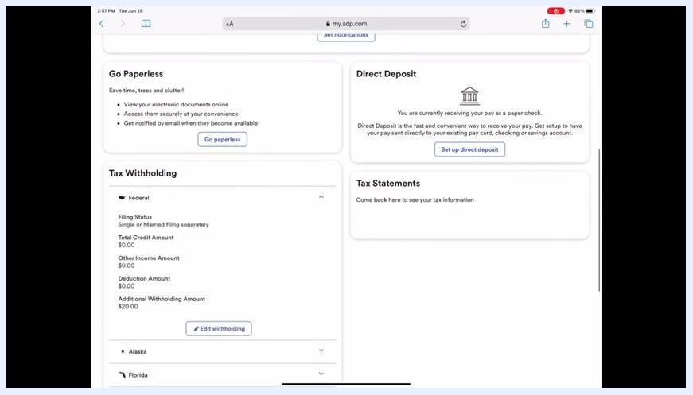
ADP Pay page showing the Tax Withholding, Go Paperless, Direct Deposit, and Tax Statements sections

Summary
By following these steps, you can change your tax withholding in ADP for both federal and Michigan state purposes, including city selection, exemptions, and any additional withholding amounts. Always review your entries for accuracy before submitting, and consult your employer if you need further help.

