How to Create a Purchase Order in Acumatica
This guide walks you through how to create a purchase order in Acumatica, from opening the Purchase Orders screen to adding line items, applying discounts, routing the order for approval, and emailing it to your vendor. You will also learn how to track vendor communications and review order activity after the purchase order has been sent.

Prerequisites
- Access to your Acumatica instance and valid login credentials.
- Permissions to create and, if applicable, approve purchase orders.
- Knowledge of the vendor and items you need to order.

Step 1: Access the Acumatica dashboard
Open your web browser, navigate to your Acumatica instance, and log in with your credentials. The dashboard displays key financial metrics such as cash on hand, cash required, overdue customers, overdue payments, and top overdue balances.
The left navigation menu gives you access to modules including Data Views, Finance, Banking, Projects, Payables, Receivables, Sales Orders, Purchases, Inventory, and more.
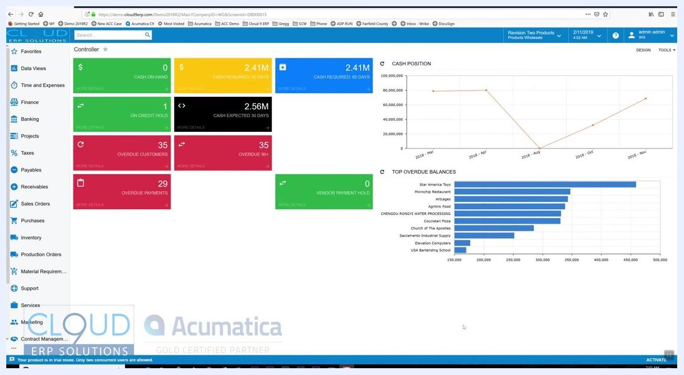
Acumatica dashboard showing financial widgets, navigation menu, and charts

Step 2: Navigate to Purchase Orders
In the left navigation menu, click Purchases to expand the section, then select Purchase Orders from the submenu.
Purchase orders can be generated automatically through mass processing screens based on inventory demands, dropships, and other triggers. This guide focuses on creating a purchase order manually.

Step 3: Create a new purchase order
Click the option to create a New Purchase Order. The Purchase Orders screen opens with a blank purchase order form containing fields for Type, Order Number, Status, Date, Promised On, Vendor, Location, Owner, Currency, and more.
By default, the status shows as On Hold, which allows you to make changes before finalizing the order. Notice the Approved checkbox and the Approval Details tab — these are optional features for routing purchase orders through your company's approval process.
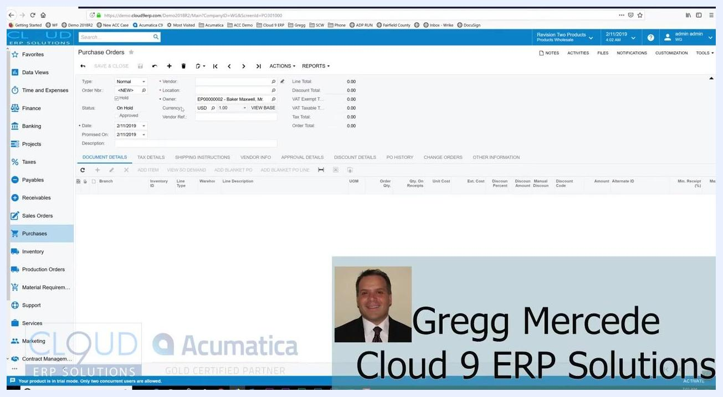
Blank purchase order form with fields for type, vendor, status, date, and detail tabs

Step 4: Review the purchase order status
Confirm that the purchase order status is On Hold. While on hold, the order remains editable. Once you take the purchase order off hold, it becomes locked for editing.

Step 5: Set the purchase order dates
Enter or confirm the Date field (for example, 2/11/2019). Set the Promised On date to indicate when you expect the vendor to deliver the goods (for example, 2/11/2019).

Step 6: Select a vendor
Click into the Vendor field and begin typing the vendor's name or a few letters of it. Select the appropriate vendor from the dropdown list (for example, "AAVENDOR - Goto Vendor Inc").
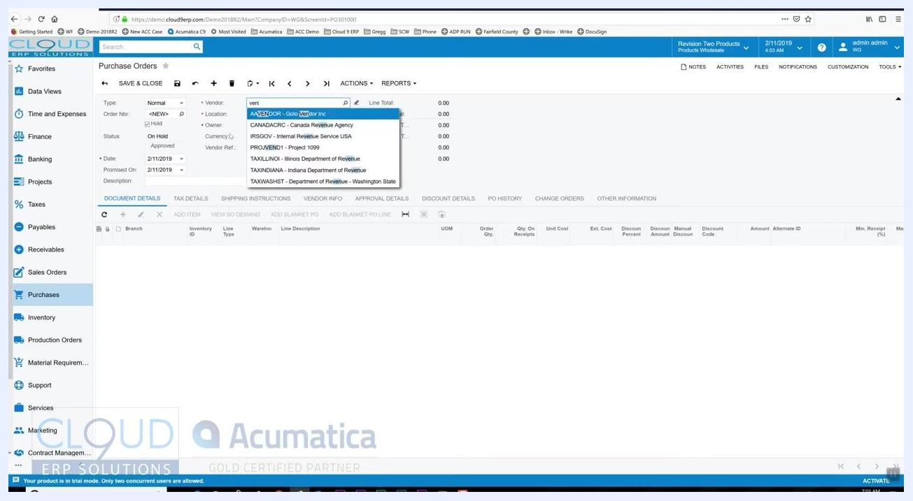
Vendor selection dropdown showing multiple vendor options

Step 7: Add items to the purchase order
Scroll down to the Document Details section and click Add Item. Type a few letters of the inventory ID or item description in the Inventory ID field, then select the desired item from the suggestions (for example, "AACOMPUT01 - Acer Laptop Computer").
If a pop-up note appears — for example, indicating a three-year warranty is available — review the information before continuing. Enter the required order quantity (for example, 5 units).
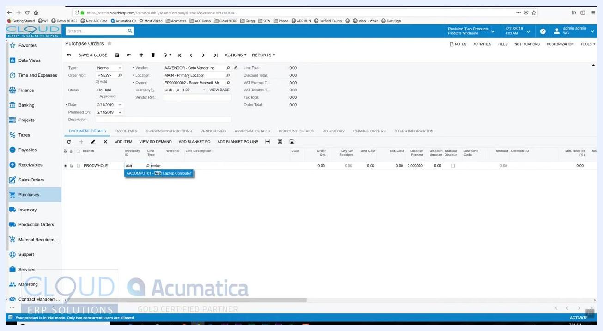
Adding an item to the purchase order by typing the inventory ID and selecting from suggestions

Step 8: Adjust the unit cost for a line item
Locate the Unit Cost field for the item you added (for example, "Acer Laptop Computer"). The default value reflects the last cost received for this item (for example, 247.07).
If needed, click into the Unit Cost field and enter a new value (for example, 245.00). The last cost can be updated based on your organization's preferences, such as upon receipt of the vendor's bill.
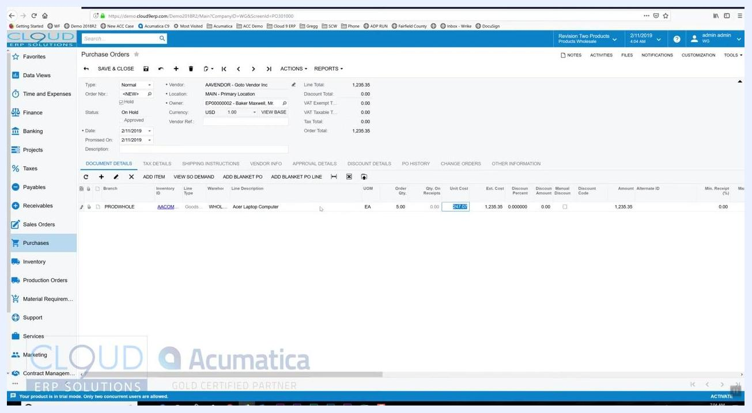
Purchase order screen with an editable Unit Cost field for a line item

Step 9: Apply a discount to a line item
If the vendor offers a discount (for example, 5%), enter the discount percentage in the Discount Percent field for the item. The Discount Amount calculates automatically (for example, 61.25 for a 5% discount on 5 units at $245.00 each).
Confirm that the Manual Discount checkbox is checked if you entered the discount manually, and review the updated Amount field, which reflects the discounted total for the line item.
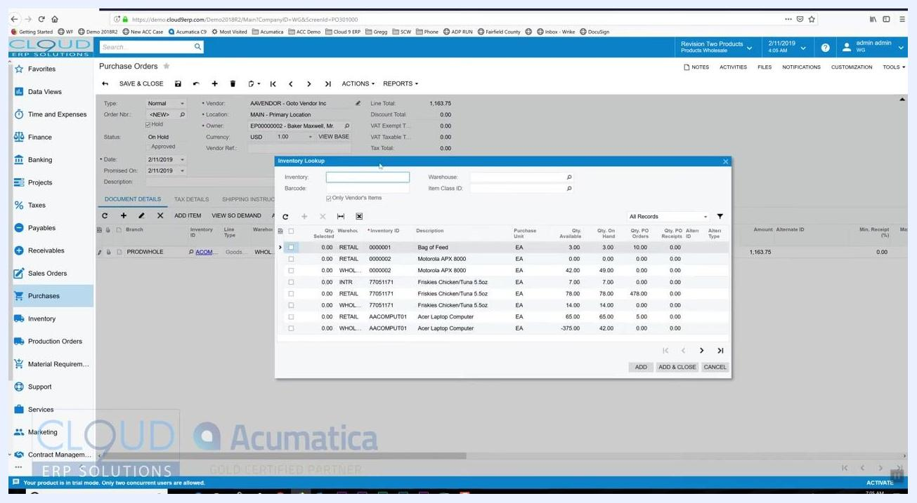
Purchase order screen with a discount applied to a line item, showing the calculated discount amount

Step 10: Add additional items using the Inventory Lookup
Click Add Item above the Document Details grid to open the Inventory Lookup window, which is filtered to show items available from the selected vendor. Browse or search for additional items you want to add.
Enter the desired order quantities directly in the Qty. Ordered column (for example, 3 for "Motorola APX 8000" and 6 for "Friskies Chicken/Tuna 5.5oz"). Click Add & Close to add the selected items to your purchase order.

Step 11: Review and edit line items
After adding items, review the updated list in the Document Details section. Double-click any line to edit quantities, unit costs, or discounts as needed.
Confirm that all items, quantities, and costs are correct. The purchase order remains On Hold at this stage, allowing you to make further changes.
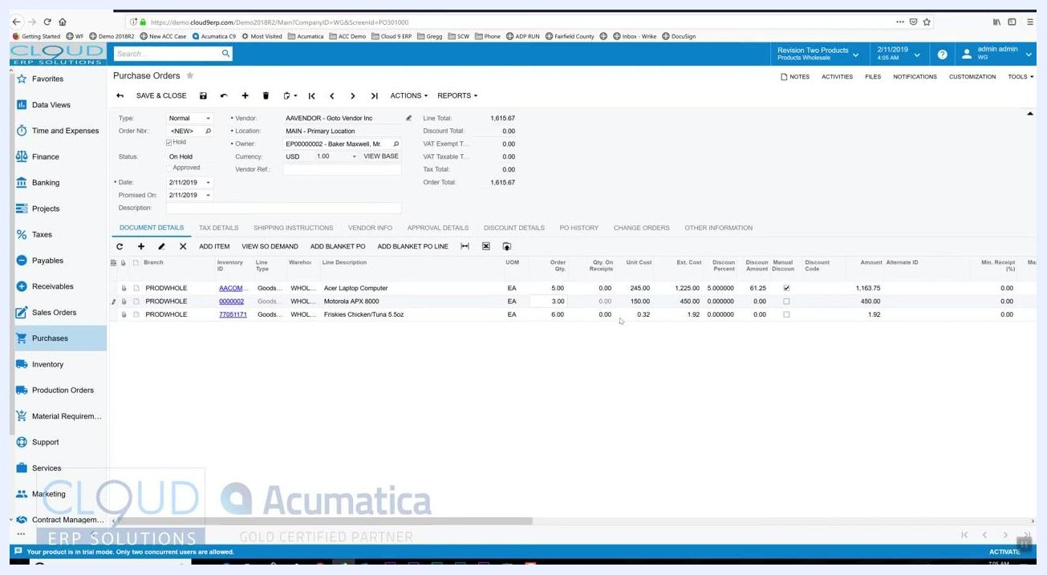
Purchase order screen with multiple line items and editable fields for quantity, cost, and discount

Step 12: Approve the purchase order
Once you take the purchase order off hold, it proceeds through your organization's approval workflow if approvals are enabled. Approval rules can be configured based on criteria such as order amount, vendor, or item type.
Approval requirements depend on the rules your organization has set. For example, orders over $2,000 may require approval, while orders under that threshold may not. Approval rules are optional and can be customized to fit your business needs. As an administrator or authorized approver, you may have the ability to approve your own purchase orders.
If you have the necessary permissions, click the Approve button. The Status field changes from "Pending Approval" to "Open" and "Approved," and the purchase order is ready for further processing.
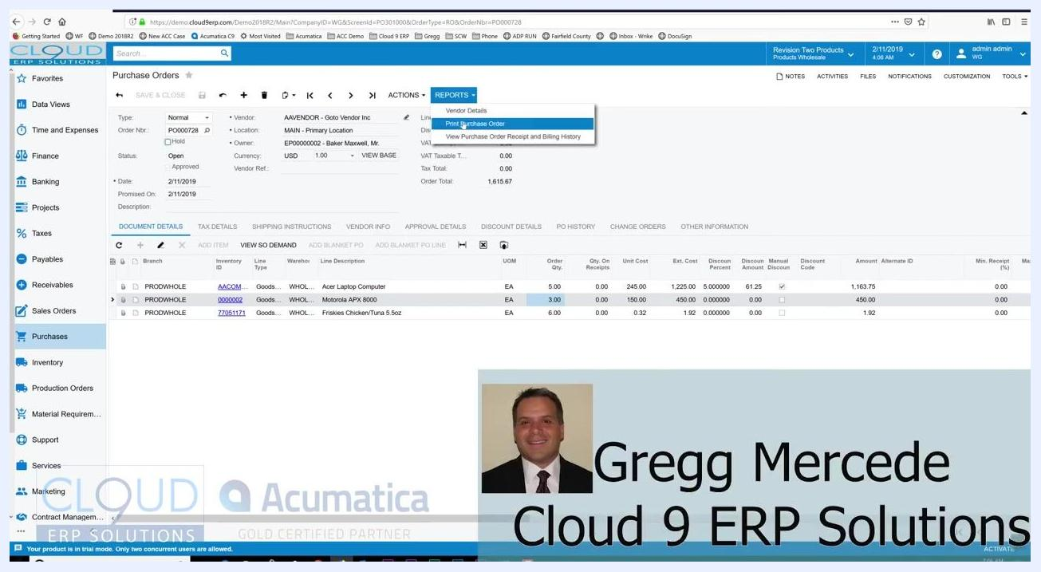
Purchase order screen showing the status changed to "Open" and "Approved" after approval

Step 13: Print the purchase order
With the purchase order in the "Open" state, go to the REPORTS dropdown menu and select Print Purchase Order. The system generates a printable version of the purchase order that includes your company logo and all order details.
Reports dropdown menu with "Print Purchase Order" selected and the purchase order status showing "Open"

Step 14: Review the purchase order printout
Review the generated document for accuracy, confirming that all vendor, shipping, item, and pricing details are correct. The printout displays your company logo, vendor address, shipping address, itemized list, quantities, unit prices, and totals.
Printable purchase order document with company logo, vendor and shipping details, itemized list, and totals

Step 15: Send the purchase order via email
Click the SEND button to open the email activity window. The system automatically populates the recipient (vendor email), subject, and a default message body, and attaches the purchase order PDF.
You can customize the email template in the report form to include additional fields, such as the vendor contact name.
Email Activity window with populated recipient, subject, and editable message body, showing purchase order details

Step 16: Customize the email message
Edit the email body as needed — for example, add special instructions such as "Please put a rush on this." Any signature configured in your user profile appears automatically in the email. Review all details before sending.
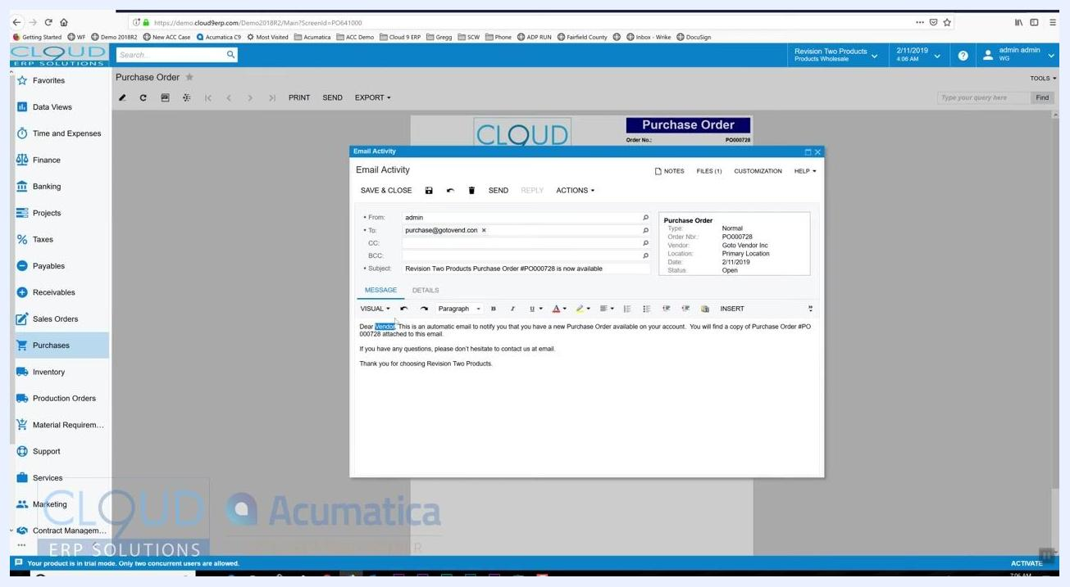
Email Activity window with a custom message, "Please put a rush on this," added to the email body

Step 17: Send the email to the vendor
Click the SEND button in the Email Activity window to email the purchase order to the vendor. The vendor receives the purchase order as an attachment, along with your customized message and signature.

Step 18: Review purchase order details after sending
Navigate back to the Purchase Orders screen and confirm you are viewing the correct order (for example, Order Nbr: PO000728). Verify the vendor details (AAVENDOR - Goto Vendor Inc, Location: Main - Primary Location), the order status ("Open" and "Approved"), and the order date and promised date (2/11/2019 in this example).
Note the order total (1,615.67 USD) and review the line items for accuracy:
- Acer Laptop Computer: 5 units at 245.00 each, discount 61.25, total 1,163.75.
- Motorola APX 8000: 3 units at 150.00 each, total 450.00.
- Friskies Chicken/Tuna 5.5oz: 6 units at 0.32 each, total 1.92.
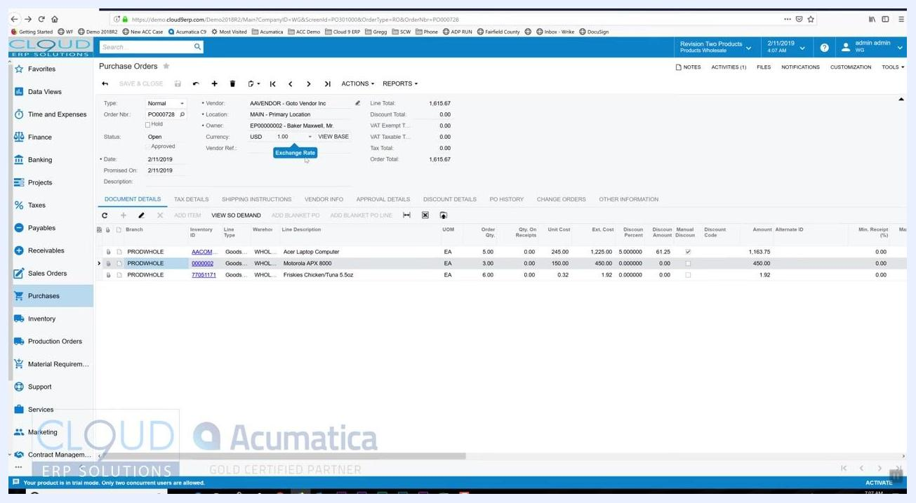
Purchase Orders screen showing order details, vendor, status, line items, and totals

Step 19: Review activities and email tracking
Locate the ACTIVITIES tab at the top right of the purchase order screen. Notice the indicator showing the number of activities associated with the order (for example, 1 activity).
Click the ACTIVITIES (1) tab to open the "Tasks & Activities" window, which lists all activities, tasks, events, and emails associated with the order. For example, you may see an entry dated "11 Feb" with the subject "Revision Two Products Purchase Order #PO000728 is now available."
Tasks & Activities window showing an email activity for the purchase order
The email address attached to your user name is used to send the purchase order. In addition to the email being recorded in the system, you also receive a copy in your own inbox. Any responses from the vendor are tracked and displayed as additional entries in the "Tasks & Activities" window.
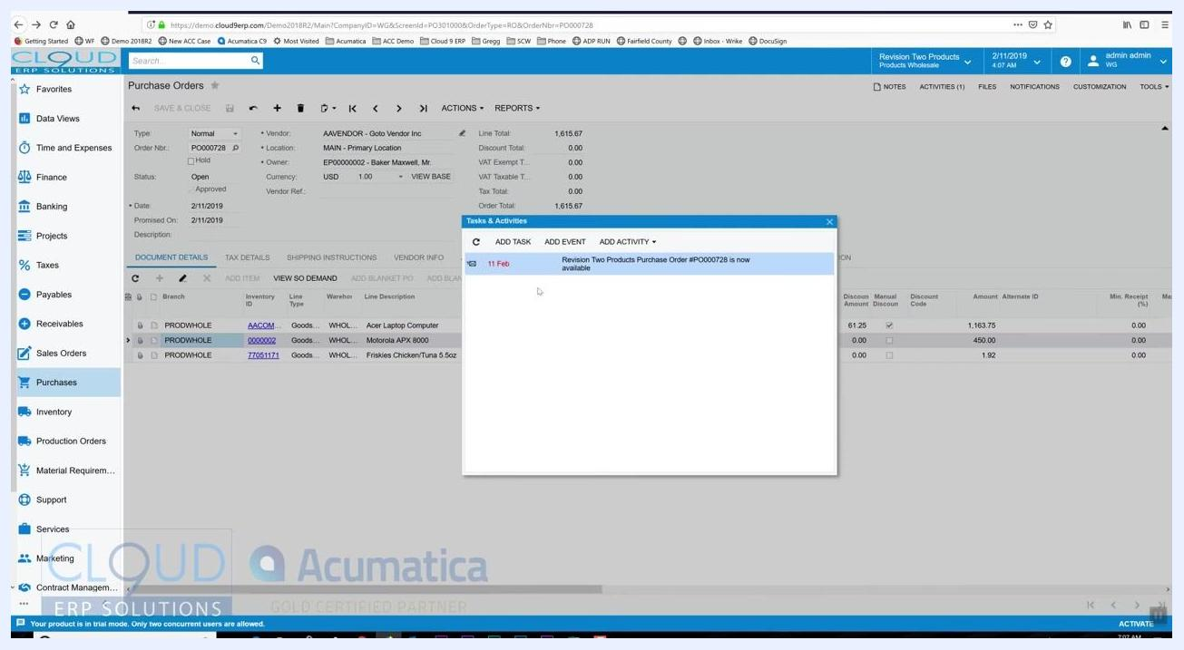
Tasks & Activities window showing a single email activity entry

Step 20: Review or update document details as needed
Return to the DOCUMENT DETAILS tab to review or update order line items as needed. If someone else accesses the purchase order, they can see that it has already been communicated to the vendor, which helps identify and address any discrepancies, such as an incorrect price or quantity.
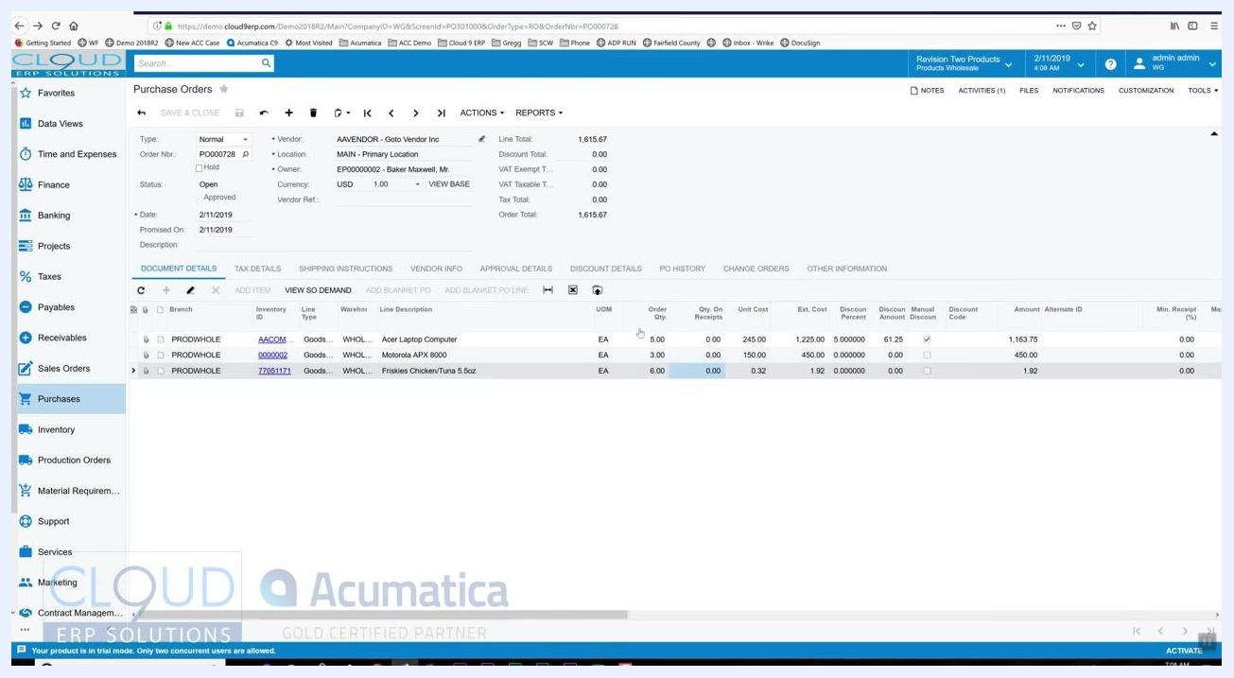
Purchase Orders screen with line items highlighted, showing order quantities and costs

Summary
By following these steps, you can create a purchase order in Acumatica, add and adjust line items, route it through approval, and send it to your vendor by email. The system keeps all purchase order communications tracked, visible, and auditable, while integrating seamlessly with your email workflow.

