How to Complete One-Step Sales Order Processing in Acumatica
This guide shows you how to complete one-step sales order processing in Acumatica using the Quick Process feature. You'll learn how to configure Quick Process settings for an order type, create a new sales order, and process shipment, inventory, and invoicing tasks in a single action — ideal for situations where a customer is present and waiting for immediate fulfillment.

Prerequisites
- An active Acumatica account with access to the Sales Orders module.
- Permission to edit Order Types under Preferences.
- At least one inventory item and customer record set up in the system.

Step 1: Log in to Acumatica
Launch Acumatica and log in to your account. The dashboard displays widgets such as Cash On-Hand, Cash Required, Overdue Payments, and Top Overdue Balances. The left navigation menu gives you access to modules including Favorites, Data Views, Time and Expenses, Finance, Banking, Projects, Payables, Receivables, Sales Orders, Purchases, Inventory, and Dashboards.
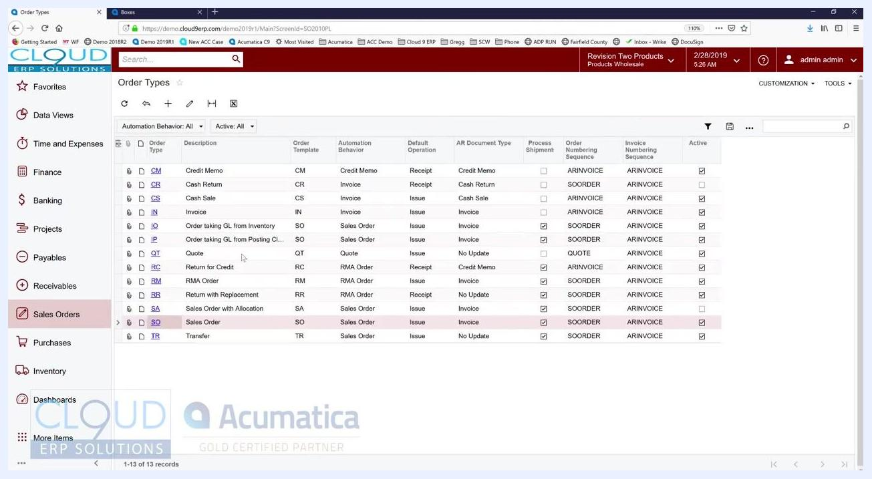
Acumatica dashboard showing cash position widgets, overdue payments, and the navigation menu

Step 2: Open order types
Go to the Sales Orders: Quick Menu. Under Preferences, click Order Types.
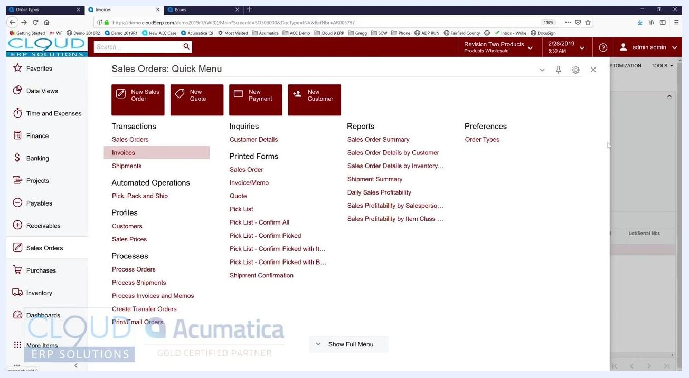
Sales Orders Quick Menu with Preferences and Order Types highlighted
In the Order Types screen, select the order type you want to configure — for example, SO for Sales Order. Click the QUICK PROCESS SETTINGS tab to begin setting up one-step processing for this order type.

Step 3: Review general and template settings
The Order Type SO screen displays tabs for General Settings, Template Settings, and Quick Process Settings. The General Settings tab includes fields for Order Numbering Sequence, Days To Keep, and various checkboxes for order and posting settings.
Order Type SO settings screen with General, Template, and Quick Process Settings tabs
Click the Template Settings tab and locate the checkbox that enables Quick Process Settings. Make sure this checkbox is selected so the Quick Process Settings tab becomes active.

Step 4: Configure quick process steps
In the Quick Process Settings tab, check the boxes for each step you want Quick Process to perform automatically:
- Create Shipment (checked by default)
- Print Pick List
- Prepare Invoice
- Email Invoice
- Release Invoice
- Update IN (inventory)
If you use Acumatica DeviceHub for automated printing, check Print with DeviceHub. You can also define printers manually if needed.
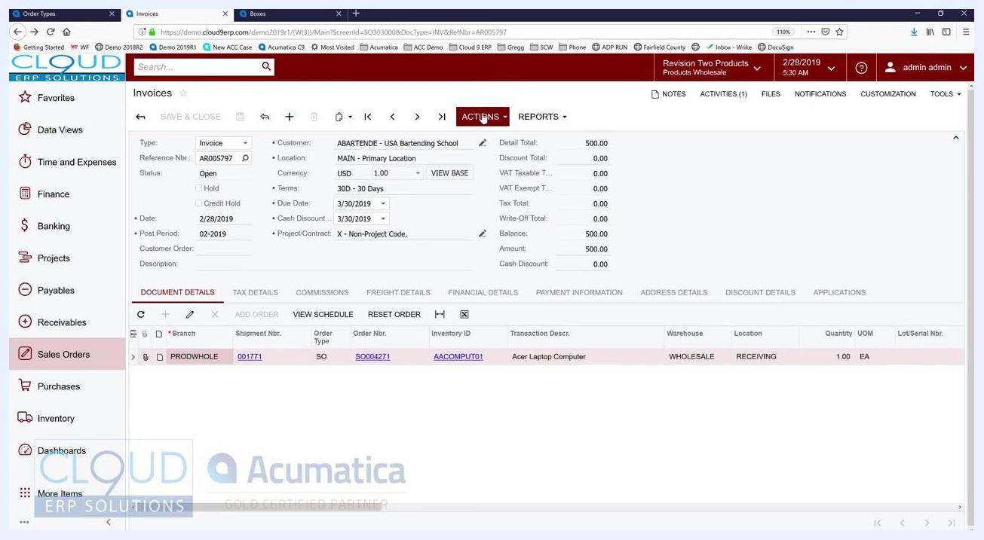
Order Types screen showing multiple Quick Process steps selected, including Create Shipment, Prepare Invoice, Email Invoice, Release Invoice, and Update IN

Step 5: Save your configuration
Click SAVE & CLOSE to apply your Quick Process settings for the selected order type.

Step 6: Start a new sales order
Return to the Sales Orders: Quick Menu and click New Sales Order to start a new order.
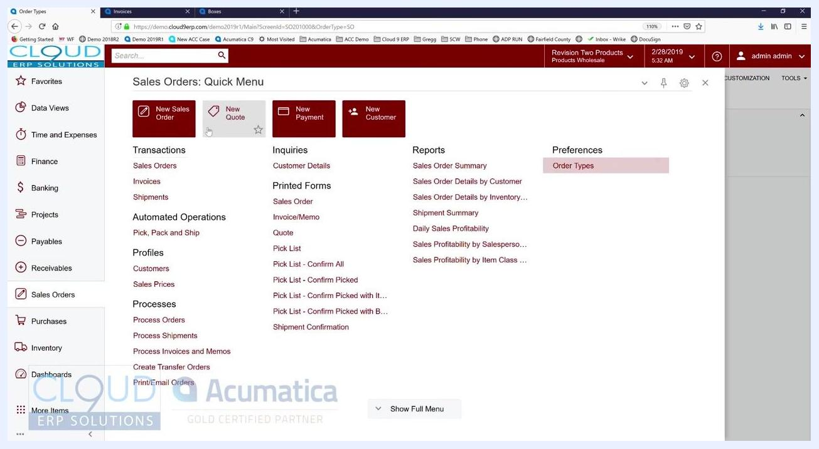
Sales Orders Quick Menu with the New Sales Order button highlighted

Step 7: Enter the order header details
Fill in the required order details:
- Order Type: SO
- Customer: ABARTENDE - USA Bartending School
- Location: MAIN - Primary Location
- Currency: USD, Rate: 1.00
- Date: 2/28/2019
- Requested On: 2/28/2019
- Project: X - Non-Project Code
- Status: Open

Step 8: Add a line item in document details
In the Document Details section, add a line item. Set the Branch to PRODWHOLE and select the appropriate Inventory ID for the item you want to sell.
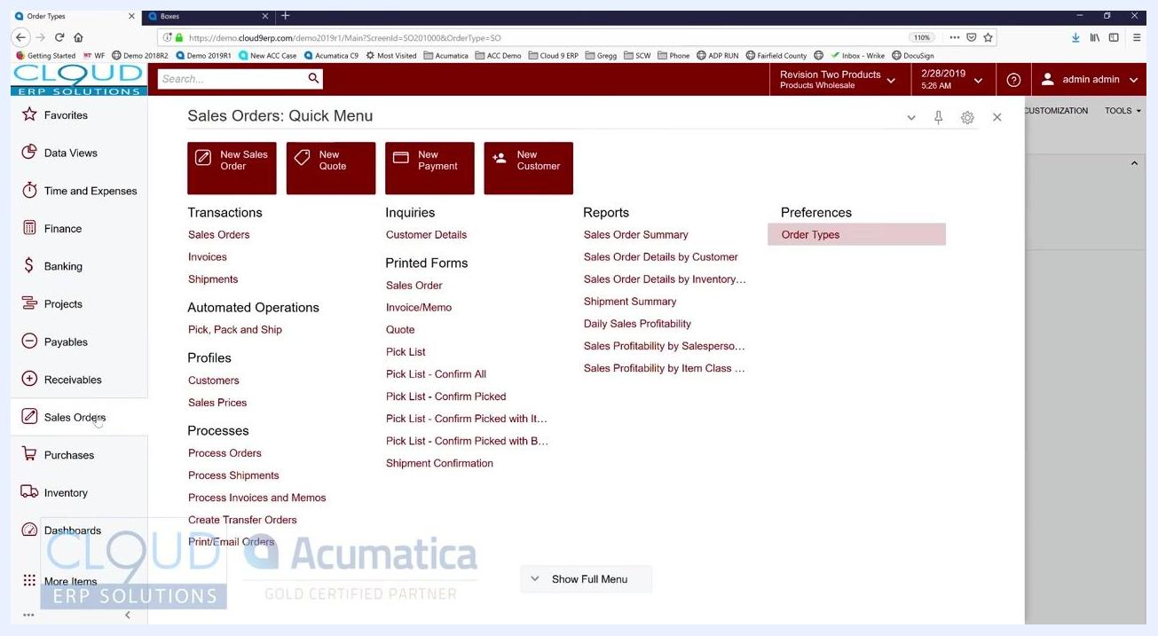
Sales Order entry screen with fields for customer, location, and inventory ID
Complete the line item details:
- Inventory ID: AACOMPUT01
- Warehouse: WHOLESALE
- Line Description: Acer Laptop Computer
- UOM: EA (Each)
- Quantity: 1.00
- Unit Price: 500.00
- Ext. Price: 500.00
- Discount Percent: 0.000000
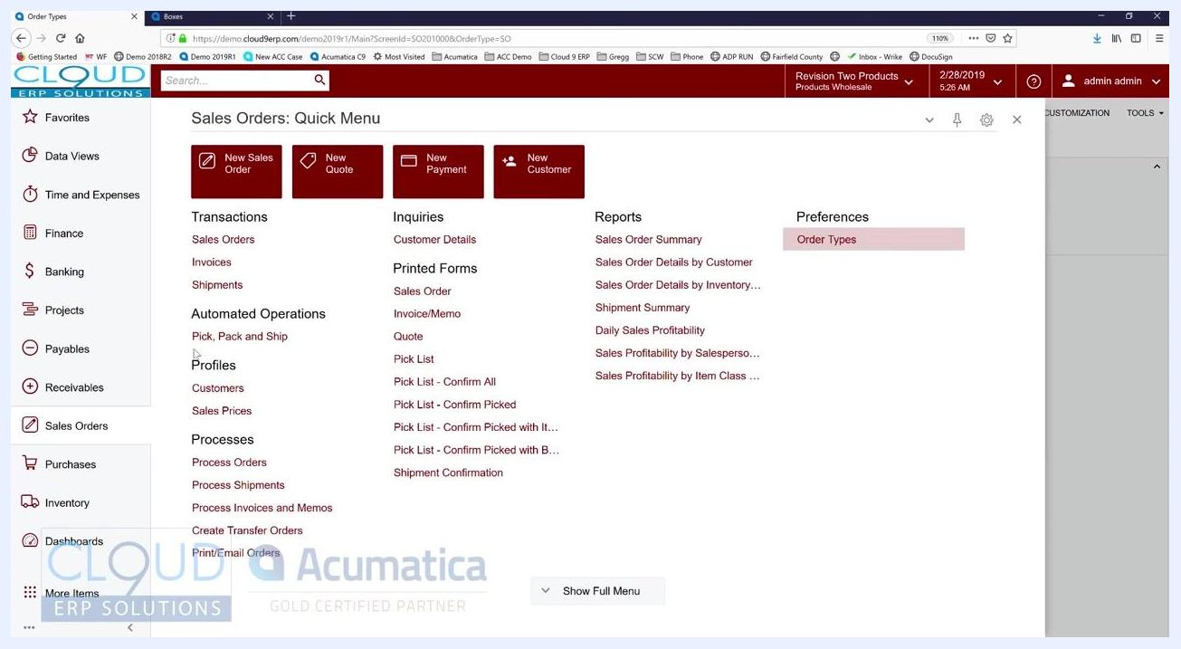
Sales Order with completed line item for Acer Laptop Computer, quantity 1, unit price 500.00

Step 9: Run quick process for one-step order fulfillment
Use the Quick Process feature when you need to complete all order fulfillment steps in one go — for example, when the customer is present and waiting. Quick Process automates multiple steps that would otherwise require separate manual actions.
Instead of processing each step individually, click the QUICK PROCESS button at the top of the screen. This button is located in the toolbar above the order details, next to ACTIONS and REPORTS. Clicking it streamlines the entire order processing workflow into one step.
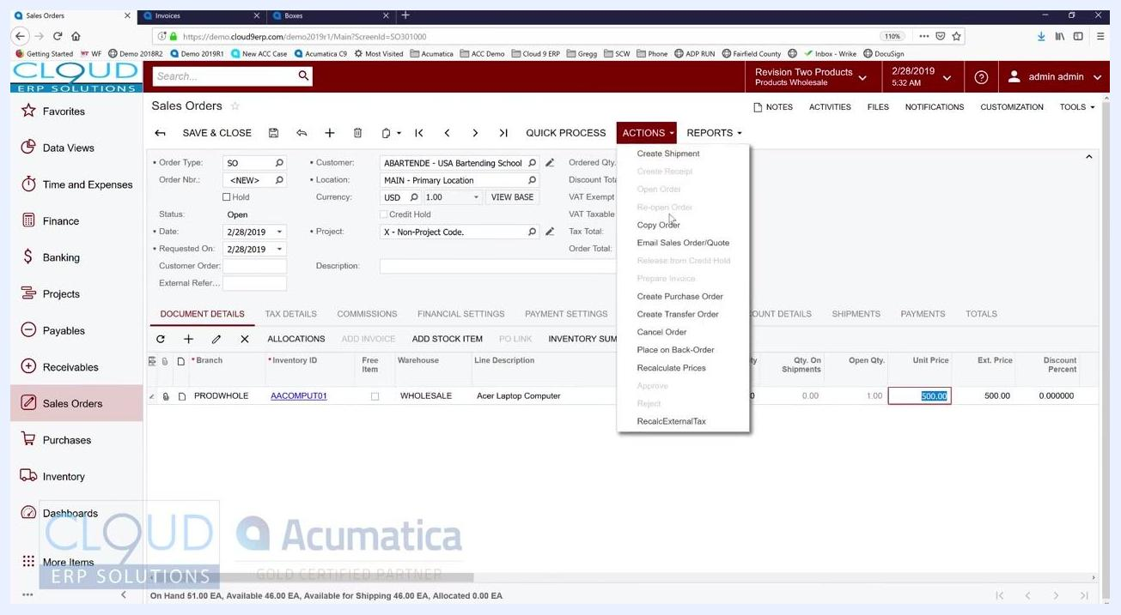
Sales Orders screen with the Quick Process button visible, order details filled in, and the Actions dropdown open

Step 10: Confirm processing options
In the Process Order dialog that appears, confirm the Warehouse ID is set to "WHOLESALE - HQ Wholesale Warehouse." Set the Shipment Date to "Custom" and enter "2/28/2019."
Under Shipping, ensure the following options are checked:
- Create Shipment
- Print Pick List
- Confirm Shipment
- Print Labels
- Print Shipment Confirmation
- Update IN
Under Invoicing, ensure the following options are checked:
- Prepare Invoice
- Print Invoice
- Email Invoice
- Release Invoice
Click OK to process the order.
Process Order dialog with all shipping and invoicing options checked, shipment date set to 2/28/2019, and the cursor on the OK button

Step 11: Review the processing results
Wait for the system to process the order. A Processing Results dialog appears confirming successful completion, displaying the message "The document is successfully processed." The following documents are created, each with a clickable link:
- Shipment: 001772
- Inventory Document: 002009
- Invoice: AR005798
Click OK to close the dialog.
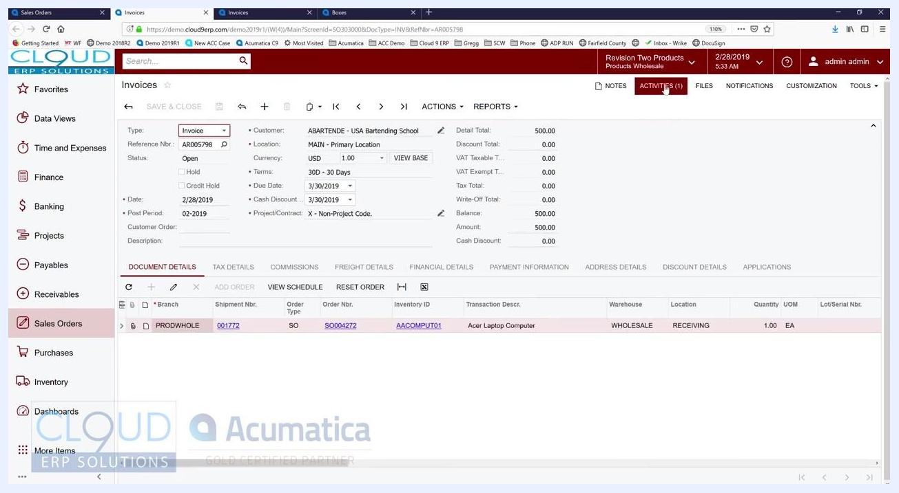
Processing Results dialog showing successful creation of Shipment 001772, Inventory Document 002009, and Invoice AR005798

Step 12: Review the generated invoice
The system automatically navigates to the Invoices screen, where the invoice details are displayed:
- Type: Invoice
- Reference Nbr.: AR005798
- Status: Open
- Customer: ABARTENDE - USA Bartending School
- Location: MAIN - Primary Location
- Amount: 500.00
- Due Date: 3/30/2019
- Order Nbr.: SO004272
- Inventory ID: AACOMPUT01
- Transaction Description: Acer Laptop Computer
- Warehouse: WHOLESALE
- Location: RECEIVING
- Quantity: 1.00 EA
The shipment number (001772) and order number (SO004272) are linked on the invoice for easy reference.
Invoices screen showing invoice AR005798, linked shipment 001772, order SO004272, and item details

Step 13: Confirm the invoice was sent
Since the Email Invoice option was checked during quick processing, the customer automatically receives the invoice for their review — no separate send step is required.

Optional: Process orders in batch
Acumatica also allows you to process multiple orders, shipments, or invoices in bulk rather than one at a time. Navigate to the Sales Orders: Quick Menu and, under the Processes section, select options such as:
- Process Orders
- Process Shipments
- Process Invoices and Memos
These processes can be scheduled or assigned to different users, enabling automation or division of labor across your team.
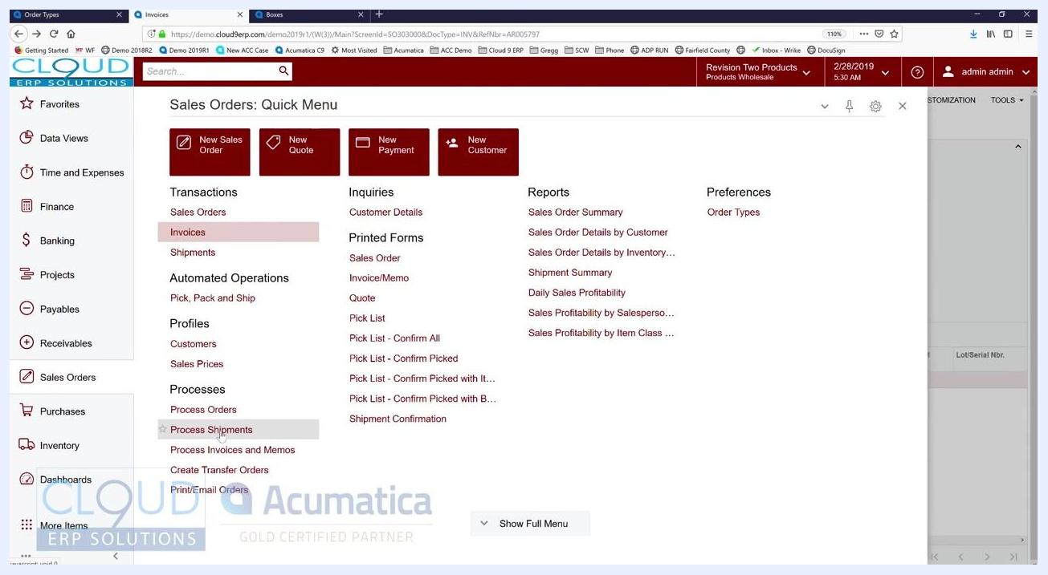
Sales Orders Quick Menu with batch process options for orders, shipments, and invoices

What's next
By following these steps, you can process a sales order from creation through shipment and invoicing in a single action using Quick Process, with the option to switch to batch processing when you need to handle multiple orders at once.

